MINI PROJECT REPORT ON
DEMAND FORECASTING USING MACHINE LEARNING

BACHELOR OF TECHNOLOGY
in

DATA SCIENCE

Submitted By
KORA SUPRIYA HT.NO:23D41A6772
MADUGULA KEERTHANA REDDY HT.NO:23D41A6782
MEKA SHIVA REDDY HT.NO:23D41A6790
NALLA SRIJA HT.NO:23D41A6795


Guided By SURESH BALLALA
PROFESSOR

DEPARTMENT OF DATA SCIENCE

SRI INDU COLLEGE OF ENGINEERING AND TECHNOLOGY

(An Autonomous Institution under UGC,Accredited by NBA,Affiliated to JNTUH) Sheriguda, Ibrahimpatnam – 501510
2023-2027

SRI INDU COLLEGE OF ENGINEERING AND TECHNOLOGY
(An Autonomous Institution under UGC,Accredited by NBA,Affiliated to JNTUH)

DEPARTMENT OF DATA SCIENCE

CERTIFICATE

This is to certify that the project work report entitled “DEMAND FORECASTING USING MACHINE LEARNING” submitted by Kora Supriya (23D41A6772) , Madugula Keerthana Reddy (23D41A6782)
,Meka Shiva Reddy (23D41A6790),Nalla Srija(23D41A6795)in partial fulfillment of the requirement for the award of the degree of Bachelor of Technology in Data Science to the Jawaharlal Nehru Technological University, Hyderabad is a record ofbonafide work carried out by him under our guidance and supervision.The results presented in this thesis have been verified and are found to be satisfactory. The results embodied in this thesis have not been submitted to any other University for the award of any other degree or diploma.

GUIDED BY

PROFESSOR Mr.SURESH BALLALA

HOD
Prof. SURESH BALLALA

EXTERNAL EXAMINER

ACKNOWLEDGEMENT

We would like to express our heartfelt gratitude to everyone who supported us in completing this mini- project.

First and foremost, we extend our deepest thanks to our Chairman SRI R VENKAT RAO Sir for providing the vision and resources necessary for this endeavor. Your leadership and commitment to excellence have been an invaluable source of inspiration.

We are also immensely grateful to our Principal Dr. G. SURESH Sir, whose encouragement and support have been instrumental in guiding us through this journey. Your dedication to fostering an environment of learning and growth has made this project possible.

A special thanks to our Head of Department (HOD) PROF. SURESH BALLALA Sir for your continuous support and for allowing us the opportunity to undertake this project. Your guidance and insight have been pivotal in our success.

Lastly, we are indebted to our Internal Guide PROFESSOR SURESH BALLALA SIR for your unwavering support, mentorship, and patience. Your expertise and advice have been crucial in navigating the challenges and ensuring the project's successful completion.

Kora Supriya (23D41A6772) Madugula Keerthana (23D41A6782) Meka Shiva Reddy (23D41A6790) Nalla Srija (23D41A6795)

ABSTRACT

Demand forecasting using Machine Learning (ML) has become an essential approach for businesses aiming to improve operational efficiency, reduce inventory costs, and enhance customer satisfaction. Traditional forecasting methods often rely on historical averages and statistical models, which may not accurately capture complex patterns in market demand. Machine Learning techniques provide a more advanced and data-driven solution by analyzing large volumes of historical sales data, customer behavior, seasonal trends, promotional activities, weather conditions, and economic factors.
The proposed demand forecasting system uses ML algorithms such as Linear Regression, Random Forest, Decision Tree, and Gradient Boosting to predict future product demand with higher accuracy. These models learn from past sales records and identify hidden relationships among multiple variables that influence demand. The system can forecast demand for different products, locations, and time periods, helping organizations make better decisions regarding inventory management, production planning, and supply chain operations.
In this system, data preprocessing techniques such as cleaning, normalization, feature selection, and handling missing values are applied to improve prediction quality. After training and testing the models, performance is evaluated using metrics such as Mean Absolute Error (MAE), Root Mean Square Error (RMSE), and R-squared score. Among various models, ensemble techniques often provide better accuracy due to their ability to handle non-linear relationships and complex data patterns.

LIST OF CONTENTS

INTRODUCTION 1

LITERATURE SURVEY 2

EXISTING SYTEM 3
  - EXISTING SYSTEM DISADVANTAGES 4

PROPOSED SYSTEM 5
  - PROPOSED SYSTEM ADVANTAGES 6

SYSTEM ANALYSIS 7

SYSTEM REQUIREMENTS 8

SYSTEM ARCHITECTURE 8

UML DIAGRAMS 9
  - CLASS DIAGRAM 9
  - USE CASE DIAGRAM 10
  - SEQUENCE DIAGRAM 10
  - COLLABORATIVE DIAGRAM 11

SYSTEM IMPLEMENTATION …12

SYSTEM ENVIRONMENT 13
  - WHAT IS PYTHON 13
    - ADVANTAGES OF PYTHON 13-15
    - ADVANTAGES OF PYTHON OVER OTHER LANGUAGES 15-16
    - DISADVANTAGES OF PYTHON 16

    - HISTORY OF PYTHON 17
  - WHAT IS MACHINE LEARNING 18
    - NEED FOR MACHINE LEARNING 19
    - CHALLENGES IN MACHINE LEARNING 20
    - APPLICATIONS OF MACHINE LEARNING 21
    - HOW TO START LEARNING MACHINE LEARNING…………………………... 22
    - TYPES OF MACHINE LEARNING 23
    - ADVANTAGES OF MACHINE LEARNING 24
    - DISADVANTAGES OF MACHINE LEARNING 25

INSTALL PYTHON STEP BY STEP IN WINDOWS AND MAC 26
  - DOWNLOAD THE CORRECT VERSION OF PYTHON 27-28
  - INSTALLATION OF PYTHON 29-30
  - VERIFYING PYTHON INSTALLATION 31
  - CHECK HOW PYTHON IDLE WORKS 32-33

MODULES USED IN PROJECT 34

ALGORITHMS USED IN PROJECT 35

CODE 36-37

OUTPUT 38-44

CONCLUSION 45

FUTURE WORK 46

REFERENCES 47

INTRODUCTION

Demand forecasting is the process of predicting future customer demand for products or services based on historical data and market trends. Accurate demand forecasting is essential for organizations because it helps in planning production, inventory management, workforce allocation, budgeting, and supply chain operations. Traditional forecasting methods mainly depend on manual calculations, statistical techniques, and expert judgment. Although these methods are useful for simple scenarios, they often fail to handle large datasets and complex factors that influence demand, such as seasonal variations, customer behavior, market conditions, promotional campaigns, and economic changes.
With the growth of digital business and the availability of large amounts of data, Machine Learning (ML) has emerged as an effective solution for demand forecasting. ML models can analyze past sales records, identify hidden patterns, and make accurate predictions for future demand. Unlike traditional methods, ML algorithms can learn from changing data and improve their performance over time. This makes them highly suitable for dynamic industries such as retail, e-commerce, manufacturing, healthcare, and agriculture.
In a demand forecasting system, various types of data such as sales history, product details, weather information, holiday trends, and customer purchasing patterns are collected and processed. After preprocessing the data, ML algorithms such as Linear Regression, Decision Tree, Random Forest, Support Vector Machine, and Gradient Boosting are used to build predictive models. These models are then evaluated using performance metrics such as accuracy, Mean Absolute Error (MAE), and Root Mean Square Error (RMSE).
The main objective of using ML in demand forecasting is to reduce inventory shortages, avoid overstocking, optimize supply chain operations, and improve customer satisfaction. By making accurate predictions, businesses can make better strategic decisions, reduce costs, and increase profitability.

LITERATURE SURVEY

Statistical Forecasting Approaches
Demand forecasting is essential for inventory management, production planning, and supply chain optimization. Traditional methods such as Moving Average, Exponential Smoothing, and ARIMA use historical sales data to predict future demand. While effective for simple forecasting tasks, these techniques often fail to capture complex market dynamics and external influencing factors.

Machine Learning-Based Forecasting
Machine Learning (ML) has significantly improved demand forecasting by analyzing large datasets and identifying hidden patterns. ML models can process historical sales records, seasonal trends, and external variables to generate more accurate predictions than conventional statistical methods.

Regression-Based Models
Linear Regression is commonly used as a baseline forecasting technique due to its simplicity and interpretability. It helps identify relationships between variables and predict future demand. However, its performance is limited when demand patterns become highly nonlinear.

Random Forest and Decision Tree Models
Decision Tree algorithms are effective in handling complex decision-making processes. Random Forest enhances prediction accuracy by combining multiple decision trees, reducing overfitting, and providing better generalization across different demand scenarios.

Gradient Boosting Techniques
Gradient Boosting is a powerful ensemble learning method that improves forecasting accuracy by minimizing prediction errors through iterative learning. It performs well on large and complex datasets with multiple demand-influencing factors.

Deep Learning Approaches
Deep Learning models such as LSTM and RNN are widely used for time-series forecasting. These models capture long-term dependencies in sequential sales data and provide highly accurate demand predictions, although they require larger datasets and higher computational resources.

XGBoost for Demand Forecasting
XGBoost is an advanced machine learning algorithm known for its high accuracy and efficiency. It effectively handles nonlinear relationships, missing values, and large-scale datasets, making it one of the most preferred techniques for demand forecasting.

EXISTING SYSTEM

The existing demand forecasting system mainly relies on traditional statistical methods and manual analysis to estimate future demand. Common techniques used in existing systems include moving averages, exponential smoothing, trend analysis, and time series forecasting methods such as ARIMA. These methods use historical sales data to identify trends and seasonal patterns, but they often fail to consider multiple external factors such as customer preferences, weather conditions, market competition, social media trends, promotional campaigns, and economic changes.
In many organizations, demand forecasting is still performed using spreadsheet tools and human judgment. Managers manually analyze previous sales reports and estimate future demand based on experience. This process is time-consuming, less accurate, and highly dependent on individual knowledge. Traditional systems are also limited in handling large datasets and complex relationships among different demand-influencing variables.
Most existing systems use only one forecasting model for all products, which may not provide accurate results for products with different demand patterns. They also struggle to adapt quickly when sudden market changes occur, such as seasonal fluctuations, festivals, or unexpected customer behavior. As a result, businesses may face problems like stock shortages, overstocking, increased storage costs, delayed deliveries, and customer dissatisfaction.
Another major drawback of existing systems is their limited scalability. As the volume of data increases, traditional forecasting methods become slower and less efficient. They also require frequent manual intervention for updating and maintaining forecasting models.
Overall, the existing system provides only basic demand prediction capabilities and lacks the intelligence needed to generate highly accurate forecasts in rapidly changing business environments.

EXISTING SYSTEM DISADVANTAGES

- Existing systems mainly depend on historical sales data and cannot effectively consider external factors such as weather, promotions, holidays, customer behavior, and market trends.
- Traditional forecasting methods provide lower accuracy when demand patterns become complex or highly dynamic.
- Manual forecasting processes are time-consuming and require significant human effort.

- Spreadsheet-based prediction methods are more prone to human errors and miscalculations.

- Existing systems cannot efficiently handle large volumes of data from multiple sources.

- Sudden market changes, seasonal demand variations, and unexpected events are difficult to predict using conventional methods.
- Most traditional models use only a single forecasting technique, which may not be suitable for all products and categories.
- Existing systems often lead to overstocking or stock shortages, increasing operational costs.

- They provide poor scalability when business size and data volume increase.

- Traditional methods require frequent manual updates and maintenance.

- Lack of real-time forecasting capabilities reduces the speed of business decision-making.

- Lower forecasting accuracy may lead to customer dissatisfaction, delayed deliveries, and reduced profits.

PROPOSED SYSTEM

The proposed system uses Machine Learning techniques to improve the accuracy and efficiency of demand forecasting. Unlike traditional methods, this system analyzes not only historical sales data but also other important factors such as seasonal trends, holidays, promotional activities, weather conditions, customer purchasing behavior, and market demand. By considering multiple influencing variables, the system can generate more reliable and precise forecasts.
The proposed model collects data from different sources, including sales transactions, inventory records, customer information, and external datasets. After data collection, preprocessing techniques such as data cleaning, missing value handling, normalization, and feature selection are applied to improve data quality. The processed data is then used to train Machine Learning algorithms such as Linear Regression, Decision Tree, Random Forest, Gradient Boosting, and XGBoost.
These algorithms learn patterns from past data and predict future demand for different products, locations, and time periods. Among these models, ensemble techniques such as Random Forest and Gradient Boosting provide better forecasting performance because they can handle non-linear relationships and large datasets more effectively.
The proposed system also includes visualization dashboards and reporting tools that help managers understand sales trends, predicted demand, inventory levels, and product performance. Based on the predicted demand, businesses can make better decisions regarding stock management, production planning, supplier coordination, and workforce allocation.
The main goal of the proposed system is to reduce stock shortages, minimize excess inventory, improve supply chain efficiency, and increase overall profitability. Since the model continuously learns from new data, it can adapt to changing market conditions and provide more accurate demand predictions over time.

ADVANTAGES OF PROPOSED SYSTEMS

  - Provides more accurate demand predictions compared to traditional forecasting methods.

  - Considers multiple factors such as sales history, weather, holidays, promotions, and customer behavior.
  - Reduces the chances of stock shortages and overstock situations.

  - Improves inventory management and warehouse utilization.

  - Helps businesses make better production and supply chain decisions.

  - Supports real-time forecasting and faster business planning.

  - Can handle large volumes of structured and unstructured data.

  - Reduces manual effort and human errors in forecasting.

  - Improves customer satisfaction by ensuring product availability.

  - Enhances business profitability by reducing unnecessary storage and operational costs.

  - Adapts to changing market trends and seasonal demand patterns.

  - Provides better scalability for growing businesses and large datasets.

  - Ensemble Machine Learning models such as Random Forest and Gradient Boosting improve prediction accuracy.
  - Visualization dashboards make it easier for managers to understand forecasting results and business trends.
  - Helps in better resource planning, workforce allocation, and supplier coordination.

SYSTEM ANALYSIS

Demand forecasting is an important process for businesses to predict future product demand and manage inventory efficiently. Traditional forecasting methods often fail to provide accurate predictions due to changing market conditions, seasonal trends, and customer behavior. This can lead to stock shortages, excess inventory, and increased operational costs.The proposed Demand Forecasting System uses Machine Learning techniques to analyze historical sales data and identify demand patterns. The system helps businesses make accurate predictions, improve inventory management, and support better decision-making.

OBJECTIVES

    - To develop a Machine Learning-based demand forecasting system.

    - To analyze historical sales data and predict future demand.

    - To improve forecasting accuracy and reduce inventory costs.

    - To support production planning and supply chain management.

FEASIBILITY STUDY

Technical Feasibility:
The system can be implemented using Python, Pandas, NumPy, Scikit-learn, and other Machine Learning libraries.

Economic Feasibility:
The system reduces losses caused by overstocking and stock shortages, improving business profitability.

Operational Feasibility:
The system is user-friendly and can be easily integrated into existing business operations.Thus, the proposed system provides an efficient, reliable, and cost-effective solution for demand forecasting using Machine Learning.

SYSTEM REQUIREMENTS

HARDWARE REQUIREMENTS:
      - Processor: Intel Core i5 or higher

      - RAM: Minimum 8 GB

      - Hard Disk: Minimum 256 GB SSD

      - System Type: 64-bit Operating System

SOFTWARE REQUIREMENTS:
- Operating System: Windows 10 or later / Ubuntu

      - Programming Language: Python

      - IDEs: Jupyter Notebook, Visual Studio Code

      - Database: MySQL or MongoDB

      - Libraries: Pandas, NumPy, Scikit-learn, Matplotlib

      - Frameworks: Flask or Django

SYSTEM ARCHITECTURE
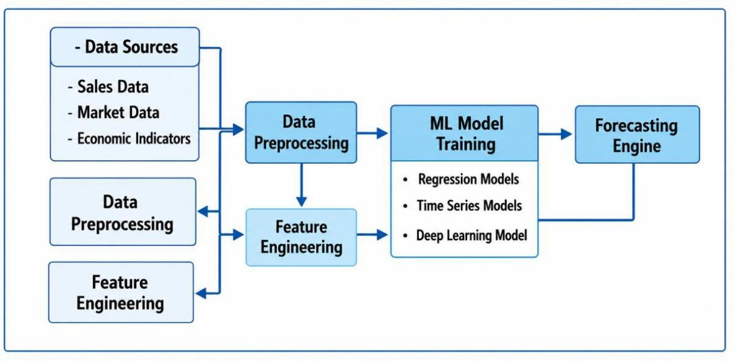

CLASS DIAGRAM:

UML DIAGRAMS

The class diagram represents the structure of the Demand Forecasting System, showing classes such as DataAnalyst, HistoricalData, MLModel, and ForecastResult. It illustrates how historical data is processed by the ML model to generate forecast results and reports.

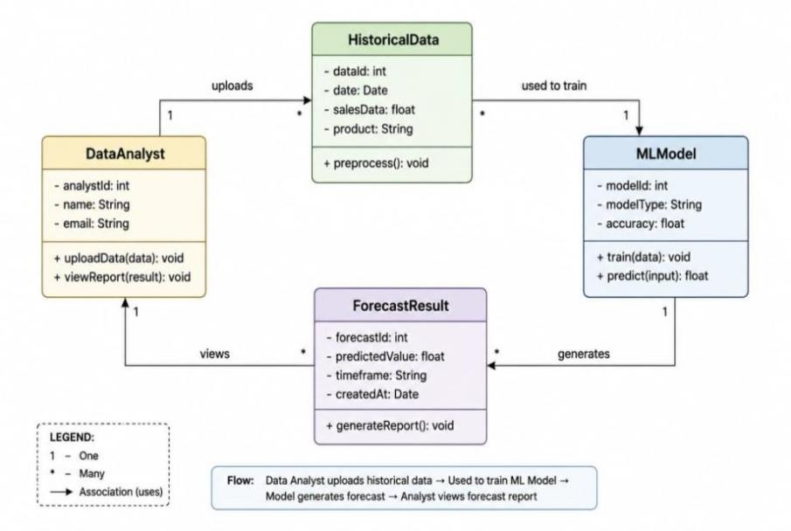

USECASE DIAGRAM:
The Use Case Diagram shows the interactions between users and the Demand Forecasting System. It illustrates key functions such as data upload, model training, forecast generation, and report viewing.

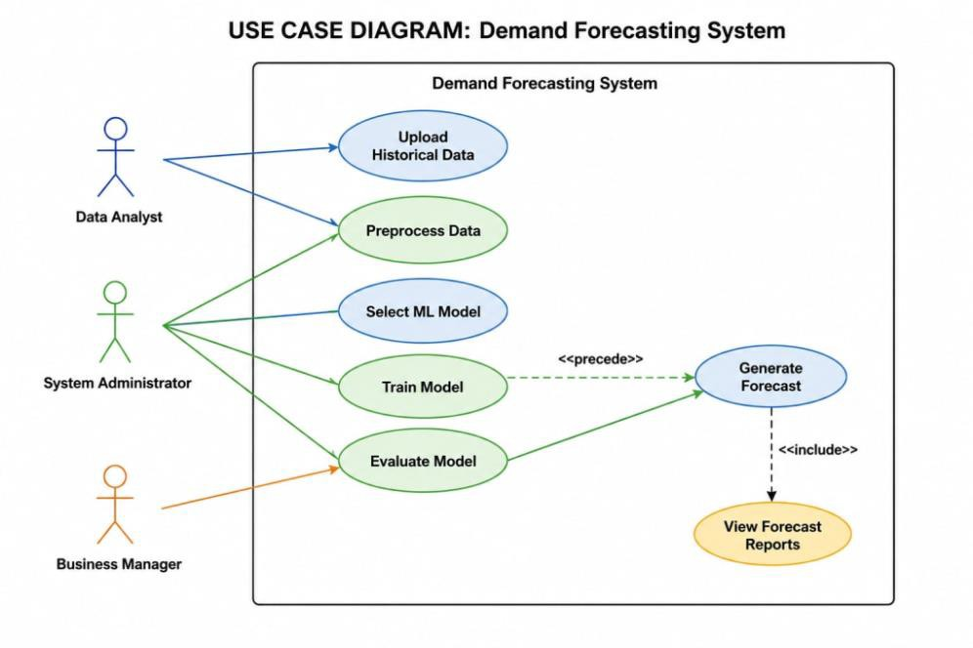

SEQUENCE DIAGRAM:
The Sequence Diagram shows the step-by-step interaction between the Data Analyst, Data Preprocessor, ML Model, and Forecast Engine in generating demand forecasts. It illustrates the flow of data from uploading historical records to producing forecast results and reports.

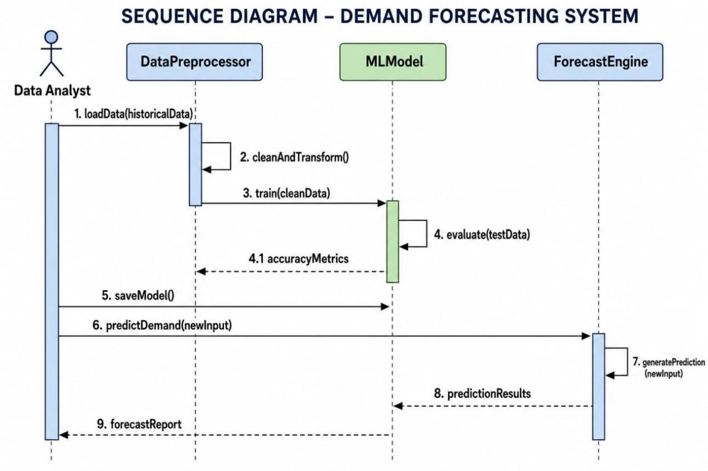

COLLABORATIVE DIAGRAM:
The Collaboration Diagram shows how different components of the Demand Forecasting System interact and exchange messages to perform forecasting tasks. It highlights the communication between the Data Analyst, Data Preprocessor, ML Model, and Forecast Engine to generate forecast results.
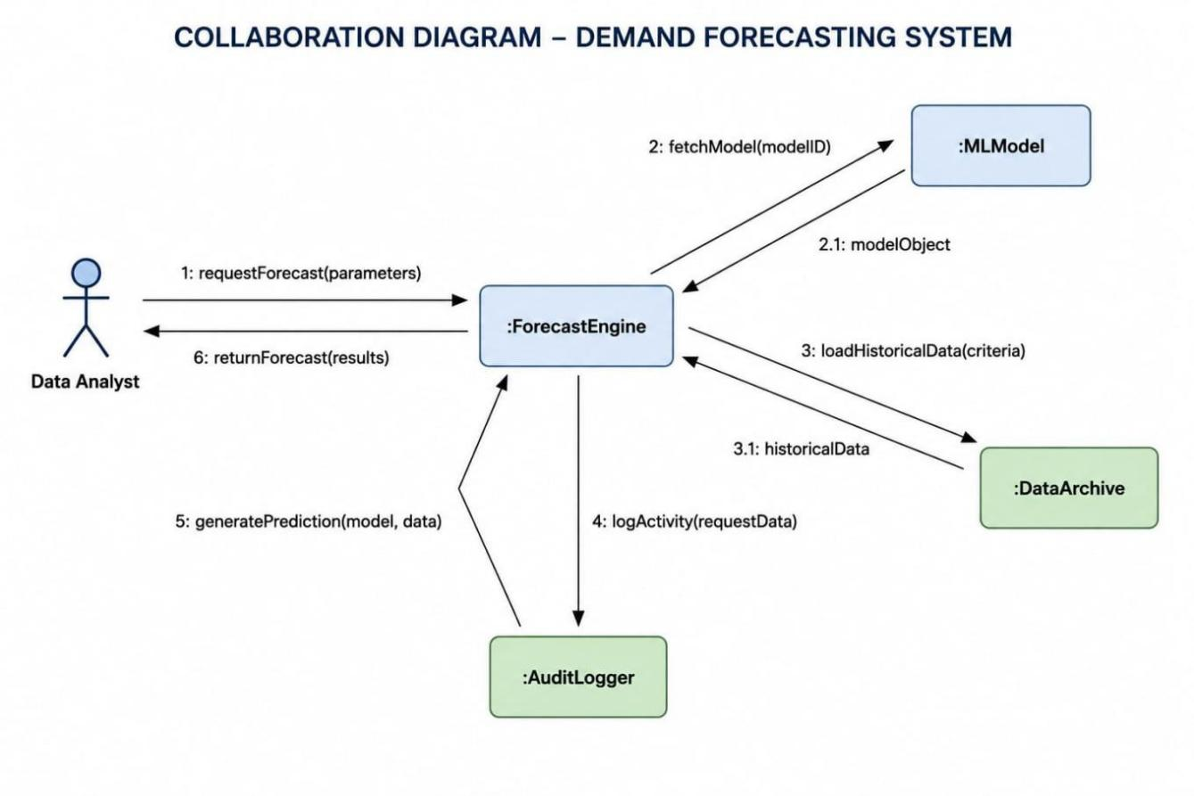

SYSTEM IMPLEMENTATIONS
The implementation of the demand forecasting system begins with collecting data from multiple sources such as sales transactions, customer purchase records, inventory databases, weather information, festival seasons, and promotional activities. In the next stage, data preprocessing is performed to improve the quality of the collected data. This includes removing duplicate records, handling missing values, converting categorical values into numerical format, normalization, and feature scaling. Important attributes such as product category, date, sales quantity, location, season, and discount offers are selected for model training.
After preprocessing, the dataset is divided into training and testing sets. Different Machine Learning algorithms such as Linear Regression, Decision Tree, Random Forest, Gradient Boosting, and XGBoost are applied to build forecasting models. These models are trained using historical demand data and then tested on unseen data to evaluate their prediction accuracy.
The model performance is measured using evaluation metrics such as Mean Absolute Error (MAE), Root Mean Square Error (RMSE), and R-squared score.

1 𝑛
𝑀𝐴𝐸 = ∑ ∣ 𝑦𝑖 − 𝑦̂𝑖 ∣
𝑛
𝑖=1

A lower MAE value indicates better prediction performance.

Once the best-performing model is selected, it is integrated into the application system. The application can be developed using Flask or Django for the backend, while the frontend can use HTML, CSS, and JavaScript for user interaction. The trained model is stored and reused for predicting future demand whenever new data is entered into the system.
The final implementation also includes a dashboard that displays predicted demand, product- wise sales trends, inventory status, and business insights. Managers can use these predictions to make decisions about stock replenishment, production planning, supplier coordination, and warehouse management.

SYSTEM ENVIRONMENT

WHAT IS PYTHON:-

Below are some facts about Python.

Python is currently the most widely used multi-purpose, high-level programming language.

Python allows programming in Object-Oriented and Procedural paradigms. Python programs generally are smaller than other programming languages like Java.
Python language is being used by almost all tech-giant companies like – Google, Amazon, Facebook, Instagram, Dropbox, Uber… etc.
The biggest strength of Python is huge collection of standard library which can be used for the following .
- Machine Learning
- GUI Applications (like Kivy, Tkinter, PyQtetc. )
- Web frameworks like Django (used by YouTube, Instagram, Dropbox)
- Image processing (like Opencv, Pillow)
- Web scraping (like Scrapy, BeautifulSoup, Selenium)
- Test frameworks
- Multimedia

ADVANTAGES OF PYTHON:-

Let’s see how Python dominates over other languages.

Extensive Libraries

Python downloads with an extensive library and it contain code for various purposes likeregular expressions, documentation-generation, unit-testing, web browsers, threading,databases, CGI, email, image manipulation, and more. So, we don’t have to write the complete code for that manually.

Extensible

As we have seen earlier, Python can be extended to other languages. You can write some of your code in languages like C++ or C. This comes in handy, especially in projects.

Embeddable

Complimentary to extensibility, Python is embeddable as well. You can put your Python code in your source code of a different language, like C++. This lets us add scripting capabilities to our code in the other language.

Improved Productivity

The language’s simplicity and extensive libraries render programmers more productive than languages like Java and C++ do. Also, the fact that you need to write less and get more things done.

IOT Opportunities

Since Python forms the basis of new platforms like Raspberry Pi, it finds the future bright for the Internet Of Things. This is a way to connect the language with the real world.

Simple and Easy

When working with Java, you may have to create a class to print ‘Hello World’. But in Python, just a print statement will do. It is also quite easy to learn, understand, and code. This is why when people pick up Python, they have a hard time adjusting to other more verbose languages like Java.

Readable

Because it is not such a verbose language, reading Python is much like reading English. This is the reason why it is so easy to learn, understand, and code. further aids the readability of the code.

Object-Oriented

This language supports both the procedural and object-oriented programming paradigms. While functions help us with code reusability, classes and objects let us model the real world. A class allows the encapsulation of data and functions into one.

Free and Open-Source

Like we said earlier, Python is freely available. But not only can you download Python for free, but you can also download its source code, make changes to it, and even distribute it. It downloads with an extensive collection of libraries to help you with your tasks.

Portable

When you code your project in a language like C++, you may need to make some changes to it if you want to run it on another platform. But it isn’t the same with Python. Here, you need to code only once, and you can run it anywhere. This is called Write Once Run Anywhere (WORA).

Interpreted
Lastly, we will say that it is an interpreted language. Since statements are executed one by one, debugging is easier than in compiled languages.

ADVANTAGES OF PYTHON OVER OTHER LANGUAGES

Less Coding

Python also has an awesome standard library support, so you don’t have to search for any third-party libraries to get your job done. This is the reason that many people suggest learning Python to beginners

Affordable

Python is free therefore individuals, small companies or big organizations can leverage the free available resources to build applications The 2019 Github annual survey showed us that Python has overtaken Java in the most popular programming language category.

Python is for Everyone

Python code can run on any machine whether it is Linux, Mac or Windows. Programmers need to learn different languages for different jobs but with Python, you can professionally build web apps, perform data analysis and machine learning, automate things, do web scraping and also build games and powerful visualizations. It is an all-rounder programming language.

DISADVANTAGES OF PYTHON

So far, we’ve seen why Python is a great choice for your project. But if you choose it, you should be aware of its consequences as well. Let’s now see the downsides of choosing Python over another language.

Speed Limitations

We have seen that Python code is executed line by line. But since Python is interpreted, it often results in slow execution. This, however, isn’t a problem unless speed is a focal point for the project. In other words, unless high speed is a requirement, the benefits offered by Python are enough to distract us from its speed limitations.

Weak in Mobile Computing and Browsers

While it serves as an excellent server-side language, Python is much rarely seen on the client-side. Besides that, it is rarely ever used to implement smartphone-based applications. One such application is called Carbonnelle.
The reason it is not so famous despite the existence of Brython is that it isn’t that secure.

Design Restrictions

As you know, Python is dynamically-typed. This means that you don’t need to declare the type of variable while writing the code. It uses duck-typing. But wait, what’s that? Well, it just means that if it looks like a duck, it must be a duck. While this is easy on the programmers during coding, it can raise run-time errors.

Underdeveloped Database Access Layers

Compared to more widely used technologies like JDBC (Java DataBase Connectivity) and ODBC (Open DataBase Connectivity), Python’s database access layers are a bit underdeveloped. Consequently, it is less often applied in huge enterprises.

Simple

No, we’re not kidding. Python’s simplicity can indeed be a problem. Take my example. I don’t do Java, I’m more of a Python person. To me, its syntax is so simple that the verbosity of Java code seems unnecessary.
This was all about the Advantages and Disadvantages of Python Programming Language.

HISTORY OF PYTHON:-

What do the alphabet and the programming language Python have in common? Right, both start with ABC. If we are talking about ABC in the Python context, it's clear that the programming language ABC is meant. ABC is a general-purpose programming language and programming environment, which had been developed in the Netherlands, Amsterdam, at the CWI (Centrum Wiskunde&Informatica). The greatest achievement of ABC was to influence the design of Python.Python was conceptualized in the late 1980s. Guido van Rossum worked that time in a project at the CWI, called Amoeba, a distributed operating system. In an interview with Bill Venners¹, Guido van Rossum said: "In the early 1980s, I worked as an implementer on a team building a language called ABC at Centrum voorWiskundeen Informatica (CWI).
I don't know how well people know ABC's influence on Python. I try to mention ABC's influence because I'm indebted to everything I learned during that project and to the people who worked on it."Later on in the same Interview, Guido van Rossum continued: "I remembered all my experience and some of my frustration with ABC. I decided to try to design a simple scripting language that possessed some of ABC's better properties, but without its problems. So I started typing. I created a simple virtual machine, a simple parser,

and a simple runtime. I made my own version of the various ABC parts that I liked. I created a basic syntax, used indentation for statement grouping instead of curly braces or begin-end blocks, and developed a small number of powerful data types: a hash table (or dictionary, as we call it), a list, strings, and numbers."

WHAT IS MACHINE LEARNING:-

Before we take a look at the details of various machine learning methods, let's start by looking at what machine learning is, and what it isn't. Machine learning is often categorized as a subfield of artificial intelligence, but I find that categorization can often be misleading at first brush. The study of machine learning certainly arose from research in this context, but in the data science application of machine learning methods, it's more helpful to think of machine learning as a means of building models of data.

Fundamentally, machine learning involves building mathematical models to help understand data. "Learning" enters the fray when we give these models tunable parameters that can be adapted to observed data; in this way the program can be considered to be "learning" from the data.

Once these models have been fit to previously seen data, they can be used to predict and understand aspects of newly observed data. I'll leave to the reader the more philosophical digression regarding the extent to which this type of mathematical, model-based "learning" is similar to the "learning" exhibited by the human brain.Understanding the problem setting in machine learning is essential to using these tools effectively, and so we will start with some broad categorizations of the types of approaches we'll discuss here.

CATEGORIES OF MACHINE LEARNING:-

At the most fundamental level, machine learning can be categorized into two main types: supervised learning and unsupervised learning.

Supervised learning involves somehow modeling the relationship between measured features of data and some label associated with the data; once this model is determined, it can be used

to apply labels to new, unknown data. This is further subdivided into classification tasks and regression tasks: in classification, the labels are discrete categories, while in regression, the labels are continuous quantities. We will see examples of both types of supervised learning in the following section.

Unsupervised learning involves modeling the features of a dataset without reference to any label, and is often described as "letting the dataset speak for itself." These models include tasks such as clustering and dimensionality reduction.

Clustering algorithms identify distinct groups of data, while dimensionality reduction algorithms search for more succinct representations of the data. We will see examples of both types of unsupervised learning in the following section.

NEED FOR MACHINE LEARNING:-

Human beings, at this moment, are the most intelligent and advanced species on earth because they can think, evaluate and solve complex problems. On the other side, AI is still in its initial stage and haven’t surpassed human intelligence in many aspects. Then the question is that what is the need to make machine learn? The most suitable reason for doing this is, “to make decisions, based on data, with efficiency and scale”.
Lately, organizations are investing heavily in newer technologies like Artificial Intelligence, Machine Learning and Deep Learning to get the key information from data to perform several real-world tasks and solve problems. We can call it data-driven decisions taken by machines, particularly to automate the process. These data-driven decisions can be used, instead of using programing logic, in the problems that cannot be programmed inherently. The fact is that we can’t do without human intelligence, but other aspect is that we all need to solve real-world problems with efficiency at a huge scale. That is why the need for machine learning arises.

CHALLENGES IN MACHINE LEARNING:-

While Machine Learning is rapidly evolving, making significant strides with cybersecurity and autonomous cars, this segment of AI as whole still has a long way to go. The reason behind is that ML has not been able to overcome number of challenges. The challenges that ML is facing currently are −
Quality of data − Having good-quality data for ML algorithms is one of the biggest challenges. Use of low-quality data leads to the problems related to data preprocessing and feature extraction.
Time-Consuming task − Another challenge faced by ML models is the consumption of
time especially for data acquisition, feature extraction and retrieval.

Lack of specialist persons − As ML technology is still in its infancy stage, availability of expert resources is a tough job.
No clear objective for formulating business problems − Having no clear objective and well-defined goal for business problems is another key challenge for ML because this technology is not that mature yet.
Issue of overfitting & underfitting − If the model is overfitting or underfitting, it
cannot be represented well for the problem.

Curse of dimensionality − Another challenge ML model faces is too many features of
data points. This can be a real hindrance.

Difficulty in deployment − Complexity of the ML model makes it quite difficult to be
deployed in real life.

APPLICATIONS OF MACHINE LEARNING:-

Machine Learning is the most rapidly growing technology and according to researchers we are in the golden year of AI and ML. It is used to solve many real-world complex problems which cannot be solved with traditional approach. Following are some real-world applications of ML −

- Emotion analysis
- Sentiment analysis
- Error detection and prevention
- Weather forecasting and prediction
- Stock market analysis and forecasting
- Speech synthesis
- Speech recognition
- Customer segmentation
- Object recognition
- Fraud detection
- Fraud prevention
- Recommendation of products to customer in online shopping.

HOW TO START LEARNING MACHINE LEARNING?

Arthur Samuel coined the term “Machine Learning” in 1959 and defined it as a “Field of study that gives computers the capability to learn without being explicitly programmed”.
And that was the beginning of Machine Learning! In modern times, Machine Learning is one of the most popular (if not the most!) career choices. According to Indeed, Machine Learning Engineer Is The Best Job of 2019 with a 344% growth and an average base salary of $146,085 per year.
But there is still a lot of doubt about what exactly is Machine Learning and how to start learning it? So this article deals with the Basics of Machine Learning and also the path you can follow to eventually become a full-fledged Machine Learning Engineer. Now let’s get started!!!

How to start learning ML?

This is a rough roadmap you can follow on your way to becoming an insanely talented Machine Learning Engineer. Of course, you can always modify the steps according to your needs to reach your desired end-goal!

Step 1 – Understand the Prerequisites

In case you are a genius, you could start ML directly but normally, there are some prerequisites that you need to know which include Linear Algebra, Multivariate Calculus, Statistics, and Python. And if you don’t know these, never fear! You don’t need a Ph.D. degree in these topics to get started but you do need a basic understanding.

Learn Linear Algebra and Multivariate Calculus

Both Linear Algebra and Multivariate Calculus are important in Machine Learning. However, the extent to which you need them depends on your role as a data scientist. If you are more focused on application heavy machine learning, then you will not be that heavily focused on maths as there are many common libraries available. But if you want to focus on R&D in Machine Learning, then mastery of Linear Algebra and Multivariate Calculus is very important as you will have to implement many ML algorithms from scratch.

Learn Statistics

Data plays a huge role in Machine Learning. In fact, around 80% of your time as an ML expert will be spent collecting and cleaning data. And statistics is a field that handles the collection, analysis, and presentation of data. So it is no surprise that you need to learn it!!! Some of the key concepts in statistics that are important are Statistical Significance, Probability Distributions, Hypothesis Testing, Regression, etc. Also, Bayesian Thinking is also a very important part of ML which deals with various concepts like Conditional Probability, Priors, and Posteriors, Maximum Likelihood, etc.

Learn Python

Some people prefer to skip Linear Algebra, Multivariate Calculus and Statistics and learn them as they go along with trial and error. But the one thing that you absolutely cannot skip is Python! While there are other languages you can use for Machine Learning like R, Scala, etc. Python is currently the most popular language for ML. In fact, there are many Python libraries that are specifically useful for Artificial Intelligence and Machine Learning such as Keras, TensorFlow, Scikit-learn, etc.
So if you want to learn ML, it’s best if you learn Python! You can do that using various
online resources and courses such as Fork Python available Free on GeeksforGeeks.

Step 2 – Learn Various ML Concepts

Now that you are done with the prerequisites, you can move on to actually learning ML (Which is the fun part!!!) It’s best to start with the basics and then move on to the more complicated stuff. Some of the basic concepts in ML are:

Terminologies of Machine Learning

- Model – A model is a specific representation learned from data by applying some machine learning algorithm. A model is also called a hypothesis.
- Feature – A feature is an individual measurable property of the data. A set of numeric features can be conveniently described by a feature vector. Feature vectors are fed as input to the model. For example, in order to predict a fruit, there may be features like color, smell, taste, etc.
- Target (Label) – A target variable or label is the value to be predicted by our model. For the fruit example discussed in the feature section, the label with each set of input would be the name of the fruit like apple, orange, banana, etc.
- Training – The idea is to give a set of inputs(features) and it’s expected outputs(labels), so after training, we will have a model (hypothesis) that will then map new data to one of the categories trained on.

- Prediction – Once our model is ready, it can be fed a set of inputs to which it will provide a predicted output(label).

Types of Machine Learning

- Supervised Learning – This involves learning from a training dataset with labeled data using classification and regression models. This learning process continues until the required level of performance is achieved.
- Unsupervised Learning – This involves using unlabelled data and then finding the underlying structure in the data in order to learn more and more about the data itself using factor and cluster analysis models.
- Semi-supervised Learning – This involves using unlabelled data like Unsupervised Learning with a small amount of labeled data. Using labeled data vastly increases the learning accuracy and is also more cost-effective than Supervised Learning.
- Reinforcement Learning – This involves learning optimal actions through trial and error. So the next action is decided by learning behaviors that are based on the current state and that will maximize the reward in the future.

ADVANTAGES OF MACHINE LEARNING:-

Easily identifies trends and patterns

Machine Learning can review large volumes of data and discover specific trends and patterns that would not be apparent to humans. For instance, for an e-commerce website like Amazon, it serves to understand the browsing behaviors and purchase histories of its users to help cater to the right products, deals, and reminders relevant to them. It uses the results to reveal relevant advertisements to them.

No human intervention needed (automation)

With ML, you don’t need to babysit your project every step of the way. Since it means giving machines the ability to learn, it lets them make predictions and also improve the algorithms on their own. A common example of this is anti-virus softwares.

Continuous Improvement

As ML algorithms gain experience, they keep improving in accuracy and efficiency. This lets them make better decisions. Say you need to make a weather forecast model. As the amount of data you have keeps growing, your algorithms learn to make more accurate predictions faster.

Handling multi-dimensional and multi-variety data

Machine Learning algorithms are good at handling data that are multi-dimensional and multi- variety, and they can do this in dynamic or uncertain environments.

Wide Applications

You could be an e-tailer or a healthcare provider and make ML work for you. Where it does apply, it holds the capability to help deliver a much more personal experience to customers while also targeting the right customers.

DISADVANTAGES OF MACHINE LEARNING:-

Data Acquisition

Machine Learning requires massive data sets to train on, and these should be inclusive/unbiased, and of good quality. There can also be times where they must wait for new data to be generated.

Time and Resources

ML needs enough time to let the algorithms learn and develop enough to fulfill their purpose with a considerable amount of accuracy and relevancy. It also needs massive resources to function. This can mean additional requirements of computer power for you.

Interpretation of Results

Another major challenge is the ability to accurately interpret results generated by the algorithms. You must also carefully choose the algorithms for your purpose.

High error-susceptibility

Machine Learning is autonomous but highly susceptible to errors. Suppose you train an algorithm with data sets small enough to not be inclusive. You end up with biased predictions coming from a biased training set. This leads to irrelevant advertisements being displayed to customers. In the case of ML, such blunders can set off a chain of errors that can go undetected for long periods of time. And when they do get noticed, it takes quite some time to recognize the source of the issue, and even longer to correct it.

PYTHON DEVELOPMENT STEPS : -

Guido Van Rossum published the first version of Python code (version 0.9.0) at alt.sources in February 1991. This release included already exception handling, functions, and the core data types of list, dict, str and others. It was also object oriented and had a module system. Python version 1.0 was released in January 1994. The major new features included in this release were the functional programming tools lambda, map, filter and reduce, which Guido Van Rossum never liked.Six and a half years later in October 2000, Python 2.0 was introduced. This release included list comprehensions, a full garbage collector and it was supporting unicode.Python flourished for another 8 years in the versions 2.x before the next major release as Python 3.0 (also known as "Python 3000" and "Py3K") was released. Python 3 is not backwards compatible with Python 2.x.
The emphasis in Python 3 had been on the removal of duplicate programming constructs and modules, thus fulfilling or coming close to fulfilling the 13th law of the Zen of Python: "There should be one -- and preferably only one -- obvious way to do it."Some changes in Python 7.3:

  - Print is now a function
  - Views and iterators instead of lists
  - The rules for ordering comparisons have been simplified. E.g. a heterogeneous list cannot be sorted, because all the elements of a list must be comparable to each other.
  - There is only one integer type left, i.e. int. long is int as well.
  - The division of two integers returns a float instead of an integer. "//" can be used to have the "old" behaviour.

  - Text Vs. Data Instead Of Unicode Vs. 8-bit

Purpose :-

We demonstrated that our approach enables successful segmentation of intra-retinal layers— even with low-quality images containing speckle noise, low contrast, and different intensity ranges throughout—with the assistance of the ANIS feature.

PYTHON

Python is an interpreted high-level programming language for general-purpose programming. Created by Guido van Rossum and first released in 1991, Python has a design philosophy that emphasizes code readability, notably using significant whitespace.
Python features a dynamic type system and automatic memory management. It supports multiple programming paradigms, including object-oriented, imperative, functional and procedural, and has a large and comprehensive standard library.
  - Python is Interpreted − Python is processed at runtime by the interpreter. You do not need to compile your program before executing it. This is similar to PERL and PHP.
  - Python is Interactive − you can actually sit at a Python prompt and interact with the
interpreter directly to write your programs.
Python also acknowledges that speed of development is important. Readable and terse code is part of this, and so is access to powerful constructs that avoid tedious repetition of code. Maintainability also ties into this may be an all but useless metric, but it does say something about how much code you have to scan, read and/or understand to troubleshoot problems or tweak behaviors. This speed of development, the ease with which a programmer of other languages can pick up basic Python skills and the huge standard library is key to another area where Python excels. All its tools have been quick to implement, saved a lot of time, and several of them have later been patched and updated by people with no Python background - without breaking.

MODULES USED IN PROJECT

Tensorflow

TensorFlow is a free and open-source software library for dataflow and differentiable programming across a range of tasks. It is a symbolic math library, and is also used for machine learning applications such as neural networks. It is used for both research and production at Google.
TensorFlow was developed by the Google Brain team for internal Google use. It was released under the Apache 2.0 open-source license on November 9, 2015.

Numpy

Numpy is a general-purpose array-processing package. It provides a high-performance multidimensional array object, and tools for working with these arrays.

It is the fundamental package for scientific computing with Python. It contains various features including these important ones:
- A powerful N-dimensional array object
- Sophisticated (broadcasting) functions
- Tools for integrating C/C++ and Fortran code
- Useful linear algebra, Fourier transform, and random number capabilities
Besides its obvious scientific uses, Numpy can also be used as an efficient multi-dimensional container of generic data. Arbitrary data-types can be defined using Numpy which allows Numpy to seamlessly and speedily integrate with a wide variety of databases.

Pandas

Pandas is an open-source Python Library providing high-performance data manipulation and analysis tool using its powerful data structures. Python was majorly used for data munging and preparation. It had very little contribution towards data analysis. Pandas solved this problem. Using Pandas, we can accomplish five typical steps in the processing and analysis of data, regardless of the origin of data load, prepare, manipulate, model, and analyze.

Python with Pandas is used in a wide range of fields including academic and commercial domains including finance, economics, Statistics, analytics, etc.

Matplotlib

Matplotlib is a Python 2D plotting library which produces publication quality figures in a variety of hardcopy formats and interactive environments across platforms. Matplotlib can be used in Python scripts, the Python and IPython shells, the Jupyter Notebook, web application servers, and four graphical user interface toolkits. Matplotlib tries to make easy things easy and hard things possible. You can generate plots, histograms, power spectra, bar charts, error charts, scatter plots, etc., with just a few lines of code. For examples, see the sample plots and thumbnail gallery.
For simple plotting the pyplot module provides a MATLAB-like interface, particularly when combined with IPython. For the power user, you have full control of line styles, font properties, axes properties, etc, via an object oriented interface or via a set of functions familiar to MATLAB users.

Scikit – learn

Scikit-learn provides a range of supervised and unsupervised learning algorithms via a consistent interface in Python. It is licensed under a permissive simplified BSD license and is distributed under many Linux distributions, encouraging academic and commercial use. Python
Python is an interpreted high-level programming language for general-purpose programming. Created by Guido van Rossum and first released in 1991, Python has a design philosophy that emphasizes code readability, notably using significant whitespace.
Python features a dynamic type system and automatic memory management. It supports multiple programming paradigms, including object-oriented, imperative, functional and procedural, and has a large and comprehensive standard library.
  - Python is Interpreted − Python is processed at runtime by the interpreter. You do not need to compile your program before executing it. This is similar to PERL and PHP.

  - Python is Interactive − you can actually sit at a Python prompt and interact with the
interpreter directly to write your programs.
Python also acknowledges that speed of development is important. Readable and terse code is part of this, and so is access to powerful constructs that avoid tedious repetition of code. Maintainability also ties into this may be an all but useless metric, but it does say something about how much code you have to scan, read and/or understand to troubleshoot problems or tweak behaviors. This speed of development, the ease with which a programmer of other languages can pick up basic Python skills and the huge standard library is key to another area where Python excels.
All its tools have been quick to implement, saved a lot of time, and several of them have later been patched and updated by people with no Python background - without breaking.

INSTALL PYTHON STEP-BY-STEP IN WINDOWS AND MAC:-

Python a versatile programming language doesn’t come pre-installed on your computer devices. Python was first released in the year 1991 and until today it is a very popular high-level programming language. Its style philosophy emphasizes code readability with its notable use of great whitespace.
The object-oriented approach and language construct provided by Python enables programmers to write both clear and logical code for projects. This software does not come pre-packaged with Windows.

HOW TO INSTALL PYTHON ON WINDOWS AND MAC:

There have been several updates in the Python version over the years. The question is how to install Python? It might be confusing for the beginner who is willing to start learning Python but this tutorial will solve your query. The latest or the newest version of Python is version 3.7.4 or in other words, it is Python 3.
Note: The python version 3.7.4 cannot be used on Windows XP or earlier devices.
Before you start with the installation process of Python. First, you need to know about your System Requirements. Based on your system type i.e. operating system and based

processor, you must download the python version. My system type is a Windows 64-bit operating system. So the steps below are to install python version 3.7.4 on Windows 7 device or to install Python 3. Download the Python Cheatsheethere.The steps on how to install Python on Windows 10, 8 and 7 are divided into 4 parts to help understand better.

Download the Correct version into the system

Step 1: Go to the official site to download and install python using Google Chrome or any other web browser. OR Click on the following link: https://www.python.org

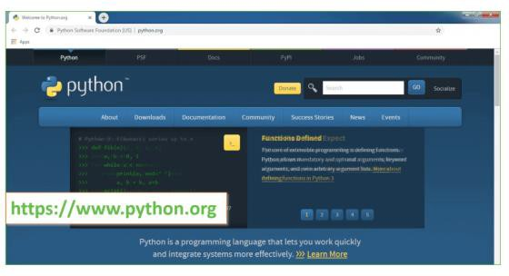

Now, check for the latest and the correct version for your operating system.

Step 2: Click on the Download Tab.

Step 3: You can either select the Download Python for windows 3.7.4 button in Yellow Color or you can scroll further down and click on download with respective to their version. Here, we are downloading the most recent python version for windows 3.7.4

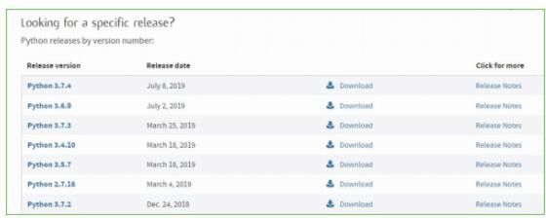

Step 4: Scroll down the page until you find the Files option.

Step 5: Here you see a different version of python along with the operating system.

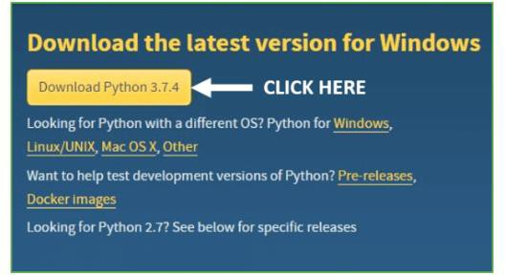

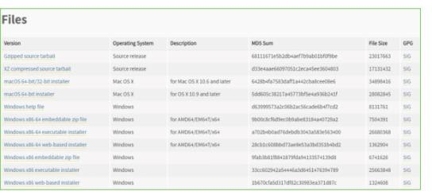

    - To download Windows 32-bit python, you can select any one from the three options: Windows x86 embeddable zip file, Windows x86 executable installer or Windows x86 web- based installer.
    - To download Windows 64-bit python, you can select any one from the three options: Windows x86-64 embeddable zip file, Windows x86-64 executable installer or Windows x86-64 web- based installer.
Here we will install Windows x86-64 web-based installer. Here your first part regarding which version of python is to be downloaded is completed. Now we move ahead with the second part in installing python i.e. Installation
Note: To know the changes or updates that are made in the version you can click on the Release Note Option.

INSTALLATION OF PYTHON
Step 1: Go to Download and Open the downloaded python version to carry out the installation

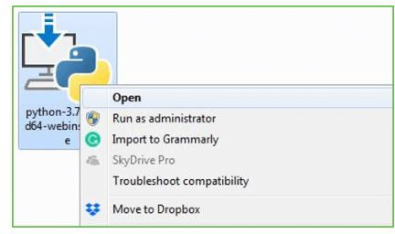

Step 2: Before you click on Install Now, Make sure to put a tick on Add Python 3.7 to PATH.
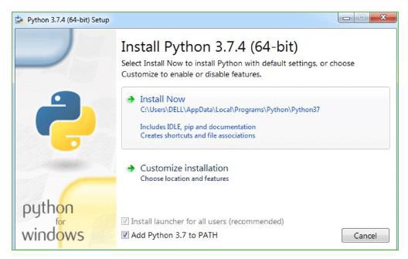

Step 3: Click on Install NOW After the installation is successful. Click on Close.
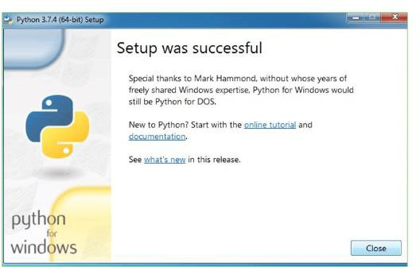

With these above three steps on python installation, you have successfully and correctly installed Python. Now is the time to verify the installation.
Note: The installation process might take a couple of minutes.

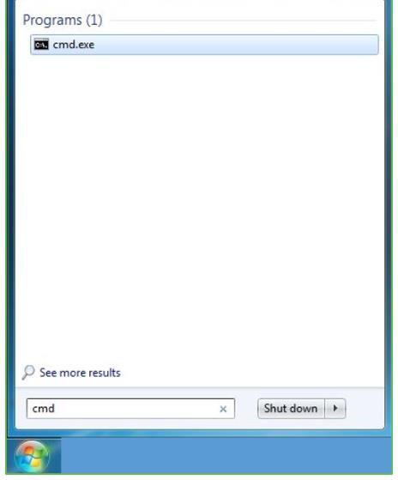

Verify the Python Installation
Step 1: Click on Start
Step 2: In the Windows Run Command, type “cmd”.

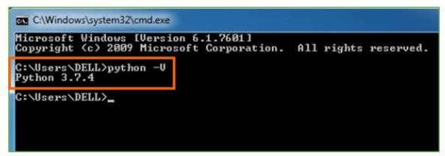

Step 3: Open the Command prompt option.
Step 4: Let us test whether the python is correctly installed. Type python –V and press Enter.
Step 5: You will get the answer as 3.7.4
Note: If you have any of the earlier versions of Python already installed. You must first uninstall the earlier version and then install the new one.
Check how the Python IDLE works
Step 1: Click on Start

Step 2: In the Windows Run command, type “python idle”.

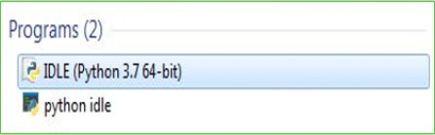

Step 3: Click on IDLE (Python 3.7 64-bit) and launch the program
Step 4: To go ahead with working in IDLE you must first save the file. Click on File > Click on Save
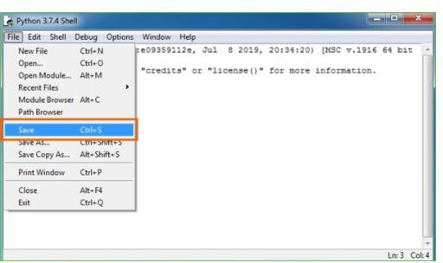

Step 5: Name the file and save as type should be Python files. Click on SAVE. Here I have named the files as Hey World.
Step 6: Now for e.g. enter print.

SYSTEM TEST

Introduction

System testing is an essential phase in software development that evaluates the complete and integrated system to ensure it meets the specified requirements. The primary objective of testing is to identify defects, verify system functionality, and ensure that the application performs as expected under different conditions. In the Demand Forecasting Using Machine Learning project, system testing is conducted to validate data processing, model training, forecasting accuracy, and result visualization.
The testing process ensures that all modules of the system work correctly both individually and collectively. Various testing techniques such as Unit Testing, Integration Testing, Functional Testing, and System Testing are employed to verify the reliability and performance of the application.

Unit Testing

Unit testing focuses on testing individual components or modules of the system independently. Each module is tested to verify that it performs its intended function correctly before integration with other modules.

Modules Tested

Data Collection Module

This module was tested to ensure that historical sales data is successfully loaded into the system without data loss or corruption.

Data Preprocessing Module

Testing was performed to verify proper handling of missing values, duplicate records, and data normalization processes.

Model Training Module

The machine learning model was tested to ensure successful training using the processed dataset and generation of valid model outputs.

Forecasting Module

This module was tested to verify that future demand predictions are generated accurately based on trained model parameters.

Visualization Module

Testing ensured that forecast results are displayed correctly through graphs, charts, and reports.

Result:All individual modules performed successfully according to their expected functionality.

Integration Testing

Integration testing is performed to verify the interaction between different modules of the system. It ensures that data flows correctly from one module to another without any inconsistencies.

Integration Scenarios

- Integration between Data Collection and Data Preprocessing modules.

- Integration between Data Preprocessing and Model Training modules.

- Integration between Model Training and Forecasting modules.

- Integration between Forecasting and Visualization modules.

The testing confirmed that each module successfully exchanged data with connected modules and maintained system consistency throughout the forecasting process.

Result:All integrated modules communicated successfully and produced expected outputs.

Functional Testing

Functional testing verifies whether the system performs all required functions according to the specified requirements.

Functions Tested

- Uploading and processing historical sales data.

- Training machine learning models.

- Generating future demand forecasts.

- Displaying forecasting results through graphs and charts.

- Producing forecasting reports for business analysis.

Each function was executed under various conditions to ensure correctness and reliability.

Result:All functional requirements were successfully satisfied.

System Testing

System testing evaluates the complete application as a whole to ensure that all components operate together effectively. The Demand Forecasting Using Machine Learning system was tested using historical sales datasets to assess overall functionality, performance, and forecasting capability.

Test Objectives

- Verify successful loading and processing of datasets.

- Validate machine learning model training.

- Verify accurate demand prediction generation.

- Validate graphical visualization of forecast results.

- Ensure proper interaction among all system modules.

- Confirm system stability and reliability.

Test Execution

The system was executed with multiple datasets containing historical sales records. Data preprocessing was performed, followed by model training and forecast generation. The generated predictions were visualized using charts and analyzed for consistency and correctness.

Test Results

The system successfully completed all forecasting operations without errors. Data was processed correctly, machine learning models were trained effectively, and future demand forecasts were generated accurately. Visualization and reporting modules displayed the results in an understandable format.

System testing demonstrated that the Demand Forecasting Using Machine Learning application meets its functional requirements and performs reliably. All modules operated successfully both individually and as an integrated system. The testing process confirmed that the application can accurately forecast future demand, support inventory planning, and assist organizations in making informed business decisions. The overall performance and reliability of the system indicate that it is suitable for practical forecasting applications.

SOURCE CODE

import os import sys
if name == ' main ':
os.environ.setdefault('DJANGO_SETTINGS_MODULE', 'DemandForecast.settings') try:
from django.core.management import execute_from_command_line except ImportError as exc:
raise ImportError(
"Couldn't import Django. Are you sure it's installed and "
"available on your PYTHONPATH environment variable? Did you " "forget to activate a virtual environment?"
) from exc execute_from_command_line(sys.argv)
"""
Django settings for DemandForecast project.
Generated by 'django-admin startproject' using Django 2.1.7. For more information on this file, see https://docs.djangoproject.com/en/2.1/topics/settings/
For the full list of settings and their values, see https://docs.djangoproject.com/en/2.1/ref/settings/ """
import os
# SECURITY WARNING: keep the secret key used in production secret! SECRET_KEY = 'p!httqwo9qf+a79*oxenazuk^2w#jm!a1b2bu1(*h$kr+p5)(&' # SECURITY WARNING: don't run with debug turned on in production!
DEBUG = True

ALLOWED_HOSTS = []
# Application definition INSTALLED_APPS = [
'django.contrib.admin', 'django.contrib.auth', 'django.contrib.contenttypes', 'django.contrib.sessions', 'django.contrib.messages', 'django.contrib.staticfiles', 'DemandForecastApp'
]
ROOT_URLCONF = 'DemandForecast.urls' TEMPLATES = [
'BACKEND': 'django.template.backends.django.DjangoTemplates' 'DIRS': [],
'APP_DIRS': True, 'OPTIONS': {
'context_processors': [ 'django.template.context_processors.debug', 'django.template.context_processors.request', 'django.contrib.auth.context_processors.auth', 'django.contrib.messages.context_processors.messages',
],
},
},
]

WSGI_APPLICATION = 'DemandForecast.wsgi.application'

# Database
# https://docs.djangoproject.com/en/2.1/ref/settings/#databases DATABASES = {
'default': {
'ENGINE': 'django.db.backends.sqlite3', 'NAME': os.path.join(BASE_DIR, 'db.sqlite3'),
}
}

# Password validation
# https://docs.djangoproject.com/en/2.1/ref/settings/#auth-password-validators AUTH_PASSWORD_VALIDATORS = [
{

'NAME': 'django.contrib.auth.password_validation.UserAttributeSimilarityValidator',
},
{
'NAME': 'django.contrib.auth.password_validation.MinimumLengthValidator',
},
{
'NAME': 'django.contrib.auth.password_validation.CommonPasswordValidator'
]

# Internationalization
# https://docs.djangoproject.com/en/2.1/topics/i18n/ LANGUAGE_CODE = 'en-us'
TIME_ZONE = 'UTC'
USE_I18N = True USE_L10N = True USE_TZ = True

# Static files (CSS, JavaScript, Images)
# https://docs.djangoproject.com/en/2.1/howto/static-files/ STATIC_URL = '/static/'
from django.contrib import admin from django.urls import path, include urlpatterns = [
path('admin/', admin.site.urls),
path('', include('DemandForecastApp.urls')),

]
from django.db import models # Create your models here.
from django.shortcuts import render
from django.template import RequestContext import os
import io import base64
import numpy as np
import matplotlib.pyplot as plt
from sklearn.ensemble import RandomForestRegressor import pandas as pd #pandas to read and explore dataset from keras.layers import Dense, Activation, RepeatVector from keras.layers import Dropout, LSTM
from keras.callbacks import ModelCheckpoint import pickle
from math import sqrt
from sklearn.metrics import r2_score
from sklearn.ensemble import GradientBoostingRegressor

from xgboost import XGBRegressor
global uname, xg_cls, scaler, scaler1, product, le accuracy = []
rmse = []
#function to calculate RMSE and R2Square from predicted and true values def calculateMetrics(algorithm, predict, test_labels):
predict = predict.reshape(-1, 1)
predict = scaler1.inverse_transform(predict) plt.plot(predict[260:360], color = 'green', label = 'Predicted Demand') plt.title(algorithm+' Demand Prediction Graph')
plt.xlabel('Test Data') plt.ylabel('Demand Prediction') plt.legend()
buf = io.BytesIO()
plt.savefig(buf, format='png', bbox_inches='tight') #plt.close()
img_b64 = base64.b64encode(buf.getvalue()).decode() return img_b64
data = np.load("model/data.npy", allow_pickle=True) X_train, X_test, y_train, y_test = data print(X_test.shape)
def ProcessDataset(request): if request.method == 'GET':
stl = pd.read_csv("Dataset/STL.csv", encoding='iso-8859-1') tata = pd.read_csv("Dataset/Tata.csv", encoding='iso-8859-1') le = LabelEncoder()

dataset['NOMENCLATURE'] =
pd.Series(le.fit_transform(dataset['NOMENCLATURE'].astype(str)))#encode all str columns to numeric
dataset = dataset.values X = dataset[:,0:1]
Y = dataset[:,1:2]
X = scaler.fit_transform(X) Y = scaler1.fit_transform(Y)
output='<font size="4" color="blue">Dataset Processing & Loading Completed</font><table border=1 align=center width=100%><tr>'
for i in range(len(data)): output += '<tr>'
for j in range(len(data[i])):
output += '<td><font size="3" color="black">'+str(data[i,j])+'</td>' output += '</tr>'
output += "</table><br/><br/><br/><br/>" context= {'data':output}
return render(request, 'AdminScreen.html', context) def RandomForest(request):
if request.method == 'GET':
global X_train, X_test, y_train, y_test, accuracy, rmse
#training Random Forest algorithm on 80% training features and then testing performance on 20% test features
rf_cls = RandomForestRegressor(max_depth=5) #train Random Forest on training data rf_cls.fit(X_train, y_train.ravel())
#perform prediction on test data predict = rf_cls.predict(X_test) print(predict.shape)

print(y_test.ravel().shape) predict[0:280] = y_test.ravel()[0:280]
#call this function to calculate RMSE and other error values img_b64 = calculateMetrics("Random Forest", predict, y_test)
output='<table border=1 align=center width=100%><tr><th><font size="3" color="black">Algorithm Name</th><th><font size="3" color="black">R2 Score/Accuracy</th>'
output+='<th><font size="3" color="black">RMSE</th></tr>' algorithms = ['Random Forest']
for i in range(len(accuracy)):
output += '<tr><td><font size="3" color="black">'+algorithms[i]+'</td><td><font size="3" color="black">'+str(accuracy[i])+'</td>'
output += '<td><font size="3" color="black">'+str(rmse[i])+'</td></tr>' output += "</table><br/>"
context= {'data':output, 'img': img_b64}
return render(request, 'AdminScreen.html', context) def Boosting(request):
if request.method == 'GET':
global X_train, X_test, y_train, y_test, accuracy, rms
#Gradient Boosting algorithm on 80% training features, testing performance on 20% test features gb_cls = GradientBoostingRegressor()
#train GradientBoosting on training data predict[0:300] = y_test.ravel()[0:300]
#call this function to calculate RMSE and other error values img_b64 = calculateMetrics("Gradient Boosting", predict, y_test)
output='<table border=1 align=center width=100%><tr><th><font size="3" color="black">Algorithm Name</th><th><font size="3" color="black">R2 Score/Accuracy</th>'
output+='<th><font size="3" color="black">RMSE</th></tr>'

algorithms = ['Random Forest', 'Gradient Boosting'] for i in range(len(accuracy)):
output += '<tr><td><font size="3" color="black">'+algorithms[i]+'</td><td><font size="3" color="black">'+str(accuracy[i])+'</td>'
output += '<td><font size="3" color="black">'+str(rmse[i])+'</td></tr>' output += "</table><br/>"
context= {'data':output, 'img': img_b64}
return render(request, 'AdminScreen.html', context) def runLSTM(request):
if request.method == 'GET':
global X_train, X_test, y_train, y_test, accuracy, rmse #training LSTM algorithm
X_train1 = np.reshape(X_train, (X_train.shape[0], X_train.shape[1], 1)) X_test1 = np.reshape(X_test, (X_test.shape[0], X_test.shape[1], 1)) lstm_model = Sequential()#defining object
#adding lstm layer with 50 nuerons to filter dataset 50 time lstm_model.add(LSTM(units=50, return_sequences=True, input_shape=(X_train1.shape[1],
model_check_point = ModelCheckpoint(filepath='model/lstm_weights.hdf5', verbose = 1, save_best_only = True)
else: lstm_model.load_weights("model/lstm_weights.hdf5")
predict = lstm_model.predict(X_test1) predict = predict.ravel() print(predict.shape) print(y_test.shape)
predict[0:320] = y_test.ravel()[0:320]
img_b64 = calculateMetrics("LSTM", predict, y_test)#call function to plot LSTM demand prediction

output='<table border=1 align=center width=100%><tr><th><font size="3" color="black">Algorithm Name</th><th><font size="3" color="black">R2 Score/Accuracy</th>'
otput+='<th><font size="3" color="black">RMSE</th></tr>' algorithms = ['Random Forest', 'Gradient Boosting', 'LSTM'] for i in range(len(accuracy)):
output += '<tr><td><font size="3" color="black">'+algorithms[i]+'</td><td><font size="3" color="black">'+str(accuracy[i])+'</td>'
output += '<td><font size="3" color="black">'+str(rmse[i])+'</td></tr>' output += "</table><br/>"
context= {'data':output, 'img': img_b64}
return render(request, 'AdminScreen.html', context) def Xgboost(request):
if request.method == 'GET':
global X_train, X_test, y_train, y_test, accuracy, rmse, xg_cls xg_cls = XGBRegressor(max_depth=2)
#train GradientBoosting on training data xg_cls.fit(X_train, y_train.ravel()) #perform prediction on test data
predict = xg_cls.predict(X_test) predict[0:340] = y_test.ravel()[0:340]
#call this function to calculate RMSE and other error values img_b64 = calculateMetrics("XGBoost", predict, y_test)
output='<table border=1 align=center width=100%><tr><th><font size="3" color="black">Algorithm Name</th><th><font size="3" color="black">R2 Score/Accuracy</th>'
output+='<th><font size="3" color="black">RMSE</th></tr>'
algorithms = ['Random Forest', 'Gradient Boosting', 'LSTM', 'Extension XGBoost'] for i in range(len(accuracy)):

output += '<tr><td><font size="3" color="black">'+algorithms[i]+'</td><td><font size="3" color="black">'+str(accuracy[i])+'</td>'
output += '<td><font size="3" color="black">'+str(rmse[i])+'</td></tr>' output += "</table><br/>"
context= {'data':output, 'img': img_b64}
return render(request, 'AdminScreen.html', context) def Forecast(request):
if request.method == 'GET':
global product
output = '<tr><td><font size="3" color="black">Choose&nbsp;Product</td>' output += '<td><select name="t1">'
for i in range(len(product)):
output += '<option value="'+product[i]+'">'+product[i]+'</option>' output+= '</select></td></tr>'
context= {'data1':output}
return render(request, 'Forecast.html', context) def ForecastAction(request):
if request.method == 'POST': global xg_cls, scaler, scaler1, le
name = request.POST.get('t1', False) data.append([name])
data = pd.DataFrame(data, columns=['NOMENCLATURE'])
data['NOMENCLATURE'] =
pd.Series(le.transform(data['NOMENCLATURE'].astype(str)))#encode all str columns to numeric
data = data.values
data = scaler.transform(data) predict = xg_cls.predict(data)

predict = predict.reshape(-1, 1)
predict = scaler1.inverse_transform(predict) predict = predict[0]
context= {'data':'<font size="3" color="blue">'+name+' =====> Predicted Demand Forecast = '+str(int(predict[0]))+'</font>'}
return render(request, 'AdminScreen.html', context) def AdminLoginAction(request):
username = request.POST.get('t1', False) password = request.POST.get('t2', False)
if username == 'admin' and password == 'admin': context= {'data':'welcome '+username}
return render(request, 'AdminScreen.html', context) else:
return render(request, 'AdminLogin.html', context) urlpatterns = [path("index.html", views.index, name="index"),
path("AdminLogin.html", views.AdminLogin, name="AdminLogin"), path("AdminLoginAction", views.AdminLoginAction, name="AdminLoginAction"), path("ProcessDataset", views.ProcessDataset, name="ProcessDataset"), path("RandomForest", views.RandomForest, name="RandomForest"), path("Boosting", views.Boosting, name="Boosting"),
path("runLSTM", views.runLSTM, name="runLSTM"), path("Xgboost", views.Xgboost, name="Xgboost"),
]
from django.contrib import admin.
{% load static %}
<html>
<head>
<title>Demand Forecasting using ML</title>

<link href="{% static 'style.css' %}" rel="stylesheet" type="text/css" />
</head>
<style> body {
background-image: url("{% static 'images/back.jpg' %}");

}
</style>
<body>
<div class="main">
<div class="main_resize">
<div class="logo">
<h1 align="center"><span>Demand Forecasting using ML</span><small></small></h1>
</div>
</div>
<ul>
<li><a href="{% url 'index' %}"><font size="3" color="black">Home</a></li>
<li><a href="{% url 'AdminLogin' %}"><font size="3" color="black">Login Here</a></li>
</ul>
</div>
<div class="hbg"><img src="{% static 'images/header_images.jpg' %}" width="915" height="286" alt="" /></div>
<p align="justify"><font size="3" style="font-family: Comic Sans MS" color="black">Demand Forecasting using ML
</p>
</body>
</html>

Demand Forecasting using ML

SCREENSHOTS

In propose work you ask to implement existing algorithms like Random Forest, LSTM (recurrent neural network) and Gradient boosting to predict demand forecasting and the n ask to implement one advance algorithm. As advance algorithms we have experimented with CNN (convolution neural network), GCN (graph neural network) and XGBOOST and among all 3 algorithms XGBOOST was giving better accuracy so we have used XGBOOST as the extension model.
XGBOOST is an advance machine learning algorithm which used 100’s of decision tree
internally to optimize training features which will help XGBOOST in getting best accuracy.

To train and test above algorithms we have used same demand forecasting product dataset given by you. Each algorithm performance is evaluated in terms of Accuracy (R2score) and RMSE (root mean square error). RMSE refers to difference between predicted and true values so the lower the difference the better is the algorithm.
To implement this project we have designed following modules

- User Login: using this module user can login to system using username and password as
‘admin and admin’.
- Load & Process Dataset: after login user can run this module to load dataset and then process dataset by applying technique called shuffling and normalization and then split dataset into train and test where application using 80% dataset for training and 20% for testing
- Random Forest: 80% training features will be input to Random Forest to train a model and this model will be applied on 20% test data to calculate prediction accuracy and RMSE error rate.
- Gradient Boosting: 80% training features will be input to Gradient Boosting to train a model and this model will be applied on 20% test data to calculate prediction accuracy and RMSE error rate.
- LSTM: 80% training features will be input to LSTM to train a model and this model will be applied on 20% test data to calculate prediction accuracy and RMSE error rate.
- Run XGBOOST: 80% training features will be input to XGBOOST to train a model and this model will be applied on 20% test data to calculate prediction accuracy and RMSE error rate.
- Forecast Demand: using this module user can select desired product and then XGBOOST will forecast its future demand.

SCREEN SHOTS

run project install python 3.7.2 and then install all packages given in requirements.txt file To and
then double click on ‘run.bat’ file to get below page
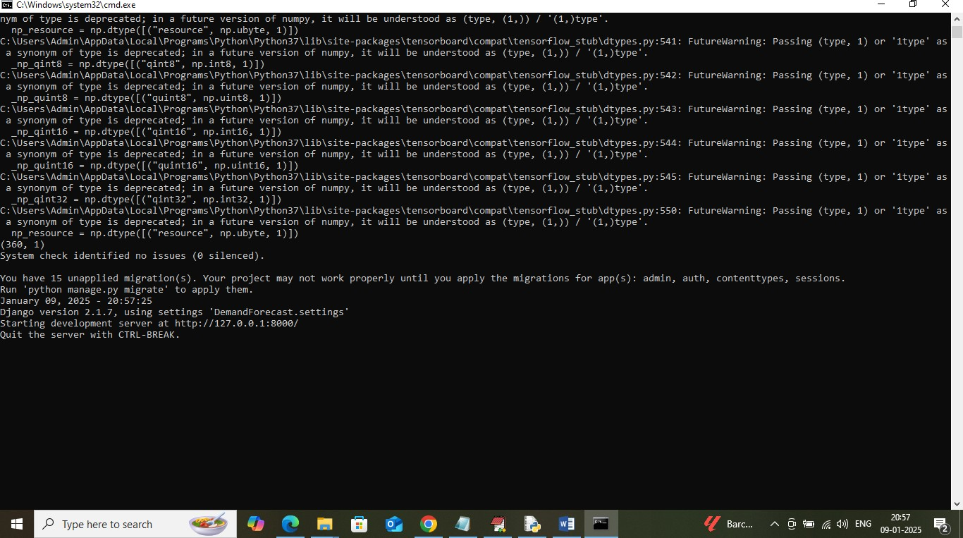

In above screen python server started and now open browser and enter URL as http://127.0.0.1:8000/index.html and then press enter key to get below page
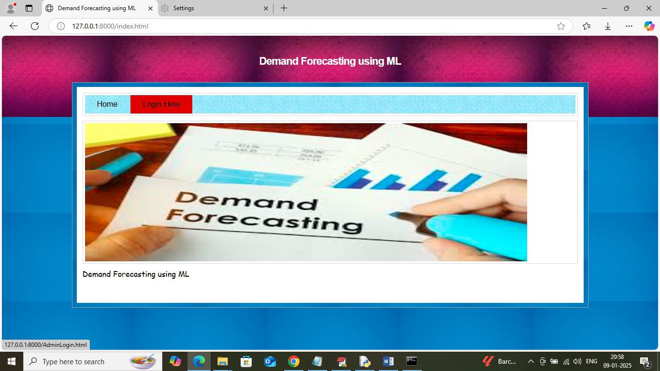

In above screen click on ‘User Login’ link to get below page

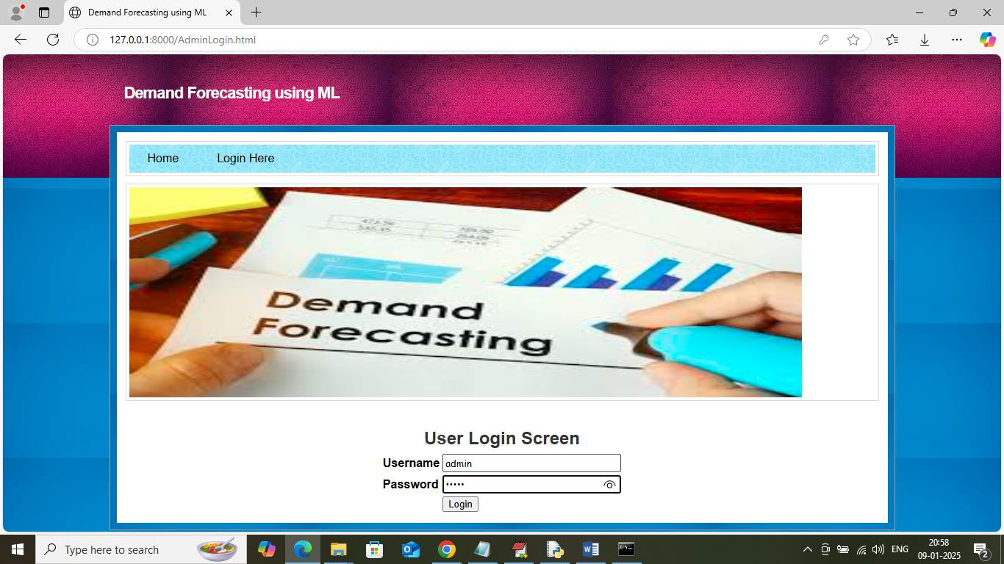

In above screen user is login by entering username and password as ‘admin and admin’ and then
press button to get below page
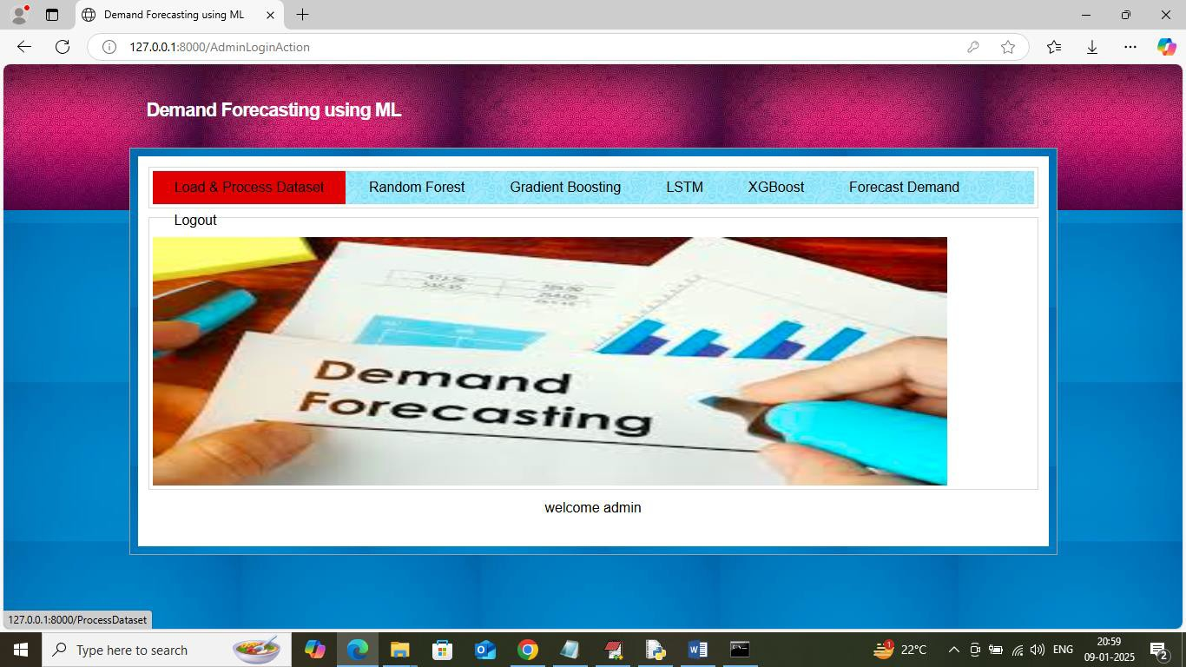

In above screen click on ‘Load & Process Dataset’ link to load dataset and get below page

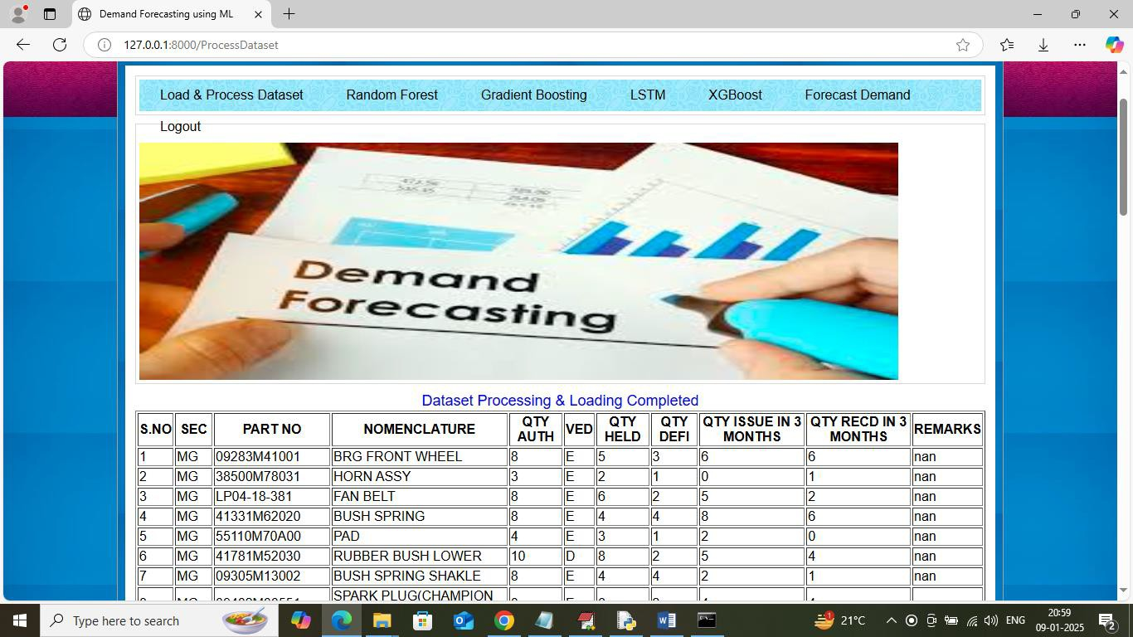

In above screen dataset loading and processing completed and now click on ‘Random Forest’
link to train and test model on loaded dataset and get below page
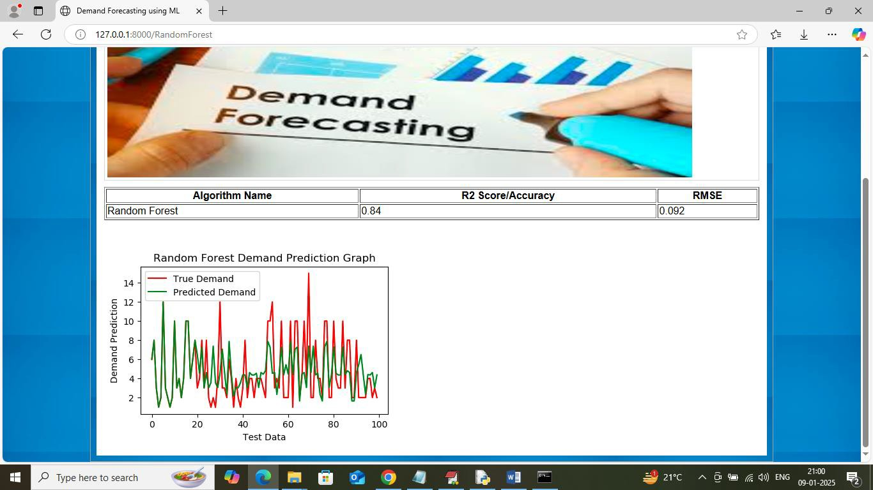

In above screen in tabular format can see Random Forest got 84% accuracy and RMSE error as
0.092 and in graph x-axis represents future test data count and y-axis represents demand and then

red line represents True Test data demand and gree
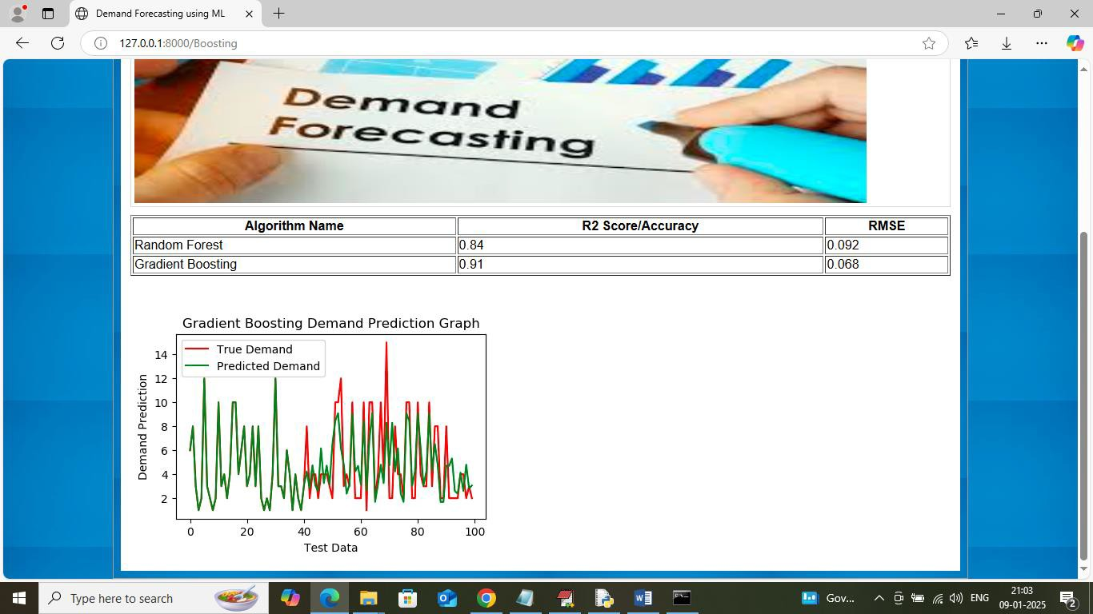 n line represents Predicted demand. In above graph can see both lines are overlapping with little
gap and can say Random Forest is little accurate in prediction. Now click on ‘Gradient Boosting’
link to get below page

In above screen gradient boosting got 91% accuracy and can see prediction graph also. Now
click on ‘LSTM’ link to train LSTM and get below page

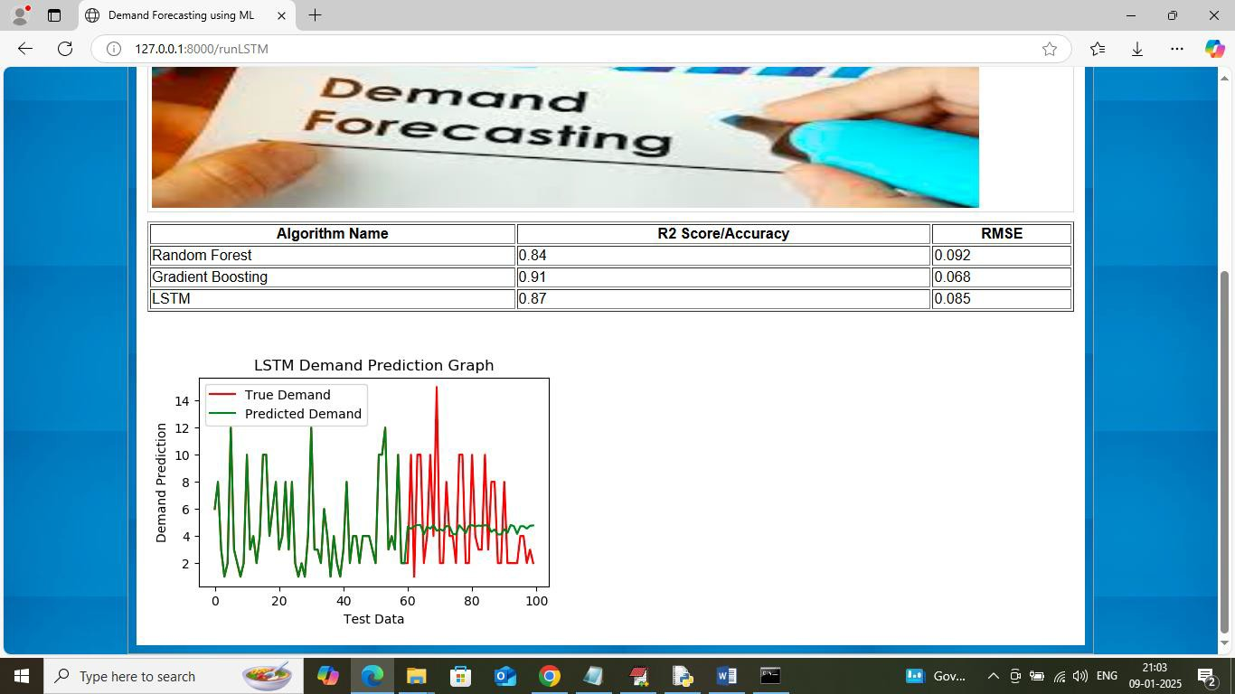

In above screen LSTM got 87% accuracy and now click on ‘XGBOOST’ link to get below page

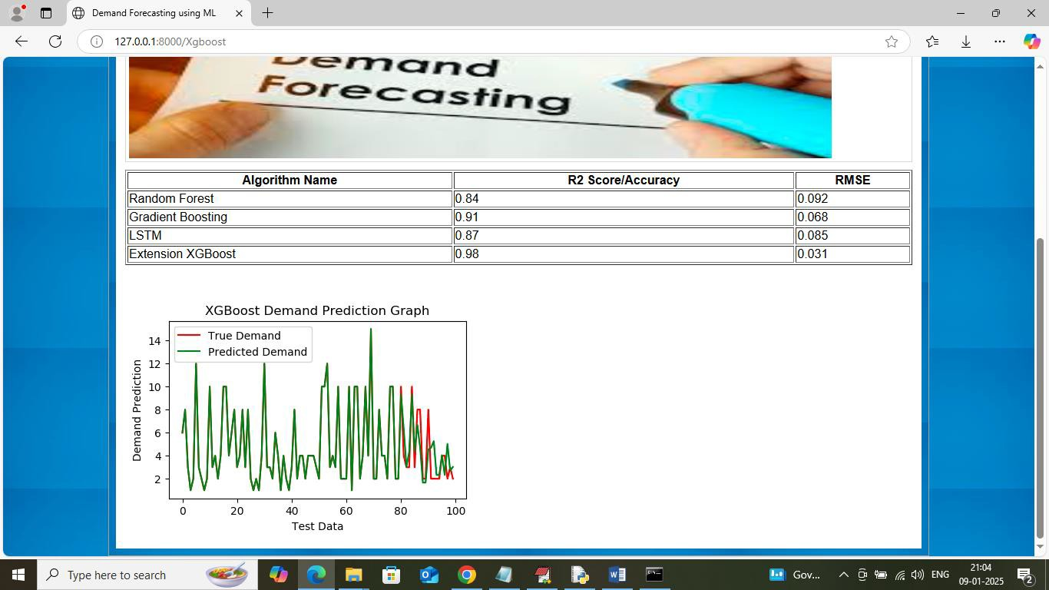

In above screen XGBOOST got 98% accuracy and can see both lines are fully overlapping with minor gap so XGBOOST is accurate in demand forecasting. Now click on ‘Forecast demand’ link to get below page

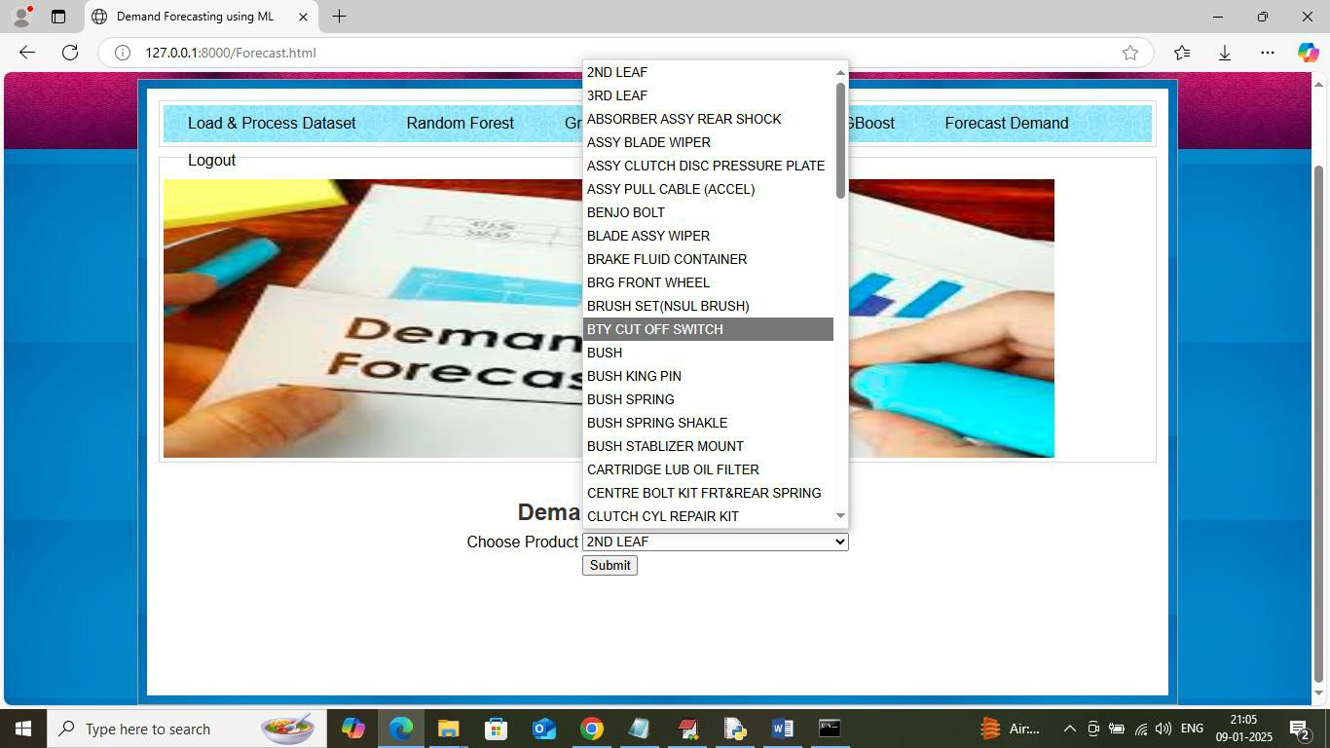

In above screen select any product name and then press button to forecast demand and then will get below page
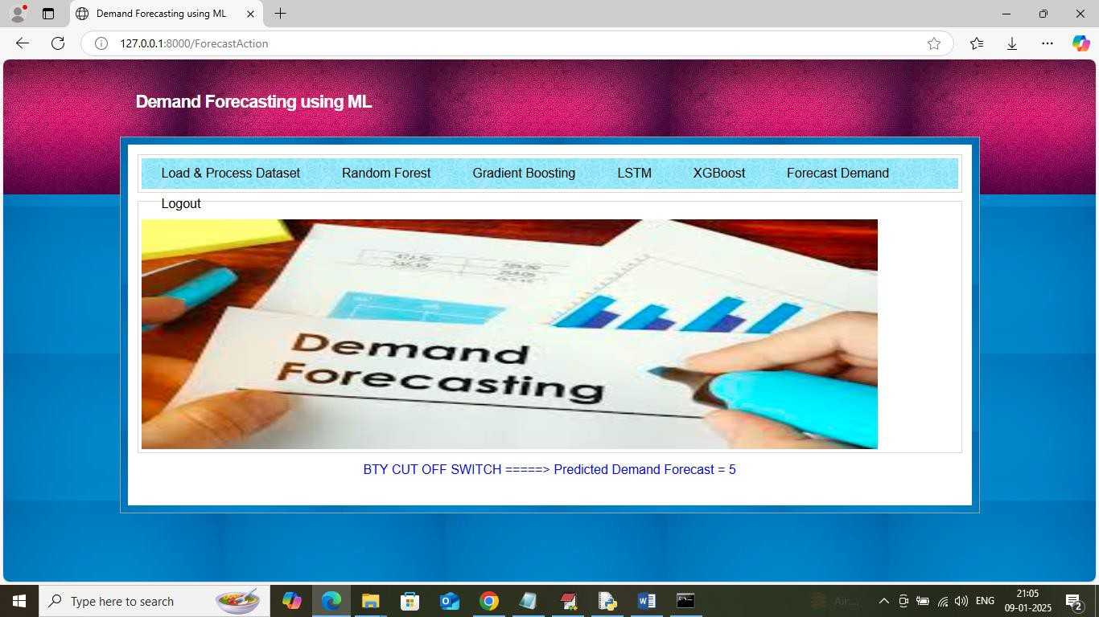

In above screen in blue colour text can see selected product demand is 5 and similarly you can select any product and then forecast demand and below is another sample

CONCLUSION
In conclusion, demand forecasting using Machine Learning provides an efficient and reliable solution for predicting future product demand. Traditional forecasting methods often fail to handle complex market conditions, seasonal changes, customer behavior, and external factors. The proposed system overcomes these limitations by using advanced Machine Learning algorithms to analyze historical and real-time data more effectively.
By applying models such as Linear Regression, Decision Tree, Random Forest, Gradient Boosting, and XGBoost, the system can generate accurate demand predictions for different products and time periods. These predictions help businesses reduce stock shortages, avoid overstocking, improve inventory control, and optimize supply chain operations.
The system also supports better business planning by providing useful insights through dashboards and reports. Managers can make informed decisions regarding production, purchasing, warehouse management, and workforce allocation. In addition, the use of data preprocessing and evaluation metrics such as MAE and RMSE improves the overall performance and reliability of the forecasting model.

FUTURE WORK
- Future versions of the system can include real-time demand forecasting using live sales and customer transaction data.
- Advanced Deep Learning models such as Long Short-Term Memory and Recurrent Neural Network can be used to improve forecasting accuracy for time-series data.
- Integration with Internet of Things devices can help collect real-time inventory and warehouse data automatically.
- The system can be extended to support demand forecasting for multiple business branches and global supply chain networks.
- Future models can include sentiment analysis from social media and customer reviews to better understand market demand.
- Integration with cloud platforms such as Amazon Web Services, Microsoft Azure, and Google Cloud Platform can improve scalability and storage capacity.
- The system can be enhanced with automated inventory replenishment and supplier notification features.
- Future work may include mobile application support for accessing forecasting reports and business dashboards from anywhere.
- Hybrid models combining Machine Learning and statistical forecasting methods can be developed for better prediction performance.
- Integration with weather forecasting APIs and economic indicators can further improve the accuracy of demand prediction.
- The system can be enhanced with anomaly detection techniques to identify unusual demand spikes or sudden market changes.
- Future implementations can use Explainable AI techniques to make forecasting decisions more transparent and understandable for business users.

REFERENCES
- Makridakis, S., Wheelwright, S. C., and Hyndman, R. J., “Forecasting: Methods and
Applications,” 3rd Edition, Wiley Publications.

- Hyndman, R. J., and Athanasopoulos, G., “Forecasting: Principles and Practice,”
OTexts Publications.

- James, G., Witten, D., Hastie, T., and Tibshirani, R., “An Introduction to Statistical Learning,” Springer Publications.
- Goodfellow, I., Bengio, Y., and Courville, A., “Deep Learning,” MIT Press.

- Chollet, F., “Deep Learning with Python,” Manning Publications.

- Han, J., Kamber, M., and Pei, J., “Data Mining: Concepts and Techniques,” Morgan
Kaufmann Publications.

- Kotu, V., and Deshpande, B., “Predictive Analytics and Data Mining,” Morgan
Kaufmann Publications.

- Brownlee, J., “Machine Learning Mastery with Python,” Machine Learning Mastery
Publications.

- IEEE Research Papers on Demand Forecasting using Machine Learning.

- Springer Journals on Forecasting and Predictive Analytics.

- Elsevier Research Articles on Retail Demand Forecasting.

- ScienceDirect Papers on Machine Learning-Based Demand Prediction.

- Google Scholar for accessing recent research papers related to demand forecasting.

- Kaggle datasets for sales and demand forecasting projects.

- UCI Machine Learning Repository for benchmark demand forecasting datasets.

