Most of the practical-life structural mechanics problems are statically indeterminate i.e. either the reactions or the internal forces can’t be determined using the equations of statics alone. In such cases, number of unknowns exceed the number of variables (here, reactions or internal forces).

In the analysis of indeterminate structures we need to satisfy :

1. Equilibrium equations (implying that the structure is in equilibrium)
2. Compatibility equations (to assure that the structure doesn’t fall apart or breaks)
3. Force-Displacement equations (to know how displacements are related to forces, also called constitutive relations e.g Hooke’s law)

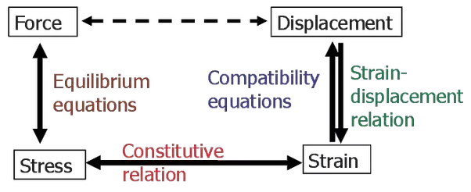

There are two methods to solve for a structural mechanics problem depending upon how the above equations are satisfied, using Finite Element Analysis (FEA) :

1. **Displacement Method** (Stiffness Matrix Method)
2. **Force Method** (Flexibility Matrix Method)

In the *displacement method of analysis*, the primary unknowns are the displacements. In this method, first force-displacement relations are computed and subsequently equations are written satisfying the equilibrium conditions of the structure. After determining the unknown displacements, the other forces are calculated satisfying the compatibility conditions and force displacement relations. The displacement-based method is amenable to computer programming and hence the method is being widely used in the modern day structural analysis.

In the *force method of analysis*, primary unknown are forces. In this method compatibility equations are written for displacement and rotations (which are calculated by force displacement equations). Solving these equations, redundant forces are calculated. Once the redundant forces are calculated, the remaining reactions are evaluated by equations of equilibrium.

**Conclusion** :

Most of the leading commercial FEA softwares today use displacement method of analysis i.e they first calculate nodal displacements - which give elemental strains - then finally elemental stresses are calculated.

Thanks [Farazuddin Zafaruddin](https://www.quora.com/profile/Farazuddin-Zafaruddin) for this A2A.

Hope it helps.