NAME:- J SATYA SRIKAR

ROLL NO:- A24126552259

BRANCH:- CSM

SECTION:- B

COURSE NAME:- FULL STACK WEB DEVELOPMENT

CODE:- 23CM4121

TITLE OF THE EXPERIMENT:
To understand how CSS3 enhances the appearance of web pages and explore HTML5 graphics using the Canvas element.Concepts Covered

DESCRIPTION:
The "My Styled Webpage" project demonstrates the visual design capabilities of modern CSS3 combined with the programmatic drawing features of HTML5. It features a structured layout containing a header, navigation bar, footer, and a grid of interactive content cards. The webpage highlights advanced presentation techniques including custom gradients, text and box shadows, rounded borders, and dynamic hover transformations, while integrating a localized native <canvas> rendering script to draw geometric shapes and custom text

PROGRAM:
CANVAS.html
<!DOCTYPE html>
<html lang="en">
<head>
<meta charset="UTF-8">
<meta name="viewport" content="width=device-width, initial-scale=1.0">
<title>Styled WebPage</title>
</head>
<body>
<center><canvas height="500px" width="1000px" id="canvas" style="border: 1px solid black; border-radius: 5px;"></canvas></center>
</body>
<script>
const canvas = document.getElementById("canvas")
const ctx = canvas.getContext("2d")
// ctx.fillStyle = "blue"
ctx.fillRect(20,20,150,200)
// ctx.strokeStyle = "red"
// ctx.lineWidth = 5
ctx.strokeRect(200,20,150,100)
ctx.beginPath();
ctx.moveTo(50,300)
ctx.lineTo(200,300)
ctx.strokeStyle = "green"
ctx.lineWidth = 5
ctx.stroke()
ctx.beginPath()
ctx.arc(300,200,50,0,Math.PI*2)
ctx.fill()
// ctx.beginPath()
ctx.fillText("KING CYCLONE BY SRIKAR", 500, 250);
</script>
</html>
OUTPUT:
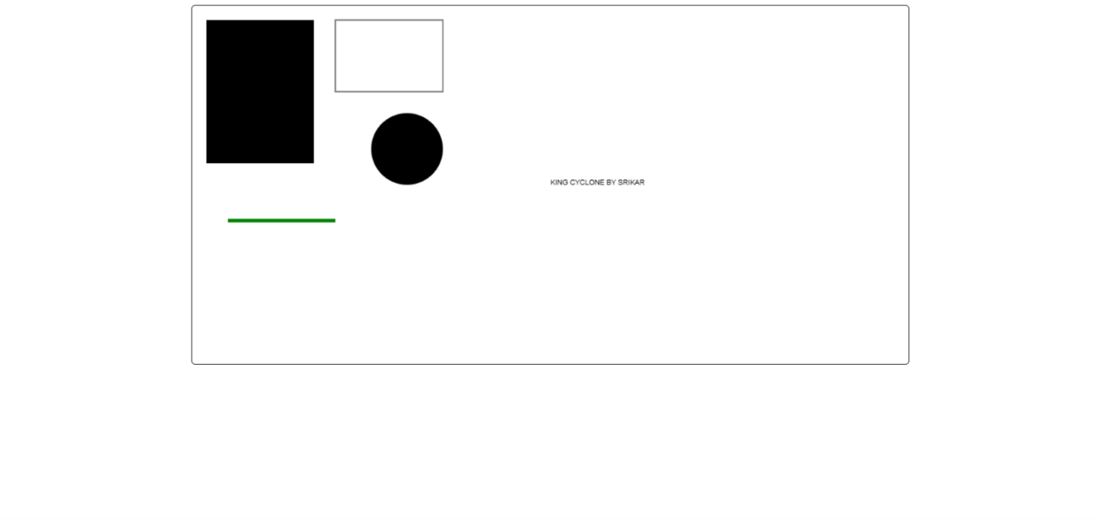
PART-B.html

<!DOCTYPE html>
<html lang="en">
<head>
<meta charset="UTF-8">
<meta name="viewport" content="width=device-width, initial-scale=1.0">
<title>Styled</title>
<style>
* {
margin: 0;
padding: 0;
box-sizing: border-box;
font-family: Arial, sans-serif;
}
#nav{
background-color: blue;
/* width: 100%; */
height: 45px;
color: white;
/* display: flex; */
}
ul{
list-style: none;
display: flex;
height: 100%;
/* padding-left: 1000px; */
gap: 15px;
align-items: center;
justify-content: flex-end;
}
.title{
width: 100%;
height: 100px;
background-color: black;
color: white;
text-align: center;
padding-top: 30px;
}
.container{
display: flex;
gap: 30px;
padding: 20px;
justify-content: center;
}
.card{
width: 500px;
height: 300px;
border: 2px solid black;
border-radius: 15px;
padding: 30px;
text-align: center;
justify-content: center;
box-shadow: 2px 2px 10px rgba(0, 0, 0, 0.1);
background-color: #67b46a;

font-size: 20px;
display: flex;
flex-direction: column;
gap: 15px;
}
.btn{
width: 100px;
height: 40px;
border: none;
border-radius: 5px;
background-color: blue;
color: white;
cursor: pointer;
transition: all 0.5s ease;
}
.btn:hover{
background-color: rgb(0, 0, 0);
box-shadow: 0px 0px 20px 10px rgb(229, 255, 0);
transform: translateY(-3px);
}
li{
cursor: pointer;
transition: all 0.5s ease;
}
li:hover{
color: rgb(255, 255, 255);

transform: translateY(-3px);
}
</style>
</head>
<body>
<header>
<div class="title">
<h1>WELCOME TO PAGE</h1>
</div>
<nav id="nav">
<ul>
<li>HOME</li>
<li>CONTEXT</li>
<li>BOOK</li>
<li>NEAR BY</li>
<li>ABOUT US</li>
</ul>
</nav>
</header>
<main class="container">
<article class="card">
<h2>Card One</h2>
<p>This is the first content card. It uses a custom serif font for the heading to stand out from the body text style.</p>
<center><button class="btn">Read More</button></center>
</article>

<!-- Card 2 -->
<article class="card">
<h2>Card Two</h2>
<p>This is the second content card. Notice the subtle drop shadow and rounded corners applied to the card container framework.</p>
<center><button class="btn" >Read More</button></center>
</article>

<!-- Card 3 -->
<article class="card">
<h2>Card Three</h2>
<p>This is the third content card. Hover over the button below or the top navigation bar links to see color changes instantly.</p>
<center><button class="btn">Read More</button></center>
</article>
</main>
</body>
</html>

OUTPUT:
