NEWSPAPER

RATANTATA

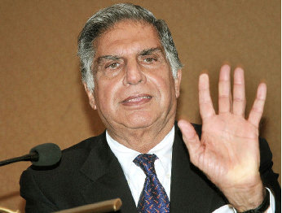 RATAN TATA IS MOST FAMOUS PERSON IN THE WORLD.RATAN NAVAL TATA (28 DECEMBER 1937- 9 OCTOBER 2024) WAS AN INDIAN INDUSTRIALIST AND PHILANTHROPIST.HE SERVED AS THE CHAIRMAN OF TATA GROUP AND TATA SONS FROM 1991 AND HE HELD THE POSITION OF OF INTERIM CHAIRMAN FROM OCTOBER 2016 TO FEBRUARY 2017 .IN 2000,HE RECEIVED THE PADMA BHUSHA, THE THIRD HIGHEST CIVILIAN HONOUR,IN 2008.

RATAN TATA WAS THE SON OF NAVAL TATA, WHO WAS ADOPTED BY RATANJI TATA, SON OF JAMSHEDJI TATA, THE FOUNDER OF THE TATA GROUP.HE GRADUATED FROM CORNELL UNIVERSITY.

RATAN TATA