Creators: Ryan Hichens, James Koval, Brian Twitchell, and Vladimir Darmin

Components of Our Project

- 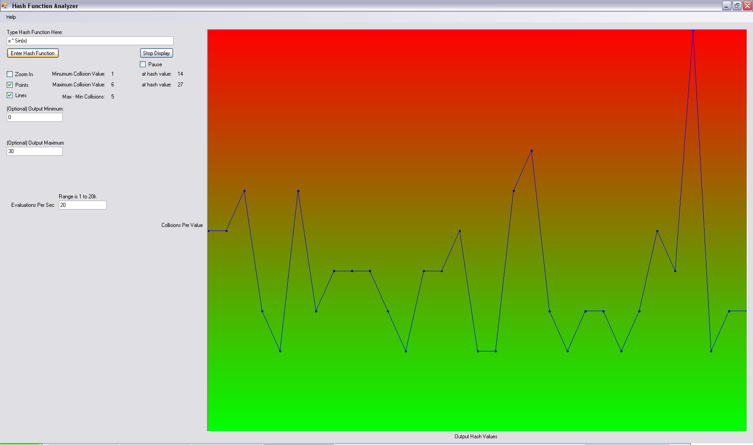
This is used to enter a hash function that you wish to analyze. (Hash Function: Look up in an encyclopedia if unsure of definition)
This tells the program that there is a hash function in the text box to use and the graphing process is started.
This stops the graphing process.
This pauses the graphing process.
This stretches the graph, setting the lowest point at the bottom and the highest point at the top of the graphic area.
This toggles the graphing of points.
This toggles the graphing of lines.
- 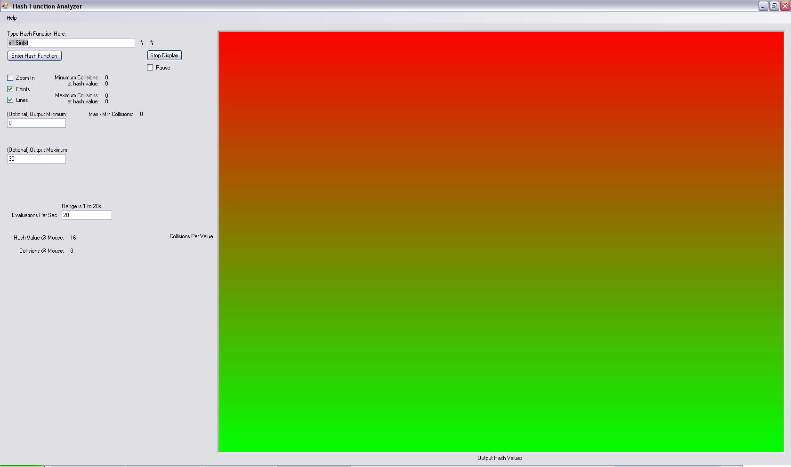
This displays the minimum collisions and the hash value with that minimum.
This displays the maximum collisions and the hash value with that maximum.
The difference between the maximum and minimum collisions
The minimum value of the range of values gotten from the hash function.
The maximum value of the range of values gotten from the hash function.
The number of evaluations of the hash between refreshes of the graphic area.
- 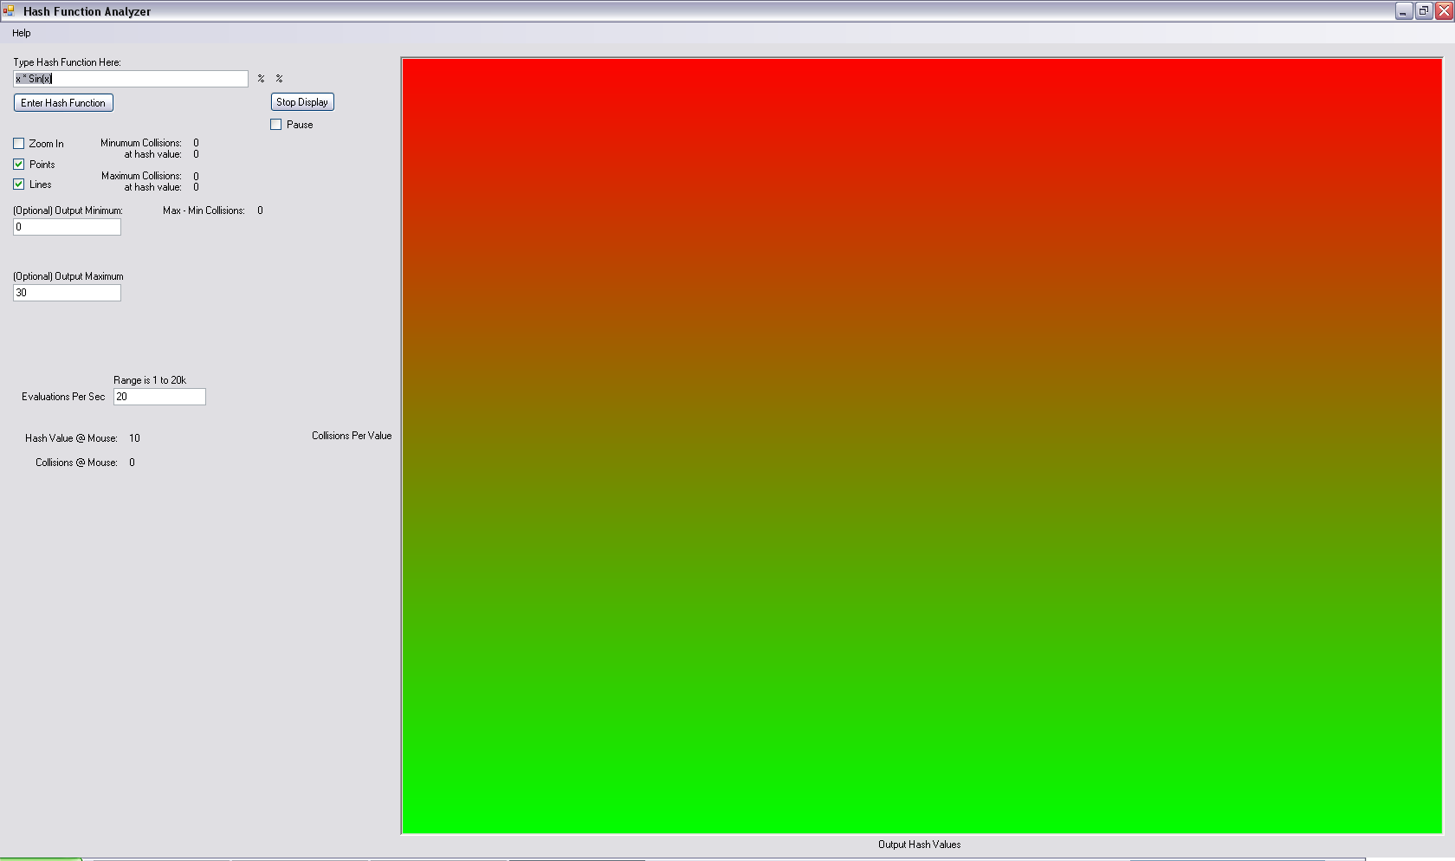
The hash value at mouse location.
The collisions at mouse location.

How To Use This Program

First the user can enter a hash function or they can use the default function that is given [1]. The user can then change the range of values for the hash function [11,12]. Now you can click “Enter Hash Function” [2]. If you want to change any of these mentioned values, you need to press “Enter Hash Function” [2] to enable these changes.

The user now has the options to edit the graphing of the hash values. The toggling of points [6], lines[7], zoom in [5], and altering the evaluations per second [13]. These can all be changed while the graph is plotting.

The user can hover the mouse over a desired hash value to see that hash value and its collisions [14,15].

All of the source code, licensed under free BSD license, can be found at:
http://code.assembla.com/hashites/subversion/nodes

