Iterative Literature Review Approach (ILRA)

Instructional & Trial Tracking Document

Username:

Trial Number:

Date:

# Files Organization

This study will be organized in trials. In order for us to track progress and identify important parameters, please organize your data as follows:

* Trial Folder – Username_ILRA_trialnumber
* Tracking document (this one) – Username_Tracking_ILRA_trialnumber
* Exported search results (.csv or .xlsx) – Username_exportnumber_exportdate_ILRA_trialnumber (automatically implemented in the code)
* Etc.

# Defining Keywords

*Keywords*, also known as *search terms*, are arguably the most important component of any literature search as all academic search engines (e.g., Google scholar, Microsoft Academic) and bibliographic databases (e.g., Web of Science, Scopus) use them to retrieve items pertinent to your topic of interest. Generally speaking, a good set of keywords should include a mix of highly specific topic words and more general research area words. This section includes some simple guidelines for defining a set of initial keywords, as well as how to structure them prior to using a bibliographic database.

## Step 1: Brainstorming

The first step of keyword generation is to simply write down as many words related to your search topic as possible. It is always possible to remove words later, but, for now, don’t hold back. Use the textbox below to track your words (we will look at this later):

* Keyword 1
* Keyword 2
* Keyword 3
* Etc.

## Step 2: Word Grouping

Now that you have your initial list, group words together that are either synonyms or variants. Here are some useful examples:

* Fibre ≈ reinforcement
* Resin ≈ matrix ≈ polymer ≈ plastic
* Recycling ≈ reuse ≈ upcycling ≈ recovery

As before, please track your keyword groups in the textbox provided:

* Group 1 (Keyword 1, Keyword 2, …)
* Group 2 (Keyword, Keyword, …)
* Group 3 (Keyword, Keyword, …)
* Etc.

## Step 3: Spelling Variations

It is also possible to miss important search items due to the differences in spelling between the British and American English systems (e.g., fiber-fibre, mold-mould, modeling-modelling). Please use an online tool like [gotranscript](https://gotranscript.com/translation-services/british-to-american) to ensure you have both types of spelling within your keyword groups from the previous step.

* Group 1 (Keyword 1, Synonym 1, Synonym 2, Keyword 2, …)
* Group 2 (Keyword, Keyword, Synonym, …)
* Group 3 (Keyword, Synonym, Keyword, …)
* Etc.

## Step 4: Keyword Priority Level

Organize the keyword groups by priority level to indicate which terms are more specific to your topic (primary) and which are more general (secondary & tertiary). This step will help us organize your results by relevance to your topic later on.

* Primary
  + Group 1 (Keyword 1, Synonym 1, Synonym 2, Keyword 2, …)
  + Group 2 (Keyword, Keyword, Synonym, …)
* Secondary
  + Group 3 (Keyword, Synonym, Keyword, …)
  + Etc.

# Search Formatting

Most databases compare user search terms with words mined from an item’s *title*, *abstract*, and *keywords*. Boolean logic can help organize your search terms. Web of Science (WoS) offers the following functions in the topic search field:

NOT (search priority 1)

Excludes records that contain a given search term. For example, a search of (fibre NOT carbon) retrieves documents with *fibre* excluding any which also contain *carbon*.

AND (search priority 2)

All search terms must occur to be retrieved. For example, a search of (fibre AND carbon) only retrieves documents that contain both *fibre* and *carbon*.

OR (search priority 3)

Any one of the search terms must occur to be retrieved (use for synonyms/variants). For example, a search of (fibre OR carbon OR reinforcement) retrieves documents that contain at least one of these terms.

Additional information from WoS can be found [here](https://clarivate.libguides.com/woscc/searchtips).

You are free to explore different methods of searching using your keywords – it is not necessary to use all of the Boolean operators presented. It is, however, **critical** that you clearly define your approach and maintain it throughout a given search trial. You may modify your approach in subsequent trials, so that we may study the effect of the changes.

# Web of Science Search

## Enter Search Terms

Enter the search terms you have defined and grouped in the previous sections into the Web of Science search field with the Topic search type selected (see below).

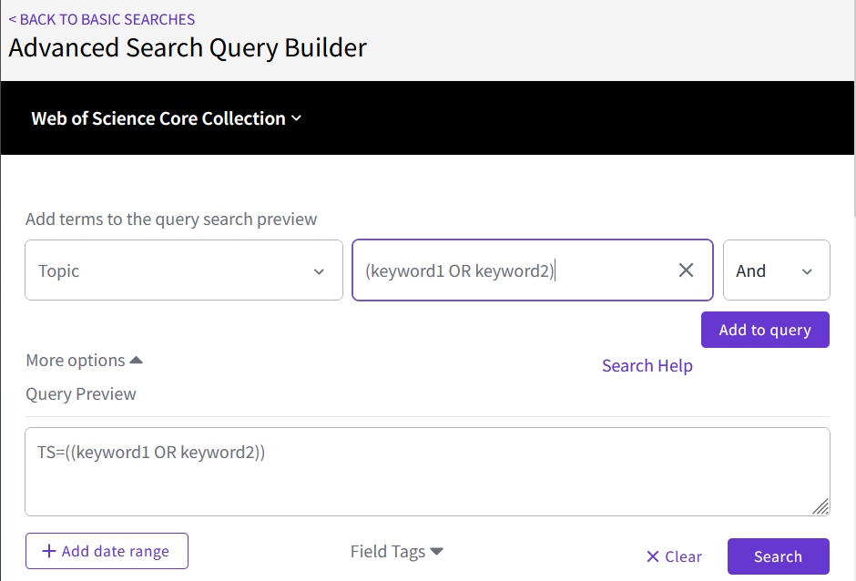

## Export Search Results

Export the records collected to Excel using the naming convention outlined at the beginning of this document. N.B. Web of Science can only export 1000 items at a time. You will have to combine the records into one document if there are more than one export.

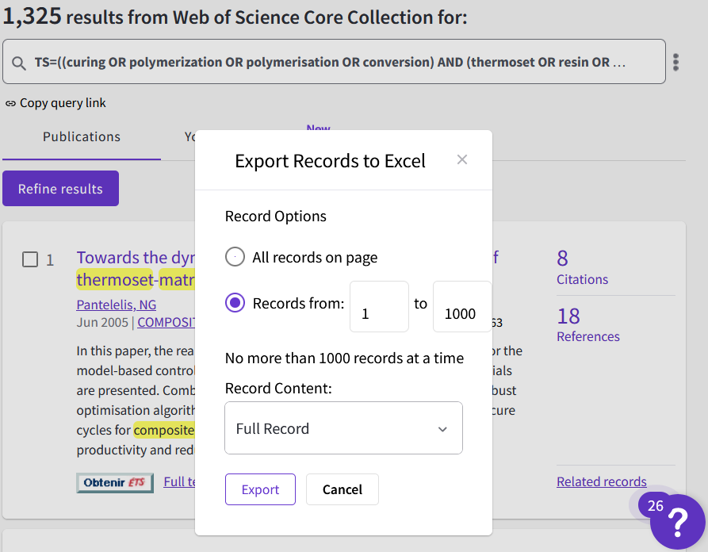

# Data Mining (Python Code)

1. Run the ILRA data mining python code (<https://github.com/jaklengaigne/ILRA>) using the records exported from WoS and select new keywords, if pertinent, from the lists provided by the code.
2. Perform another search using WoS with your updated list of keywords. Try to keep the same format as before and simply add the new terms.
3. Run the ILRA code again and repeat until no new keywords are generated.