

USER MANUAL

Contents

Introduction 3

System Overview 3

How can I log the wolower in? 4

Do you want to sell something? 6

Do you want to buy something via the wolower? 9

Masterpass Pairing 9

Giving Order 12

# Introduction

This section explains general terms about the system.

## System Overview

The wolower is a Twitter-based application that is analyzed, designed, developed and managed for the lesson SWE-573 Software Development Practice at Bogaziçi University.

By using the wolower, you can carry out your payments of the purchases that you make on Twitter easily and automatically. The wolower integrates your Twitter account and Masterpass wallet to facilitate your experience on Twitter. You can also review your transaction that is effected by the wolower.

# How can I log the wolower in?

It is quite simple to log the wolower in because you do not memorize any credentials, the only thing that you have to do is to click on the “Sign in with Twitter” button. That is it.

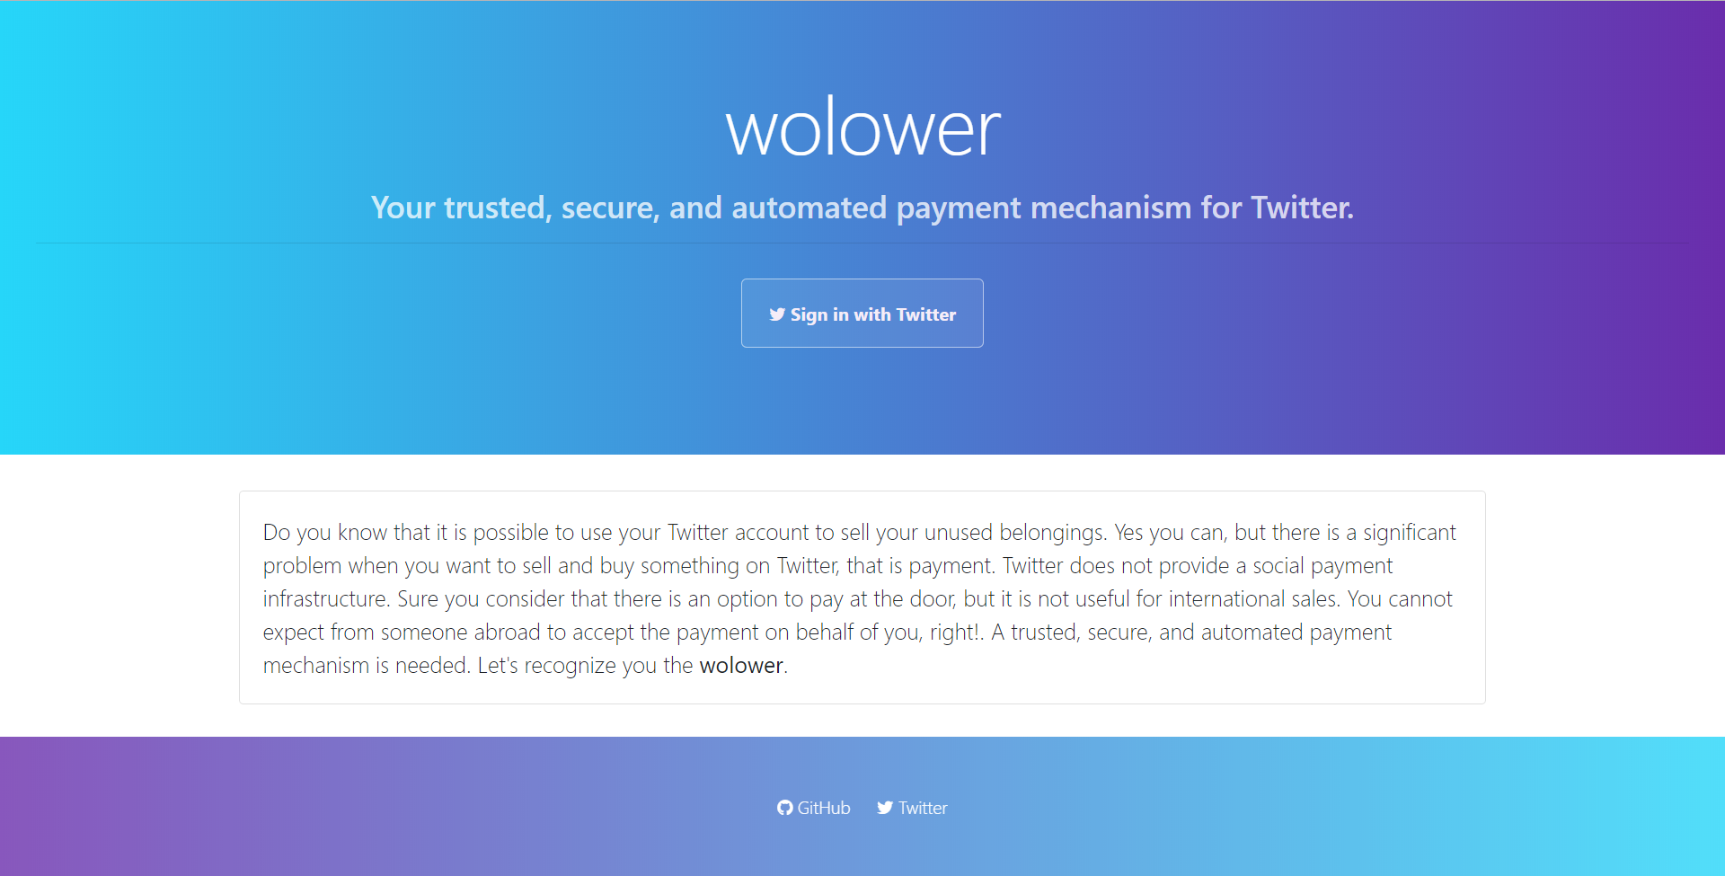

Figure 1 Login Page

When you click “Sign-in with Twitter” button, the wolower will redirect you to Twitter application authorization page which looks like;

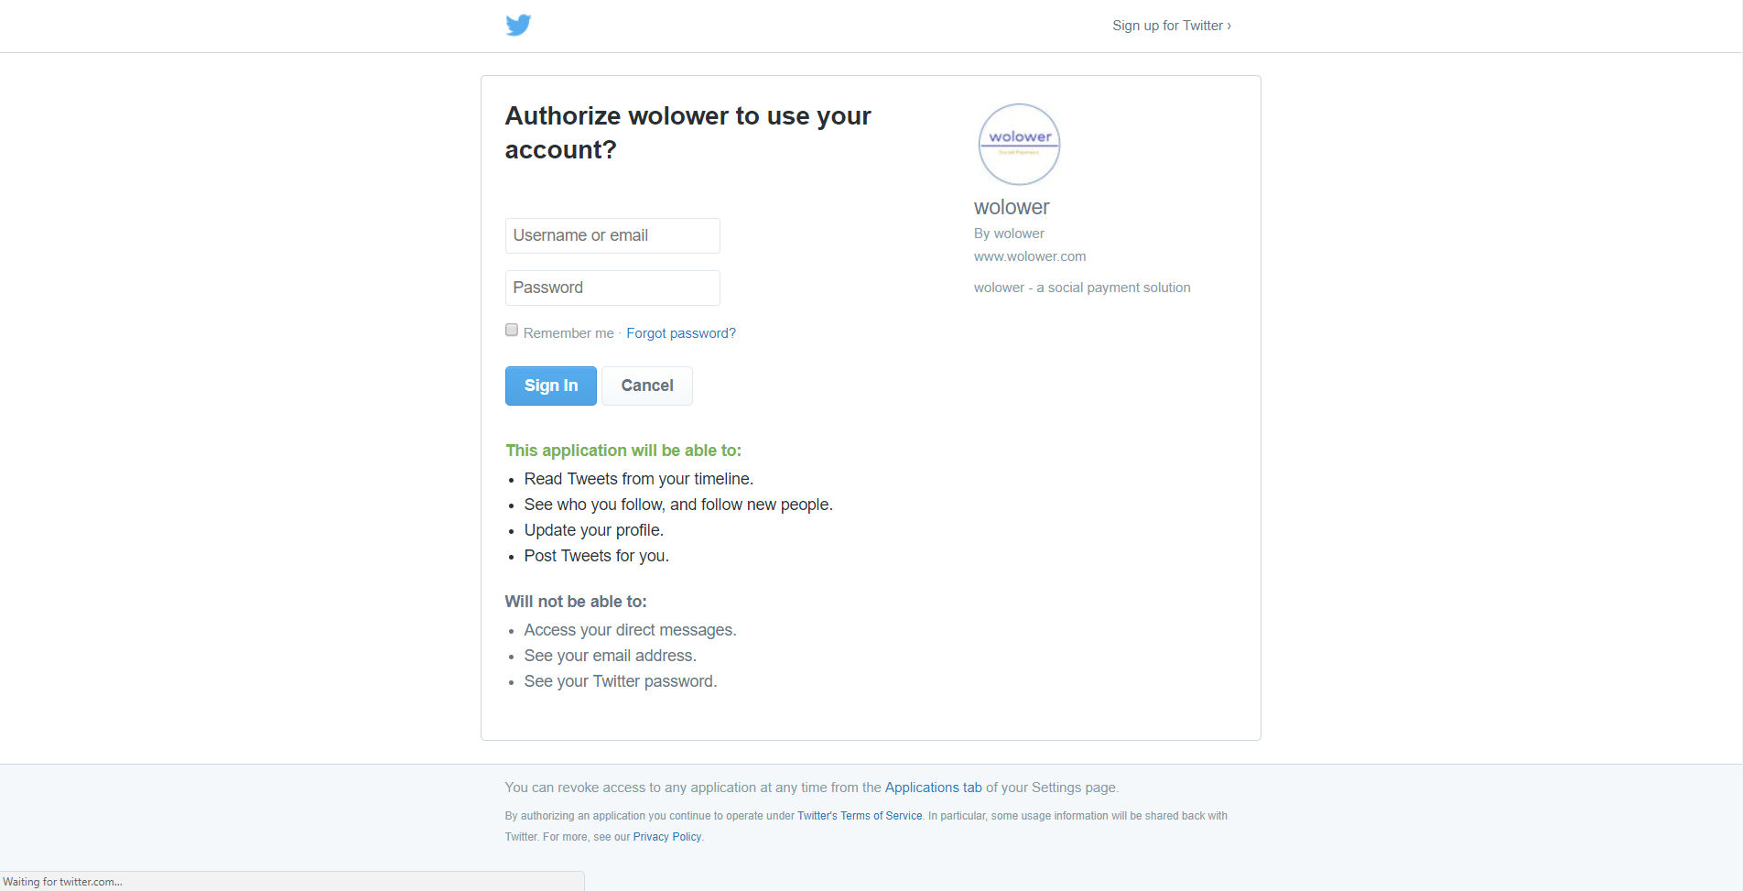

Figure 2 Twitter Application Authorization Page

After you provided your Twitter credential, Twitter will redirect you to the dashboard page of the wolower back;

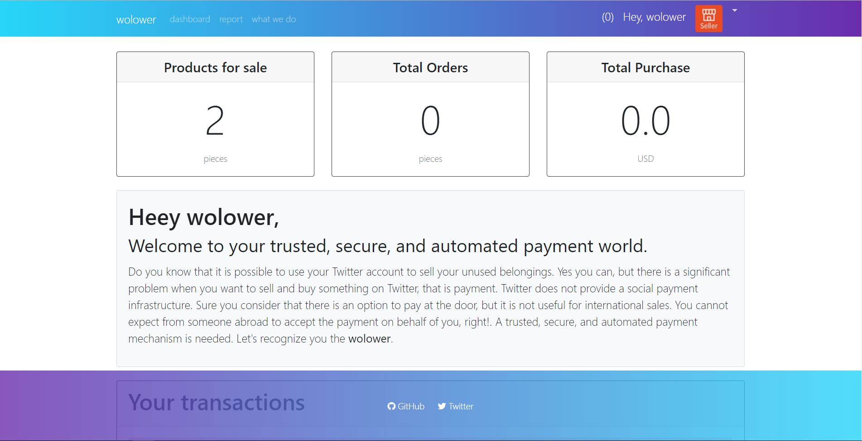

Figure 3 Dashboard Page

Congratulations! you registered to the wolower successfully.

# Do you want to sell something?

If you want to sell something through the wolower, it is the only thing needed by the wolower you being registered to the system. This is only prerequisite to begin facilitating your transactions. Let’s start selling!

Tweet what you want to sell by mentioning the wolower (@wolower_payment) to say “Hey wolower, I am selling this”

Please note that the wolower can only detect the amounts in the tweets in a specific format, formats are as follows regardless of the position of the amount in a tweet:

|  |  |
| --- | --- |
| **The amount** | **How detected** |
| $100 | 100 USD |
| $100.9 | 100.90 USD |
| $101,90 | 101.90 USD |
| $10.5055 | 10.50 USD |
| 10$ | Cannot be detected |
| $ 10 | Cannot be detected |

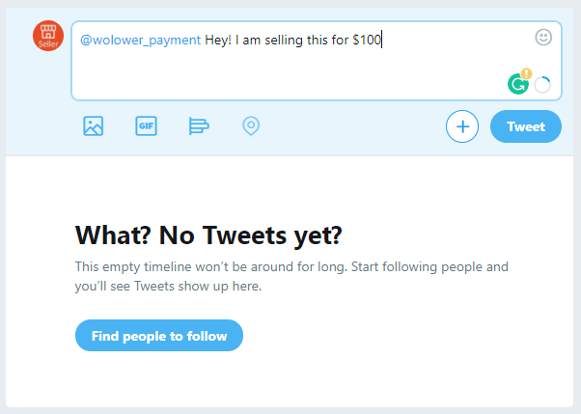

Figure 4 Tweeting your product

After your tweet, the wolower will detect your selling (it will be stored as a product that is being sold by you) and reply your tweet to indicate that it is stored.

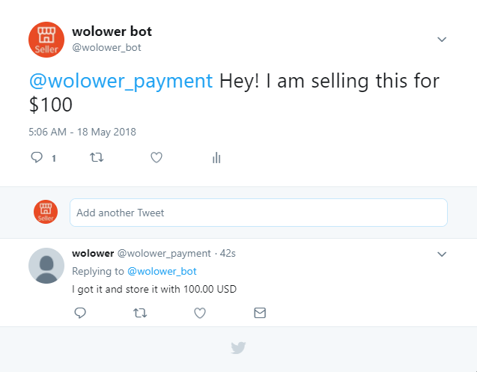

Figure 5 The wolower catching new product

When you go to the report page of the wolower, you can also your product as follows;

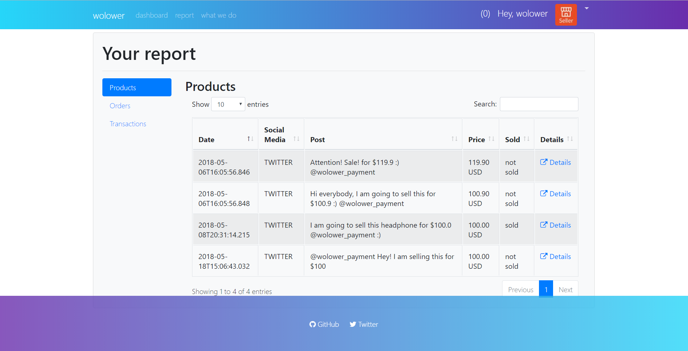

Figure 6 Your products

# Do you want to buy something via the wolower?

The wolower first checks your payment method which Masterpass is only available, if you have not paired your Masterpass wallet with the wolower, you will have to complete it first.

## Masterpass Pairing

To pair your Masterpass wallet, visit your profile page by clicking the little arrow your profile page and go to the payment method tab. You will see a page like below;

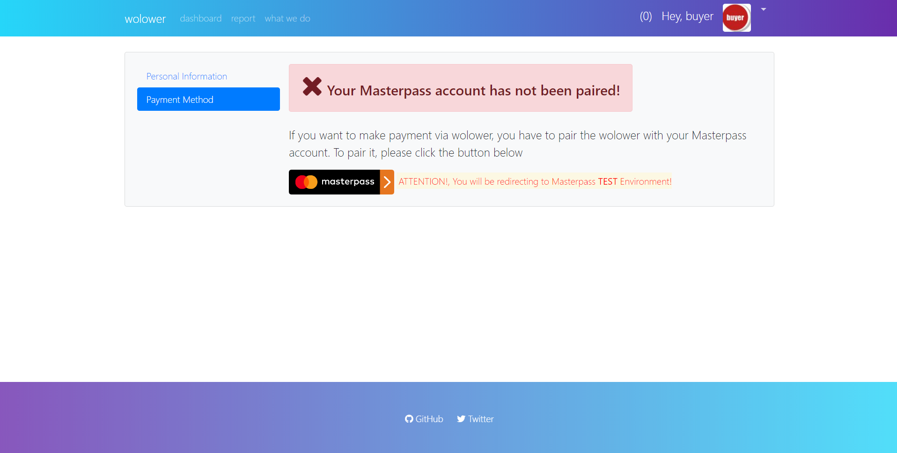

Figure 7 Payment method

When you clicked on the Masterpass button, the system will redirect you to Masterpass test environment and Masterpass requires you to provide your Masterpass wallet credentials.

You can follow the instructions to enable pairing between Masterpass and the wolower. After you are completed, Masterpass will redirect you to the profile page back;

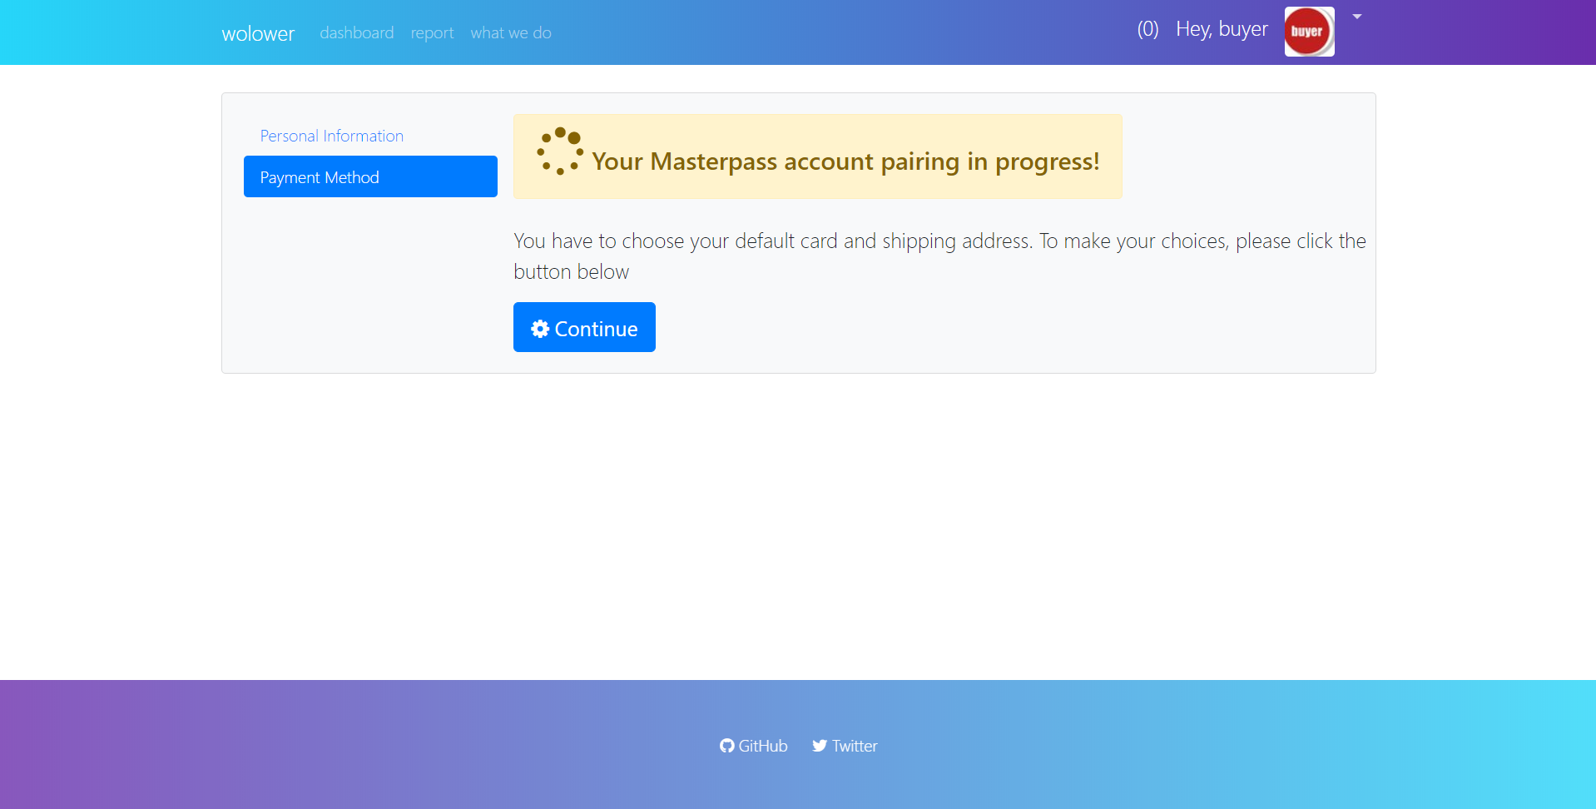

Figure 8 Pairing in progress

Now you need to choose your card and shipping address that will be used by the wolower when performing your transactions. To continue, please click the button Continue, the wolower will fetch your cards and shipping addresses stored by Masterpass and populate them on the screen.

Your default card and address in Masterpass will be populated as selected by default.

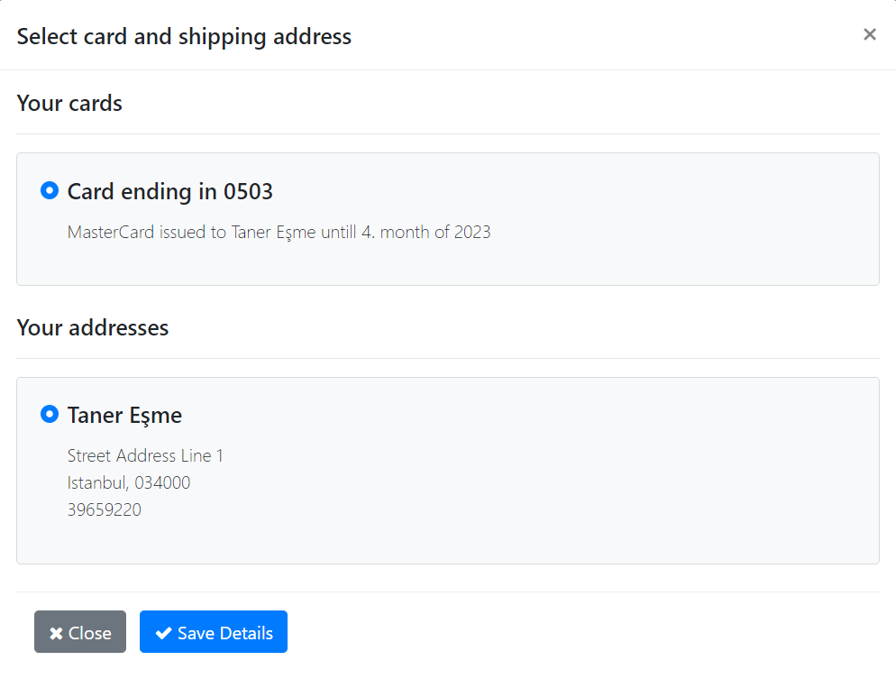

Figure 9 Cards and Shipping Addresses

After clicking “Save Details”, the wolower stores your choices.

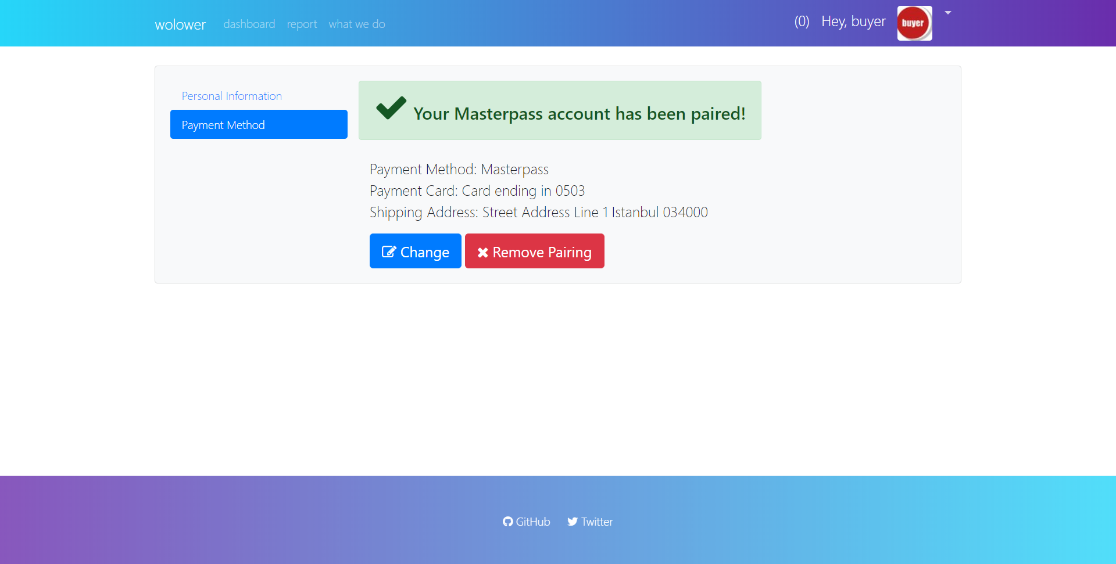

Figure 10 Masterpass pairing completed

Whenever you want, you can remove the pairing between the wolower and your Masterpass wallet by using the “Remove Pairing” button on the profile page and also you can change your card and shipping address by using “Change” button whenever you desire.

You are now ready to buy your orders via the wolower!

## Giving Order

You can find a sample scenario when buying something. There are a few rules to give attention when ordering.

1. Bargain before giving your order.
2. Do not reply main (product) tweet for bargaining purposes with prices. The wolower will behave as you are giving an order.
3. Bargain completed, reply main tweet (product) with the process. You do not have to mention the wolower (@wolower_payment) when ordering.

Please look at the following order taking account the above items.

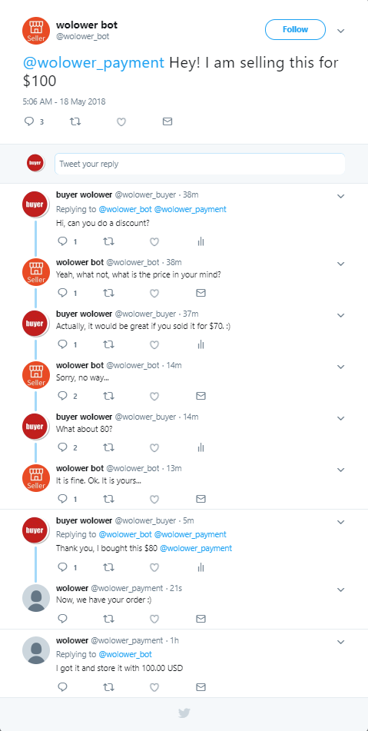

Figure 11 Bargain and buying

After completing your order, you can see your transaction like below on Dashboard page;

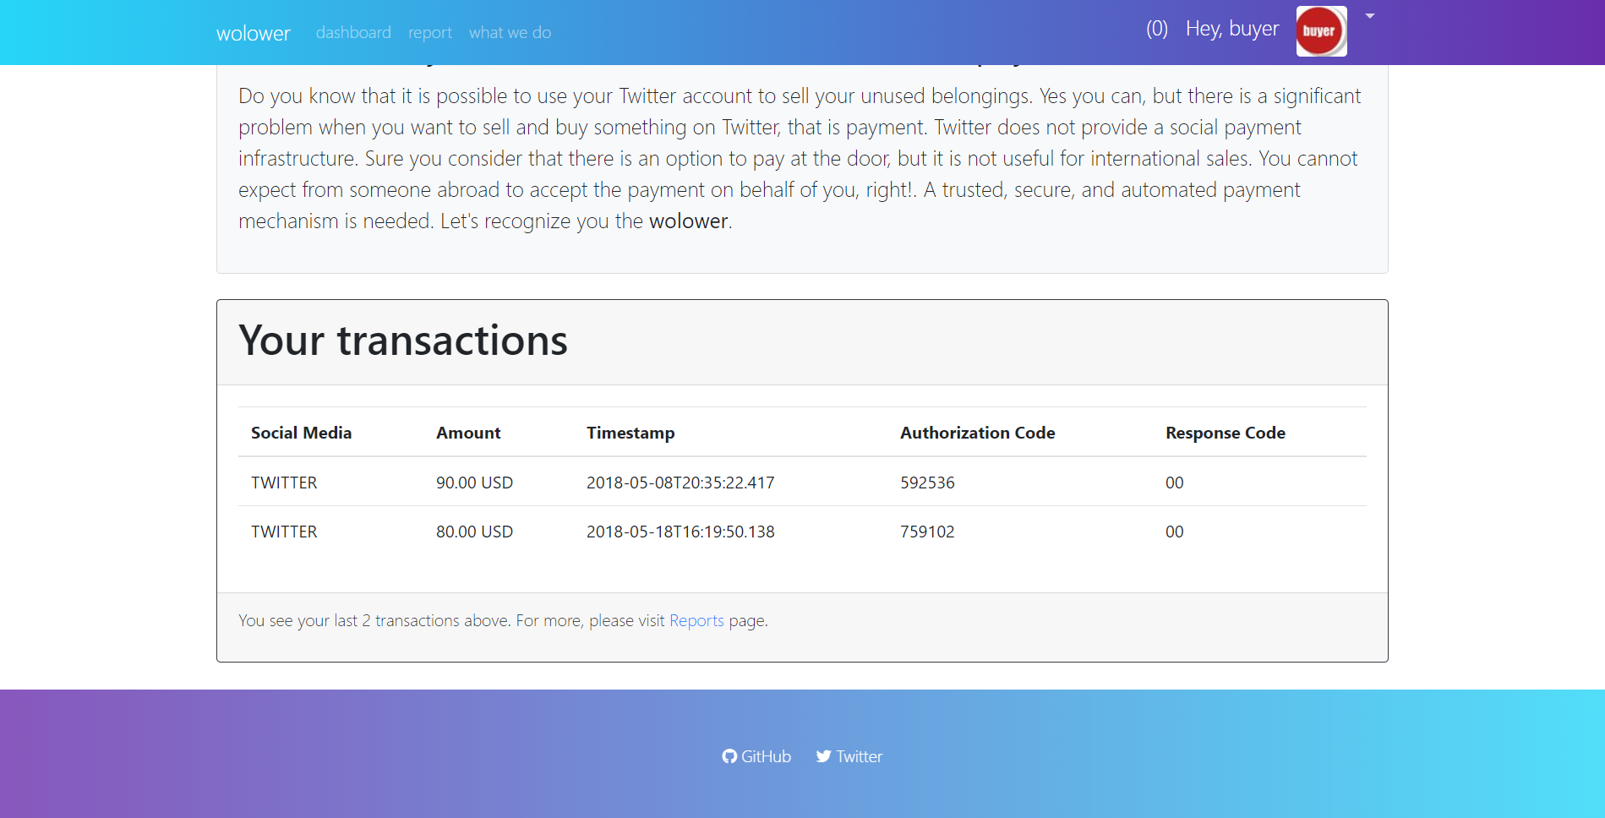

Figure 12 Last transactions