[Instructions for installing Python and the xlsxwriter library are below.]

Instructions to configure and run PdbToExcel:
- Configuration:
  - Settings are located in PdbToExcel.ini
  - Set Team to your team name
  - Set PnflPath to the directory containing your play files in order to get play category information
  - Set CalculateTotalStats to Yes or No depending on if you want PdbToExcel to calculate total stats for each play.
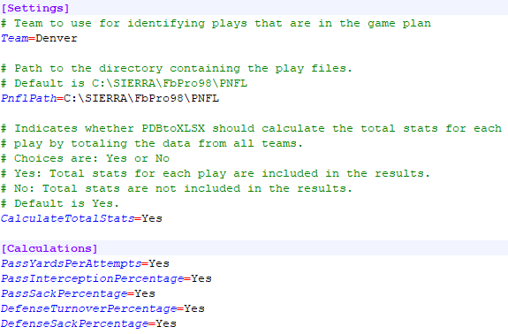

- Running PdbToExcel:
  - Update file PdbToExcel.bat with correct paths to the PDB and XLSM file, and, optionally, paths to the defensive game plan file and/or the offensive game plan file.
Quotation marks are required if the paths contain any spaces.
Name the destination file with extension .xlsm if you want double-click sorting*.
*Double-click sorting not compatible with OpenOffice.
  - Run PdbToExcel.bat

Instructions for installing Python and the Python library xlsxwriter:
- Install Python. https://www.python.org/downloads/
Make sure “Add python.exe to PATH” is checked.
Also, I recommend checking “Use admin privileges”, in case a system update for the C Runtime Library is needed, or you choose to install for all users.
Besides the checkboxes, you shouldn’t need to customize the installation.
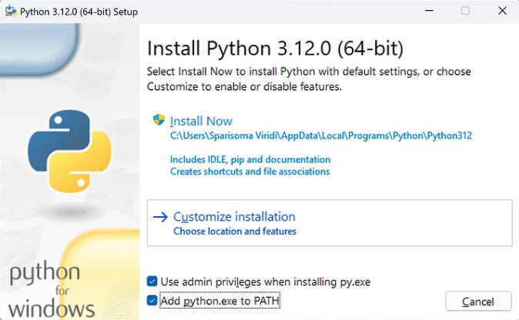
- After installing, open a new command prompt and run the following command to verify Python is working: python --version
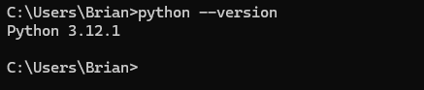
If python isn’t found, make sure all three of these paths make it into your User’s PATH variable. And then open a new command prompt.
  - C:\Users\<user>\AppData\Local\Programs\Python\Python312\Scripts\
  - C:\Users\<user>\AppData\Local\Programs\Python\Python312\
  - C:\Users\<user>\AppData\Local\Programs\Python\Launcher\

This link has decent instructions on how to update the User’s PATH environment variable:
https://www.computerhope.com/issues/ch000549.htm
- Once you have Python working, install the Python library xlsxwriter by running command: pip3 install xlsxwriter
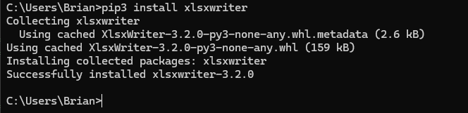
If pip3 isn’t found, make sure all those paths in step 2 make it into your User’s PATH environment variable. And then open a new command prompt.
Now that Python and xlsxwriter is installed, you should be able to run the script.

