The following screenshots always show the terminal commands run and the terminal outputs for the exercises in Tasks 1-3. I always just run my scripts (initialize.sh, post.sh, show.sh, automate.sh) and the requested commands in the tasks. The source code files are also in the folder to look at the commented source code.

Task 1 – Initialization

1b)
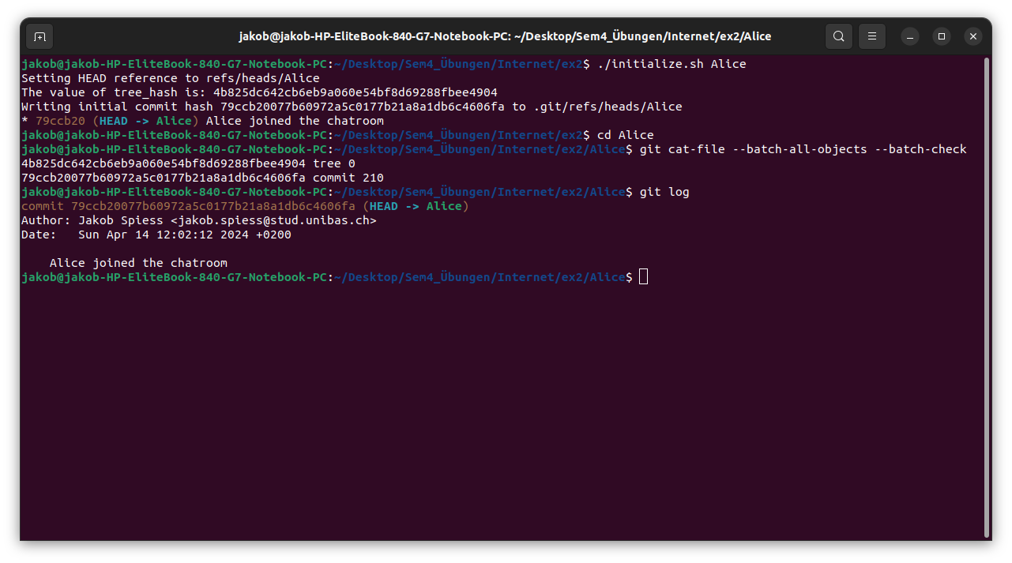
1c)
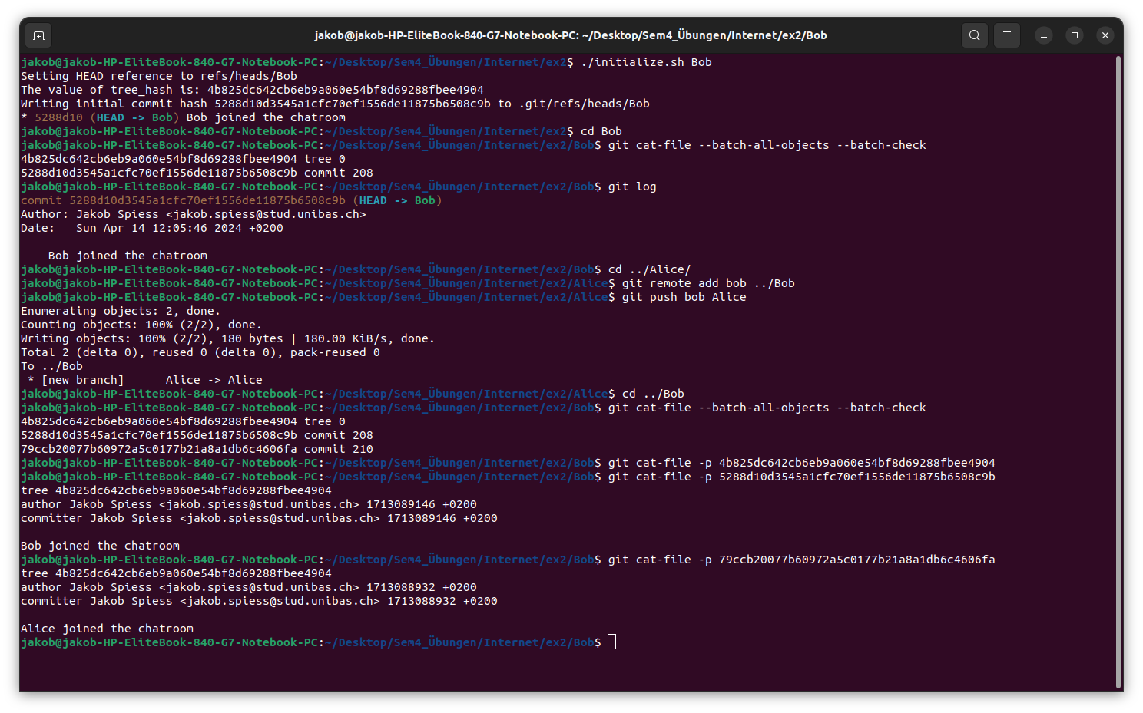
1d)
The problem is that git log only shows the commit history for the branch currently checked out (https://www.warp.dev/terminus/git-commit-history). But we now have 2 branches in this repository with HEAD pointing to Bob, so it only shows the 1 commit on Bob’s branch. At first I made a new commit and added Alice’s one to Bob’s one as a parent and saved this new one into .git/refs/heads/Bob, but since ordering doesn’t have to be absolute I think this isn’t necessary. Now I just ran git log - -all to show commits across all branches:
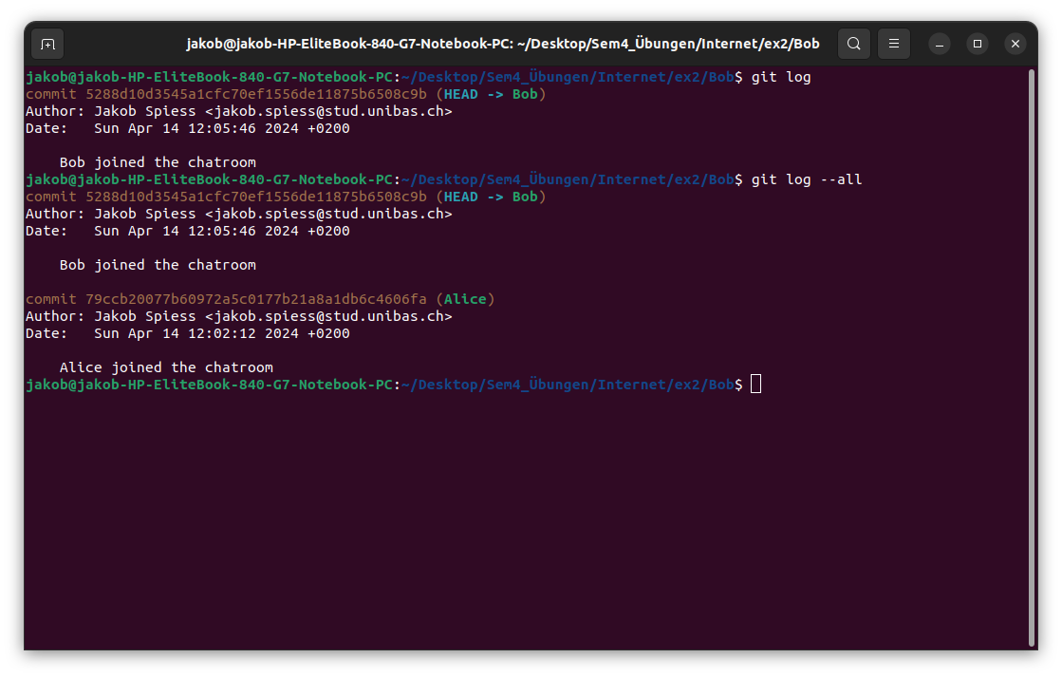

Task 2 – Posting Messages
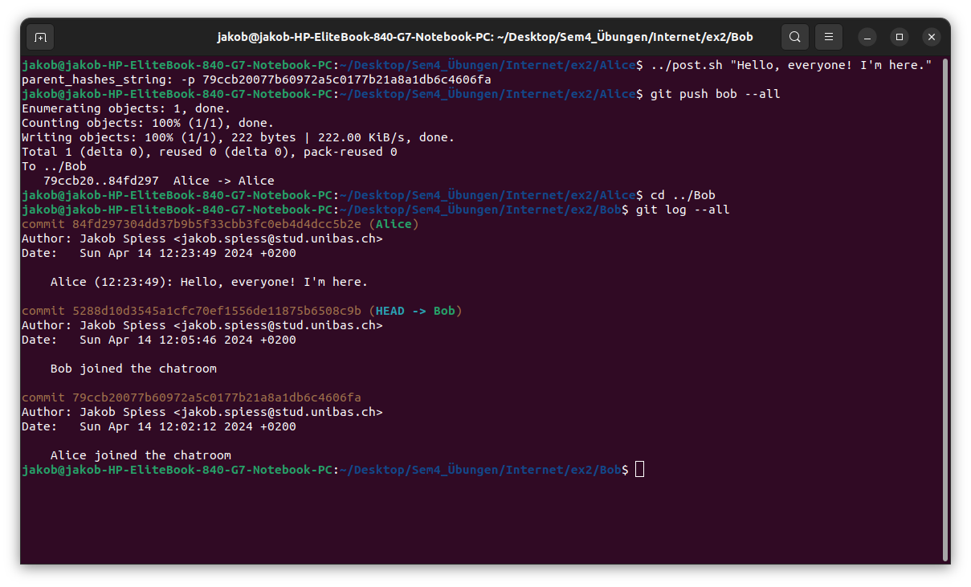
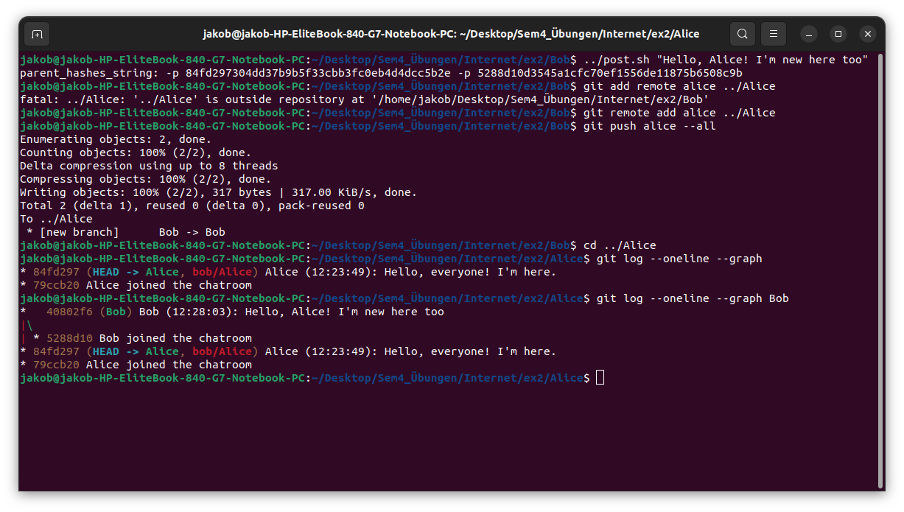

Task 3 – User Interface
3b)
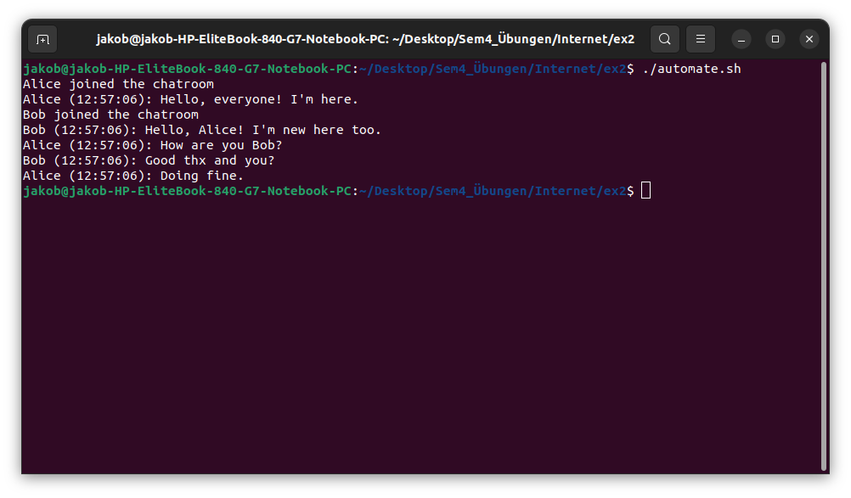

3c)
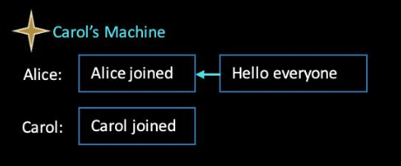

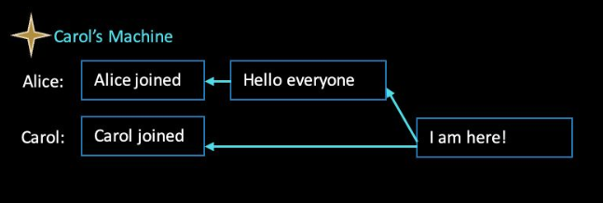
In the slides 56 & 57 it is shown how it would look if Carol pulls Alice’s repo and then posts a message (just here the message “I am here!” instead of “Hi all”). If Carol posted the message without pulling Alice’s repo, the commit with the message would only have 1 parent which is the commit that is Carols initial join message.

