1.
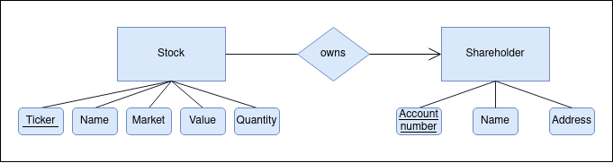

2.

CREATE TABLE Stocks (
ticker VARCHAR(10) ALWAYS AS IDENTITY,
name VARCHAR(255) NOT NULL,
market VARCHAR(255) NOT NULL,
value FLOAT NOT NULL,
quantity INT NOT NULL,
PRIMARY KEY(ticker)
);

CREATE TABLE Shareholders (
account_number INT ALWAYS AS IDENTITY
owned_ticker VARCHAR(10) ALWAYS AS IDENTITY,
name VARCHAR(255),
address VARCHAR(255),
PRIMARY KEY(account_number)
PRIMARY KEY(owned_ticker)
CONSTRAINT fk_stocks
FOREIGN KEY(owned_ticker)
REFERENCES Stocks(ticker)
);

3.
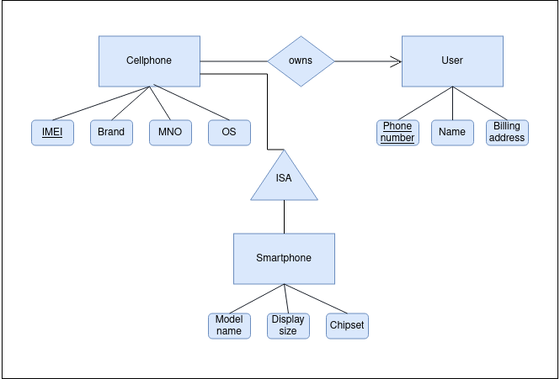

4. Map using the nulls method
Table(Phone number, Name, IMEI, Brand, MNO, OS, Model name, Display size, Chipset)

CREATE TABLE Phones (
phone_number INT ALWAYS AS IDENTITY,
name VARCHAR(255),
billing_address VARCHAR(255),
imei INT NOT NULL,
brand VARCHAR(255) NOT NULL,
mno VARCHAR(255),
os VARCHAR(255),
model_name
PRIMARY KEY(ticker)
);

5. Map using the ER method

User(Phone number, IMEI, Name, Billing address)
Cellphone(IMEI, Brand, MNO, OS)
Smartphone(IMEI, Model name, Display size, Chipset)

CREATE TABLE Users (
phone_number INT ALWAYS AS IDENTITY,
imei INT,
name VARCHAR(255),
billing_address VARCHAR(255),
imei INT NOT NULL,
brand VARCHAR(255) NOT NULL,
mno VARCHAR(255),
os VARCHAR(255),
model_name
PRIMARY KEY(phone_number),
CONSTRAINT fk_cellphones
FOREIGN KEY(imei)
REFERENCES Cellphones(imei)
);

CREATE TABLE Cellphones (
imei INT ALWAYS AS IDENTITY,
brand VARCHAR(255) NOT NULL,
mno VARCHAR(255),
os VARCHAR(255),
PRIMARY KEY(imei)
CONSTRAINT fk_smartphone
FOREIGN KEY(imei)
REFERENCES Smartphones(imei)
);

CREATE TABLE Smartphone (
model_name VARCHAR(255) ALWAYS AS IDENTITY,
imei INT NOT NULL,
display_size FLOAT,
chipset VARCHAR(255),
PRIMARY KEY(imei),
CONSTRAINT fk_cellphone
FOREIGN KEY(imei)
REFERENCES Cellphones(imei)
);

6.

Person(name, address, child_of_name, child_of_address, mother_of_name, mother_of_address, father_of_name, father_of_address, married_to_name, married_to_address)

CREATE TABLE Person (
name VARCHAR(255) ALWAYS AS IDENTITY,
address VARCHAR(255) ALWAYS AS IDENTITY,
child_of_name VARCHAR(255),
child_of_address VARCHAR(255),
mother_of_name VARCHAR(255),
mother_of_address VARCHAR(255),
father_of_name VARCHAR(255),
father_of_address VARCHAR(255),
married_to_name VARCHAR(255),
married_to_address VARCHAR(255),
PRIMARY KEY(name),
PRIMARY KEY(address),
);

7.
Person(name, address)
Child(name, address, child_of_name, child_of_address)
Mother(name, address, mother_of_name, mother_of_address, married_to_name, married_to_address)
Father(name, address, father_of_name, father_of_address, married_to_name, married_to_address)

CREATE TABLE Person (
name VARCHAR(255) ALWAYS AS IDENTITY,
address VARCHAR(255) ALWAYS AS IDENTITY,
PRIMARY KEY(name),
PRIMARY KEY(address),
);

CREATE TABLE Child (
name VARCHAR(255) ALWAYS AS IDENTITY,
address VARCHAR(255) ALWAYS AS IDENTITY,
child_of_name VARCHAR(255),
child_of_address VARCHAR(255),
PRIMARY KEY(name),
PRIMARY KEY(address),
CONSTRAINT fk_person_name
FOREIGN KEY(name)
REFERENCES Person(name)
CONSTRAINT fk_person_address
FOREIGN KEY(address)
REFERENCES Person(address)
);

CREATE TABLE Mother (
name VARCHAR(255) ALWAYS AS IDENTITY,
address VARCHAR(255) ALWAYS AS IDENTITY,
mother_of VARCHAR(255),
mother_of_address VARCHAR(255),
married_to_name VARCHAR(255),
married_to_address VARCHAR(255),
PRIMARY KEY(name),
PRIMARY KEY(address),
CONSTRAINT fk_child_name
FOREIGN KEY(name)
REFERENCES Child(name)
CONSTRAINT fk_child_address
FOREIGN KEY(address)
REFERENCES Child(address)
CONSTRAINT fk_married_to_name
FOREIGN KEY(married_to_name)
REFERENCES Father(name)
CONSTRAINT fk_married_to_address
FOREIGN KEY(married_to_address)
REFERENCES Father(address)
);

CREATE TABLE Father (
name VARCHAR(255) ALWAYS AS IDENTITY,
address VARCHAR(255) ALWAYS AS IDENTITY,
father_of VARCHAR(255),
father_of_address VARCHAR(255),
married_to_name VARCHAR(255),
married_to_address VARCHAR(255),
PRIMARY KEY(name),
PRIMARY KEY(address),
CONSTRAINT fk_child_name
FOREIGN KEY(name)
REFERENCES Child(name)
CONSTRAINT fk_child_address
FOREIGN KEY(address)
REFERENCES Child(address)
CONSTRAINT fk_married_to_name
FOREIGN KEY(married_to_name)
REFERENCES Mother(name)
CONSTRAINT fk_married_to_address
FOREIGN KEY(married_to_address)
REFERENCES Mother(address)
);

