**<Torso – with rotor inertia to calculate the mass of the body>**

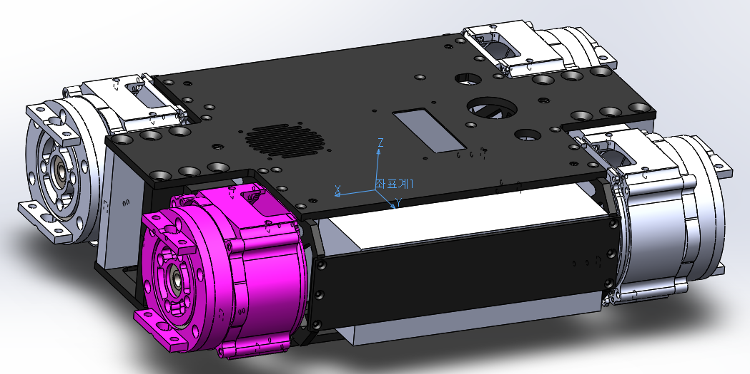

Temp_body의 물성치

설정: 기본

좌표계: 좌표계1

**질량 = 11575.56 그램**

볼륨 = 3466593.57 입방 밀리미터

면적 = 1052638.53 평방 밀리미터

중심: ( 밀리미터 )

X = -0.30

Y = -0.01

Z = -3.16

주관성축(Principal axes of inertia)과 주관성 모멘트(principal moments of inertia): ( 그램 * 평방 밀리미터 )

질량 중심에서 얻음.

Ix = (-1.00, 0.00, 0.00) Px = 75602009.67

Iy = ( 0.00, -1.00, 0.00) Py = 150503894.60

Iz = ( 0.00, 0.00, 1.00) Pz = 211441971.29

관성 모멘트: ( 그램 * 평방 밀리미터 )

질량 중심에서 계산되며 출력 좌표계에 맞추어집니다.

Lxx = 75602108.15 Lxy = -63569.79 Lxz = -77794.19

Lyx = -63569.79 Lyy = 150503848.62 Lyz = -21976.46

Lzx = -77794.19 Lzy = -21976.46 Lzz = 211441918.79

관성 모멘트: ( 그램 * 평방 밀리미터 )

출력 사용자 좌표계에서 얻은 값.

Ixx = 75717424.69 Ixy = -63548.72 Ixz = -66779.01

Iyx = -63548.72 Iyy = 150620216.93 Iyz = -21755.89

Izx = -66779.01 Izy = -21755.89 Izz = 211442971.40

한 개 이상의 부품에서 물성치를 덮어썼습니다.

1번축_모터_하우징<1><기본> **+ 340g(stator) +100g(board,bolts)**

기어_프레임_3<5><기본> **+ 130g(ring gear)**

로터_프레임<1><기본> **+160g(rotor) + 140g(planet gears)**

배터리<1><기본> **+1400g x2**

PC+파워보드<1><기본> **+1500g**

**<Torso – without rotor inertia to calculate the inertia of the body>**

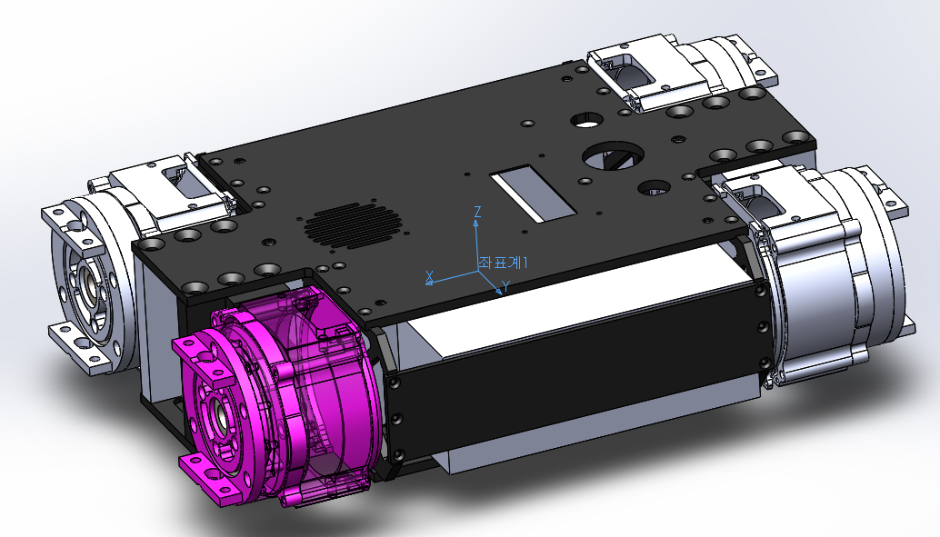

Temp_body의 물성치

설정: 기본

좌표계: 좌표계1

질량 = 10222.39 그램

볼륨 = 3389662.72 입방 밀리미터

면적 = 992977.49 평방 밀리미터

중심: ( 밀리미터 )

X = -0.34

Y = -0.01

Z = -3.57

주관성축(Principal axes of inertia)과 주관성 모멘트(principal moments of inertia): ( 그램 * 평방 밀리미터 )

질량 중심에서 얻음.

Ix = (-1.00, 0.00, 0.00) Px = 66749927.15

Iy = ( 0.00, -1.00, 0.00) Py = 124905706.20

Iz = ( 0.00, 0.00, 1.00) Pz = 177312131.80

관성 모멘트: ( 그램 * 평방 밀리미터 )

질량 중심에서 계산되며 출력 좌표계에 맞추어집니다.

Lxx = 66750053.32 Lxy = -63531.87 Lxz = -79250.07

Lyx = -63531.87 Lyy = 124905646.11 Lyz = -22005.65

Lzx = -79250.07 Lzy = -22005.65 Lzz = 177312065.71

관성 모멘트: ( 그램 * 평방 밀리미터 )

출력 사용자 좌표계에서 얻은 값.

Ixx = 66880626.22 Ixy = -63508.02 Ixz = -66779.01

Iyx = -63508.02 Iyy = 125037409.65 Iyz = -21755.89

Izx = -66779.01 Izy = -21755.89 Izz = 177313257.31

한 개 이상의 부품에서 물성치를 덮어썼습니다.

1번축_모터_하우징<1><기본>

기어_프레임_3<5><기본>

배터리<1><기본>

PC+파워보드<1><기본>

**<Hip Roll Link – with rotor inertia to calculate the mass of the body >**

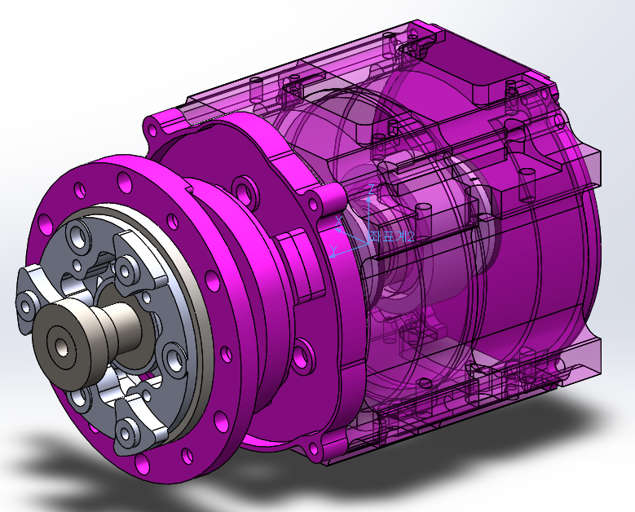

골반의 물성치

설정: 기본

좌표계: 좌표계2

**질량 = 2386.74 그램**

볼륨 = 290100.43 입방 밀리미터

면적 = 192113.67 평방 밀리미터

중심: ( 밀리미터 )

X = -3.16

Y = 15.98

Z = 0.03

주관성축(Principal axes of inertia)과 주관성 모멘트(principal moments of inertia): ( 그램 * 평방 밀리미터 )

질량 중심에서 얻음.

Ix = (-0.09, -1.00, 0.00) Px = 2855608.86

Iy = ( 0.99, -0.09, 0.13) Py = 4100730.47

Iz = (-0.13, 0.01, 0.99) Pz = 4101621.82

관성 모멘트: ( 그램 * 평방 밀리미터 )

질량 중심에서 계산되며 출력 좌표계에 맞추어집니다.

Lxx = 4091261.43 Lxy = 108250.84 Lxz = 448.60

Lyx = 108250.84 Lyy = 2865104.31 Lyz = 3828.39

Lzx = 448.60 Lzy = 3828.39 Lzz = 4101595.40

관성 모멘트: ( 그램 * 평방 밀리미터 )

출력 사용자 좌표계에서 얻은 값.

Ixx = 4701006.90 Ixy = -12137.65 Ixz = 216.85

Iyx = -12137.65 Iyy = 2888876.23 Iyz = 5002.13

Izx = 216.85 Izy = 5002.13 Izz = 4735108.27

한 개 이상의 부품에서 물성치를 덮어썼습니다.

2번축_모터_하우징<3><기본>

3번축_모터_하우징<3><기본>

3번축_로터_프레임<1><기본>

로터_프레임<2><기본>

**<Hip Roll Link – without rotor inertia to calculate the inertia of the body >**



골반의 물성치

설정: 기본

좌표계: 좌표계2

질량 = 1672.24 그램

볼륨 = 244808.81 입방 밀리미터

면적 = 160126.86 평방 밀리미터

중심: ( 밀리미터 )

X = -4.51

Y = 17.58

Z = 0.04

주관성축(Principal axes of inertia)과 주관성 모멘트(principal moments of inertia): ( 그램 * 평방 밀리미터 )

질량 중심에서 얻음.

Ix = (-0.16, -0.99, -0.01) Px = 2698972.43

Iy = ( 0.00, 0.00, 1.00) Py = 3437732.67

Iz = (-0.99, 0.16, 0.00) Pz = 3457280.51

**관성 모멘트: ( 그램 * 평방 밀리미터 )**

**질량 중심에서 계산되며 출력 좌표계에 맞추어집니다.**

**Lxx = 3437636.42 Lxy = 120456.91 Lxz = 569.13**

**Lyx = 120456.91 Lyy = 2718636.62 Lyz = 3826.95**

**Lzx = 569.13 Lzy = 3826.95 Lzz = 3437712.56**

관성 모멘트: ( 그램 * 평방 밀리미터 )

출력 사용자 좌표계에서 얻은 값.

Ixx = 3954633.45 Ixy = -12113.44 Ixz = 238.88

Iyx = -12113.44 Iyy = 2752634.23 Iyz = 5114.85

Izx = 238.88 Izy = 5114.85 Izz = 3988700.78

한 개 이상의 부품에서 물성치를 덮어썼습니다.

2번축_모터_하우징<3><기본>

3번축_모터_하우징<3><기본>

**<Hip Pitch Link>**

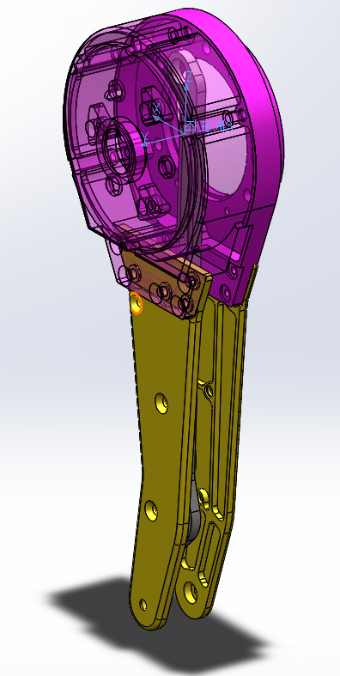

허벅지의 물성치

설정: 기본

좌표계: 좌표계3

**질량 = 672.31 그램**

볼륨 = 170723.46 입방 밀리미터

면적 = 126986.47 평방 밀리미터

중심: ( 밀리미터 )

X = -2.26

Y = 7.68

Z = -41.12

주관성축(Principal axes of inertia)과 주관성 모멘트(principal moments of inertia): ( 그램 * 평방 밀리미터 )

질량 중심에서 얻음.

Ix = ( 0.04, 0.06, 1.00) Px = 623320.18

Iy = (-1.00, 0.01, 0.04) Py = 3150792.02

Iz = ( 0.00, -1.00, 0.06) Pz = 3438085.72

**관성 모멘트: ( 그램 * 평방 밀리미터 )**

**질량 중심에서 계산되며 출력 좌표계에 맞추어집니다.**

**Lxx = 3146944.77 Lxy = 4356.11 Lxz = 98512.25**

**Lyx = 4356.11 Lyy = 3429086.75 Lyz = 158744.35**

**Lzx = 98512.25 Lzy = 158744.35 Lzz = 636166.40**

관성 모멘트: ( 그램 * 평방 밀리미터 )

출력 사용자 좌표계에서 얻은 값.

Ixx = 4323408.43 Ixy = -7299.09 Ixz = 160928.67

Iyx = -7299.09 Iyy = 4569337.23 Iyz = -53538.03

Izx = 160928.67 Izy = -53538.03 Izz = 679233.43

한 개 이상의 부품에서 물성치를 덮어썼습니다.

3번축_고정_프레임<1><기본>

**<Knee Pitch Link>**

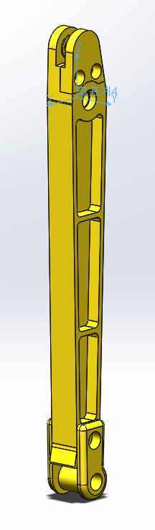

종아리의 물성치

설정: 기본

좌표계: 좌표계4

**질량 = 173.19 그램**

볼륨 = 67313.54 입방 밀리미터

면적 = 41192.06 평방 밀리미터

중심: ( 밀리미터 )

X = 0.75

Y = 0.35

Z = -88.03

주관성축(Principal axes of inertia)과 주관성 모멘트(principal moments of inertia): ( 그램 * 평방 밀리미터 )

질량 중심에서 얻음.

Ix = ( 0.00, -0.01, 1.00) Px = 18765.98

Iy = (-1.00, 0.00, 0.00) Py = 1256861.37

Iz = ( 0.00, -1.00, -0.01) Pz = 1263650.96

**관성 모멘트: ( 그램 * 평방 밀리미터 )**

**질량 중심에서 계산되며 출력 좌표계에 맞추어집니다.**

**Lxx = 1256859.90 Lxy = 13.94 Lxz = -1349.76**

**Lyx = 13.94 Lyy = 1263569.86 Lyz = -10047.10**

**Lzx = -1349.76 Lzy = -10047.10 Lzz = 18848.54**

관성 모멘트: ( 그램 * 평방 밀리미터 )

출력 사용자 좌표계에서 얻은 값.

Ixx = 2599045.40 Ixy = 60.14 Ixz = -12820.84

Iyx = 60.14 Iyy = 2605831.63 Iyz = -15452.53

Izx = -12820.84 Izy = -15452.53 Izz = 18968.35

**<Foot Link>**

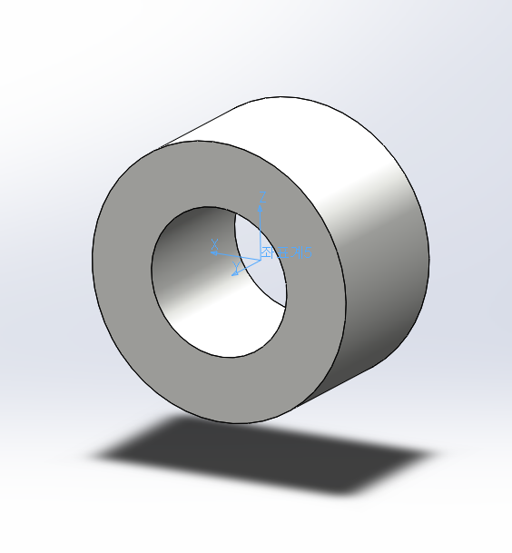

발바닥의 물성치

설정: 기본

좌표계: 좌표계5

**질량 = 20.03 그램**

볼륨 = 8598.54 입방 밀리미터

면적 = 3468.32 평방 밀리미터

중심: ( 밀리미터 )

X = 0.00

Y = 0.00

Z = 0.00

주관성축(Principal axes of inertia)과 주관성 모멘트(principal moments of inertia): ( 그램 * 평방 밀리미터 )

질량 중심에서 얻음.

Ix = ( 0.00, 0.00, 1.00) Px = 1930.00

Iy = (-1.00, 0.00, 0.00) Py = 1930.00

Iz = ( 0.00, -1.00, 0.00) Pz = 2895.00

**관성 모멘트: ( 그램 * 평방 밀리미터 )**

**질량 중심에서 계산되며 출력 좌표계에 맞추어집니다.**

**Lxx = 1930.00 Lxy = 0.00 Lxz = 0.00**

**Lyx = 0.00 Lyy = 2895.00 Lyz = 0.00**

**Lzx = 0.00 Lzy = 0.00 Lzz = 1930.00**

관성 모멘트: ( 그램 * 평방 밀리미터 )

출력 사용자 좌표계에서 얻은 값.

Ixx = 1930.00 Ixy = 0.00 Ixz = 0.00

Iyx = 0.00 Iyy = 2895.00 Iyz = 0.00

Izx = 0.00 Izy = 0.00 Izz = 1930.00

<body to hip roll>

거리: 238.10mm

델타 X: 224.45mm

델타 Y: 79.46mm

델타 Z: 0.00mm

<hip roll to hip pitch>

거리: 69.95mm

델타 X: 0.00mm

델타 Y: 69.95mm

델타 Z: 0.00mm

<hip pitch to knee pitch>

거리: 225.00mm

델타 X: 0.00mm

델타 Y: 0.00mm

델타 Z: 225.00mm

<knee pitch to foot>

거리: 225.00mm

델타 X: 0.00mm

델타 Y: 0.00mm

델타 Z: 225.00mm

<Symmetric properties of inertia>

**LF – Hip roll link**

Mass properties of Assembly_all

Configuration: 기본

Coordinate system: LF_hr

Mass = 2.38613 kilograms

Volume = 0.00029 cubic meters

Surface area = 0.191692 square meters

Center of mass: ( meters )

X = -0.003157

Y = 0.01597

Z = 2.3e-05

Principal axes of inertia and principal moments of inertia: ( kilograms * square meters )

Taken at the center of mass.

Ix = (-0.087241, -0.996184, -0.00234) Px = 0.002855

Iy = ( 0.994116, -0.087211, 0.064248) Py = 0.004099

Iz = (-0.064207, 0.003279, 0.997931) Pz = 0.0041

Moments of inertia: ( kilograms * square meters )

Taken at the center of mass and aligned with the output coordinate system.

Lxx = 0.004089 Lxy = 0.000108 Lxz = 0

Lyx = 0.000108 Lyy = 0.002865 Lyz = 3e-06

Lzx = 0 Lzy = 3e-06 Lzz = 0.0041

Moments of inertia: ( kilograms * square meters )

Taken at the output coordinate system.

Ixx = 0.004698 Ixy = -1.2e-05 Ixz = 0

Iyx = -1.2e-05 Iyy = 0.002888 Iyz = 4e-06

Izx = 0 Izy = 4e-06 Izz = 0.004732

One or more components have overridden mass properties:

2번축_모터_하우징_sw<3><기본>@Assembly_LF_leg<1><기본>

3번축_모터_하우징_sw<3><기본>@Assembly_LF_leg<1><기본>

3번축_로터_프레임_sw<1><기본>@Assembly_LF_leg<1><기본>

로터_프레임_sw<2><기본>@Assembly_LF_leg<1><기본>

**LF – hip pitch link**

Mass properties of Assembly_all

Configuration: 기본

Coordinate system: LF_hp

Mass = 0.735195 kilograms

Volume = 0.000194 cubic meters

Surface area = 0.145094 square meters

Center of mass: ( meters )

X = -0.001855

Y = 0.007098

Z = -0.046311

Principal axes of inertia and principal moments of inertia: ( kilograms * square meters )

Taken at the center of mass.

Ix = ( 0.033525, 0.059, 0.997695) Px = 0.000638

Iy = (-0.999392, 0.011553, 0.032898) Py = 0.003476

Iz = (-0.009586, -0.998191, 0.059352) Pz = 0.003773

Moments of inertia: ( kilograms * square meters )

Taken at the center of mass and aligned with the output coordinate system.

Lxx = 0.003473 Lxy = 3e-06 Lxz = 9.5e-05

Lyx = 3e-06 Lyy = 0.003762 Lyz = 0.000185

Lzx = 9.5e-05 Lzy = 0.000185 Lzz = 0.000653

Moments of inertia: ( kilograms * square meters )

Taken at the output coordinate system.

Ixx = 0.005087 Ixy = -7e-06 Ixz = 0.000158

Iyx = -7e-06 Iyy = 0.005341 Iyz = -5.7e-05

Izx = 0.000158 Izy = -5.7e-05 Izz = 0.000692

One or more components have overridden mass properties:

3번축_고정_프레임_sw<1><기본>@Assembly_LF_leg<1><기본>

**RF – hip roll link**

Mass properties of Assembly_all

Configuration: 기본

Coordinate system: RF_hr

Mass = 0.980756 kilograms

Volume = 0.00029 cubic meters

Surface area = 0.191692 square meters

Center of mass: ( meters )

X = -0.002096

Y = -0.031434

Z = 5.8e-05

Principal axes of inertia and principal moments of inertia: ( kilograms * square meters )

Taken at the center of mass.

Ix = ( 0.058597, -0.99828, 0.001971) Px = 0.001028

Iy = ( 0.231372, 0.015502, 0.972742) Py = 0.00214

Iz = (-0.971099, -0.056544, 0.231882) Pz = 0.002141

Moments of inertia: ( kilograms * square meters )

Taken at the center of mass and aligned with the output coordinate system.

Lxx = 0.002137 Lxy = -6.5e-05 Lxz = 0

Lyx = -6.5e-05 Lyy = 0.001031 Lyz = -2e-06

Lzx = 0 Lzy = -2e-06 Lzz = 0.00214

Moments of inertia: ( kilograms * square meters )

Taken at the output coordinate system.

Ixx = 0.003106 Ixy = -1e-06 Ixz = 0

Iyx = -1e-06 Iyy = 0.001036 Iyz = -4e-06

Izx = 0 Izy = -4e-06 Izz = 0.003114

**RF – hip pitch link**

Mass properties of Assembly_all

Configuration: 기본

Coordinate system: RF_hp

Mass = 0.589663 kilograms

Volume = 0.000194 cubic meters

Surface area = 0.145094 square meters

Center of mass: ( meters )

X = -0.002093

Y = -0.003628

Z = -0.054979

Principal axes of inertia and principal moments of inertia: ( kilograms * square meters )

Taken at the center of mass.

Ix = ( 0.032258, -0.032231, 0.99896) Px = 0.00046

Iy = (-0.999448, -0.008932, 0.031986) Py = 0.003011

Iz = ( 0.007892, -0.999441, -0.032501) Pz = 0.003212

Moments of inertia: ( kilograms * square meters )

Taken at the center of mass and aligned with the output coordinate system.

Lxx = 0.003009 Lxy = -1e-06 Lxz = 8.2e-05

Lyx = -1e-06 Lyy = 0.003209 Lyz = -8.9e-05

Lzx = 8.2e-05 Lzy = -8.9e-05 Lzz = 0.000465

Moments of inertia: ( kilograms * square meters )

Taken at the output coordinate system.

Ixx = 0.004799 Ixy = 3e-06 Ixz = 0.00015

Iyx = 3e-06 Iyy = 0.004994 Iyz = 2.9e-05

Izx = 0.00015 Izy = 2.9e-05 Izz = 0.000475

**LH – hip roll link**

Mass properties of Assembly_all

Configuration: 기본

Coordinate system: LH_hr

Mass = 0.980756 kilograms

Volume = 0.00029 cubic meters

Surface area = 0.191692 square meters

Center of mass: ( meters )

X = 0.002096

Y = 0.031434

Z = 5.8e-05

Principal axes of inertia and principal moments of inertia: ( kilograms * square meters )

Taken at the center of mass.

Ix = ( 0.058597, -0.99828, -0.001971) Px = 0.001028

Iy = (-0.231372, -0.015502, 0.972742) Py = 0.00214

Iz = (-0.971099, -0.056544, -0.231882) Pz = 0.002141

Moments of inertia: ( kilograms * square meters )

Taken at the center of mass and aligned with the output coordinate system.

Lxx = 0.002137 Lxy = -6.5e-05 Lxz = 0

Lyx = -6.5e-05 Lyy = 0.001031 Lyz = 2e-06

Lzx = 0 Lzy = 2e-06 Lzz = 0.00214

Moments of inertia: ( kilograms * square meters )

Taken at the output coordinate system.

Ixx = 0.003106 Ixy = -1e-06 Ixz = 0

Iyx = -1e-06 Iyy = 0.001036 Iyz = 4e-06

Izx = 0 Izy = 4e-06 Izz = 0.003114

**LH – hip pitch link**

Mass properties of Assembly_all

Configuration: 기본

Coordinate system: LH_hp

Mass = 0.589663 kilograms

Volume = 0.000194 cubic meters

Surface area = 0.145094 square meters

Center of mass: ( meters )

X = 0.002093

Y = 0.003628

Z = -0.054979

Principal axes of inertia and principal moments of inertia: ( kilograms * square meters )

Taken at the center of mass.

Ix = (-0.032258, 0.032231, 0.99896) Px = 0.00046

Iy = (-0.999448, -0.008932, -0.031986) Py = 0.003011

Iz = ( 0.007892, -0.999441, 0.032501) Pz = 0.003212

Moments of inertia: ( kilograms * square meters )

Taken at the center of mass and aligned with the output coordinate system.

Lxx = 0.003009 Lxy = -1e-06 Lxz = -8.2e-05

Lyx = -1e-06 Lyy = 0.003209 Lyz = 8.9e-05

Lzx = -8.2e-05 Lzy = 8.9e-05 Lzz = 0.000465

Moments of inertia: ( kilograms * square meters )

Taken at the output coordinate system.

Ixx = 0.004799 Ixy = 3e-06 Ixz = -0.00015

Iyx = 3e-06 Iyy = 0.004994 Iyz = -2.9e-05

Izx = -0.00015 Izy = -2.9e-05 Izz = 0.000475

**RH – hip roll link**

Mass properties of Assembly_all

Configuration: 기본

Coordinate system: RH_hr

Mass = 0.980759 kilograms

Volume = 0.00029 cubic meters

Surface area = 0.191692 square meters

Center of mass: ( meters )

X = 0.002096

Y = -0.031433

Z = 5.8e-05

Principal axes of inertia and principal moments of inertia: ( kilograms * square meters )

Taken at the center of mass.

Ix = (-0.058597, -0.99828, 0.001971) Px = 0.001028

Iy = (-0.231767, 0.015525, 0.972648) Py = 0.00214

Iz = (-0.971005, 0.056537, -0.232278) Pz = 0.002141

Moments of inertia: ( kilograms * square meters )

Taken at the center of mass and aligned with the output coordinate system.

Lxx = 0.002137 Lxy = 6.5e-05 Lxz = 0

Lyx = 6.5e-05 Lyy = 0.001031 Lyz = -2e-06

Lzx = 0 Lzy = -2e-06 Lzz = 0.00214

Moments of inertia: ( kilograms * square meters )

Taken at the output coordinate system.

Ixx = 0.003106 Ixy = 1e-06 Ixz = 0

Iyx = 1e-06 Iyy = 0.001036 Iyz = -4e-06

Izx = 0 Izy = -4e-06 Izz = 0.003114

**RH – hip pitch link**

Mass properties of Assembly_all

Configuration: 기본

Coordinate system: RH_hp

Mass = 0.589663 kilograms

Volume = 0.000194 cubic meters

Surface area = 0.145094 square meters

Center of mass: ( meters )

X = 0.002093

Y = -0.003628

Z = -0.054979

Principal axes of inertia and principal moments of inertia: ( kilograms * square meters )

Taken at the center of mass.

Ix = (-0.032258, -0.032231, 0.99896) Px = 0.00046

Iy = (-0.999448, 0.008932, -0.031986) Py = 0.003011

Iz = (-0.007892, -0.999441, -0.032501) Pz = 0.003212

Moments of inertia: ( kilograms * square meters )

Taken at the center of mass and aligned with the output coordinate system.

Lxx = 0.003009 Lxy = 1e-06 Lxz = -8.2e-05

Lyx = 1e-06 Lyy = 0.003209 Lyz = -8.9e-05

Lzx = -8.2e-05 Lzy = -8.9e-05 Lzz = 0.000465

Moments of inertia: ( kilograms * square meters )

Taken at the output coordinate system.

Ixx = 0.004799 Ixy = -3e-06 Ixz = -0.00015

Iyx = -3e-06 Iyy = 0.004994 Iyz = 2.9e-05

Izx = -0.00015 Izy = 2.9e-05 Izz = 0.000475

<Knee motor rotor inertia>

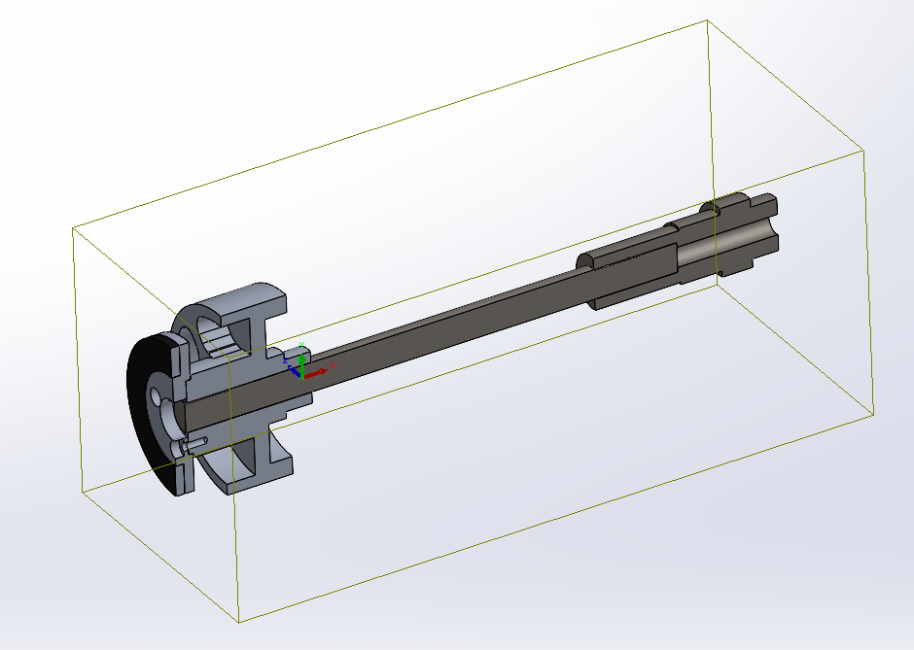

Mass properties of 골반

Configuration: 기본

Coordinate system: 좌표계2

Mass = 0.376207 kilograms

Volume = 26058.913785 cubic millimeters

Surface area = 0.017072 square meters

Center of mass: ( meters )

X = 0.000018

Y = -0.001378

Z = 0.000016

Principal axes of inertia and principal moments of inertia: ( kilograms * square meters )

Taken at the center of mass.

Ix = ( 0.000073, -1.000000, -0.000010) Px = 0.000064

Iy = (-0.655328, -0.000055, 0.755344) Py = 0.000435

Iz = (-0.755344, -0.000048, -0.655328) Pz = 0.000435

Moments of inertia: ( kilograms * square meters )

Taken at the center of mass and aligned with the output coordinate system.

Lxx = 0.000435 Lxy = 0.000000 Lxz = 0.000000

Lyx = 0.000000 Lyy = 0.000064 Lyz = 0.000000

Lzx = 0.000000 Lzy = 0.000000 Lzz = 0.000435

Moments of inertia: ( kilograms * square meters )

Taken at the output coordinate system.

Ixx = 0.000436 Ixy = 0.000000 Ixz = 0.000000

Iyx = 0.000000 Iyy = 0.000064 Iyz = 0.000000

Izx = 0.000000 Izy = 0.000000 Izz = 0.000436

One or more components have overridden mass properties:

3번축_로터_프레임<1><기본>

<Hip pitch motor rotor inertia>

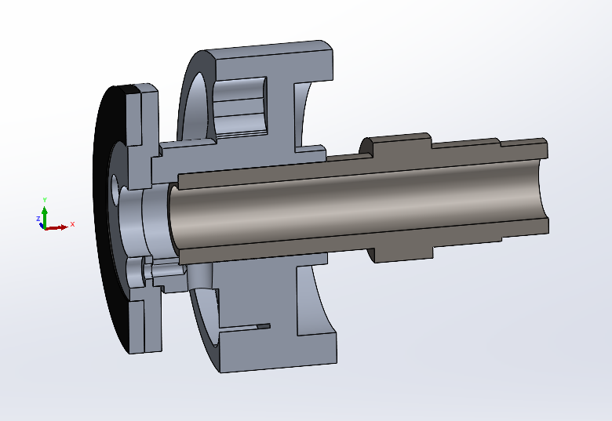

Mass properties of selected components

Coordinate system: 좌표계2

Mass = 0.338291 kilograms

Volume = 19232.712995 cubic millimeters

Surface area = 0.014915 square meters

Center of mass: ( meters )

X = 0.000002

Y = 0.027384

Z = -0.000018

Principal axes of inertia and principal moments of inertia: ( kilograms * square meters )

Taken at the center of mass.

Ix = (-0.989988, -0.000093, -0.141153) Px = 0.000057

Iy = ( 0.141152, -0.003591, -0.989981) Py = 0.000057

Iz = (-0.000415, -0.999994, 0.003568) Pz = 0.000072

Moments of inertia: ( kilograms * square meters )

Taken at the center of mass and aligned with the output coordinate system.

Lxx = 0.000057 Lxy = 0.000000 Lxz = 0.000000

Lyx = 0.000000 Lyy = 0.000072 Lyz = 0.000000

Lzx = 0.000000 Lzy = 0.000000 Lzz = 0.000057

Moments of inertia: ( kilograms * square meters )

Taken at the output coordinate system.

Ixx = 0.000311 Ixy = 0.000000 Ixz = 0.000000

Iyx = 0.000000 Iyy = 0.000072 Iyz = 0.000000

Izx = 0.000000 Izy = 0.000000 Izz = 0.000311

<Hip roll motor rotor inertia>

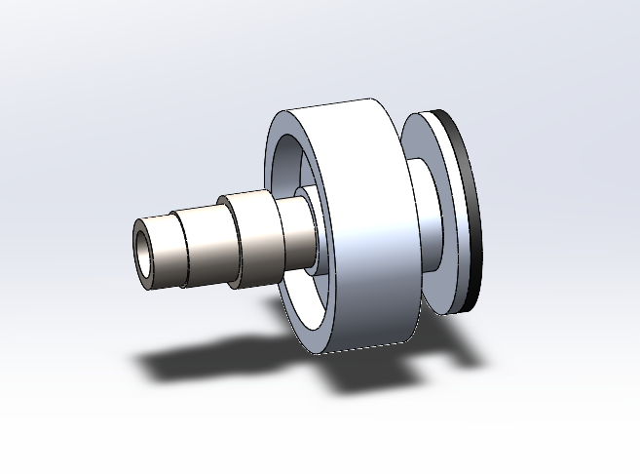

Mass properties of selected components

Coordinate system: 좌표계2

Mass = 0.338291 kilograms

Volume = 19232.712995 cubic millimeters

Surface area = 0.014915 square meters

Center of mass: ( meters )

X = -0.087566

Y = 0.000016

Z = 0.000000

Principal axes of inertia and principal moments of inertia: ( kilograms * square meters )

Taken at the center of mass.

Ix = ( 0.000112, 0.019560, 0.999809) Px = 0.000057

Iy = (-0.003184, 0.999804, -0.019560) Py = 0.000057

Iz = (-0.999995, -0.003181, 0.000174) Pz = 0.000072

Moments of inertia: ( kilograms * square meters )

Taken at the center of mass and aligned with the output coordinate system.

Lxx = 0.000072 Lxy = 0.000000 Lxz = 0.000000

Lyx = 0.000000 Lyy = 0.000057 Lyz = 0.000000

Lzx = 0.000000 Lzy = 0.000000 Lzz = 0.000057

Moments of inertia: ( kilograms * square meters )

Taken at the output coordinate system.

Ixx = 0.000072 Ixy = -0.000001 Ixz = 0.000000

Iyx = -0.000001 Iyy = 0.002651 Iyz = 0.000000

Izx = 0.000000 Izy = 0.000000 Izz = 0.002651