Written feedback on "Diskret Matematik og formelle sprog"
I have used last years course to give feedback.

1)
The 'Home page' is activity stream, which does not contain much info besides the announcements that can also be shown if the 'home page' was set to 'Front page' or 'Modules'. You can choose it in the left menu called "Choose home page"
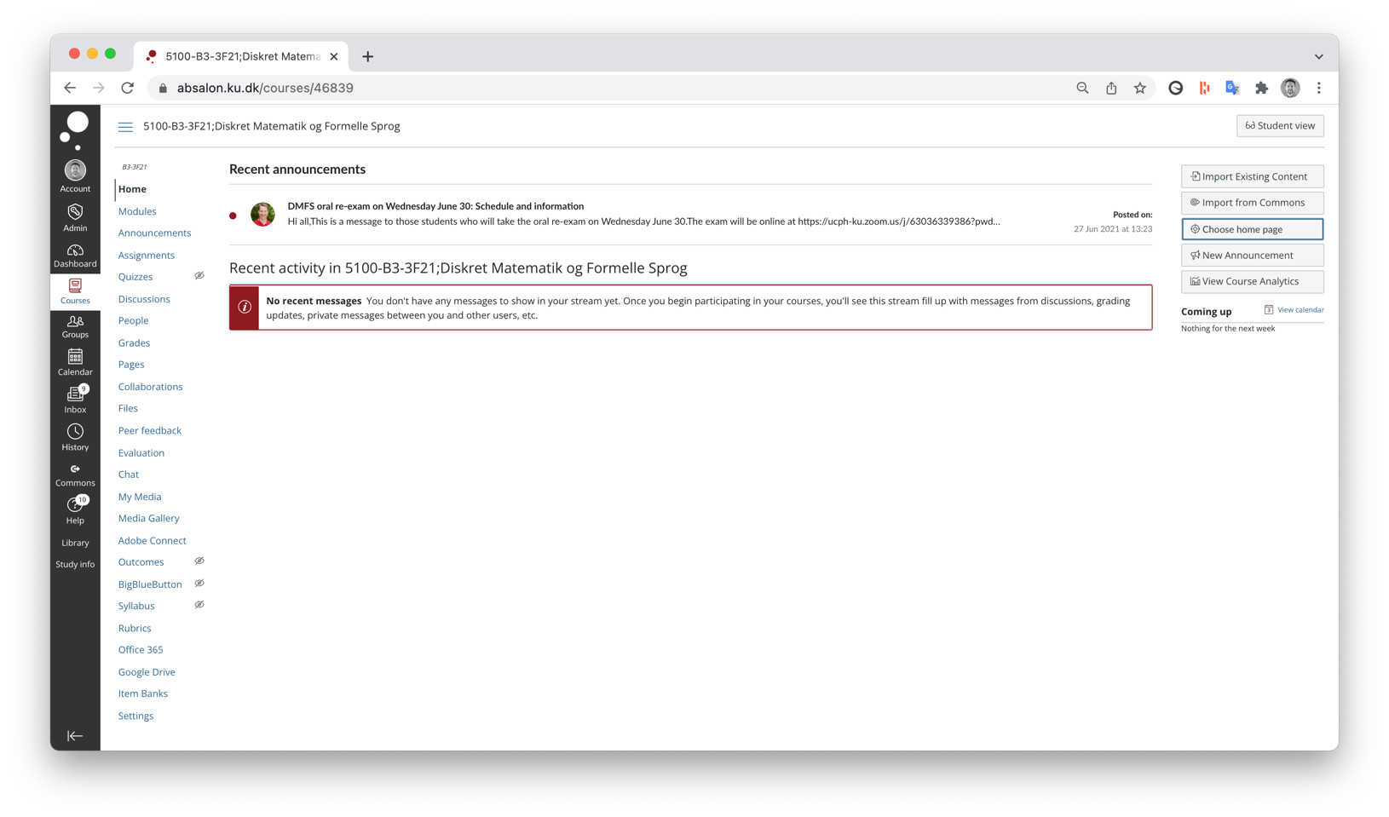

2)
Meta information about the course and teaching is important as it can make your intentions more explicit for the students, helping them understand the course better. Now this information is found in a PDF called "Course information DMFS 21" in the top module about the course (which can be a fine solution), but it could also be presented in 'front page', so the students automatically will meet it, especialley in the beginning of the course.

Relevant information:
- Structure and progression of the course (can be as simple as the schedule you have in the PDF, but it could also be a more abstract illustration of the relation between topics, especially if they build on top of each other)
- Who the teachers are (pictures, contact information and accesability is also good information)
- When what activities will happen and where (shedule as it is now)
- Forms of teaching and material (e.g. exercises and your handwritten notes), why are important/the choice and what is expected from the students.
- How you will use Absalon (assignments, Media Gallery, announcements), so they know where to look.

There is not perfect example of a front page from another course on the next page:
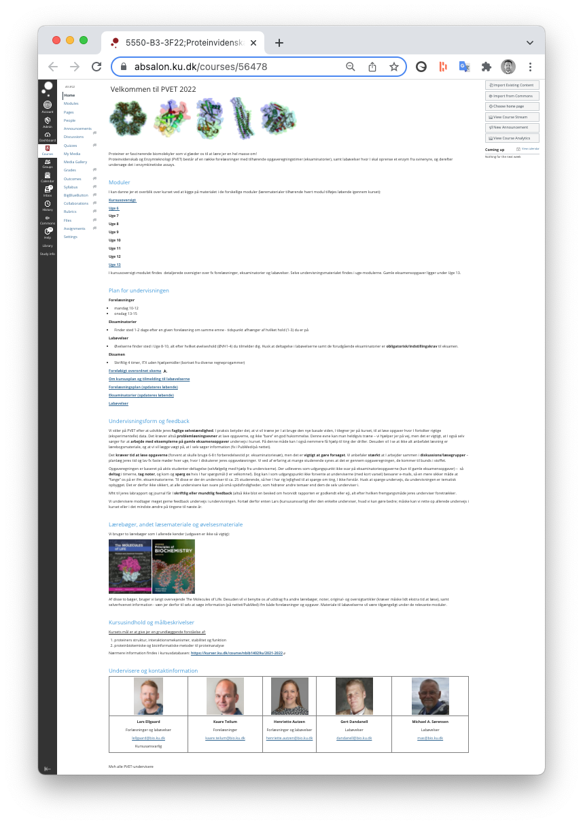

3)
The use of weeks as 'modules' is very classic and easy to follow/overview. Since there is not more content under each, it works fine without text headers which can be added to categorize different types of files.

4)
The long navigation menu should be shortened so the students do not go into exploration and confussion in unused functions. Go to Settings > Navigation and disable all the functions you do not use.

I would only keep:
- Modules
- Announcements
- Assignments
- People (if you will use it to form groups)
- Media Gallery

Other comments

I think the handwritten notes are really cool. Gives a personal and authentic feel with some insight into your way of thinking and writting about the topic. The reason why you use these could be commented in the introduction to the course as well.

