Filter Calculation

Circuit Diagram
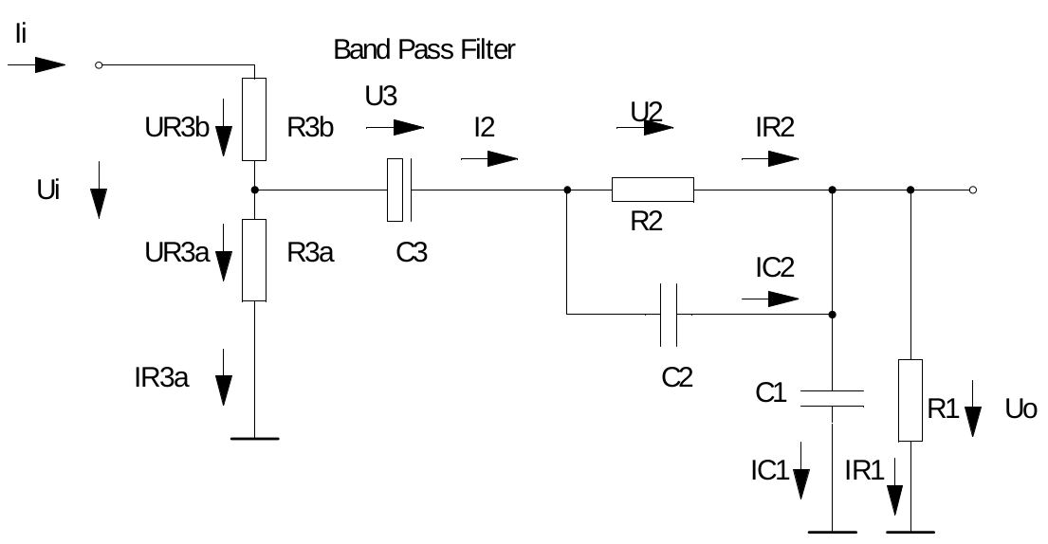
Band Pass Filter

Formulas

Boundary Conditions

Mesh Equations

Node equations

Substitution with voltages

