|  |
| --- |
| INF3190 |
| MIP DAEMON |
| Obligg 1 |

|  |
| --- |
| Jakobskr  01.03.2018 |

**MIP vs IPV4:**

MIP is a Minimal Interconnection Protocol which is a much smaller version of a normal Internet Protocol like IPV4. MIP only contains the bare minimum necessities in the header and avoids having an overhead, which makes it much smaller and therefore faster for the program to process and overall less bytes to handle, which minimizes latency and increases performance compared to IPV4. However, it lacks a lot of IPV4s functionality, like no error detection, corrections, sub netting, (error handling. And the main difference is in the size, MIP can only handle up to 256 address spaces, compared IPV4 which can handle up to 2*32 different addresses (that is a lot more). And Mip only works over ehternet.

**Runtime Graph of server and client:**

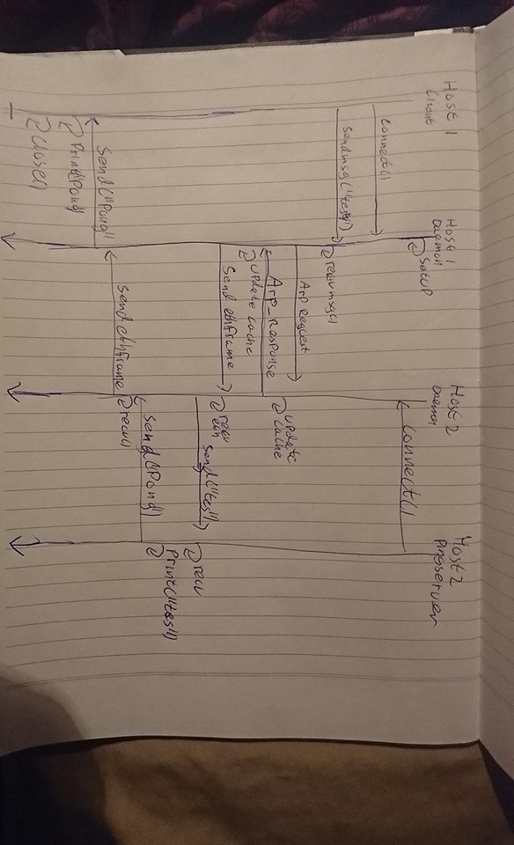

**How to run:**

The easiest way to compile is to use the supplied makefile.

make daemon

make pingc

make pings

and to run the program you can use the following commands

./daemon [-h] [-d] <socket_application> [mip_adresses]

./pings [-h] <socket_application>

./pingc [-h] <mip_destination> <message> <socket_application>

NB: mip_addresses has to be in the range of 0-255.

NB: the message length INCLUDING the terminating NULL byte has to be a multiple of 4, IE “HEL” and not “hell”

NB: the help command does not execute the programs but only prints the help.

**Program files:**

daemon.c

ping_client.c

ping_server.c

colours.h

makefile

**Closing thoughts:**

This mandatory assignment was rather hard, but after “some” work I have finally arrived at something that fulfills the requirements and works. There might be some “hacky” solutions, due to the time limitations.

NB: Memory leaks are probably abundant (didn’t manage to install Valgrind, and time limitations), and the some of the programs doesn’t have an exit feature and just run until closed by the user. And I assumed that the user is not malicious (i.e. trying to break the program intentionally) when executing the program, so I did not idiot proof everything (like testing if the mip_adress is in the given range).