

Artificial Intelligence programming IT3105

Report from Homework Module #1:
“Using the A* Algorithm to Solve Rush Hour Puzzles”

By Jakob Svennevik Notland
Fall 2017

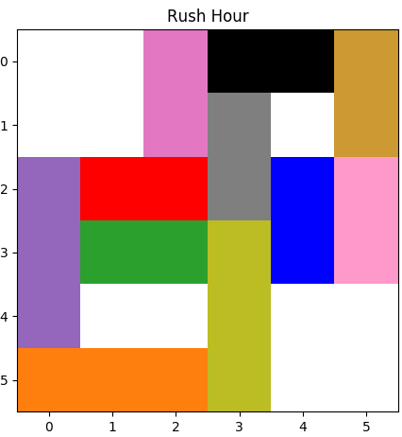
Puzzle variants
Search method | Easy-3 | Medium-1 | Hard-3 | Expert-2
Breadth-1st | 95 | 751
Depth-1st
Best-1st (A*)

