Design, implementation, and execution of the Hypothetical TimeView Machine/Pulsar and TimeView Machine/FRB surveys with the DSA-2000

…....Testing ideas……

[1] Introduction

This document is a living summary of the pulsar survey program with the DSA-2000 . The intended audience is current and potential DSA-2000 team members, and those more generally interested in working on the survey. Below I introduce basic specifications of the telescope and the planned surveys relevant to the TimeView Machine, and detail plans for implementation and operations of the latter. I also summarize the expected data products. The pulsar survey is limited to the search for periodic (with potential acceleration due to binary orbital motion) signals, and the FRB survey is limited to the search for isolated pulses with no assumptions about time-correlation. Both surveys search for signals at different dispersion measures (DMs).

[1.1] DSA-2000 reference

The TimeView Machine surveys will be executed commensally with all DSA-2000 operations, and will use compute hardware running in parallel with the Radio Camera, Pulsar Timing, and other potential pipelines.

For reference, here is a collection of useful parameters of the DSA-2000 .
Parameter | Value
Number of antennas | 1650
Dish diameter | 6.15m
Field of view | 7 deg^2 at 1.35GHz
Array size | 15km EW x 19km NS
Array configuration | Pseudo-random, designed to minimize PSF sidelobes
PSF | 3.05’’ at 1.35GHz, circular at DEC=0deg
Tsys/eta | 25-40K, elevation dependent
Array SEFD at boresight | 1.41-2.25Jy, elevation dependent
Band | 0.7-2GHz
Channelization | 10^4 x 130.2kHz
Survey tiling | 6x5 21-min pointings with approx. 2.6deg^2 unique FoV per pointing
Cadence | Galactic Plane: ~5500 deg^2 observed 2x per year, logarithmic cadence  Other: variable depth / cadence

[1.2] Specifications of the TimeView Machine/Pulsar survey

Two data-processing pipelines for pulsar searching will be implemented on the TimeView Machine hardware, enabling
- a targeted search in (nominally) 4000 beams steered towards continuum sources, and
- a blind search in (nominally) 1e6 beams that tile the central part of the DSA-2000 primary beam.

The baseline plan for the targeted pulsar search is to steer full-array beams towards continuum sources detected in early survey epochs. A few x 1e4 of sources are expected per unique survey pointing, and we anticipate that via exclusion of resolved surveys, and cross-matching with multi-wavelength surveys, we can reduce the number of candidate pulsars per pointing to ~4000. This process will likely be less efficient in regions of the Galactic Plane, where the numbers of pulsars per pointing wil exceed a few hundred. This is where the blind search, with reduced sensitivity or time-sharing, can be applied.

Fiducial parameters relevant to the pulsar searches are given below.
Parameter | Targeted search | Blind search
Number of beams | 4000 | 2e5
Channels | 2500 | 2500
Band | Approx. bottom 25% | Approx. bottom 25%
DM trials | 500 | 500
Time resolution | 0.1ms | 0.1ms
Maximum dwell time | 1260s | 60s
Period range | 1ms – 5s | 1ms – 5s
Acceleration trials | 500 | 5
Polarizations | I | I
Number of bits | 4 | 4

We do not plan to store search-mode data. Instead, all searching needs to be done in quasi-real time, on the timescale of the dwell time noted in the table above. The dwell time is bounded strongly by the memory requirements, and less strongly by the compute requirements. Typical pointings are anticipated to be around 21 min in duration.

The targeted-search beams will also be used for follow-up folding observations to confirm and time pulsar discoveries. Follow-up occurs on two timecales. First, the 6x5-pointing mosaics tiles will be observed over a ~week, with significant overlap between adjacent pointings at the bottom of the band. This enables some beams to be steered towards pulsars and pulsar candidates providing ~6 epochs over ~1 week. Second, the tiles will be repeated, at least a few times, and ~10 times in 5500 deg^2 containing the Galactic Plane and the Bulge.

The parameters given above will be extended if compute resources allow. Major extensions include the number of channels, the number of beams in the blind search, and the dwell time for the blind search. The dwell time refers to the longest-duration fully coherent search that is envisaged, including all acceleration trials. Extensions in the dwell time, and the number of channels and beams, provide S/N improvements that scale as the square root of the extension factor.

[1.3] Specifications of the TimeView Machine/FRB survey

The FRB search is commensal, conducted in real time in a large number of beams that tile the FoV.

Fiducial parameters relevant to the FRB search are given below.
Parameter | Value
Number of beams | 6e6
Channels | 2500
Band | Approx. bottom 25%
DM trials | 2000
Time resolution | 1ms
Width trials | 9 (2^0 to 2^8 samples)
Maximum DM (pc/cc) | 5000
Polarizations | I
Number of bits | 4
Max trigger latency | DM delay * 1.2

The search is expected to provide low-latency triggers upon candidate detection to enable voltage dumps. The search occurs in two stages: naïve peak-finding, followed by a clustering / correlation analysis of the peaks to identify likely candidates.

The parameters given above will be extended if compute resources allow. The number of channels is the major potential extension, potentially providing S/N improvements that scale as the square root of the number of channels. Additional width and DM trials will provide more marginal improvements.

[2] Pipeline design considerations

[2.1] Overview

Block diagrams of the pipelines are shown below in Figures 1 and 2. The pipelines begin with beamformer blocks, which in our terms also include dedispersion transforms. These are the most compute intensive stages of the pipelines, outputting time-series data for different beams / DMs, and potentially a few frequency sub-bands. In the case of the FRB search, little additional processing is required besides peak finding and clustering. The search is expected to be dynamic in the sense of the search thresholds being responsive to the detection rate. In the case of the pulsar search, time-series data need to be transformed to a periodicity basis (via, e.g., FFT, or a streaming folding algorithm) prior to searching. An iterative approach is assumed, where probabilistic choices will be made to reject datasets based on partial searches. In both pipelines, candidates trigger the preparation of output metadata based on further analysis of specific datasets from the buffered time series.
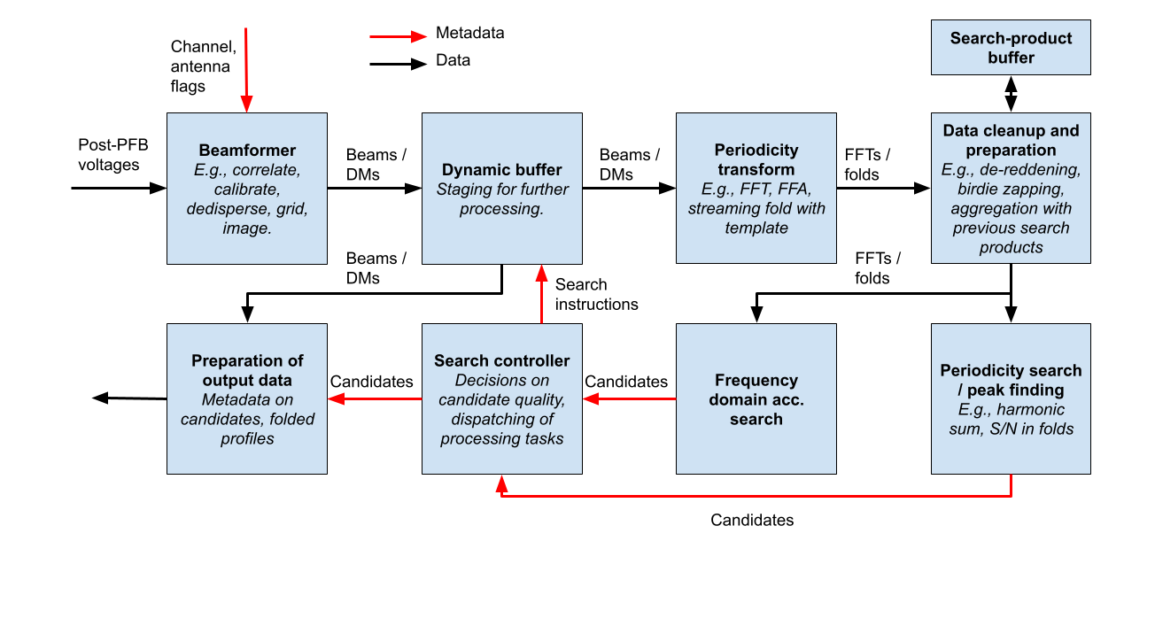
Figure 1: Outline of the TimeView Machine/Pulsar search

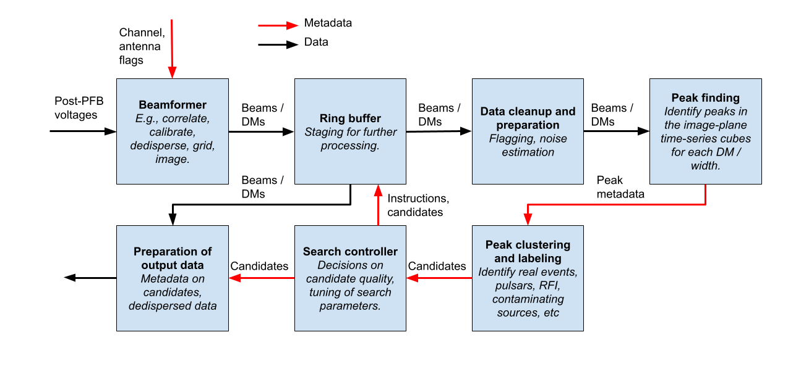
Figure 2: Outline of the TimeView Machine/FRB search
[2.2] Computational considerations for the beamformer, including dedispersion

For the targeted pulsar search, we envisage a voltage beamformer followed by dedispersion. Given input voltage data from N_{A} antennas in N_{C} channels of width F_{C}, the compute required to form N_{B} beams is approximately
R_{IN} = 16N_{A}N_{C}F_{C} bits/s, assuming 4-bit complex data
OPS = 16N_{A}N_{C}N_{B}F_{C} operations / s
R_{OUT} = 4N_{B}N_{C}/T_{samp} bits/s, assuming 4-bit intensities.

For the fiducial numbers in the tables above, we have R_{IN} = 8.6 Tb/s, OPS = 34.4 POPS, and R_{OUT} = 0.4 Tb/s. The beamforming operation is dominated by matrix multiplications with approximate dimensions M=N_{B}, K=N_{A}, and N can be tuned to be as large or as small as required.

Brute-force dedispersion, given N_{DM} DM trials and a sampling time of T_{samp}, requires approximately
OPS = 2N_{B}N_{C}N_{DM}/ T_{samp} operations / s
R_{OUT} = 16N_{B}N_{DM}/ T_{samp} bits/s, assuming 16-bit time series.

For the fiducial numbers in the tables above, we have OPS = 100 TOPS and R_{OUT} = 0.32 Tb/s. With a data preparation step that involves FFT-ing each time-series in each channel and beam (a relatively small compute load), the dedispersion can be entirely done via matrix operations, followed by a relatively small output step where inverse-FFTs are applied.

Forming a significantly larger number of beams via voltage beamforming is not feasible, given the already high compute costs that scale as N_{B}. Thus visibility-based beamforming is required. The compute is approximately
OPS = 8(N_{A}+1)N_{A}N_{C}F_{C} + 16N_{B}log₂(N_{B})N_{C}/T_{samp} operations / s
with input and output data rates calculated as before. For fiducial numbers this is around 13 POPS, and R_{OUT} = 60 Tb/s. The operations are dominated by matrix multiplications with approximate dimensions M=N_{A}, K>=256, and N=N_{A}.

Compute costs for dedispersion are also similar feasible. However, the memory requirements for dedispersion are significant. The DM delay is given by
T_{DM} = 4.15 * DM * (F_{1,GHz}⁻² – F_{2,GHz}⁻²) ms.
For a kernel to compute a single time sample at each DM, an amount of data totaling T_{DM} in time must be buffered at either the input or the output. Considering the FRB search, and assuming 2500 channels above 0.8GHz are used, T_{DM} = 16s. Given the output data rate of the beamformer, which would not change significantly post dedispersion, this corresponds to 120 TB. Some minor compromises could be made to make this feasible, for example, shifting the lower frequency to 1 GHz, or lowering the number of beams. If this were done, and brute-force dedispersion were applied, something like 60 POPS would be required. A Fourier domain approach could again be used, enabling matrix operations.

However, it is also possible to further integrate the beamforming and dedispersion steps to save memory if required, but at the expense of compute. In this scenario, the input voltages are buffered for a length >=T_{DM}, and are brute-force dedispersed with no frequency summation into N_{CDM} coarse DM trials spanning the full DM range of interest. The beamforming is then duplicated N_{CDM} times, but frequency summation by a factor of N_{CDM} is possible in the gridding step prior to beamforming. The value of K in the matrix multiplications is, for example, increased by N_{CDM}. Post-beamforming, fine dedispersion is done for each of the coarse DM trials.

[2.3] Computational considerations for pulsar searching

Real-time pulsar searching can be a major sink of computational resources, including memory. Pulsar searching involves transforming input time-series into a basis that separates signals of different periodicities. In practise, pulsar searching usually involves the Fourier analysis of data spanning an entire observation. The total data volume for an observation would be
D_{PSR} = N_{B}N_{DM}T_{OBS}/ T_{samp} bytes, assuming 8-bit data
For the fiducial numbers in the tables above, including T_{OBS} = 21min, D_{PSR} = 25.2TB (targeted search), and D_{PSR} = 6.3PB (blind search). A factor of two greater memory is likely required for processing.

Some savings can be realized. For example, the overlap-add method can be used to combine DFTs of time-chunks. For example, given the period range of interest, all frequency information is contained within 10s of data. The compute costs are
OPS = 5N_{ACC}N_{B}N_{DM}/ T_{samp} * log₂(T_{OBS}/T_{samp})
R_{IO} = 3N_{ACC}N_{B}N_{DM}/ T_{samp} bytes/s, assuming out of place FFT
Considering T_{OBS} = 10s, we have OPS = 850 TOPS and R_{IO} = 30 TB/s (targeted search), and OPS = 2.1 POPS and R_{IO} = 75 TB/s (blind search).

Folding operations, with computational complexity O(N_{samp}N_{candidates}), will be applied where possible to maximize S/N. For example, once candidate periodicities are identified using a part of the data, the remainder of the data can be folded on these periods. After an observation, the data will anyway need to be folded on all candidate periodicities. We also intend to investigate full Keplerian template searches, which involve convolution operations.

[4] Implementation plans

A vast body of software exists that performs all functionality incorporated within the TimeView Machine. For example, tensor-core implementations exist for both the voltage-beamforming and correlation steps. Various high-performance FFT libraries exist, including cuFFT/cuFFTDx, vkFFT, and tcFFT. Dedispersion on GPUs is well-developed, e.g., in the dedisp and AstroAccelerate libraries, with well-understood performance. Moderate-performance FRB and pulsar search codes exist.

However, it is unlikely that existing codes meet our performance requirements within a reasonable hardware cap. We have thus embarked on a process to implement an integrated pipeline within the framework of the quda package, which offers several advantages in terms of e.g., memory-management, auto-tuning, and integration of kernels. The development is focused at present on the beamforming and dedispersion steps, which dominate the compute. In parallel, to enable the testing of assumptions regarding performance of target hardware architectures, we have embarked on the creation of a benchmarking package, described below in Section [7].

The target hardware for the TimeView Machine is two Vera Rubin NVL144 racks (see Figure 3 below). Each rack includes 18 trays of compute, fully connected via NVLink. Each tray contains two Vera CPUs, and two packages of four Rubin GPU dies each. Each GPU has 144GB of HBM4 memory, and each CPU has 1.5TB of likely LPDDR6X memory, addressible on the GPU via NVLink-C2C. Interconnect between racks via CX9 is possible at up to 28.8TB/s, which is also the data ingest rate. Based on the existing Grace Blackwell NVL72 systems, each rack is likely to have 144 NVMe drives, which can be, e.g., 8TB each with 1-3 DWPD, providing a PB of storage per rack.

Anticipated performance specifications of the Vera Rubin NVL144 racks, pieced together from online information and using the existing Grace Blackwell GB200 NVL72 racks as a reference, are given below.
Parameter | Rubin GPU | NVL144 rack
FP4 FLOPS (tensor) | 25 PFLOPS | 3.6 EFLOPS
FP8 FLOPS (tensor | 8.33 PFLOPS | 1.2 EFLOPS
FP16 FLOPS (tensor) | 4.17 PFLOPS | 600 PFLOPS
FP32 FLOPS (CUDA cores) | >80 TFLOPS | 11.5 PFLOPS
HBM (TB) | 0.144 | 20.736
HBM bandwidth (TB/s) | 13 | 13
LPDDR6X memory (TB) | 0.375 | 54
LPDDR6X bandwidth (TB/s) | ~1 | ~1
NVLink bandwidth (TB/s) | 1.8 | 260
NVMe storage (TB) | 8 | 1152
Data ingest rate (Tb/s) | 1.024 (PCIe 6x) | 230.4 (to CPUs)

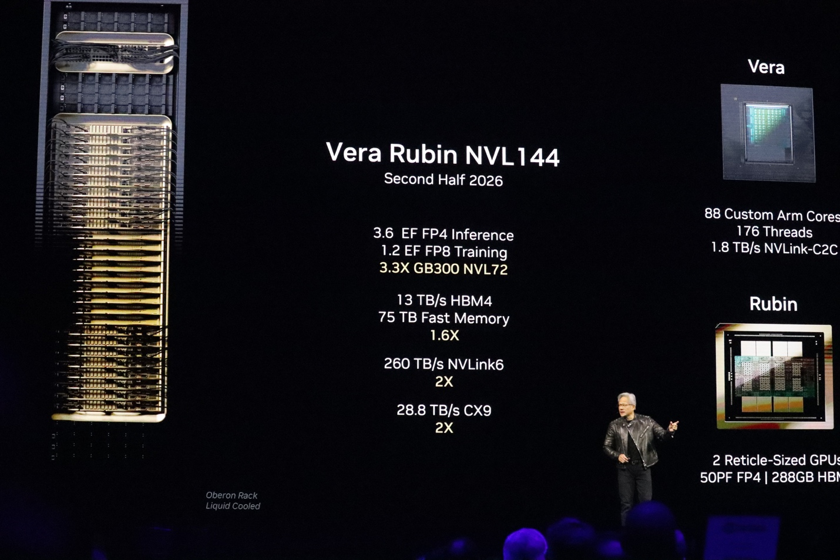
Figure 3: Highest-level anticipated specs of the Vera Rubin NVL144 rack.

[5] Data products

The TimeView Machine surveys will produce data products on the cadence of candidate output. These will be metered based on intelligence within the search systems (the Search Controllers in Figures 1 and 2).

Each FRB candidate will trigger the storage of the following:
- FP16 intensity data for 64 nearby beams at the time of detection, assuming 4 frequency sub-bands, and 4s post-dedispersion: 2MB. After additional processing, this can be reduced by 64x to 32kB.
- 4-bit voltage data for 16 beams formed around each FRB, assuming full-band data, 4s post-dedispersion, full-pol: 334GB. After additional processing, this can be reduced by 16x to 21GB. These data will only be stored for real FRBs, as determined by this processing.
- Pipeline metadata, including lowest-level candidate detections for a few s surrounding each event.

Each pulsar candidate will trigger the storage of the following:
- Dedispersed intensity data for the detection beam, assuming 4 frequency sub-bands, 2160s, and 4-bit data: 43.2 MB
- Pipeline metadata, including summary of candidates detected during a pointing.

Each time a pulsar is timed with the TimeView Machine, the following data will be stored.
- A Stokes I folded profile in 500 channels and 512 phase bins, assuming 4-byte data and 10s subints: 110MB.

We anticipate metering the output of the TimeView Machine as follows, resulting in the given data volumes.
- 1 FRB candidate and single pulse from unknown pulsar per 4s on average, with long-term storage of intensity data only: 1.26TB total
- 1 real FRB per 600s, with long-term storage of intensity and voltage data: 5.52PB total
- Up to 100 pulsar candidates per pointing on average, for future follow-up: 332TB total, assuming 6x12801 pointings.
- Up to 100 pulsars timed per pointing on average: 768TB total, assuming 6x12801 pointings.

No significant processing of these data is anticipated within the DAT subsystem, besides the minor editing of headers with additional observation metadata.

[6] Survey execution

Day to day survey operations can be broken down into understanding what is required on a per-pointing basis. Each pointing will require the TimeView Machine to be automatically configured according to the location in the sky, and the progress of the survey. The data products will largely be automatically analyzed and archived, but the results will feed forward into the future operations in a variety of ways.

The remainder of this section Is a WIP.

[7] Appendix – limited benchmark plan

Purpose

- To test basic assumptions regarding performance scaling in the TimeView Machine
- To deliver a simple, easily installable package that we can share with others to run benchmarking on different hardware
- To familiarize ourselves and others with some major TimeView Machine operations

The code will be written specifically with Nvidia superchip architectures in mind, with coherent CPU and GPU memory.

[7.1] Visibility-based beamforming and dedispersion

Given input complex voltage data of shape [Frequency, Time, Antenna], with N_F frequencies, N_T times, and N_A antennas, the following operations are performed:
- Weight application. Apply frequency-dependent weights via Hadamard product to input complex voltage data. The weighs will have shape [Frequency, Antenna].
- Coarse dedispersion. For N_CD coarse DM trials out to DM_MAX, do a brute-force dedispersion operation to generate an array of shape [Coarse DMs, Coarse frequency, Coarse Time, Fine frequency, Fine time, Antenna]. The number of coarse frequencies is N_CF = N_F / N_CD, and the number of fine frequencies is N_CD. The number of fine times is, e.g., N_FT = 128. The number of coarse times is low: N_CT = N_T / N_CD / N_FT.
- Matrix multiplication. Next, each sub-array of [Fine frequency * Fine time, Antenna] is multiplied by its hermitian transpose with m=N_A, n=N_A, k=N_FT*N_CD, such that we end up with an array of shape [Coarse DMs, Coarse frequency, Coarse Time, Baseline]. The matrix multiplication can be implemented efficiently with, e.g., the CUTLASS HERK operation.
- Fine dedispersion. Here, we can apply a simple brute-force approach (e.g., see https://iopscience.iop.org/article/10.3847/1538-4365/acfef6#apjsacfef6s4) as a starting point to calculate the full range of DM trials. In each case, the accumulator must be a uniform UV grid, not the baseline array. This can be accomplished with a lookup table of grid indices of shape [Coarse frequency, Baseline]. The output array will then be [DMs, Coarse Time, Grid cell].
- Imaging. Finally, each grid will be subject to a 2D FFT to form beams, such that the output array will be [DMs, Coarse Time, Beams].

Each step can be benchmarked independently. In practise, some concurrency is likely achievable, especially between operations that are memory-access intensive like dedispersion, and more compute intensive, like matrix multiplication.

Reasonable numbers include:
N_F = 2048
N_T = 1e7
N_A = 1650
At 8-bit complex, this will use 33792GB of memory for the inputs to steps [1] and [2], which is not reasonable for benchmarking. I suggest benchmarking step [1] as a straightforward parallel Hadamard product on the CPU in a reasonably large (e.g., ~20GB) input array, with similar ratios between N_F : N_T : N_A as the real data. You can assume FP16 input and FP16 weights for this initial test.

Step [2] is best benchmarked on a per-antenna basis. I suggest using the CPU (via a multi-threaded implementation) to operate on data of dimensions [N_F, N_T] for each antenna sequentially to populate a GPU-memory array of shape [Coarse DMs, Coarse frequency, Fine frequency, Fine time, Antenna] (dimensions [N_CD, N_CF, N_CD, N_FT, N_A]). This will test memory access speeds, and the resulting timing can be scaled to multi-CPU systems. Reasonable numbers:
N_CD = 16
N_CF = N_F / N_CD = 128
N_FT = 128
For the dedispersion, consider uniformly spaced DM trials in the range [0,5000) pc/cc, with channel frequencies given in MHz by array(2048)*0.1302+F_LO, where a good starting point for F_LO is 700MHz. Consider time sampling of 1/0.1302MHz = 7.68us. Given that this operation simply involves moving data around, I suggest moving vectors with lengths that assume 8-bit depths for the voltage data.

The matrix multiplication in step [3] can be done from/to GPU HBM, via a strided batched CUTLASS HERK operating on FP8 data. Again, appropriate scaling can be applied to the timing results. The data can be output in FP16.

Step [4] in principle operates on a very large array, and benchmarks must therefore be split up. It’s likely best to consider a single coarse DM, and use something like 2e4 baselines. Using N_CT = 5000 would be appropriate. The data can be assumed to be FP8 on the input, accumulated to FP16 in the dedispersed grids.

Finally, step [5] represents a straightforward set of 2D FFTs. I suggest assuming FP16 complex data, and performing complex-to-real FFTs. Batching is likely preferred. I suggest comparing cuFFT and tcFFT with identical plans.

The above can be run with different input parameters to benchmark visibility-based beamforming and dedispersion for the full-field pulsar- and FRB-search cases. It would be interesting to look at various scalings, e.g., with N_CD, and N_FT, as well as with N_F and F_LO.

[7.2] Voltage beamforming

The dominant step here is the brute-force multiplications needed to perform the voltage-based beamforming. These are only feasible if tensor cores are used. I suggest benchmarking voltage-based beamforming assuming FP16 complex input data, using a simple configuration passed to CUTLASS strided batched GEMMs, e.g., data of shape [Frequency, Coarse time, Fine time, Antenna] where the sub-matrices [Fine time, Antenna] of shape [16, 2048] (m=2048, k=16) are multiplied by weights matrices of shape [Weights, Fine time] (n=4000, k=16). It’s likely best to assume that the weights matrix is also strided, rather than doing something fancier. This is possible in the case where we need to steer the beams as a function of time. I would try a reasonable N_F and N_CT such that the input data size is a few tens of GB.

Then, I think it is worth giving the same problem to the TCBF wrapper around ccglib, and do a comparative benchmark.

[7.3] Pulsar searching

At this initial stage, the most important benchmarks for pulsar searching are the FFTs. This will give us an idea of the urgency of exploring more exotic techniques. We want to benchmark the performance of 1D real to complex FFTs of lengths between 2^18 and 2^24 points. We want to consider batched FFTs with total data lengths of a few tens of GB (essentially using much of the HBM on a given superchip). For example, for 2^20-point FFTs, the number of FFTs in the batch would be ~1e4.

We should try three libraries at this stage: cuFFT, tcFFT, and nvpl. The first two can operate on FP16 data, but nvpl (which operates on CPUs) requires FP32 data. We should determine the performance vs FFT length for these large-batch cases, and compare to expectations for the architecture.

A TimeView Machine is an instrument designed to measure very short time intervals with high precision. In science fiction, a TimeView Machine is typically portrayed as a device that can observe events across time - essentially a "time viewer" that allows you to see into the past or future without physically traveling there.
In practise, around 35% of this data actually need be buffered, given the DM curve.
https://arxiv.org/abs/2505.03269
https://www.aanda.org/articles/aa/full_html/2021/12/aa41896-21/aa41896-21.html
https://github.com/svlugt/dedisp
https://github.com/AstroAccelerateOrg/astro-accelerate
https://github.com/lattice/quda
https://www.storagenewsletter.com/2024/10/23/wd-pcie-gen5-dc-sn861-e-1s-enterprise-class-nvme-ssds-certified/

