|  |  |  |
| --- | --- | --- |
|  | **Tasks** | **Preliminary links/notes** |
| 1 | Add soil type layer to the US map | https://www.arcgis.com/home/item.html?id=0edea1c7bbb84ba5842d20483af11679 |
|  | rasterized across US using values 0-2 assigned to each of the soil types | numeric values will be determined and assigned based on ongoing research |
| 2 | plant hardiness layer to the map | http://planthardiness.ars.usda.gov/PHZMWeb/ |
|  | plant hardiness zones will be correlated to turf types for the outputs into the GUI | http://www.planthardiness.gc.ca/ |
| 3 | Add the Cultivar plant factor and the soil factors to the water calculator | TWCA will correlate plant hardiness to turf types once we know the values going into the map |
| 4 | Create a GUI similar to the one pictured below | The final math for this is: ((Pr*60)/R)*((ET*Kc*Cpf*Sf)-Pe) | Pr= precipitation runtime, R = number of run events /week, ET= Reference ET, Kc= crop coefficient, Cpf= Cultivar plant factor, Sf= soil factor, Pe= 40% of Weekly rainfall). |
| 5 | have the same geolocator that triggers ET and the rainfall API also suggest, based on the soil layer a Soil Factor (Sf), and based on the hardiness zones layer a crop coefficient (Kc) and Cultivar plant factor (Cpf) |
| 6 | add ET for Canada |  |
|  | Rasterized for complete coverage | http://www.iwmi.cgiar.org/resources/world-water-and-climate-atlas/ |
| 7 | add a soil layer for Canada |  |
|  | rasterize across Canada using values 0-2 assigned to each of the soil types | http://www.soilsofcanada.ca/index.php |
| 8 | "Green level" on the GUI dial will correlate to the Maintenance levels on the current tool |  |
|  | "Watering Level" on dial |  |

# Add soil type layer to the US map rasterized across US using values 0-2 assigned to each of the soil types numeric values will be determined and assigned based on ongoing research

We need to find the raw data rather than the wen map services.

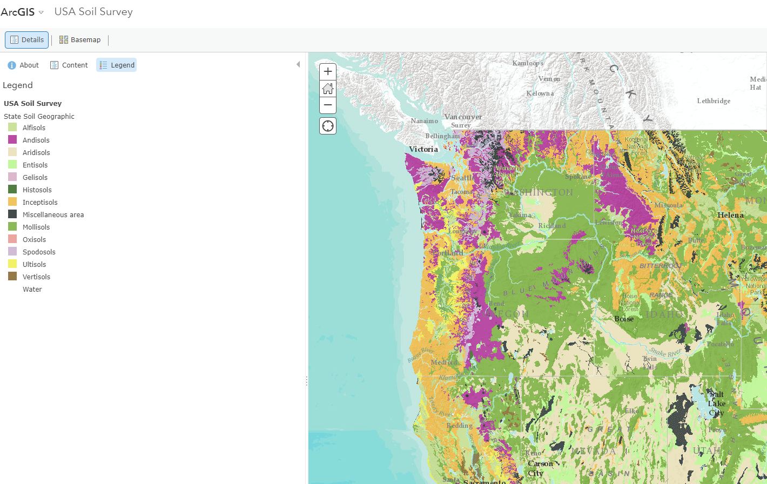

# plant hardiness **layer** to the map.

# plant hardiness zones will be correlated to turf types for the outputs into the GUI.

<http://planthardiness.ars.usda.gov/PHZMWeb/>

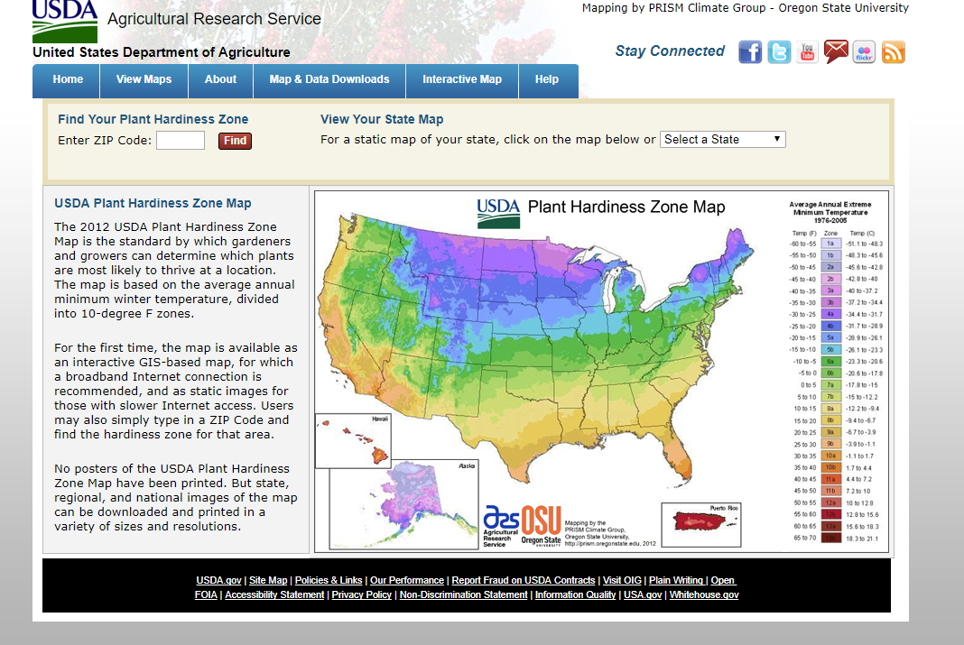

This link goes to a static map, maybe we can download the data from the link.

# Add the Cultivar plant factor and the soil factors to the water calculator . TWCA will correlate plant hardiness to turf types once we know the values going into the map

3.1 Where can we find these two factors? I assume the soil type facto can be got from the soil type.

3.2 Culivar

# Create a GUI similar to the one pictured below

Doable, should be supported by javascript.

# have the same geolocator that triggers ET and the rainfall API also suggest, based on the soil layer a Soil Factor (Sf), and based on the hardiness zones layer a crop coefficient (Kc) and Cultivar plant factor (Cpf)

Excuse for my ignorance, what does ET stand for?

The algorithm is doable.

# add ET for Canada Rasterized for complete coverage

A ET result will be calculated for each location.

# add a soil layer for Canada rasterize across Canada using values 0-2 assigned to each of the soil types

http://www.soilsofcanada.ca/index.php

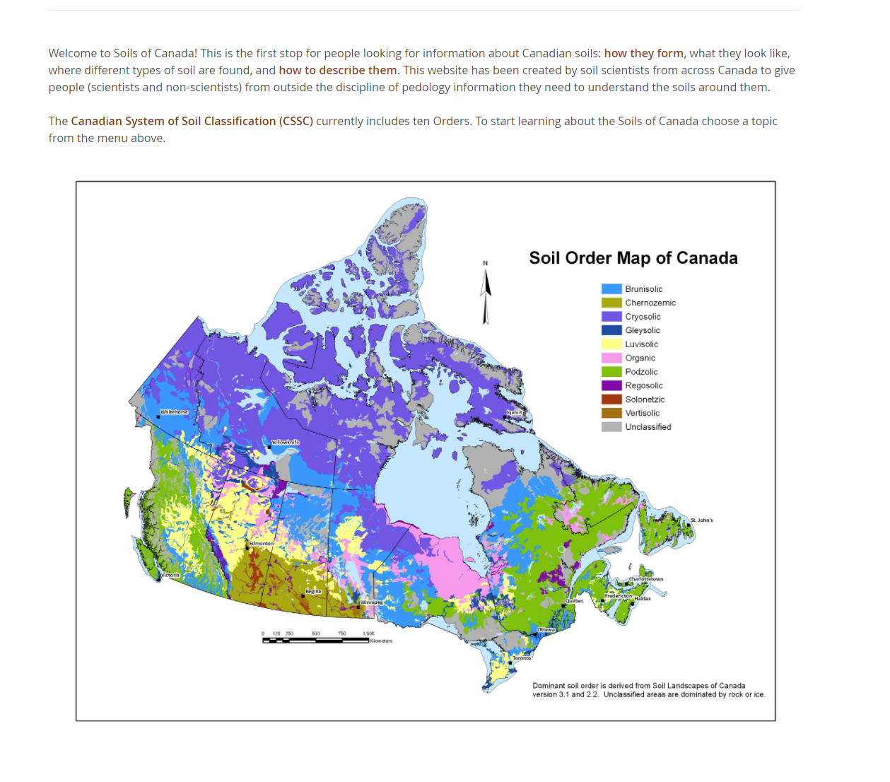

# "Green level" on the GUI dial will correlate to the Maintenance levels on the current tool

Doable.