Initial concept

I defined the information I would like to have in order to find a book in my library.

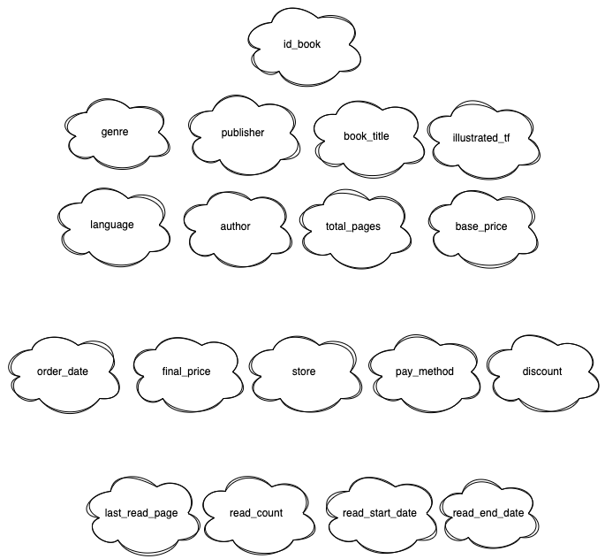

The Entity-Relationship Model
Defined the criteria to look up the book based on the price and purchase information:

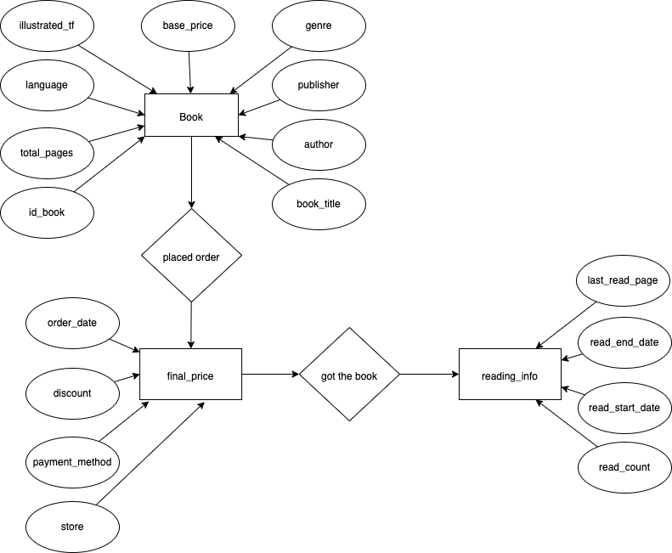

The Unified Modeling Language (UML)
