Stuff to do:

* Add the calories column.
* The free text query is implemented on the instructions of meals\drinks. Maybe We need to combine them to 1 table? (when will this be not good?)
* Yuval bad: make sure the columns in “cocktails_ingredients” and “meal_ingredients” and foreign keys of the other tables we taken them from.
* Do indexes. Atleast 7 (for each query)
* Website – go over and change text stuff ( jakov)

1. Main screen query names..

* After text is changed in website, change it on the user-manual accordingly

**UI bugs:**

* when you press a food type, after scrolling foods, it does nothing.
* Looking at a drink result, there is a “the drink ingredients” with no ingredients…
* Free text query: when looking for foods, there isn’t any info… and It says “drink name” etc…. not good.
* Free-text sometimes have no “back” button..



* “easy to make drinks and meals by category” : change the ‘500’ to the real number according to the SQL schema

Software Documentation

*EER DIAGRAM:*

Complex Queries:

1. קלט: מס' קלוריות מינימלי, מס' קלוריות מקסימלי, משקה אלכוהולי (כן/לא)

מחזיר רשימה של זוגות – (מאכל, קוקטייל) שסכום הקלוריות של המרכיבים שלהם הוא בrange של הקלוריות שהוגדר ושהמשקה הוא אלכוהולי (כן\לא לפי הInput)

1. קלט: רשימת קטגוריות, סוג כוס, אלכוהולי/לא אלכוהולי

מחזיר כמה קוקטיילים מוגשים ע"י סוג הכוס הנ"ל ושהם גם אלכוהוליים/לא אלכוהוליים, לכל אחת מהקטגוריות שניתנו ברשימה בסדר עולה.

1. קלט: שני מספרים שלמים – X , Y

מחזיר את כל המרכיבים שמשתתפים בלפחות X משקאות שונים שבהם (במשקאות האלה) יש לפחות Y מרכיבים שונים.

1. קלט: --

מחזיר את סוג הכוס שמשתמשים בה הכי הרבה במשקאות לא אלכוהוליים וגם יש משקה אלכוהולי שמכינים אותה באותה הכוס.

1. קלט: רשימת קטגוריות

מחזיר את הקטגוריות לפי מספר המרכיבים הממוצע שיש בכל משקה בקטגוריה. (מוצג מהגדול לקטן)

1. קלט: קטגוריה(אוכל) , קטגוריה(משקה)

מחזיר זוגות של (מאכל,משקה) כך שהמאכלים מקטגוריית אוכל מסוימת וקל להכין אותם, ובנוסף את כל המשקאות מקטגוריה מסוימת שקל להכין אותם (קל להכין = האורך של הinstruction שלהם קטן מ50 אותיות)

שמות, לינקים לתמונות

1. קלט: full text search

כל הקוקטיילים והארוחות שמכילים את המילים X בהוראות הכנה שלהם מסודרים בסדר יורד לפי מספר הקלוריות שלהם ולאחר מכן לפי כמה קל להכין אותם, כמו כן המשקאות מופיעים לפני הארוחות ללא קשר למיון (full text search)

ערך חזרה שם תמונה ומספר הקלוריות

1. קלט: מספר X

מחזיר את כל הזוגות של (קוקטייל, ארוחה) שיש בהם לפחות X מרכיבים משותפים.

# DATABASE STRUCTURE AND DESIGN PROCESS

We based our idea on [TheCocktailDB](https://www.thecocktaildb.com/) , which led us to several database design decisions.

It was clear to us that we needed separate tables for Drinks, Meals and Ingredients as the API contained each drink\meal with several ingredients which had lots of duplicates. The initial idea started with the concept of having a website where you can find a desirable cocktail which is suitable for you in terms of calories, favorite glass type, alcohol preferences and more. After a consultation with Amit (who’s probably the one reading this), we worked on adding another API integration (due to not having enough data and the need to create a more complex idea\ query-base).

**\*\*** In the conversation with Amit, we were told we can continue with our plan and not reach 10k unique records.

We decided to add meals into our concept. The idea was that a person can look for his desirable cocktail and together pair a meal that satisfies his\her preferences. Meals were taken from [TheMealDB](https://www.themealdb.com/).

An additional integration process was the addition of “Calories”. This wasn’t present in the API, and therefore we contemplated regarding adding this manually. The API only contained the ingredients for every drink, and the measurement of this ingredient. We integrated them both in a calories column.

Few more steps in out design process inducted:

1. When deciding where to store data regarding the Drinks\Meal Ingredients , we contemplated storing the data in a separate table. The pros of this approach are to keep the database consistent, and to enable easy and simple updates, inserts or deletions of the ingredients in our database. Once we decided on our queries, we realized that an index on the ingredients could speed up the query execution time, which wasn’t possible when the ingredients were contained in the other tables.

Also, we decided that keeping the ingredients of the meals and drinks together, can avoid duplicates in ingredients

1. It was clear to us that when searching for food and drinks, most people consider calorie intake. This feature was not originally based in the API we used, so when building our DB, we used the [open food facts](https://world.openfoodfacts.org/) DB to add a calories column into our ingredients table. TODO: add this..
2. We had a difference of opinions regarding storing our drinks and meals in the same table. In the end, we decided to create separate tables for them. The reason for that is to enable simpler updates, inserts and deletion. In addition, we were able to easily fetch pairs of meals and drinks that go together in various scenarios that are used in our queries and display them together in the user interface.
3. We tried our best using column types while giving minimal int\string lengths to our fields. Some examples are:

* URL’s having 2083 characters max (As the maximum length of internet URLs)
* Any description columns having no more than 5k characters.
* Ingredient’s calories are 5-digit unsigned ints.

1. To keep the database consistent and less sparse, we decided on taking the meal categories from the [TheMealDB](https://www.themealdb.com/) and create a table featuring these categories with their images and description from the API. This mainly let us constrain all of the food categories for present and future inserted meals to have only certain categories that present a wide food concept. We thought this would make the interface less overwhelming to a standard user.
2. We wanted to use full-text search on the instructions of drinks and meals. We contemplated whether we should add an instruction column to each table. When looking into this option, we decided that the column is relatively large and it might be better to use it from a different table, which would be indexed accordingly with a full-text index. It is important to note that the drinks data is relatively large. The fact that the instructions are in a separate table speeds up any of the queries that involve looking for drinks\meals without the need of instructions (which is how our queries turned up to be). Also, the index regarding the instructions doesn’t have to save any info other then the related cocktail_id, which is saving space on the disk.

# TABLES

## drinks table

The drinks table lists information regarding all of the cocktails and alcoholic drinks.

The drinks table is referred to by a foreign key in the drinks_instructions and cocktails_ingredients tables.

Columns

* id: A surrogate primary key used to uniquely identify each drink in the table.
* name: The drink’s name.
* category: The name of the drink’s category.
* iba: An IBA official cocktail is one of many cocktails selected by the International Bartenders Association
* Is_alcoholic: indicates if the drink is alcoholic \ non-alcoholic or could be both.
* glass_type: the glass type that the drink is being served at
* drink_img_url: url for the image of the drink
* instructions: regarding how to make this cocktail

|  |  |  |  |  |  |  |
| --- | --- | --- | --- | --- | --- | --- |
|  |  |  | Columns |  |  |  |
| Column Name | Data Type | Not NULL | Unique | Unsigned | Auto Increment | Default |
| id | INT(5) | V | - | - | - | - |
| name | VARCHAR(100) | V | - | - | - | - |
| category | VARCHAR(50) | V | - | - | - | - |
| iba | VARCHAR(50) | - | - | - | - | NULL |
| is_alcoholic | VARCHAR(50) | V | - | - | - | - |
| Glass_type | VARCHAR(50) | V | - | - | - | - |
| drink_img_url | VARCHAR(2083) | - | - | - | - | NULL |
| Instructions | VARCHAR(2083) | V | - | - | - | - |

|  |  |  |  |
| --- | --- | --- | --- |
|  |  | Columns |  |
| Column Name | Index Name | Type | Index Column |
| id | Primary | Primary | id |
| name | VARCHAR(100) | V | - |
| category | VARCHAR(50) | V | - |
| iba | VARCHAR(50) | - | - |
| is_alcoholic | VARCHAR(50) | V | - |
| Glass_type | VARCHAR(50) | V | - |
| drink_img_url | VARCHAR(2083) | - | - |
| Instructions | VARCHAR(2083) | V | - |

Indexes

Index

Name

Type

Index Column

PRIMARY

PRIMARY

id

INDEX

INDEX

## cocktails_ingredients Table

The cocktails_ingredients table contains all pairs of cocktails and their related ingredients, with the measurement of that ingredient.

The cocktails_ingredients refers to the drinks and ingredients tables using a foreign key.

Columns

* cocktail_id: a primary key used to uniquely identify each id from the drinks table
* Ingredient_name: a primary key used to uniquely identify each name from the ingredients table
* measure: How much of that ingredient should be put

|  |  |  |  |  |  |  |
| --- | --- | --- | --- | --- | --- | --- |
|  |  |  | Columns |  |  |  |
| Column Name | Data Type | Not NULL | Unique | Unsigned | Auto Increment | Default |
| cocktail_id | INT(5) | V | - | - | - | - |
| Ingredient_name | VARCHAR(50) | V | - | - | - | - |
| measure | VARCHAR(50) | - | - | - | - | NULL |

|  |  |  |  |  |
| --- | --- | --- | --- | --- |
|  |  | Indexes |  |  |
| Index Name |  | Type |  | Index Column |
| PRIMARY |  | PRIMARY |  | cocktail_id, Ingredient_name |
|  |  | INDEX |  |  |
|  |  | INDEX |  |  |

|  |  |  |  |
| --- | --- | --- | --- |
|  | Foreign Keys |  |  |
| Foreign Key Name | Refers to | On Update | On Delete |
| cocktail_id | drinks. id | CASCADE | RESTRICT |
| ingredient_name | Ingredient. ingredient_name |  |  |

## food_categories Table

The food_categories table lists all the possible categories for the meals table’s entries.

The food_categories table is referred to by a foreign key in the Meals table.

Columns

* id: A surrogate primary key used to uniquely identify each album in the table.
* name: The album’s title.
* category_img_link: A foreign key identifying the artist which released the album.
* description: The release year of the album.

|  |  |  |  |  |  |  |
| --- | --- | --- | --- | --- | --- | --- |
|  |  |  | Columns |  |  |  |
| Column Name | Data Type | Not NULL | Unique | Unsigned | Auto Increment | Default |
| id | INT(3) | V | - | V | V | - |
| name | VARCHAR(100) | V | - | - | - | - |
| category_img_link | SMALLINT(2083) | - | - | V | - | NULL |
| description | YEAR(5083) | - | - | - | - | NULL |

|  |  |  |  |  |
| --- | --- | --- | --- | --- |
|  |  | Indexes |  |  |
| Index Name |  | Type |  | Index Column |
| PRIMARY |  | PRIMARY |  | name |
| UNIQUE |  | INDEX |  | id |
|  |  | INDEX |  |  |

## ingredients table

The ingredients table lists information regarding all of the ingredients that are present in meals and drinks.

The ingredients table is referred to by a foreign key in the cocktails_ingredients and meals_ingredients tables.

Columns

* ingredient_name: A surrogate primary key used to uniquely identify each ingredient in the table.
* description: A description of the ingredient
* type: higher-level description type of the ingredient
* Ingredient_img_url: a URL for an image of the ingredient
* calories: calorie intake of 1 measurement of this ingredient

|  |  |  |  |  |  |  |
| --- | --- | --- | --- | --- | --- | --- |
|  |  |  | Columns |  |  |  |
| Column Name | Data Type | Not NULL | Unique | Unsigned | Auto Increment | Default |
| ingredient_name | VARCHAR(50) | V | - | - | - | - |
| description | VARCHAR(5000) | V | - | - | - | - |
| type | VARCHAR(50) | V | - | - | - | - |
| Ingredient_img_url | VARCHAR(2083) | V | - | - | - | - |
| calories | INT(5) | - | - | - | - | NULL |

Indexes

Index

Name

Type

Index Column

PRIMARY

PRIMARY

id

INDEX

INDEX

## meals Table

The drinks table lists information regarding all of the cocktails and alcoholic drinks.

The drinks table is referred to by a foreign key in the drinks_instructions and cocktails_ingredients tables.

Columns

* id: A surrogate primary key used to uniquely identify each drink in the table.
* name: The drink’s name.
* category: The name of the drink’s category.
* area: An IBA official cocktail is one of many cocktails selected by the International Bartenders Association
* drink_img_url: url for the image of the meal
* tags: the glass type that the drink is being served at
* youtube_video_url: url for the image of the drink
* instructions: regarding how to make this meal

|  |  |  |  |  |  |  |
| --- | --- | --- | --- | --- | --- | --- |
|  |  |  | Columns |  |  |  |
| Column Name | Data Type | Not NULL | Unique | Unsigned | Auto Increment | Default |
| id | INT(5) | V | - | - | - | - |
| name | VARCHAR(70) | - | - | - | - | NULL |
| category | VARCHAR(50) | - | - | - | - | NULL |
| area | VARCHAR(50) | - | - | - | - | NULL |
| meal_img_url | VARCHAR(2083) | - | - | - | - | NULL |
| tags | VARCHAR(500) | - | - | - | - | NULL |
| youtube_video_url | VARCHAR(2083) | - | - | - | - | NULL |
| Instructions | VARCHAR(5000) | V | - | - | - | - |

|  |  |  |  |  |
| --- | --- | --- | --- | --- |
|  |  | Indexes |  |  |
| Index Name |  | Type |  | Index Column |
| PRIMARY |  | PRIMARY |  | id |
|  |  | INDEX |  |  |
|  |  | INDEX |  |  |

|  |  |  |  |
| --- | --- | --- | --- |
|  | Foreign Keys |  |  |
| Foreign Key Name | Refers to | On Update | On Delete |
| category | Food_categories.name | RESTRICT | RESTRICT |

When a meal category is updated, it should be contained in the food_categories table.

## meal_ingredients Table

The meal_ingredients table contains all pairs of meals and their related ingredients, with the measurement of that ingredient.

The meal_ingredients refers to the meals and ingredients tables using a foreign key.

Columns

* meal_id: a primary key used to uniquely identify each id from the meals table
* Ingredient_name: a primary key used to uniquely identify each name from the ingredients table
* measure: How much of that ingredient should be put

|  |  |  |  |  |  |  |
| --- | --- | --- | --- | --- | --- | --- |
|  |  |  | Columns |  |  |  |
| Column Name | Data Type | Not NULL | Unique | Unsigned | Auto Increment | Default |
| meal_id | INT(5) | V | - | - | - | - |
| Ingredient_name | VARCHAR(50) | V | - | - | - | - |
| measure | VARCHAR(50) | - | - | - | - | NULL |

|  |  |  |  |  |
| --- | --- | --- | --- | --- |
|  |  | Indexes |  |  |
| Index Name |  | Type |  | Index Column |
| PRIMARY |  | PRIMARY |  | cocktail_id, Ingredient_name |
|  |  | INDEX |  |  |
|  |  | INDEX |  |  |

|  |  |  |  |
| --- | --- | --- | --- |
|  | Foreign Keys |  |  |
| Foreign Key Name | Refers to | On Update | On Delete |
| cocktail_id | drinks. id | CASCADE | RESTRICT |
| ingredient_name | Ingredient. ingredient_name |  |  |

Queries

1. קלט: מס' קלוריות מינימלי, מס' קלוריות מקסימלי, משקה אלכוהולי (כן/לא)

מחזיר רשימה של זוגות – (מאכל, קוקטייל) שסכום הקלוריות של המרכיבים שלהם הוא בrange של הקלוריות שהוגדר ושהמשקה הוא אלכוהולי (כן\לא לפי הInput)

1. The following query takes as input a minimal and maximal:

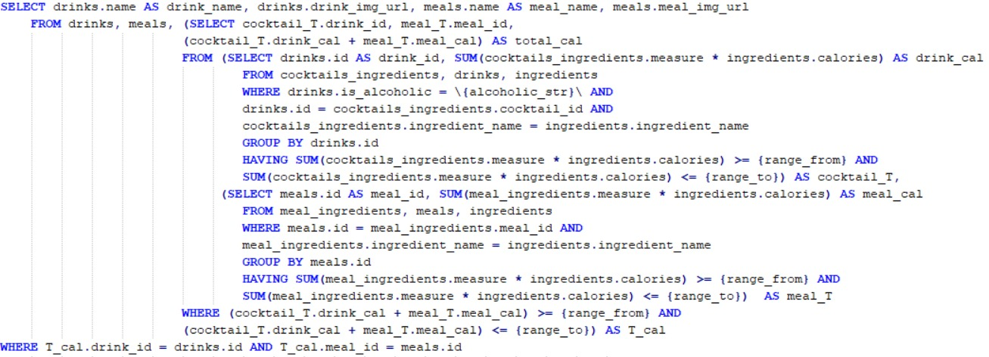

To optimize this query we used an index on the meal_ingredients(ingredient_name) and cocktail_ingredients(ingredient_name)

1. קלט: רשימת קטגוריות, סוג כוס, אלכוהולי/לא אלכוהולי

מחזיר כמה קוקטיילים מוגשים ע"י סוג הכוס הנ"ל ושהם גם אלכוהוליים/לא אלכוהוליים, לכל אחת מהקטגוריות שניתנו ברשימה בסדר עולה.

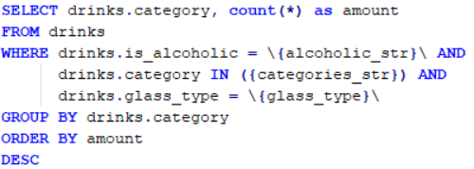

To optimize this query we used an index on the drinks(category) and drinks(glass_type)

1. קלט: שני מספרים שלמים – X , Y

מחזיר את כל המרכיבים שמשתתפים בלפחות X משקאות שונים שבהם (במשקאות האלה) יש לפחות Y מרכיבים שונים.

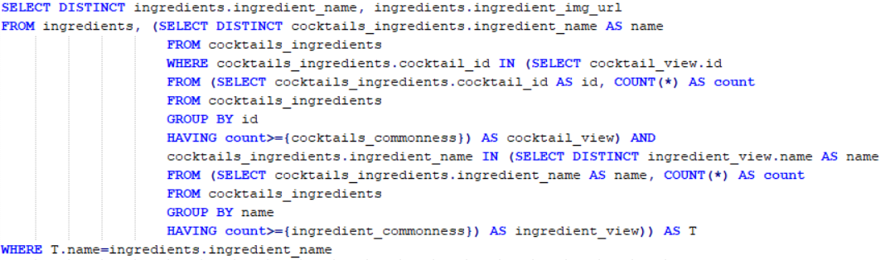To optimize this we need ingredients(name) but it’s a primary key already

1. קלט: --

מחזיר את סוג הכוס שמשתמשים בה הכי הרבה במשקאות לא אלכוהוליים וגם יש משקה אלכוהולי שמכינים אותה באותה הכוס.

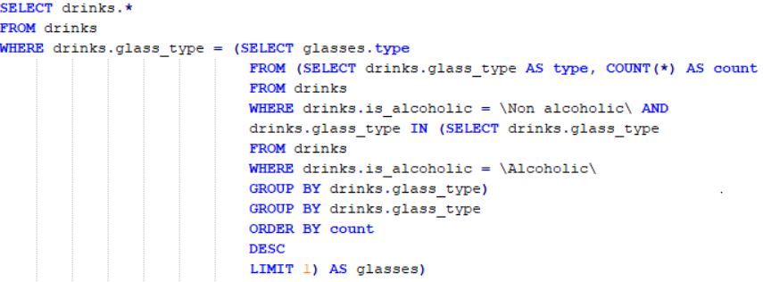

To optimize this query we used an index on drinks(glass_type)

1. קלט: רשימת קטגוריות

מחזיר את הקטגוריות לפי מספר המרכיבים הממוצע שיש בכל משקה בקטגוריה. (מוצג מהגדול לקטן)

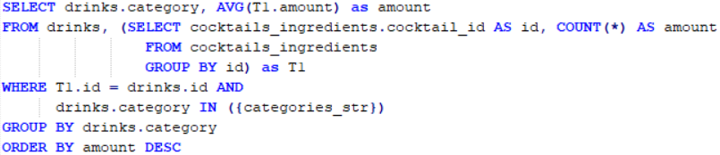

Didn’t find something

1. קלט: קטגוריה(אוכל) , קטגוריה(משקה)

מחזיר זוגות של (מאכל,משקה) כך שהמאכלים מקטגוריית אוכל מסוימת וקל להכין אותם, ובנוסף את כל המשקאות מקטגוריה מסוימת שקל להכין אותם (קל להכין = האורך של הinstruction שלהם קטן מ50 אותיות)

שמות, לינקים לתמונות

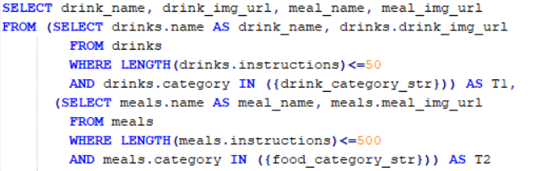

To optimize this query we used an index on drinks(category) , meals(category)

and on meal(instructions(500)) and drinks(instructions(50)) according to the “easy to make” length number we decided.

1. קלט: full text search

כל הקוקטיילים והארוחות שמכילים את המילים X בהוראות הכנה שלהם מסודרים בסדר יורד לפי מספר הקלוריות שלהם ולאחר מכן לפי כמה קל להכין אותם, כמו כן המשקאות מופיעים לפני הארוחות ללא קשר למיון (full text search)

ערך חזרה שם תמונה ומספר הקלוריות

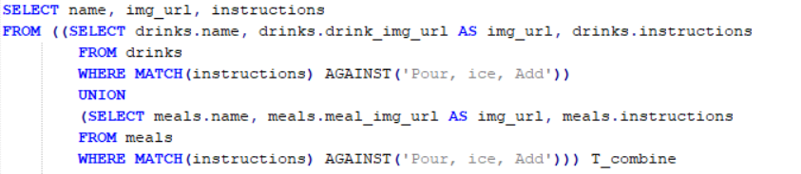

To optimize this query We used a full-text index on drinks(instructions) and meals(instructions)

1. קלט: מספר X

מחזיר את כל הזוגות של (קוקטייל, ארוחה) שיש בהם לפחות X מרכיבים משותפים.

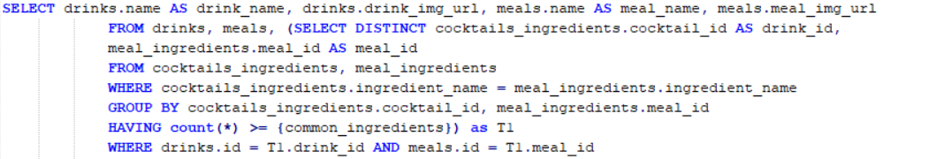

To optimize this query We used a

# BONUS

1. User interface:

We all agreed as a team on an “easy to use” application. Not too much wondering around in a crowded website, but a straight-forward “get what you need” manner.

The user interface of our application is written in angular, so the user can experience the application in the most clear, comfortable manner. The website is split into different pages for each one of our data-retrieval queries. Each screen has a short paragraph describing what is the main purpose of this window, and specifies the parameters needed to insert.

The user interface is responsive, so that it can be accessed from every technological device.

In addition, our application is immune to SQL injection. We pre-defined the input variables before the user inserts them, as taught in class, in order to keep our data base as safe as possible.