**Step 1 – Train using Sagemaker instance (not Studio)**

1. Created Sagemaker notebook instance
2. Use ‘ml.t2.medium’ instance type for notebook – it is universal instance type, which will be enough for the notebook to run (and cheap)
3. (optional) when creating notebook instance it is useful to provide git repository path – you will start with a repository cloned already
4. Creation of an instance takes 5-10 minutes – if you already have an instance it is much faster to use existing one than to create a new one every time
5. Train the network using the baseline script – fix bugs in the script such as unreachable code, wrong debug prints.
6. Train using multiple instances and prepare results
7. Multi instance training ends after 2 minutes, but in fact it required more time to be initialized

Screenshot of Sagemaker notebook instance:

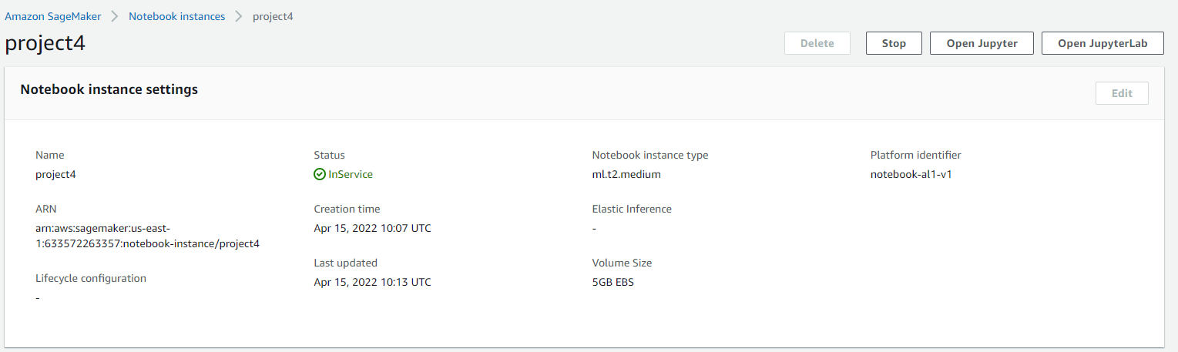

**Step 2 - run your notebooks using EC2 in your workspace**

1. Create EC2 instance  
   Instance creation looks completely different than the course described it, but after a couple tires I succeded.
2. Selected instance type is ‘m5.xlarge’ and I used spot instance for the notebook, because it is cheaper. System type: Deep Learning AMI (Amazon Linux 2) Version 60.0. I tried to train the model on t2.micro, but it was killed die to memory requirements.
3. Spot instance snapshot – on Udacity AWS account I don’t have permission to see spot instances (sceenshot 1), but the instance definitely has ‘spot’ lifecycle (screenshot 2)  
   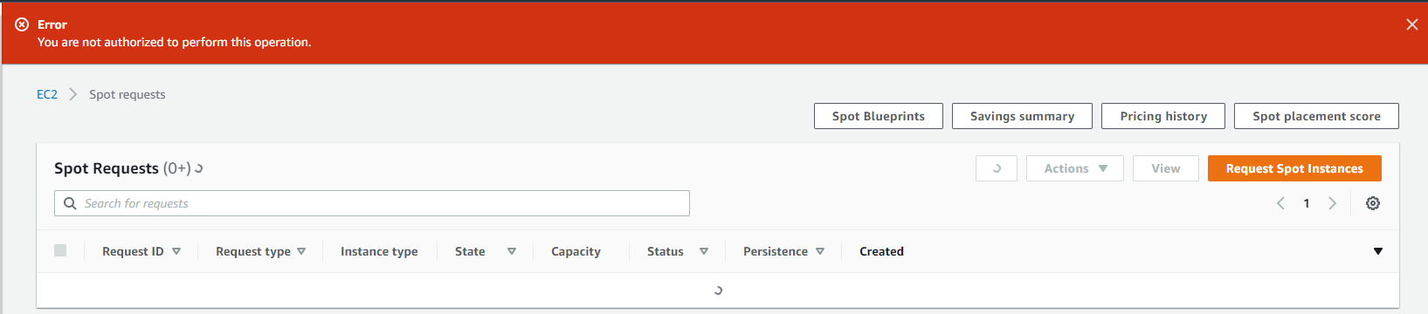

Figure Error seeing spot instances on Udacity AWS account

1. 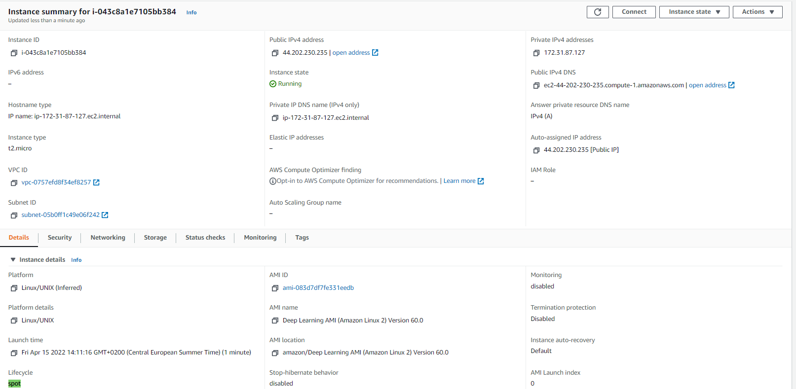

Figure EC2 instance details presenting its type and lifecycle option

1. Enter the EC2 instance console and run training form inside.  
   This step is especially tricky, because the console is slowly moving upwards. I don’t know what causes this problem, but I have only 1-3 minutes to use for each console, later it goes out of screen.
2. Training succeeded:  
   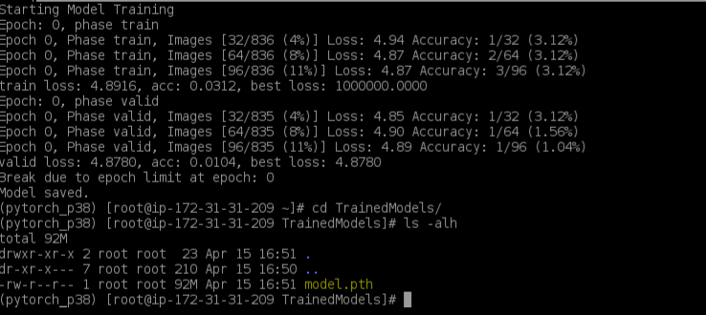

Figure Snapshot of the training logs and generated model.pth file

1. The code for EC2 instances is very similar to sagemaker one, but it should be self-containing python script which trains the model on any machine using local file system to access the data, while Sagemaker scripts required methods to access S3 dataset. Using EC2 instances is much more similar to usage of your own machine.

**Step 3 – Lambda functions for inference**

1. Create a new lambda function using provided code.
2. Initially Lambda does not have enough permissions to run the endpoint. Additional policies has to be added to Lambda in order to run it properly.
3. Lambda can be tested using JSON file with “url” entry.  
   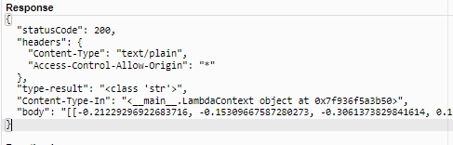

Figure Output of successful lambda execution

1. Lambda functions were already covered in project no2, the ‘invoke_endpoint’ function works like a ‘predict’ function in Sagemaker

**Step 4 – Actual running of Lambda function**

1. In order to access Endpoint Lamba required more permissions:  
   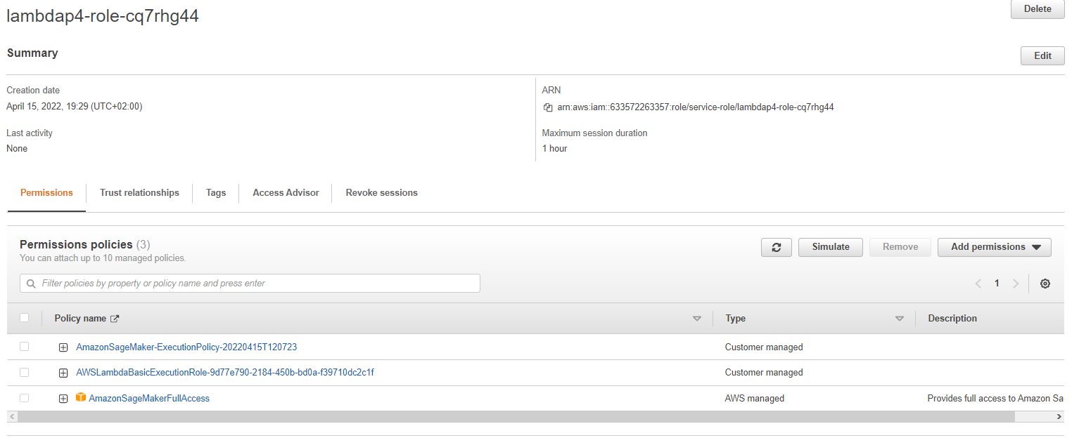

Figure Permissions for the lambda role

1. Lambda output:  
    "body": "[[-0.21229296922683716, -0.15309667587280273, -0.3061373829841614, 0.11011774092912674, -0.16774681210517883, -0.008066248148679733, -0.23197175562381744, 0.15635429322719574, -0.12622188031673431, -0.12885969877243042, 0.3695796728134155, -0.002062767744064331, -0.055869728326797485, 0.14742261171340942, -0.11725631356239319, -0.3161870837211609, -0.03053201735019684, -0.3684312105178833, -0.32753172516822815, 0.15400850772857666, 0.07220902293920517, 0.09954917430877686, 0.013533521443605423, -0.06362387537956238, -0.2291933298110962, -0.07303585857152939, -0.06227679178118706, -0.39104604721069336, 0.029530785977840424, -0.18164679408073425, -0.11869032680988312, -0.34357741475105286, 0.02373727224767208, -0.042474523186683655, 0.2240193486213684, -0.005224950611591339, -0.09473496675491333, -0.036600545048713684, 0.08635075390338898, -0.303500235080719, 0.08778636157512665, -0.025020167231559753, 0.017018944025039673, 0.10680541396141052, -0.10075695067644119, -0.15924464166164398, 0.23671609163284302, 0.0304688960313797, -0.04243922978639603, -0.046819064766168594, 0.05256631597876549, -0.03278496116399765, 0.006142046302556992, -0.01153213158249855, 0.027360720559954643, 0.08312027156352997, -0.09118440002202988, -0.08264446258544922, 0.11408921331167221, -0.09587959945201874, -0.048805855214595795, 0.058021046221256256, 0.13345670700073242, -0.13694187998771667, -0.19396939873695374, -0.3879741430282593, -0.32485464215278625, -0.10602971166372299, -0.2708476781845093, -0.0530611053109169, 0.23138290643692017, -0.016494084149599075, -0.04421060532331467, -0.2205985188484192, -0.16145184636116028, 0.0401601567864418, -0.167718306183815, -0.0998743399977684, 0.028368674218654633, 0.09563405811786652, -0.3112568259239197, -0.11798204481601715, -0.14478018879890442, -0.12296410650014877, -0.3944595754146576, 0.16801868379116058, -0.008254840970039368, -0.13363496959209442, -0.3903580605983734, 0.1054837629199028, -0.233144149184227, -0.12806618213653564, 0.03157461807131767, -0.06345967203378677, -0.163484588265419, -0.07572126388549805, -0.14463841915130615, -0.16430017352104187, -0.062421269714832306, -0.15379102528095245, -0.010581500828266144, -0.1540013700723648, 0.12033206969499588, 0.10423266142606735, -0.1938173770904541, 0.23208999633789062, -0.30273863673210144, -0.11447548866271973, -0.08791511505842209, -0.2549930512905121, -0.19253094494342804, 0.1697363406419754, -0.06303775310516357, -0.38952410221099854, -0.17013460397720337, -0.08217258006334305, -0.09334175288677216, 0.12874142825603485, -0.10503050684928894, -0.10680680721998215, -0.14144812524318695, -0.16845321655273438, -0.09375317394733429, -0.32222914695739746, -0.24126026034355164, 0.049243178218603134, -0.13309355080127716, -0.185033917427063, 0.000845693051815033, 0.037239909172058105, 0.07688818126916885, -0.4072481095790863, -0.04945005103945732]]"
2. For the personal application adding full access role to the lambda is OK, because I have only one endpoint and only one lambda, but in general the permissions should be monitored and probably have some due date for them.

**Step 5 – Autoscaling**

Autoscaling for endpoint and lambda allows concurrent request and inferences to be working on the endpoint. The values chosen should be based on expected endpoint load, which for this project is 0 (it will be deleted soon), so I set up minimum accepted values of 2 concurent runs of lambda and endpoint.