**README - CS2102 Group 23**

--------------------------

**Programs Required:**

------------------

Microsoft Visual Studio 2019

PostgreSQL

**Requirements:**

-------------

Create and load the required database tables and test data before installation of Visual Studio 2019

**Loading the Database Table:**

---------------------------

1. Create a new database in psql called cs2102proj

2. Load the .sql attached together with the source codes in the order

-init.sql

-triggers.sql

-dataload.sql

3. TriggerTesting.txt contains the list of triggers that is tested together with the constraints and expected result with a predefined query. The queries used in the txt file is on the assumption that the triggers.sql and dataload.sql have been loaded into the database already.

**Installation Guide for Visual Studio 2019:**

------------------------------------------

1. Download and Install Visual Studio Community 2019

2. Select 'ASP.NET and web development' Workload and Click 'Install'

3. Download the Source Code and Place it in a drive.

4. Select 'File' > 'Open' > 'Project/Solution' (Guide 1) Or ‘Open a project or solution’ (Guide 1.1)

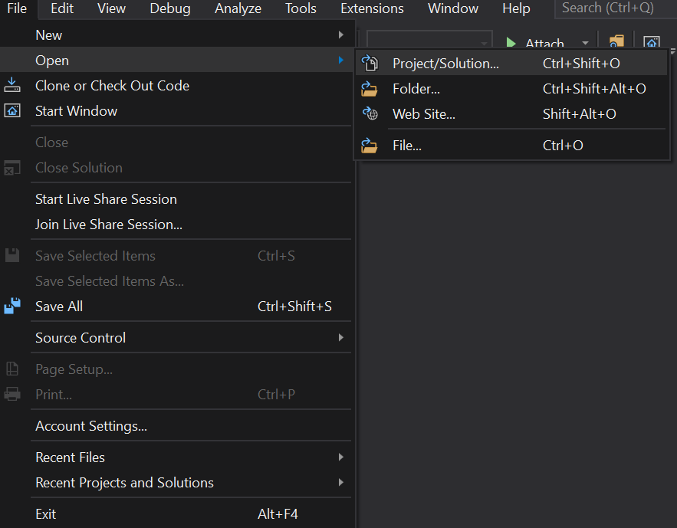

(Guide 1)

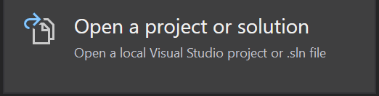

(Guide 1.1)

5. Locate the source code file and select the 'FDSApplication.sln' file, you should see all the files present.

6. Open the web.config file in Visual Studio and ensure the <connectionString> is present and directed to the correct psql database with your postgres username and password.

<add name="constr" connectionString="Server=localhost;Port=5432;User Id=postgres;Password=password;Database=cs2102proj;"></add>

7. To run the program, select double click 'Login.aspx' and then select 'IIS Express (Google Chrome)' (Guide 2) to run and deploy the application



(Guide 2)

8. To exit the application, close the website or select the Red Square Icon (Guide 3) at Visual Studio to stop the application.



(Guide 3)