Instalação kubectl

https://kubernetes.io/docs/tasks/tools/

Instalação k3d

https://k3d.io/#installation

Subir o cluster com kd3

Quantidade de control-plane: --servers 2
Quantidade de pods: –agents 2
Sem load-balance: --no-lb

k3d cluster create <nome-cluster> --servers 2 --agents 2

Setando a porta do service para load balancer

service port: 30000
porta local: 8080

k3d cluster create meucluster --servers 1 --agents 2 -p "8080:30000@loadbalancer"

Deletar cluster k3d

k3d cluster delete <nome-cluster>

Ver os cluster com kubectl & k3d & docker

kubectl get nodes

k3d cluster list

docker container ls ou docker container ls -a

Criação de pods, replicaset, deployment, services com kubectl

kubectl create -f <nome_arquivo>

Atualiza oque foi mexido no arquivo pods, replicaset, deployment, services

kubectl apply -f <nome_arquivo>

Ver os nodes, pods, replicaset, deployment

kubectl get all
kubectl get nodes
kubectl get pods
kubectl get replicaset
kubectl get deployment

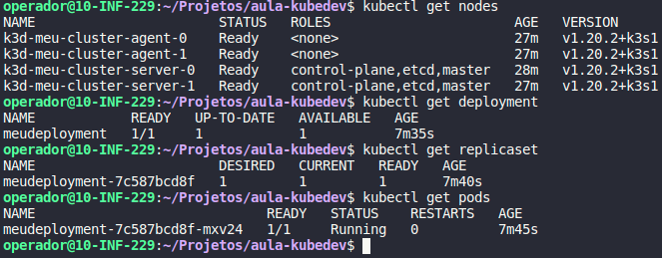

Ver detalhes pod, replicaset, deployment, services

kubectl describe pod <nome-pod>

Em caminhamento de porta para maquina local, pods, replicaset, deployment, services

kubectl port-forward services/<nome> 8080:80

Deletar pods, replicaset, deployment, services

kubectl delete pod <nome>
kubectl delete replicaset <nome>
kubectl delete deployment <nome>
kubectl delete services <nome>

Ver um pode pela label

kubectl get pods -l app=<labels-app>

