MOATNOMICS

Visual Identity
& Motion Guide
VERSION 2.0 | 20 OCTOBER 2026
LESS NOISE, MORE NUANCE.
A cross-channel working standard for brand identity, product UI, research reports, editorial content, video, motion, multilingual production and quality control.
STATUS | MEANING
Approved direction | An explicit brand-owner decision to preserve unless deliberately reopened.
Provisional hypothesis | A recommended starting point that must be tested and approved before becoming a final specification.
Production requirement | A process, accessibility, evidence-integrity or delivery rule teams must follow.
Open decision | An unresolved issue that must not be silently treated as approved.

This guide improves production readiness. It does not claim final vector artwork, licensed fonts, contrast certification or completed user research. These remain release gates.

0. How to use Version 2.0
This is a balanced operating manual for product UI, research/report design, editorial content and all video formats. It is tool-agnostic and designed for multilingual production.
Decision for v2.0 | Implementation
Priority: balanced | Comparable attention to product, reports, content and video.
Video formats: all-video | Short-form, YouTube, explainers, webinars, product demos, presentations and brand films.
Product theme: both | Light and dark are first-class themes with separate contrast testing.
Motion workflow: tool-agnostic | Specify purpose, timing, layers, easing, output and acceptance criteria rather than software steps.
Language strategy: multilingual | Plan for script coverage, text expansion, subtitles, voice, localisation and right-to-left readiness.

0.1 Approved direction vs hypotheses
- Preserve editorial authority combined with hidden perspective, a composed/reassuring quality, and a symbol plus wordmark.
- The chosen logo direction is the earlier sophisticated dimensional split-arch with a central mirror. Do not replace it with the later perfect-semicircle revision without approval.
- “Less noise, more nuance.” is the working tagline territory, not a market-validated claim.
- Palette, type, exact logo dimensions, grid values and motion ranges remain provisional until tested.
- When a spec is missing, record an assumption and decision owner rather than inventing approval.

0.2 Core principle
Nuance should make decisions clearer, not make the reader work harder.
Moatnomics helps investors look beyond the obvious by bringing evidence, context and alternative perspectives into view. Rigorous without being cold; distinctive without being theatrical; calm without being passive.

1. Brand architecture and experience
Layer | Working expression | Status
Brand | Moatnomics | Approved name direction.
Tagline | Less noise, more nuance. | Working hypothesis; validate recall and relevance.
Category descriptor | Multi-asset investment research | Confirm against actual launch scope.
Product promise | Understand the evidence. Examine the trade-offs. Know what deserves a closer look. | Strategic expression; use only where product supports it.
Behaviours | Investigate deeply. Challenge independently. Trace the evidence. Monitor what changes. | Must reflect real product behaviour.

Journey | User question | Design job
Discover | Why look at this? | Make the central question and relevance clear.
Investigate | What is the evidence? | Expose source, date, method and assumptions.
Evaluate / compare | What are the trade-offs? | Align scales, labels and assumptions for fair comparison.
Monitor | What changed, and does it matter? | Separate meaningful changes from routine movement.

- Investigate deeply: guide from headline to evidence, never hide complexity.
- Challenge independently: give risks and counterarguments visual dignity.
- Trace the evidence: make source, as-of date, method and uncertainty findable.
- Monitor what changes: explain what changed, why it matters and what could invalidate the view.
- Never let visual polish imply more certainty, verification or completeness than the underlying work supports.

2. Logo system: The Perspective Portal
The split arch creates an opening; the central mirrored plane suggests depth and another vantage. The wordmark supplies editorial authority. The symbol must remain recognisable when dimensional treatment is removed.

2.1 Master artwork
- Build final masters as editable vector paths. Required deliverables: SVG, print-ready PDF, transparent PNG exports and a native vector source agreed by the design team.
- Draw from the chosen sophisticated split-arch concept, not from a raster mock-up. Keep the mirror centred and the left/right mass optically balanced.
- Create dimensional, flat, simplified small-size, reverse, black, white and one-colour variants. The flat master is the default for UI, favicon and monochrome use.
- Large brand imagery may use two or three mirror planes; the core logo must stay simple and reproducible.
- Do not stretch, skew, rotate, outline, add unapproved shadows, independently recolour logo parts or add lens flares/glossy chrome.
- Do not place the mark over busy imagery without a quiet zone or tested contrast treatment. Never use image generation as the production logo master.
Rule | Starting hypothesis | Validation
Clear space | At least central-mirror width on every side. | Test horizontal, stacked and symbol-only lockups.
Digital symbol | 16 px initial test point. | Test at 16/20/24/32/48 px across themes.
Digital lockup | 140 px minimum width initial test. | Check wordmark legibility; omit tagline when cramped.
Print symbol | 6 mm initial test point. | Test office print and photocopy.
Print lockup | 30 mm width initial test. | Check wordmark/descriptor at actual output size.

Context | Use | Rule
Product header | Horizontal lockup where space allows; otherwise symbol if context is clear. | No tagline in cramped navigation.
Report cover | Primary lockup. | Title/date/topic remain dominant.
Report interior / dense UI | Small flat symbol or wordmark. | Never compete with data or sources.
Favicon / app tile | Simplified flat symbol. | No mirror detail that collapses.
Dark surface | Approved reverse/light variant. | No ad hoc recolouring.
Mono/photocopy | Flat one-colour master. | Preserve negative-space logic.
Video end card | Mobile-readable lockup. | Tagline only with adequate dwell time.

3. Colour system and themes
These values are provisional design hypotheses, not certified combinations. Test text, controls, focus rings, icons, charts and print output before approval.
Token | Provisional value | Role / guardrail
Forest | #0E3D32 | Brand anchor and primary action candidate; not synonymous with success.
Sage | #7DA77A | Support accent/series; test small-text contrast.
Lime | #C7E268 | Rare focal point; not automatically profit/success.
Ink Navy | #0B2337 | Editorial authority, body text and axes.
Ivory | #F7F5EE | Warm page/report surface.
Mist | #D9E3E8 | Dividers, neutral panels and secondary series.
Charcoal | #282F33 | Sustained reading and dense text.
White | #FFFFFF | Utility neutral and reverse surfaces.

Role | Light theme hypothesis | Dark theme hypothesis | Rule
Canvas | Ivory or white. | Ink or deep Forest. | Define canvas and elevated surface separately.
Primary text | Ink/Charcoal. | Ivory/validated near-white. | Do not simply invert every token.
Secondary text | Tested dark neutral. | Tested light neutral. | Metadata and sources remain readable.
Borders | Mist or tested neutral. | Dedicated lighter dark-surface border. | Boundaries remain visible.
Primary action | Forest fill with tested light label. | Validated high-contrast action token. | Same action hierarchy in both themes.
Focal accent | Small lime highlight. | Small lime highlight. | Never use as large glow or sole status cue.
Charts | Neutral grid, explicit labels. | Theme-adjusted neutral grid. | Test series independently in each theme.

3.1 Semantic status tokens
Token | Required behaviour
Positive / favourable | Dedicated token plus label/icon; distinct from generic brand green.
Negative / adverse | Dedicated token plus text, sign or line style; never red/green alone.
Caution | Distinct from error and ordinary highlight.
Error | High-salience state with actionable recovery copy.
Information | Neutral explanatory state, not a recommendation.
Focus | Visible focus ring in both themes.
Disabled / selected | Clear non-colour cue; retain readable text where possible.

Acceptance: test applicable WCAG 2.2 AA contrast requirements for text, meaningful graphics, controls and focus indicators. Record the tested pair, theme, size and result. Confirm CMYK conversions with the printer.

4. Typography and multilingual readiness
Role | Direction | Rules
Display / editorial | Serif, Tiempos-like direction only. | Major titles and selected campaign headlines; verify licence and script coverage.
Product / body | Neutral sans, Inter-like direction only. | UI, body, labels, tables and annotations.
Numeric / data | Sans with tabular figures. | Prices, returns, ratios, dates and aligned comparisons.
Micro-labels | Same sans family, restrained tracking. | Short metadata only; avoid uppercase tracking in long translated copy.

Type token | Starting range | Use
Display XL | 40–56 px responsive | Campaign/landing headline.
H1 | 30–40 px | Page/report title.
H2 | 22–28 px | Major section.
H3 | 17–21 px | Subsection/card title.
Body | 15–18 px web; 10–11 pt report | Sustained reading; validate density.
Compact body | 13–14 px web | Dense tables only after testing.
Caption / metadata | 12–14 px web; 8–9 pt print | Sources/dates must remain legible.

4.1 Multilingual rules
- Choose fonts only after testing all intended scripts, punctuation, currencies, numerals, combining marks and fallback behaviour. One family may not cover every script.
- Use locale-aware date, number, percentage, currency and unit formatting. Preserve source currency and reporting period when financially material.
- Stress-test 30–40% text expansion as a planning scenario, not a universal prediction. Use real translations before locking component widths.
- Keep critical text editable; allow line wraps and component heights to grow. Never auto-shrink translated text until it becomes hard to read.
- Support appropriate direction and bidirectional handling for right-to-left languages in scope. Mirror directional UI only where convention requires it; do not mirror the logo by default.
- Review language-specific line height, punctuation, quotes, hyphenation and line breaks with a qualified language reviewer. Localise idioms, examples and financial terminology rather than translating mechanically.
- For multilingual video, provide separate subtitle/caption files and, when required, voice tracks and title cards. Do not cram multiple languages onto one frame.

5. Layout and responsive behaviour
Element | Starting hypothesis | Rule
Spacing | 4 px scale. | Use semantic tokens, not arbitrary one-off values.
Desktop grid | 12 columns. | Record max width, gutters and breakpoints in tokens.
Mobile grid | 4 columns. | Let research content reflow; do not compress desktop tables indiscriminately.
Line length | About 60–80 characters where practical. | Prioritise reading; data tables may be wider.
Touch target | Aim for 44 × 44 px where feasible. | Separate hit area from 20–24 px artwork.
Radii | Small restrained family. | Provisional until tested; do not round every element equally.

- Align headings, body, charts, source notes and cards to a shared grid.
- Use whitespace before adding boxes. Keep source notes close to the claim/chart they qualify.
- At narrow widths, reorder only if the reading logic remains correct; never detach units, legends or caveats from charts.
- Test 200% zoom and larger text without clipping critical information.

6. Graphic language, imagery and texture
- Use layered portal forms, perspective crops, rules and framed reveals to express looking through to context. The portal is a signature device, not a mandatory background.
- Use portal art for campaign heroes, report covers, section openers and selected video transitions; keep dense UI and report interiors flat.
- One dominant perspective gesture per composition. Do not stack portal, gradient, texture, chart and photography without a clear hierarchy.
- Prefer depth, natural texture and a clear focal point where mood supports the message. Grade toward deep greens, warm neutrals and restrained cool shadows while preserving believable skin tones.
- Do not green-wash every image or use generic skyscrapers/market screens as a substitute for explanation. Research visuals must not imply a false location, event, company or investment context.
- Track source, licence, release, usage scope and expiry for imagery. Factual accuracy outranks mood.

7. Iconography and illustration
Rule | Working standard
Grid | 24 × 24 px starting grid; optical adjustments at 16/20 px.
Stroke | 1.75–2 px at 24 px as a starting hypothesis; test at real size.
Geometry | Consistent joins, corner language and optical weight.
Metaphors | Familiar, unambiguous; do not force portal motif into every icon.
Custom icons | Only when standard icons cannot express a meaningful concept; document meaning.
Accessibility | Icon-only controls need accessible names, visible focus and adequate hit areas; status icons need text/another cue.

Function | Metaphor | Caution
Research dossier | Document + search. | Not a generic download.
Markets | Chart/trend. | Label asset class if ambiguous.
Compare | Side-by-side panels/balance. | Keep semantics consistent.
Watchlist | Bookmark. | Differentiate from alerts and saved reports.
Alerts | Bell for notification; trend for thesis monitoring. | Do not conflate routine alerts with thesis drift.
Risk | Shield/gauge. | Never imply risk can be eliminated.
Valuation | Calculator/scale. | Do not imply precision beyond assumptions.
Sources | Document/link/check. | Do not imply verification unless performed.
Multi-asset | Layered cards. | Reserve brand symbol for identity.

Illustration should clarify a workflow, state or concept. Use restrained geometry and negative space; avoid mascots, financial clichés and abstract art that competes with data.

8. Data visualisation and research graphics
- Choose the simplest chart that accurately expresses the relationship. Label axes, units, periods, currency, benchmark and frequency where relevant.
- Show source and as-of date consistently. Label estimated, modelled, forecast and scenario values explicitly.
- Use labels, line styles, markers or annotations in addition to colour. Avoid 3D charts, glow, ornamental grids and misleading truncated axes.
- Do not imply causality from correlation or visual proximity. Insight-led titles must not overstate the evidence.
- Keep assumptions and caveats readable in exported and video versions. Do not animate data into existence without dates/context.
- Label gross/net, pre-tax/post-tax, nominal/real, annualised/cumulative and actual/forecast distinctions. Use comparable periods and denominators.
- Never use lime/green automatically to signal gain or recommendation. Do not hide counterevidence or invalidation conditions through visual hierarchy.

8.1 Standard chart anatomy
- Question/insight title, proportionate to evidence.
- Subtitle with period, scope, benchmark or key assumption.
- Plot with clear scales, units and series distinction.
- Annotation explaining the relevant change/comparison.
- Source, as-of date and methodology note.
- Caveat or scenario label where needed.

9. Digital product UI: light and dark
- Functional clarity outranks brand decoration. Keep dense tables, source lists and watchlists free of cinematic backgrounds.
- Brand colours do not replace semantic status colours. Define success, caution, error, information, focus, disabled and selected tokens separately.
- Use portal motif sparingly in empty states, onboarding or a simplified loading cue only when it does not delay work.
- Make uncertainty legible in labels and explanation, not vague colour or opacity. Missing/stale data must never silently become zero or an inferred value.
- Every key finding should distinguish observation, interpretation, assumption and recommendation where these differ. Sources and timestamps sit close to claims.
Component | States to design | Acceptance criteria
Buttons | Default, hover, focus, pressed, disabled, loading. | Clear hierarchy, visible focus, stable geometry.
Inputs | Empty, filled, focused, error, disabled, read-only. | Persistent label; recoverable error copy.
Tabs/navigation | Default, selected, focus, disabled. | Selected state not colour-only; keyboard behaviour defined.
Tables | Sort, filter, selected row, empty, loading, error. | Aligned numbers; headers/units remain attached; responsive plan.
Charts | Loading, no data, valid, partial, error, stale. | Missing/stale data disclosed, not shown as zero.
Alerts | Info, caution, adverse, resolved, muted. | State, consequence, evidence and action clear.
Dialogs/panels | Open, close, focus, validation, escape. | Focus order and return focus defined.

Specify behaviour for wide desktop, standard desktop, tablet, narrow mobile and zoomed layouts. Define table overflow, sticky columns, chart reflow, filter access and navigation collapse. Breakpoints are implementation decisions and belong in the token file.

10. Research reports and presentations
Cover hierarchy: lockup, report title, asset/sector/topic, publication or as-of date, and author/team where relevant. Optional hero imagery must not overpower the title or imply evidence not present.
- Executive conclusion and key takeaways.
- What changed and why it matters.
- Evidence, methodology and source quality.
- Business, asset or instrument analysis.
- Valuation/scenarios/comparison basis, where relevant.
- Risks, counterarguments and invalidation conditions.
- Assumptions, limitations, source list and as-of date.
- Use editorial headings, restrained rules, consistent source notes and shared chart grammar.
- Keep dimensional mirror imagery on covers or special openers; body pages and tables stay flat.
- Maintain black-and-white versions using labels, patterns and line weights.
- Embed fonts, use vector logos, set bleed/safe areas and confirm CMYK with the printer. Test office print and photocopy.
- One slide should have one dominant point. Do not shrink sources to preserve page count; reflow instead.

11. Motion identity
Motion enacts the brand idea: the view opens, layers separate, context appears and the conclusion becomes clearer. The drama belongs in the reveal of evidence and relationships, not generic cinematic spectacle.
- Reveal, do not explode: masking, restrained translation, measured parallax or opacity change.
- Depth must remain legible; the arch and mirror may move on separate planes but separation stays subtle.
- Calm is not slow: UI feedback must feel immediate. One dominant motion idea per sequence.
- Use spatial continuity to orient, not to dramatise every state change. Motion should orient, reveal, compare, confirm or transition.
- Respect reduced-motion preferences. Provide static/low-motion alternatives; never make information available only through animation.
- Do not animate forecast values as if actual or use movement to imply stronger evidence than exists.
Motion class | Starting duration | Behaviour
Micro feedback | 100–180 ms | Ease-out, minimal travel.
UI state | 160–240 ms | Ease-out/in-out; responsiveness first.
Card/panel | 220–360 ms | Modest travel, preserve orientation.
Chart reveal | 350–700 ms | Editorial explanation, not every refresh.
Logo reveal | 700–1,200 ms | Brand film/formal opener only.
Title/end card | 600–1,000 ms | Soft settle, no bounce.
Section transition | 300–700 ms | Only if it preserves orientation.

Property | Preferred | Avoid
Easing | Cubic ease-out arrivals; ease-in-out spatial continuity. | One curve for every use.
Spring | Rare, small UI feedback that settles quickly. | Elastic bounce.
Parallax | 2–3 layers maximum in long-form; tiny offsets. | Large UI parallax.
Mirror | Reveal after/slightly slower than arch. | Fast spin or dramatic 3D rotation.
Blur | Subtle and brief in large reveals. | Blurred text or default blur transition.
Particles/fluid | Not core identity; only story-justified. | Generic smoke/liquid/energy fields.
Overshoot | Zero or near-zero for logo/data. | Rubbery logo movement.

11.1 Tool-agnostic motion brief
- Purpose: orient, reveal, compare, confirm, transition or brand.
- Starting/ending state and what remains fixed.
- Layer order/depth; 2D, simulated depth or true 3D.
- Timing range, easing intent, direction and stagger order.
- What information enters, exits, changes or stays constant.
- Reduced-motion/static alternative and captions.
- Aspect ratio, resolution, frame rate, alpha/audio requirements and codec.
- Performance/file-size budget for web/interactivity.
- Acceptance criteria for legibility, brand, data integrity, accessibility and devices.

11.2 Master logo reveal
Beat | Approx. time | Action
Opening | 0–250 ms | Arch halves emerge through quiet mask/vertical reveal and settle.
Perspective | 200–550 ms | Mirror appears via restrained luminance shift/reflected band; no lens flare.
Wordmark | 450–800 ms | Wordmark arrives gently after symbol resolves.
Hold | 800–1,200 ms | Tagline only if screen/time allow; briefly hold full lockup.

Use for brand/launch films or formal presentation openers, not before every social clip, tutorial or short insight.
Transition | Use | Rule
Portal wipe | Major perspective/section shift. | Split-arch mask; selective use and consistent direction.
Layer reveal | Evidence then interpretation. | Shift foreground modestly to reveal labelled layer.
Context shift | Headline vs fuller picture. | Widen crop or add data layer; label what changed.
Editorial cut | Most research videos. | Hard cut; add rule/label only if orientation helps.
Chart build | Explain one relationship. | Axes, series, annotation; retain source/as-of.
End-card settle | Close sequence. | Simple cut/fade into stable lockup.

12. Video system: all formats
Format | Opening | Brand/motion | Close
Short-form social | Lead with question, evidence or conclusion immediately. | Small symbol or 200–400 ms corner reveal if useful; captions essential. | Takeaway/next step, source cue and compact signature.
YouTube explainer | State question and relevance. | Section labels, chart builds and occasional perspective shift. | Implication, watchpoint and source path.
Webinar/interview | Topic, speaker, purpose; move quickly to substance. | Lower thirds, chapter cards, restrained transitions. | Key takeaways and source links.
Product demo | Show task and expected result. | Real UI states; cursor emphasis/zoom only to aid comprehension. | Recap steps; no delaying cinematic outro.
Research briefing | Finding and as-of date. | Evidence-first charts, sources, risk/countercase. | Conclusion, assumptions, invalidation condition, sources.
Brand/launch film | Clear human/investment question. | Most expressive portal/data reveals; every effect serves narrative. | Lockup, working tagline, next action and reading time.
Presentation opener | Topic, presenter and purpose. | Short reveal; high contrast and static fallback. | Move directly into content.

12.1 Video narrative grammar
- Question: what are we trying to understand?
- Context: what must viewers know first?
- Evidence: source, period, units and comparison.
- Interpretation: what the evidence supports and does not.
- Counterpoint: risk, alternative explanation or limitation.
- Implication: what matters for understanding.
- Watchpoint: what future evidence could change the view.
- Source and brand close: provenance and next steps.
Delivery | Starting master | Rule
General web/brand | Choose 24 or 25 fps based on capture/distribution. | Decide per production; do not casually mix.
Talking head/explainer | 25 or 30 fps; match capture where practical. | Prioritise clear gestures and screen recording.
Product demo | 30 fps where native, otherwise match capture. | Keep cursor clear; avoid artificial motion blur.
Slow motion | 50/60 fps capture on 25/30 timeline only when useful. | Do not shoot everything high frame rate.
Vertical | 1080 × 1920. | Keep text/charts/logo within current safe areas.
Portrait | 1080 × 1350. | Check platform crop after upload.
Landscape | 1920 × 1080. | Test source and chart readability on mobile.
Square | 1080 × 1080 if needed. | Recompose, do not merely crop another master.

These are working master sizes, not guarantees of current platform rules. Check current upload, caption, safe-area and duration specifications before release.

12.2 Captions, language and sound
- Provide accurate captions for speech and meaningful non-speech audio; review speaker attribution.
- Deliver subtitle/caption files plus burned-in versions only where useful or required. Never rely on auto-captions without human review.
- Keep captions clear of platform controls and chart labels; check every aspect ratio.
- Dubbed versions need timing and line-length adaptation, not mechanical reuse of original subtitle timing. Keep names, numbers, dates, units and financial terms consistent with the source script.
- Provide transcripts and source references for longer educational/research videos.
- Voice and explanation outrank music. Music should support concentration, not signal unjustified urgency or certainty. Test on mobile, headphones, low volume and mono.
- Sonic logo is optional and not approved. If explored, keep it short and quiet, linked to perspective rather than a generic fintech chime. Never autoplay audio in product/web loops.

12.3 Video delivery package
Deliverable | Requirement
Master | High-quality master plus agreed project/source files.
Platform exports | Approved aspect ratios, resolutions, codecs and audio settings.
Captions | Reviewed caption/subtitle files; burned-in version if required.
Transcript/source notes | Long-form transcript; source, as-of dates and assumptions available to publisher.
Poster/still | Static fallback for reduced motion, slow networks and preview.
Localised versions | Language-labelled exports, captions, voice tracks and reviewed on-screen text.
Project handoff | Fonts/licences, linked assets, motion notes, software/version and export settings.

13. Accessibility and performance
- Do not communicate meaning through colour alone. Add labels, shapes, line styles or text.
- Provide visible keyboard focus, logical focus order and appropriate accessible names.
- Respect reduced motion; avoid continuous decorative movement, flashing and rapid high-contrast changes.
- Caption/transcribe video and provide text alternatives for meaningful visual information. Decorative images should not create redundant screen-reader content.
- Test contrast in both themes, including focus, disabled states, chart labels and data series.
- Choose SVG/CSS/Lottie/video based on complexity, platform and accessibility, not fashion. Provide static fallback.
- Test on a representative low-powered mobile device and constrained network. Optimise without sacrificing fine chart lines or source-note legibility.

14. Asset library and governance
Folder | Contents / governance
01_Logos | Approved SVG/PDF/PNG; horizontal, stacked, flat, dimensional, mono and reverse. Masters only.
02_Tokens | Colour, type, spacing, radii, breakpoints, semantic UI and motion; version-controlled with product code.
03_Icons | Canonical vectors, exports, labels, grid/stroke specs; one source of truth.
04_Graphics | Portal forms, masks, patterns, chart annotations; function-based naming.
05_Photo_Video | Licensed originals, selects, footage, crops, releases, usage scope and expiry.
06_Templates | Reports, social, slides, newsletter, video cards/lower thirds; editable content zones.
07_Motion | Logo reveal, transitions, project files, static fallbacks, timings and tool/version notes.
08_Localisation | Approved translations, glossary, fonts, subtitles and locale QA records.
09_Examples | Approved/rejected examples, edge cases and accessibility examples.
10_Archive | Superseded assets and release records; read-only.

Naming convention: `brand_asset-purpose_variant_theme_locale_version_date.ext`. Example: `moatnomics_video-endcard_vertical_dark_en-IN_v02_20261020.mp4`. Record canonical asset ID in the asset register.
- Asset register: ID/name, status, owner/approver/date, version/source/export formats, licences/expiry, theme/locale/aspect ratio, accessibility notes, fallback, spec link and change log.
- Only brand owner/delegate approves changes to logo, core palette, typography, tagline treatment and motion signature.
- Product teams may extend component tokens if semantic purpose and both-theme tests are documented. Localisation may adapt layout to preserve meaning but cannot independently alter logo or claim hierarchy.
- Archive old approved assets; never overwrite the only source master.

15. Production workflow and review gates
Gate | Work | Exit criteria
G0 Brief | Audience, objective, channel, language, theme, format, success measure. | Job-to-be-done, key message and deliverables agreed.
G1 Direction | Select concept; record hypotheses. | Brand-aligned; no unsupported claims/effects.
G2 Prototype | Test logo, type, colour, chart and motion at real size. | Small-size, theme, monochrome, multilingual and reduced-motion checks as relevant.
G3 Content integrity | Review claims, sources, data labels, assumptions and counterpoints. | Visual hierarchy does not overstate certainty; evidence traceable.
G4 Access/localisation | Contrast, keyboard/focus, captions, scripts and translations. | Required checks pass or exceptions documented.
G5 Production QA | Inspect exports on target devices, print and platform crops. | No clipping, font failures, missing sources or export artefacts.
G6 Release | Owner approval and archiving. | Approved master, exports, source files, register and change log stored.

Role | Responsibility
Brand owner | Identity changes and exceptions.
Design lead | Visual consistency, components and layout.
Product/engineering | Functional UI states, tokens and responsive behaviour.
Research/content owner | Claims, sources, assumptions and caveats.
Motion/video lead | Animation, pacing, rendering and delivery.
Accessibility reviewer | Contrast, keyboard, captions, motion and alternatives.
Language reviewer | Translation, terminology, cultural context and scripts.
Production owner | Licences, exports, naming, versions and handoff.

16. Quality-control checklist
- ☐ Chosen split-arch/mirror direction and approved logo master used.
- ☐ Provisional colours/type are not described as final approvals.
- ☐ Light and dark themes independently checked.
- ☐ Monochrome and small-size reproduction remain legible.
- ☐ Headline, data and source notes have clear hierarchy.
- ☐ Charts include units, period, benchmark, source and as-of date where relevant.
- ☐ Observed, calculated, estimated and scenario values are distinguished.
- ☐ Design does not imply unsupported verification, certainty or performance.
- ☐ Motion improves understanding and has required reduced-motion/static alternatives.
- ☐ Captions, subtitles, transcripts and localised files are included as specified.
- ☐ Fonts/glyph coverage, text expansion, script direction and locale formatting checked.
- ☐ Contrast, focus, hit targets and accessible names reviewed.
- ☐ Exports tested on target devices/platform crops and office print if relevant.
- ☐ Asset ownership, status, licences, source files and version are recorded.

17. Decision register
Topic | Status | Next decision / validation
Brand direction | Approved direction | Editorial authority + hidden perspective; calm, reassuring; symbol and wordmark.
Logo concept | Chosen concept; artwork not final | Earlier sophisticated dimensional split arch/mirror; complete vector master and small-size variant.
Tagline | Working hypothesis | Validate recall, comprehension, relevance and category inference.
Category descriptor | Working hypothesis | Confirm product scope and substantiation.
Palette | Provisional | Contrast, colour-vision, themes and print conversion.
Fonts | Provisional | Licence, scripts, weights, numeric clarity and rendering.
Grid/spacing/radii | Provisional | Test across UI, reports and video templates; record tokens.
Icon family | Provisional | Select canonical family and custom inventory.
Light + dark | Both required | Implement exact mappings and test accessible combinations.
Motion principles | Direction approved | Purposeful reveal, restrained depth, evidence-first animation.
Motion timings | Provisional ranges | Tune for content, frame rate, reading time and devices.
Video | All formats required | Create format-specific templates and platform checklists.
Language | Multilingual required | Confirm initial languages/locales and RTL scope.
Sonic identity | Open decision | Decide after assessing informational-video needs.
Tool stack | Tool-agnostic | Tools may vary; outputs must meet shared specs.
Research validation | Open gate | Test comprehension and recognition with target users.

18. Validation plan
- Logo stress test: symbol/wordmark at small sizes, favicon, report cover, monochrome and photocopy. Confirm mirror reads as intentional perspective.
- Palette/theme audit: text, controls, focus, status and charts in both themes; contrast and colour-vision checks; print conversion.
- Multilingual specimen: headlines, body, tables, dates, percentages, currencies, punctuation and mixed-script content for each intended locale.
- Research UI usability: ask users to find a source/as-of date, compare assets and locate a risk/caveat; observe without coaching.
- Video comprehension: test short explainer, longer research briefing and product demo for comprehension, source recall, caption legibility and motion distraction.
- Brand recognition: assess symbol distinctiveness and whether system communicates rigorous, calm, perspective-led research.
- Pilot production: one report, dashboard view, social insight card, vertical explainer, landscape explainer and webinar title/lower thirds before scaling.

19. Open decisions before full release
- Final logo vector construction and small-size simplification.
- Final font families, licences, script coverage and numeric settings.
- Validated colour tokens and semantic mapping for both themes.
- Initial language/locale list and right-to-left requirement.
- Canonical icon family and custom-icon inventory.
- Product breakpoints, spacing/radius tokens and component specs.
- Motion timings/frame-rate decisions for actual production pipeline.
- Sonic identity, if any.
- Tagline/descriptor after audience validation.
- Named approvers, asset storage and version-control process.

20. Final operating rule
Make the evidence easier to understand, not easier to believe.
Every visual decision should improve orientation, comprehension, comparison, recall or trust. The system should be recognisable without becoming repetitive, sophisticated without becoming ornamental, and expressive without distorting the underlying research.
Version 2.0 is a production-ready working standard with explicit release gates. It becomes a final approved identity system only after open decisions, vector masters, accessibility tests, localisation tests and target-user validation are complete.

Appendix A. Visual references from the identity exploration
Purpose. These boards preserve the visual work already explored so designers and production partners have a shared reference to build from. They communicate direction and relationships, not final specifications or editable master artwork.
How to read these references. The selected direction is the earlier, more sophisticated split-arch with a central mirror, combining editorial authority with a sense of another vantage. Do not treat every detail shown in the boards as approved: some text, font names, colours, mock-up copy, interface details and logo constructions are exploratory. Production masters, tokens and assets must be redrawn, tested and signed off.

Reference A. Concept and visual-language board
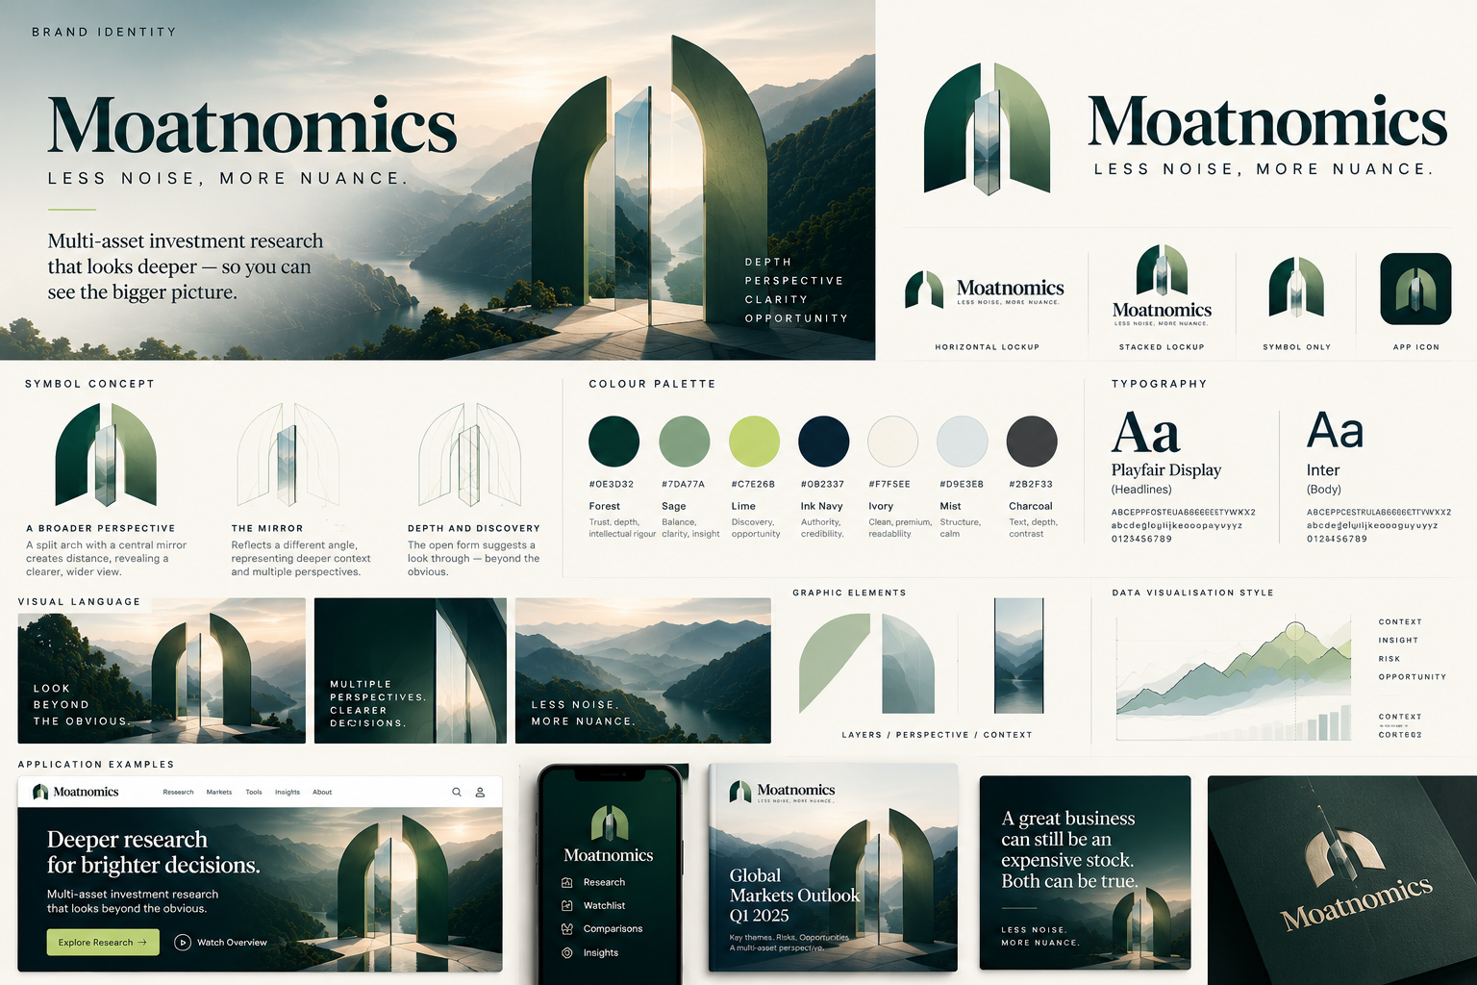
Use this board to understand the split-arch and central-mirror idea, layered perspective, provisional palette, typography direction, graphic elements and early application language.

Reference B. Logo system and application explorations
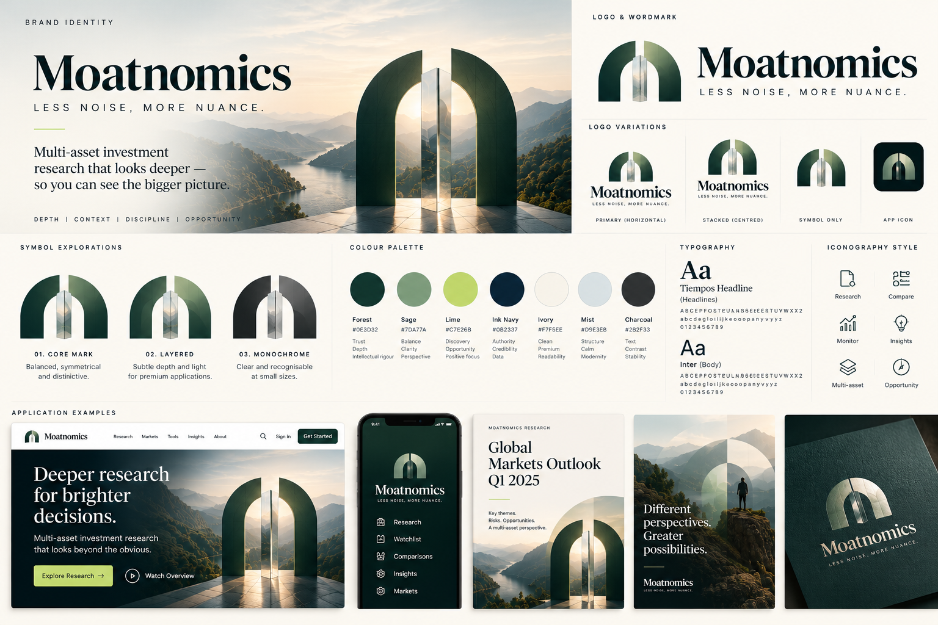
Use this board to compare proposed lockups, symbol-only use, monochrome treatment, palette, typography, iconography and example applications.

Reference C. Cross-channel identity styleboard
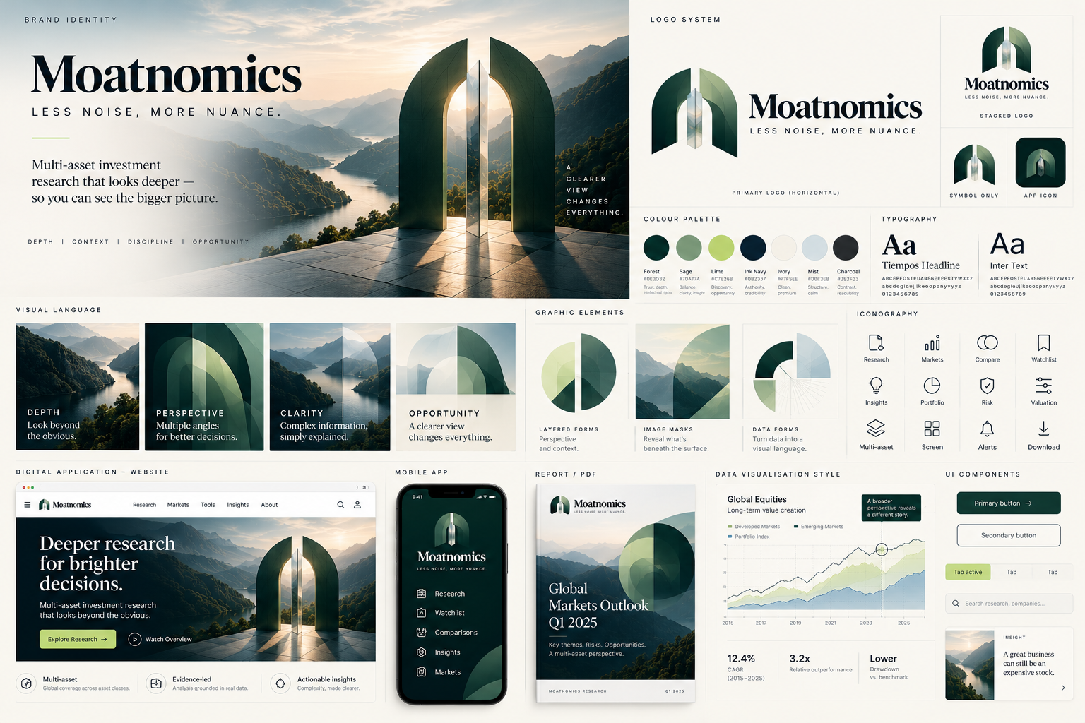
Use this board as a broad reference across web, mobile, research reports, chart styling and UI components. These are illustrative concept explorations, not final production artwork.

Appendix A.1. What the production team should carry forward
- The split-arch and central mirror as the recognisable core symbol, preserving the selected sophisticated dimensional concept.
- The sense of depth and a second perspective, used with restraint rather than as a decorative effect everywhere.
- Editorial typography paired with clean, legible product typography, subject to licensing and multilingual glyph testing.
- The forest, sage, lime, ink, ivory and mist palette as a provisional hypothesis pending contrast, theme and print validation.
- A consistent visual grammar across product, research reports, charts, content and video, while allowing each channel to prioritise its job.
- The visual boards are references only. Final logo geometry must be delivered as editable vector paths, and mock-ups must be rebuilt from approved assets and current product requirements.

