Ski lift program user manual

Table of Contents

**Installation manual**

**Application manual****:**

Login Page

Owner Panel

Administrator Panel

Cashier Panel

Open/Close Lift Page

Add New Lift Page

Add User Page

Company summary Page

Delete Lift Page

Delete User Page

Modify Lift Schedule Page

Modify Tariff Page

Installation manual

1. Open Ski lift application installation .msi file.
2. Press “Dalej”

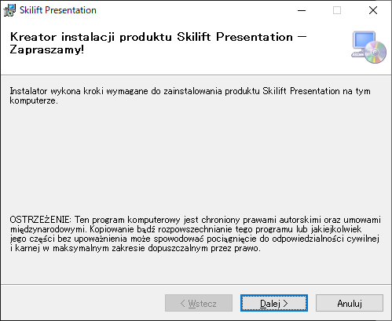

1. Select installation folder and press “Dalej”.

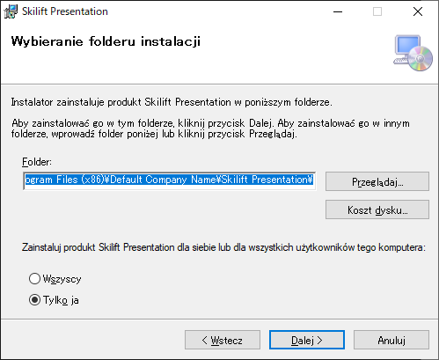

1. Press “Dalej” to confirm and start the installation.

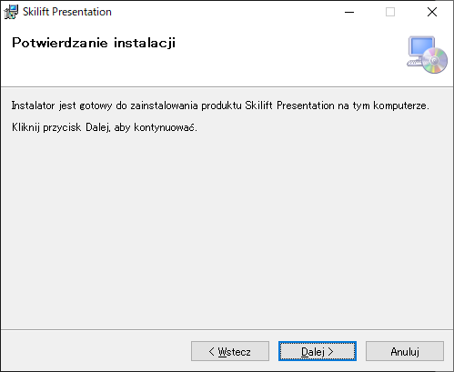

1. After the installation is finished click “Zamknij” to close the window.

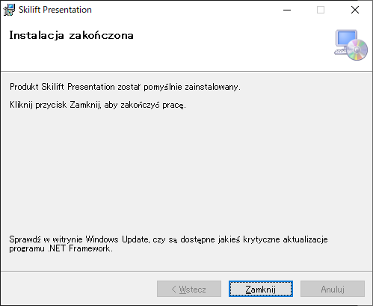

After a successful installation you can open the program by running E-SkiLift.exe file in the installation folder or by using a desktop shortcut.

**Application manual**

**Login Page**

Login - enter your login

Password - enter your password

Confirm by pressing Login button or enter key

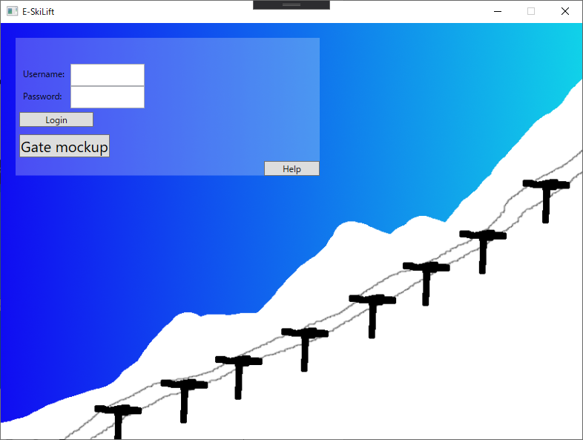

Admin panel

Owner panel

Cashier panel

**Owner Panel**

Click a button for corresponding function of the owner panel

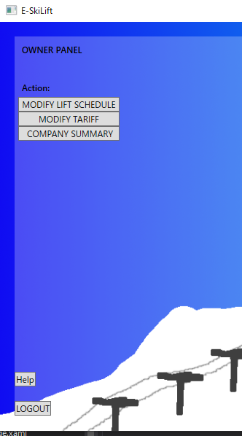

Modify lift schedule page

Modify tariff page

Company summary page

Click logout button to logout.

**Administrator Panel**

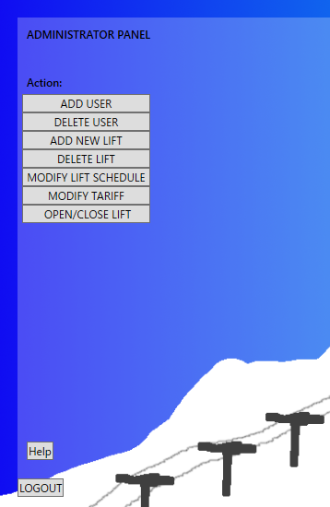

Click a button for corresponding function of the admin panel

Add user page

Delete user page

Add new lift page

Delete lift page

Modify lift schedule page

Modify tariff page

Open/Close lift page

**Cashier Panel**

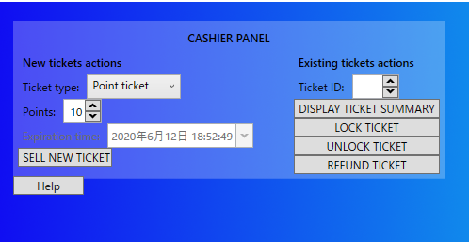

This Panel is divided into 2 parts:

New ticket actions allow you to sell new ticket

First you need to select the ticket type

For the point ticket you need to select point count

For the ski pass you need to select pass expiration time

Click 'Sell New Ticket' to sell the ticket

Existing ticket actions allows you to display ticket summary, lock ticket or refund ticket.

To do it you need to inset Ticket Id in 'Ticket ID' Field and click the corresponding button.

**Open/Close Lift Page**

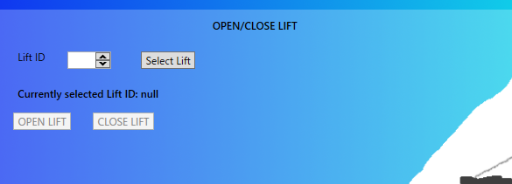

Lift ID - insert lift id of the lift you want to modify

Then click Select lift button and open or close selected lift by clicking 'Open Lift' or 'Close Lift' buttons

**Add New Lift Page**

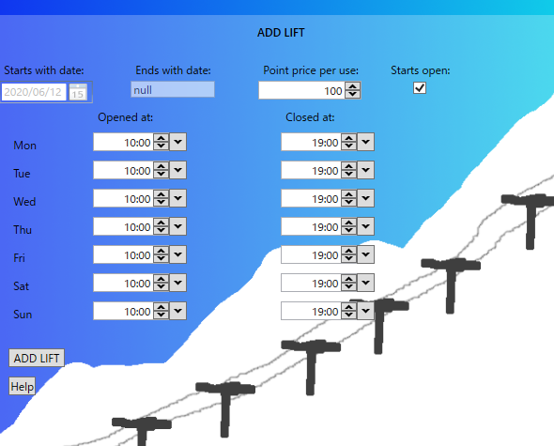

Starts with date - enter lift operation start date

Ends with date - enter lift operation end date (empty if undefined)

Point price per use - Insert point price per 1 use of lift for point tickets

Starts open - check if lift should start open

Under 'Opened at' and 'Closed at' labels insert lift schedule for corresponding days of the week.

**Add user page**

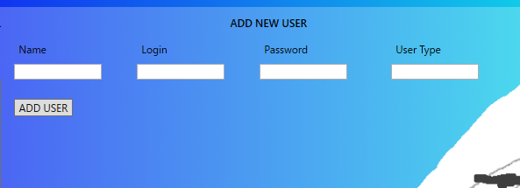

Name - insert user name

Login - insert user login

Password - enter user password

User Type - insert user type (admin, owner, cashier)

Confirm by pressing Add User button

**Company summary page**

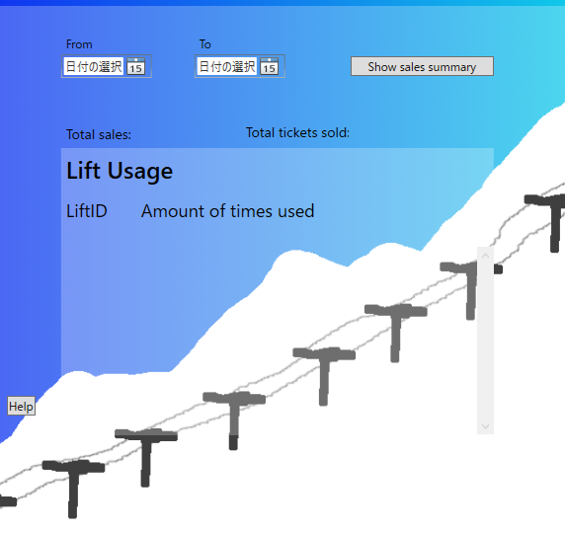

From - select summary start date

To - select summary end date

Click 'Show lift usage' or 'Show sales summary' button to show the corresponding summary.

**Delete Lift Page**

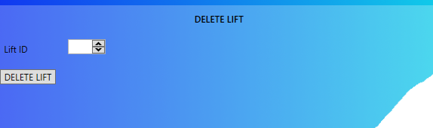

Lift ID - insert lift id of the lift you want to delete

Click Delete Lift button to delete selected lift

Return to start page

**Delete User Page**

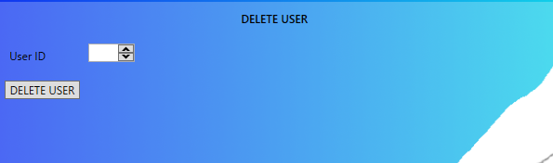

User ID - insert id of the user you want do delete

Confirm by pressing Delete User button

Return to start page

**Modify Lift Schedule Page**

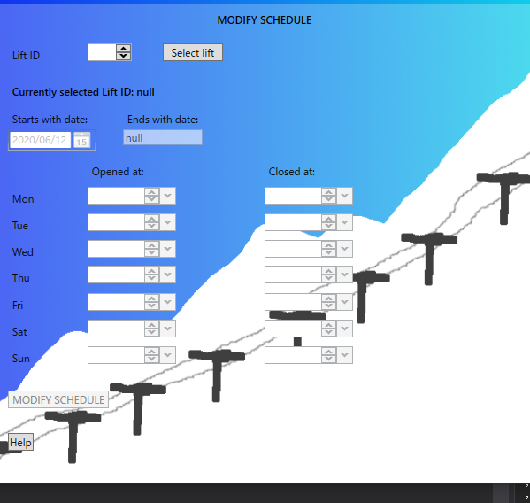

Lift ID - insert lift id of the lift you want to modify

Then click Select lift button

After that you can modify the selected lift schedule

Starts with date - enter lift operation start date

Ends with date - enter lift operation end date (empty if undefined)

Under 'Opened at' and 'Closed at' labels insert lift schedule for corresponding days of the week.

Click Modify Schedule button to confirm changes

**Modify Tariff Page**

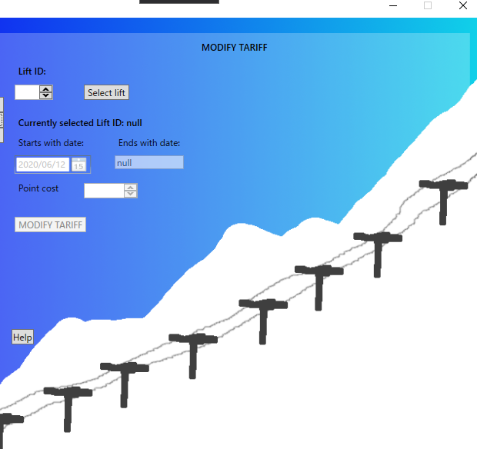

Lift ID - insert lift id of the lift you want to modify

Then click Select lift button

After that you can modify the selected lift schedule

Starts with date - enter tariff start date

Ends with date - enter tariff end date (empty if undefined)

Point cost - insert lift point cost per 1 use

Confirm by pressing Modify Tariff