Jakub Szpunar

CS4480

WS Lab 5

1. There are four headers in UDP: Source Port, Destination Port, Length and Checksum. They are seen in the following image: 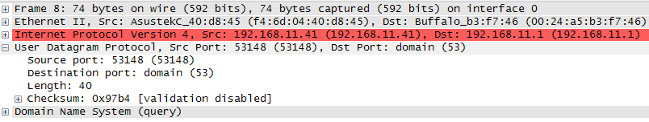
2. The length of each field is two bytes (16 bits). Below is an image taken showing the two bytes of the length field when length in the above image was selected:

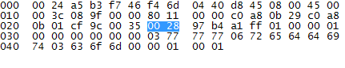

1. The length field is the length in bytes of the datagram (header + data). Below we see the DNS query highlighted and see it is 32 bytes long. When we add the 8 byte header to this, we get 40 bytes, the same as the length field:

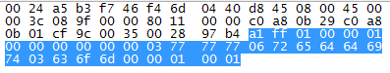

1. The Most data in a UDP packet possible is Max IP packet size - IPv4 Header – UDP header. If we assume the IPv4 header is 20 bytes, and the max packet size is 216-1 (lax length field), we get 65,535-20-8 = 65,507. If we ignore the IPv4 constraint, we get 65,535 (max of 16 bit number) -8 (header), or 65,527.
2. The largest possible source is 216-1 or 65,535. Due to the field being a 16 bit number.
3. The protocol number of UDP is 17 as seen in the below image. In hex this is 0x11.



1. Below is an image of the UDP reply to the query seen in question 1. We see that the port numbers are matching, but switched. That is, in the response the source port is the destination port of the original query, and in the response the destination port is the source port of the original query.

