Advanced application: Stackery
Jakub Dóka

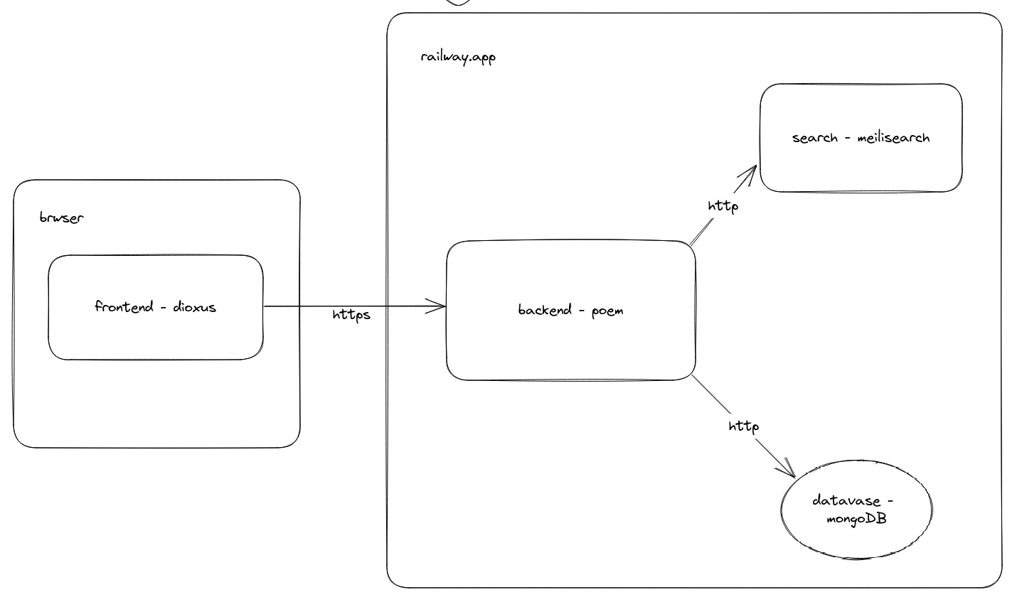
topology

Source code can be found here. Website shoud be online here. The project is fully written in rust.

Backend

The backedn microservice exposes API to frontend and manages comunication with database and search engine. The exposesd endpoints are devided into two groups:

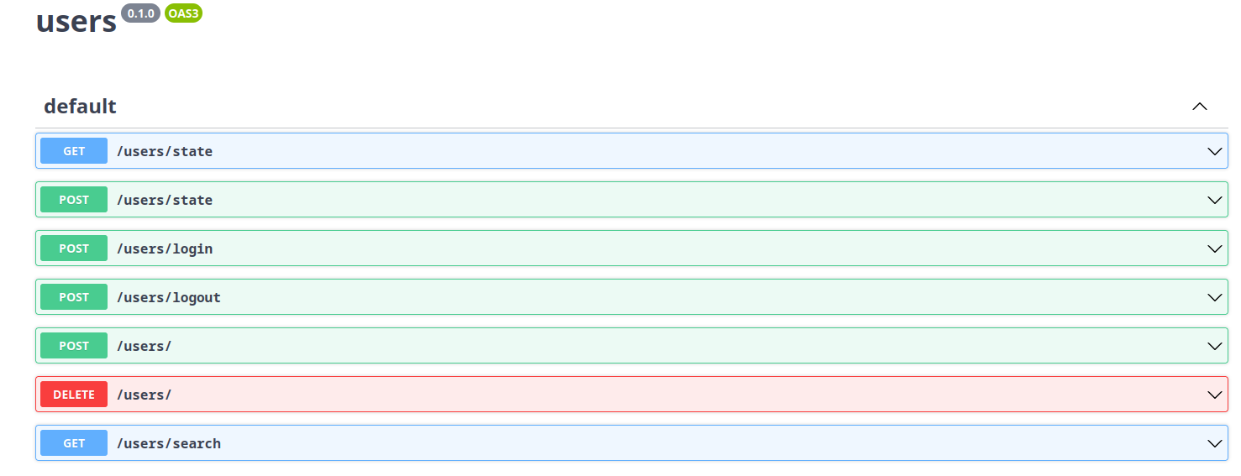
user api can be found here
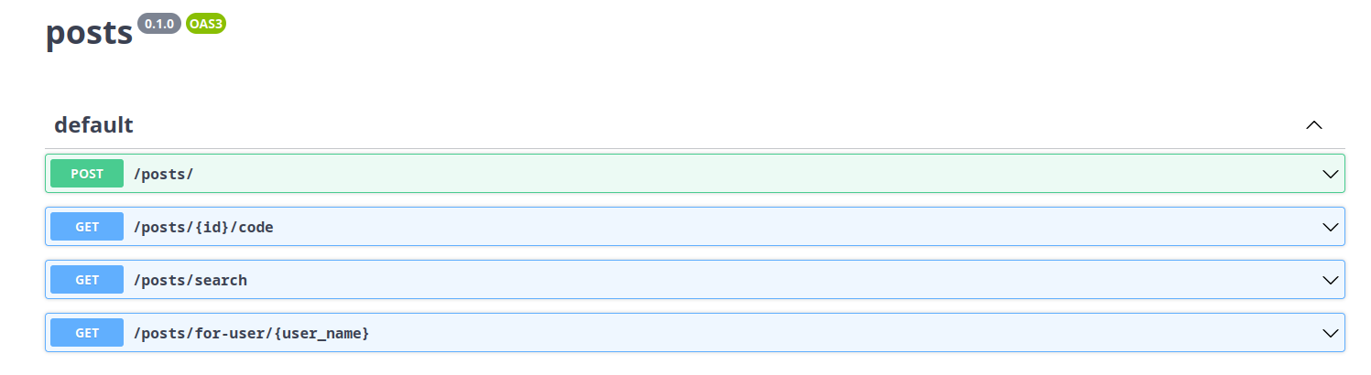
posts api can be found here

I tried to separate the concerns in the code so users endpoind is never accessing posts and vice versa.

User authentificantion process goes as follows:
1. user inpust his password in browser.
2. Password is hashed at frontend.
3. Login request is send to backend.
4. Backend hashes the hash and checks it against the database.
5.if: user with given password hash hash is forund:
User obtains a session cookie (cookie is encripted by the server).
5.else: user is not found:
Unauthorized status is returned.

After user logs in, he can among other things, request his cached session data. As of right now, session data only stores the theme user chose, but more information up to 10MB is planned.

Each group has search endpooint exposed, that offers searching interface to the search microservice. It offers responsive, search as you type experience.

All of the endpoints, except users/register, that in some way modify database are guarded by requiring session cookie from the user. This includes session state updates and creation of posts since these requests are also directly bound to users identity.

Frontend

Frontend is a webassembly application powered by dioxus framework. The app fints in under 800KB wasm binary and loads almost instantly. The page it self is very programming focused which affest its design.

Upon loading the page you are presented with home static page that will contain the full documentation of Stac programming language (not yet). The about page show some information also mentioned here. The register and login pages are displayed if you users session is not detected. Once user registers and logs in, these sections will be hidden and access to post section is granted.

Users name, logout buttonw and theme button also replace the “anonymous” in the top right corner.

The post page embeds a vim like code editor (absolutly unusable on phones) that supporst syntax highlighting and error messages. Once the user is satisfied with their post and the name is unique, they can publish it. From the point of publishing, the post is not searchable and visible from their profile.
Search tab is probably the most complex one. It contains sub sections for searching users, posts and a help section.

User search bar allows browser like searching of users with responsice suggestion list. Once a suggestion is selected, it is filled into search bar and user profile is displayed to the user.

Post search bar can search withing posts for any word sequence, either in name, author, or code. If searching only within persons posts is desired, user can click on the authors name and his query will be modified.

Database

Current database in use is mongoDB, There is no real insentive to use it other then its great programicall api.

Search

Search engine in use is called meilisearch, reason to use is si rather simple, Its open source and easi to setup (also written in rust).

