Project Everest Report

Author: Jakub Bartnik

GitHub URL

https://github.com/jakubbartnik/UCDPA_jakubbartnik

Abstract

This review contains the summary about impact of introducing new safety gear for climbing versus expedition survival that climbed in area of Hymalaya Nepal within last 100 years. Implememntation process contain six parts: setting goal, data preparation, data exploration, data modeling. The review will explain how all that was done by myself and what conclusion I made from results.

* All this report content can be found in my python notebook including the code.

Introduction

I decided upon this topic as climbing is, quite simply, my passion. As this is my first Data Science Project I felt that I should choose a topic that I am familiar with.

The aim of this research is to ascertain if, after the introduction of safety equipment such as steel carabiners (1910) or dynamic rope and harness (1964), there has been any improvement in Nepal Himalaya area climber's survival rates. My research is based on a Mount Everest dataset that tracks all expeditions that climbed in area of Nepal Himalaya from 1905 to 2019.

In recent years there have been more deaths on Mount Everest caused by climbers waiting in queues on the mountain between sections than due to failures of equipment or the difficulty of the climb (please refer to article provided in reference section). I would like to determine what the capacity of the mountain is to safely accommodate climbers during the climbing season and predict the number of climbers attempting to climb the mountain over the next two years. Within the dataset there is a field with the title 'Insufficient Supplies'. Analysis of this data I believe can help to indicate the historical point at which queues started to become a feature of attempting to climb Everest. It is my belief that this information will prove useful to expedition organisers when planning their supply requirements for expeditions to the mountain.

Dataset

The Himalayan Database is a compilation of records for all expeditions that have climbed in the Nepal Himalaya. The database is based on the expedition archives of Elizabeth Hawley, a longtime journalist based in Kathmandu, and it is supplemented by information gathered from books, alpine journals and correspondence with Himalayan climbers.

The data cover all expeditions from 1905 through Spring 2019 to more than 465 significant peaks in Nepal. Also included are expeditions to both sides of border peaks such as Everest, Cho Oyu, Makalu and Kangchenjunga as well as to some smaller border peaks. Data on expeditions to trekking peaks are included for early attempts, first ascents and major accidents.

Implementation Process

Setting goals
I like to split my main goal from introduction into smaller chunks that will be easier to archive and at the same time makes this review more structured and hopefully readable.
Goal 1 is to check impact of first climbing carabineer on expedition survival rate. Carabiner was developed in 1910. Therefore I am going to split all dataframe into two sets and compare the falls.
Goal 2 is about introduction of dynamic rope and harness in 1960’s. I am going to split all data and compare periods with and without it.
Goal 3 is to figure out when queues started to be formed and what would be climbers capacity for Mount Everest before it will became a problem.

Data preparation

I started to look at the data manually prior writing this review. Those data are splited between three csv files and I belive for my pourpose I want to merge them all in one file. I going to import all libraries in first code box and keep updating it based on functions I want to use later in the code. This hopefully makes a sense later where I dont have to look over all code boxes in python notebook and run each one of them in case of missing one library.

Reading data from all three csv (expeditions.csv, peaks.csv, members.csv). I am using commands like .shape and .info. Those commands showing me column names and few records for examination but at the same time it gives me number of records. Thanks to that I know that expeditions dataframe is 10364 rows and 16 columns, peak.csv is 467 rows and 8 columns and members.csv is 76519 rows and 21 columns. I am exploring all csv one by one using .head() which shows me five first rows to identify best column I can merge with another dataframe. This is how I identified column ‘peak_id’ to merge expeditions.csv with peak.csv and assigned it to ‘df1’ as temporary dataframe. Next I done the same with my temporary dataframe and members.csv based on ‘expedition_id’ and assigned it to dataframe -’df’. I did used .merge command to combine all three csv’s.

At this point I started looking for empty values in my current dataframe – ‘df’. I am using .isna() function to show all ‘nan’ values. Because I find the column that will make significant meaning on my results I want to take closer look at column ‘death_cause’. That is why I am using df[‘death_cause’].unique() function. Thanks to that I see that value ‘Other’ is not really make more sense then ‘nan’ or ‘unknown’ but it generate more noise so I am replacing all ‘Other’ with ‘nan’.

To limit variables in current dataset that are mainly repeated like year_x and year_y I will drop some of the columns that came after merging. Important columns from expedition.csv is ‘termination_reason’ and ‘expedition_id’, ‘year’. Important columns from peaks.csv is ‘peak_name’ and ‘climbing_status’. Important columns from members.csv is ‘death_cause’.Those I belive are important columns I want to keep. I will drop the following non important columns: trekking_agency, peak_alternative_name, sex, expedition_role, injury_type, injury_height_metres, oxygen_used_x, age, first_ascent_country, hired, success, member_id, highpoint_metres_y, year_y, season_y, peak_name_y, peak_name_x, peak_id_y. Result of dataframe without dropped columns was saved to temporary dataframe ‘cleaning’

Dropped columns did not stopped me to find duplicates in this dataframe but as this review is about expeditions there was no need to have all members listedwhere most of the values were repeated per expedition. Right now i will be able to find all duplicates that can be dropped and makes more sense for this review. I done that based on field ‘expedition_id’. I sorted values and finally dropped it and result saved to ‘exp_dup’.

Stripping down string from expedition_id using simple regex to gain additional 10 points.

Cleaned data I saved to new file clean_everest.csv to avoid running all code boxes in python notebook.

Data exploration

Cleaned data saved as result of cleaning are loaded as ‘dfc’. Features termination_reson and death_cause are nominal i need to convert it to dummy variables. I am doing it using dataframe option ‘.get_dummies’.

To get feeling an overview current dataset I want to show overall procentage of reasons to die in Himalaya based on all 114 years of experience. I am not really curius about exact procentage value but more generic representaion. I am going to represent this using pie chart.

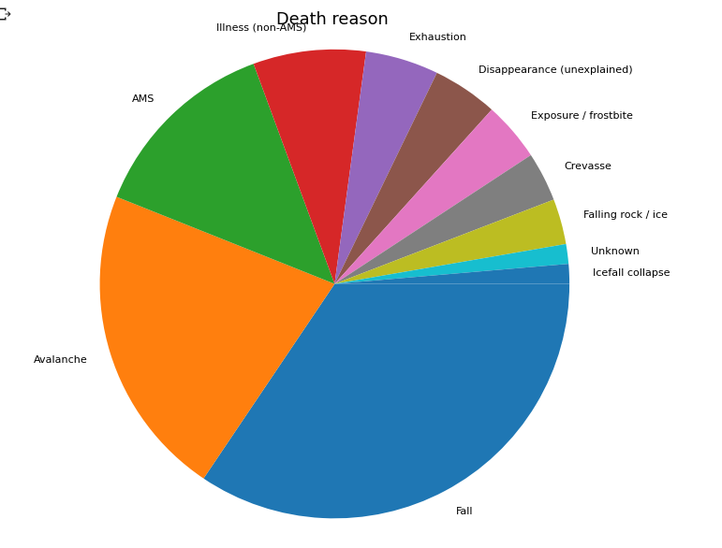
Graph 1. Death reason based on 114 years data

Avalanches, AMS(Alternated Mind status - caused by trauma or intoxication) and Illnes are the main reasons for death after falling.

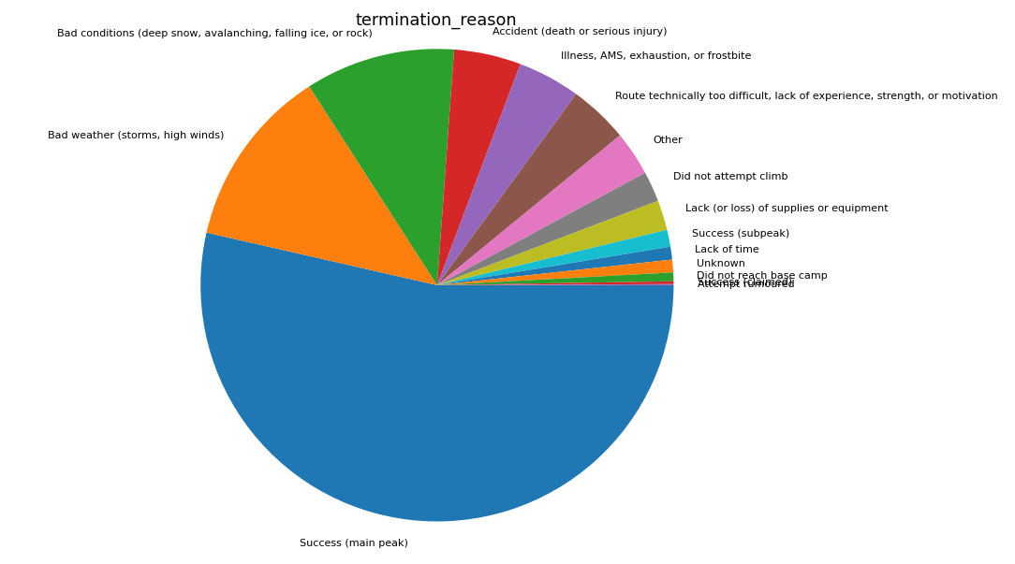
The same chart and same period of time just on termination reason for expeditions.

Graph 2. Termination reason based on 114 years data

This column will get useful further in this paper when I will try to narrow down ‘goal 3’.

Getting back to our goals and split data for goal 1 which is before 1910 assign it to dataframe ‘before1910’ and after 1911 assigned to ‘after1910’ . For goal 2 I will split from 1905 to 1960 and assigned to ‘no_harness_rope’ and from 1961 to 2019 assigned to ‘yes_harnes_rope’.

Before in the cleaning part there were columnes dropped as non-important for this review. At the moment as I am thinking to build predictive model I want to drop another column called 'peak_name' as its not numerical. I am doing it per dataset.

I want to keep exploring to find at least "apparent effect" that reasons are changing within the years.

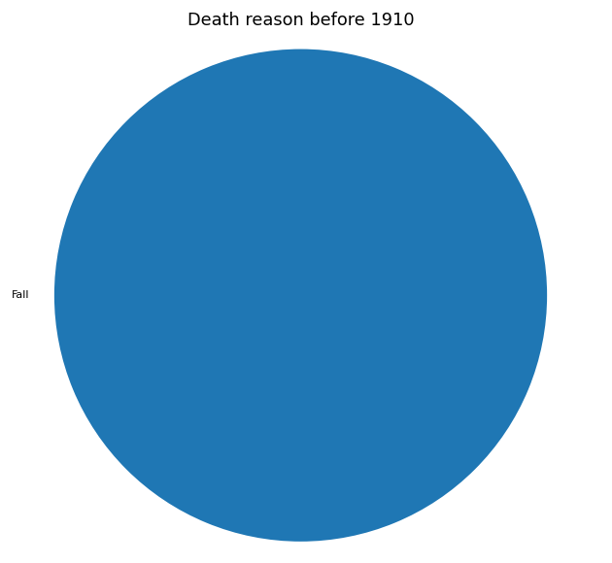
Graph 3: Death reason before 1910

The result is actually schocking it appear that falling was the only reason to die in high montains before 1910. Other reasons like frostbite, ilness or avalanche was not the case in this years. However while looking at amount of records used for this graph its obvious that there was not enough observations.

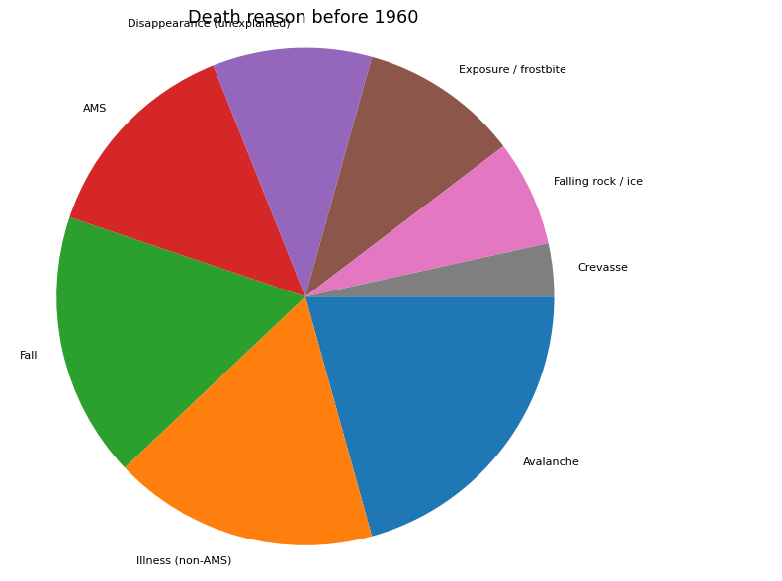
Graph 4: Death reason before 1960

Pie chart for data before 1960 indicate that avalanche and ilness was the biggest reasons to die and falling going into third place.
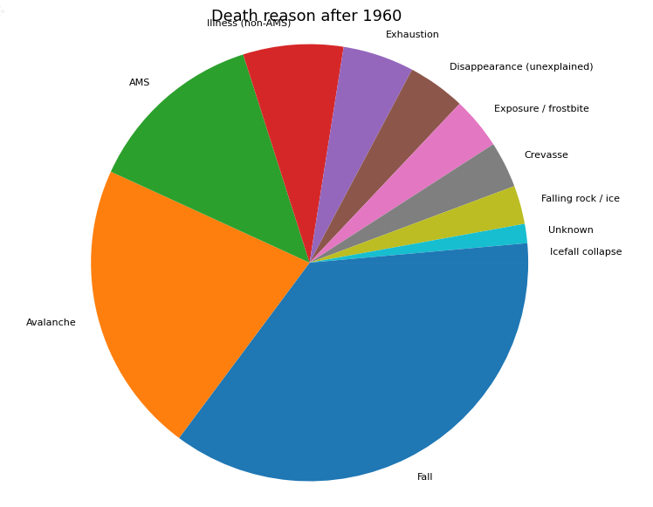

Graph 5: Death reason after 1960

Graphs 5 and 1 are very similar but graphs 3 and 4 indicating that resons were changing along the years .

Data modeling

Results

(include the charts and describe them

Insights

(point out at least 5 insights in bullet points

References

Dataset: https://www.kaggle.com/datasets/majunbajun/himalayan-climbing-expeditions

Article about forming queues on Mount Everest: https://www.theguardian.com/world/2020/jun/06/everyone-is-in-that-fine-line-between-death-and-life-inside-everests-deadliest-queue

Convert nominal to numerical values: https://machinelearningmastery.com/one-hot-encoding-for-categorical-data/

Generating more samples: https://machinelearningmastery.com/generate-test-datasets-python-scikit-learn/

Comparing: https://towardsdatascience.com/how-to-compare-two-or-more-distributions-9b06ee4d30bf

