Methodology
.
.
.
To evaluate the effect of burial on germination of L. uniflora seeds we set up an experiment with three different treatments and control. Seeds from the place of origin were covered by 1, 3 and 5 cm thick layer of sterilized sand (250°C for one hour), and one control. As control we used the same seeds, but they were sown on filter paper without any coverage. We used 75 seed per treatment (300 in total).
This experiment was done twice with the same set up and sample size. For the first time we ran the experiment inside of the climatic chamber with the same set up as in case of ....citace (photoperiod 16/8 (day/night), day temperature 20° C and night temperature 8° C). Because we were curious if the observed pattern will be similar also outside of the laboratory conditions, we set up the second trial, which took place inside of the open glasshouse with free air circulation. We did not use actual natural conditions, because heavy rain could change the size of soil layer therefore also the outcome of our experiment.
Both experiments were terminated after 60 days and germination was evaluated. We counted the number of seeds, which were able to break through the sand. We also examined the Petri dishes for seeds, which germinated, but did not make it to the top.
For quantification of the burial effect on germination of L. uniflora seeds we used generalized linear model with binomial distribution of errors. Our working hypothesis was that number of responding seeds will degrease with increasing soil depth.
We used generalized linear model because we were interested in pure effect of seed burial and we had to filter out the effect of other confounding variables (experimental setup, different seed origin, etc.) and also to rule out the interaction between the independent variables (experimental setup and soil depth). For estimation of soil depth, which is impenetrable for 95 % of seeds, was used function dose.p from package MASS (Venables & Ripley, 2002).
The significance level was set at 5%. Data management and all analysis were carried out using the R statistical program (R Core Team, 2015).

Results

In total, from 600 seeds of L. uniflora only 83 were able to germinate, 17 in the laboratory (n = 300) and 66 in the glasshouse experiment (n = 300). Germination probability of control groups in laboratory and glasshouse experiment was 13.3 % and 53.3 %, respectively.
We confirmed significant difference in germination between our experimental set-ups (z value = -6.032, p < 0.001) and also in case of increasing soil depth (z value = -6.993, p < 0.001).
We did not find any interaction between experimental design and treatments (soil depth) (z value = 0.857, p = 0.391) therefore the effect of soil depth should be constant.
These findings supporting our hypothesis that number of successfully germinated seeds of L. uniflora is declining with increasing soil depth (see Fig. 1).
Estimation of mean soil depth, which was impenetrable for 95 % seeds, is highly influenced by seed germination probability, therefore is different for each experiment. In glasshouse experiment we estimated that 2.54 cm (SE = 0.305) was enough to prevent germination of 95 % seeds. In laboratory it was 1.06 cm (SE = 0.229). These numbers, based on our observation, seems reasonable. We did not observe any successful germination in dishes with more than 3 cm of soil, but after termination of the experiment we found several failed attempts to do so.
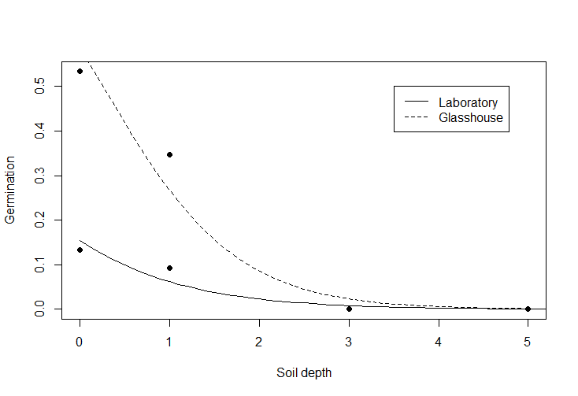
Fig. 1. Generalized linear models of germination probability on soil depth for laboratory and glasshouse experiment.

References
R Core Team 2015: R: A language and environment for statistical computing.
Venables W.N. & Ripley B.D. 2002: Modern Applied Statistics with S. Springer, New York.

