Littorella uniflora

Pavel Jakubec

# Litorela report

## Effect of soil type on germination of Litorela uniflora

### Model:

* succ = number of germinated seeds
* fail = succ - sum (all seeds)
* treat = soil type

data=read.csv ("data/prolicovani_ruzne_substraty_2.csv", header=TRUE, sep=";")

#Binomial GLM model  
mod <- glm(cbind(succ, fail) ~ treat, data=data,family=binomial)  
mod

##   
## Call: glm(formula = cbind(succ, fail) ~ treat, family = binomial, data = data)  
##   
## Coefficients:  
## (Intercept) treatcontrol treatmud treatpeat   
## -1.9924 1.9524 0.8398 -0.9520   
## treatsand treatsand_clay treatsand_mud treatsand_peat   
## -0.3212 -1.1856 0.1771 -1.4837   
## treattopsoil   
## -18.1260   
##   
## Degrees of Freedom: 89 Total (i.e. Null); 81 Residual  
## Null Deviance: 249.9   
## Residual Deviance: 107 AIC: 233.1

summary(mod)

##   
## Call:  
## glm(formula = cbind(succ, fail) ~ treat, family = binomial, data = data)  
##   
## Deviance Residuals:   
## Min 1Q Median 3Q Max   
## -2.6543 -0.9036 -0.1997 0.5192 2.7690   
##   
## Coefficients:  
## Estimate Std. Error z value Pr(>|z|)   
## (Intercept) -1.9924 0.3077 -6.475 9.50e-11 ***  
## treatcontrol 1.9524 0.3670 5.319 1.04e-07 ***  
## treatmud 0.8398 0.3867 2.172 0.0299 *   
## treatpeat -0.9520 0.5525 -1.723 0.0849 .   
## treatsand -0.3212 0.4656 -0.690 0.4903   
## treatsand_clay -1.1856 0.5959 -1.990 0.0466 *   
## treatsand_mud 0.1771 0.4216 0.420 0.6744   
## treatsand_peat -1.4837 0.6621 -2.241 0.0250 *   
## treattopsoil -18.1260 1417.4364 -0.013 0.9898   
## ---  
## Signif. codes: 0 '***' 0.001 '**' 0.01 '*' 0.05 '.' 0.1 ' ' 1  
##   
## (Dispersion parameter for binomial family taken to be 1)  
##   
## Null deviance: 249.93 on 89 degrees of freedom  
## Residual deviance: 107.05 on 81 degrees of freedom  
## AIC: 233.08  
##   
## Number of Fisher Scoring iterations: 17

#Testing effect of treatment  
anova(mod, test="Ch")

## Analysis of Deviance Table  
##   
## Model: binomial, link: logit  
##   
## Response: cbind(succ, fail)  
##   
## Terms added sequentially (first to last)  
##   
##   
## Df Deviance Resid. Df Resid. Dev Pr(>Chi)   
## NULL 89 249.93   
## treat 8 142.88 81 107.05 < 2.2e-16 ***  
## ---  
## Signif. codes: 0 '***' 0.001 '**' 0.01 '*' 0.05 '.' 0.1 ' ' 1

#Coefficient for each treatment  
coef <- coef(mod)  
control <- inv.logit(coef[1]+coef[2])  
mud <- inv.logit(coef[1]+coef[3])  
peat <- inv.logit(coef[1]+coef[4])  
sand <- inv.logit(coef[1]+coef[5])  
sand_clay <- inv.logit(coef[1]+coef[6])  
sand_mud <- inv.logit(coef[1]+coef[7])  
sand_peat <- inv.logit(coef[1]+coef[8])

### Results

Effect of soil type is statistically significant.

### Residuals

Residuals behave normaly and model is fitting the data well.

#see what is going on with residuals  
par(mfrow=c(2,2))  
plot(mod)

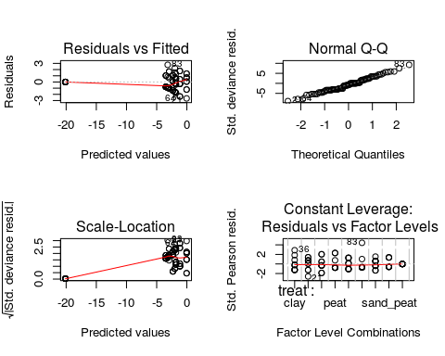

par(mfrow=c(1,2))  
rd=residuals(mod)  
plot(rd)  
qqnorm(residuals(mod, type="deviance"))  
abline(a=0,b=1)

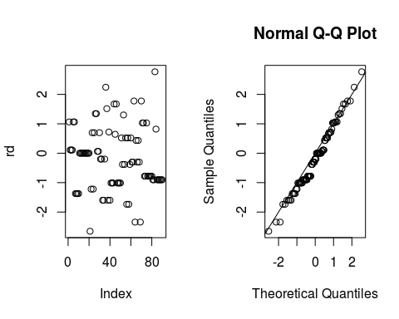

### Bar plot:

#summary for ploting  
sumary.dev = summarySE (data,   
 measurevar="succ", groupvars="treat")  
sumary.dev$succ <- sumary.dev$succ*10  
sumary.dev$se <- sumary.dev$se*10  
sumary.dev$sd <- sumary.dev$sd*10  
sumary.dev$ci <- sumary.dev$ci*10  
sumary.dev <- sumary.dev[-(9),]  
  
#Plotting barplot of germination rates on different soils  
p = ggplot (sumary.dev, aes (y=succ, x=reorder(treat,succ)))  
p2=p + stat_summary(fun.y=mean, geom="bar", position=position_dodge())+  
 xlab("Germination substrate")+  
 ylab("Mean germination rate (%)")+  
 geom_errorbar(aes(ymin=succ-se, ymax=succ+se),  
 width=.2, # Width of the error bars  
 position=position_dodge(.1))  
p3=p2+ coord_flip()  
label.df1 <- data.frame(treat="control", succ=57)  
label.df2 <- data.frame(treat=c("mud", "sand_peat", "sand_clay" ),succ=c(31,5.5,8))  
p3+scale_x_discrete(labels=c("Sand+Peat", "Sand+Clay","Peat", "Sand", "Clay", "Sand+Fishpond sediment", "Fishpond sediment", "Control"))+geom_text(data = label.df1, label = "***", nudge_x = -0.1)+geom_text(data=label.df2, label="*", nudge_x = -0.1)

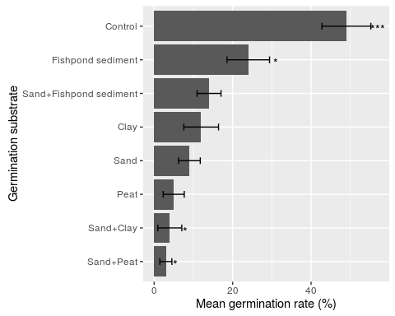

#save the output graph  
ggsave("outputs/substrate.tiff",dpi=100, scale=1.5)

## Saving 7.5 x 6 in image

### Germination probability (%)

sumary.dev

## treat N succ sd se ci  
## 1 clay 10 12 13.984118 4.422166 10.003635  
## 2 control 10 49 19.692074 6.227181 14.086861  
## 3 mud 10 24 17.126977 5.416026 12.251901  
## 4 peat 10 5 8.498366 2.687419 6.079365  
## 5 sand 10 9 8.755950 2.768875 6.263630  
## 6 sand_clay 10 4 9.660918 3.055050 6.911004  
## 7 sand_mud 10 14 9.660918 3.055050 6.911004  
## 8 sand_peat 10 3 4.830459 1.527525 3.455502

rm(list=ls())

## THE END

## Effect of place of origin on germination of Littorella uniflora

### Model:

* succ = number of germinated seeds
* fail = succ - sum (all seeds)
* loc = place of origin

### Results

Effect of place of origin is statisticly significant for germination rate of L. uniflora.

mod <- glm(cbind(succ, fail) ~ loc, data=data,family=binomial)  
mod

##   
## Call: glm(formula = cbind(succ, fail) ~ loc, family = binomial, data = data)  
##   
## Coefficients:  
## (Intercept) lockr locla locmr locno   
## -3.5973 1.4721 1.1550 -0.7068 -17.3653   
## locos locry locst   
## 1.7255 1.3237 0.4193   
##   
## Degrees of Freedom: 21 Total (i.e. Null); 14 Residual  
## Null Deviance: 33.57   
## Residual Deviance: 14.82 AIC: 71.65

summary(mod)

##   
## Call:  
## glm(formula = cbind(succ, fail) ~ loc, family = binomial, data = data)  
##   
## Deviance Residuals:   
## Min 1Q Median 3Q Max   
## -2.0418 -0.7269 -0.0001 0.3858 1.3132   
##   
## Coefficients:  
## Estimate Std. Error z value Pr(>|z|)   
## (Intercept) -3.5973 0.7167 -5.019 5.19e-07 ***  
## lockr 1.4721 0.8085 1.821 0.0686 .   
## locla 1.1550 0.8336 1.386 0.1659   
## locmr -0.7068 1.2358 -0.572 0.5674   
## locno -17.3653 4323.6575 -0.004 0.9968   
## locos 1.7255 0.7931 2.176 0.0296 *   
## locry 1.3237 0.8193 1.616 0.1062   
## locst 0.4193 0.9279 0.452 0.6514   
## ---  
## Signif. codes: 0 '***' 0.001 '**' 0.01 '*' 0.05 '.' 0.1 ' ' 1  
##   
## (Dispersion parameter for binomial family taken to be 1)  
##   
## Null deviance: 33.571 on 21 degrees of freedom  
## Residual deviance: 14.816 on 14 degrees of freedom  
## AIC: 71.651  
##   
## Number of Fisher Scoring iterations: 17

anova(mod, test="Ch")

## Analysis of Deviance Table  
##   
## Model: binomial, link: logit  
##   
## Response: cbind(succ, fail)  
##   
## Terms added sequentially (first to last)  
##   
##   
## Df Deviance Resid. Df Resid. Dev Pr(>Chi)   
## NULL 21 33.571   
## loc 7 18.755 14 14.816 0.00899 **  
## ---  
## Signif. codes: 0 '***' 0.001 '**' 0.01 '*' 0.05 '.' 0.1 ' ' 1

### Residuals

Residuals behave normaly therefore model is fitting the data well.

par(mfrow=c(2,2))  
plot(mod)

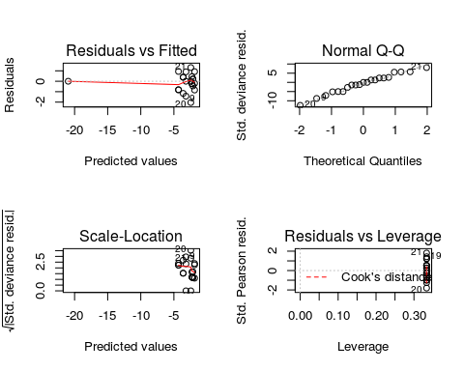

par(mfrow=c(1,2))  
rd=residuals(mod)  
plot(rd)  
qqnorm(residuals(mod, type="deviance"))  
abline(a=0,b=1)

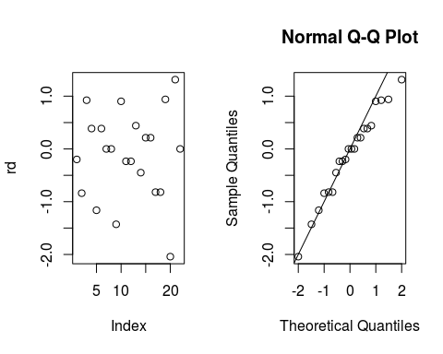

### Bar plot

sumary.dev = summarySE (data, measurevar="succ", groupvars="loc")  
sumary.dev$succ <- sumary.dev$succ/25*100  
sumary.dev$se <- sumary.dev$se/25*100  
sumary.dev$sd <- sumary.dev$sd/25*100  
sumary.dev$ci <- sumary.dev$ci/25*100  
sumary.dev <- sumary.dev[-(5),]  
  
  
p = ggplot (sumary.dev, aes (y=succ, x=reorder(loc, succ)))  
p + stat_summary(fun.y=mean, geom="bar", position=position_dodge())+  
 xlab("Locality")+  
 ylab("Mean germination (%)")+  
 geom_errorbar(aes(ymin=succ-se, ymax=succ+se),  
 width=.2, # Width of the error bars  
 position=position_dodge(.9))

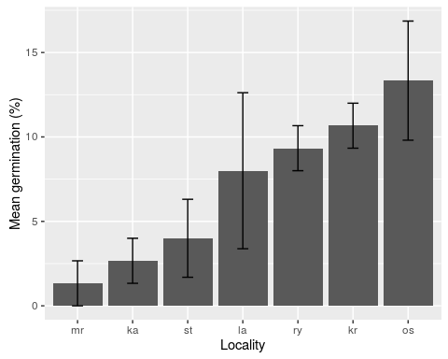

#save the output graph  
ggsave("outputs/locality.tiff",dpi=100, scale=1.5)

## Saving 7.5 x 6 in image

### Germination probability (%)

sumary.dev

## loc N succ sd se ci  
## 1 ka 3 2.666667 2.309401 1.333333 5.736870  
## 2 kr 3 10.666667 2.309401 1.333333 5.736870  
## 3 la 3 8.000000 8.000000 4.618802 19.873102  
## 4 mr 3 1.333333 2.309401 1.333333 5.736870  
## 6 os 3 13.333333 6.110101 3.527668 15.178332  
## 7 ry 3 9.333333 2.309401 1.333333 5.736870  
## 8 st 3 4.000000 4.000000 2.309401 9.936551

rm(list=ls())

### THE END

## Germination under a layer of soil (climabox)

### Model:

* succ = number of germinated seeds
* fail = succ - sum (all seeds)
* depth = soil layer depth

### Results

Effect of substrate depth is statistically significant.

#put together some model  
mod <- glm(cbind(succ, fail) ~ depth, data=substr,family=binomial)  
mod

##   
## Call: glm(formula = cbind(succ, fail) ~ depth, family = binomial, data = substr)  
##   
## Coefficients:  
## (Intercept) depth   
## -1.696 -1.019   
##   
## Degrees of Freedom: 11 Total (i.e. Null); 10 Residual  
## Null Deviance: 38.3   
## Residual Deviance: 15.95 AIC: 33.88

summary(mod)

##   
## Call:  
## glm(formula = cbind(succ, fail) ~ depth, family = binomial, data = substr)  
##   
## Deviance Residuals:   
## Min 1Q Median 3Q Max   
## -1.84721 -0.77249 -0.44611 0.09039 1.71574   
##   
## Coefficients:  
## Estimate Std. Error z value Pr(>|z|)   
## (Intercept) -1.6965 0.2984 -5.685 1.31e-08 ***  
## depth -1.0189 0.3300 -3.088 0.00202 **   
## ---  
## Signif. codes: 0 '***' 0.001 '**' 0.01 '*' 0.05 '.' 0.1 ' ' 1  
##   
## (Dispersion parameter for binomial family taken to be 1)  
##   
## Null deviance: 38.304 on 11 degrees of freedom  
## Residual deviance: 15.950 on 10 degrees of freedom  
## AIC: 33.88  
##   
## Number of Fisher Scoring iterations: 6

anova(mod, test="Ch")

## Analysis of Deviance Table  
##   
## Model: binomial, link: logit  
##   
## Response: cbind(succ, fail)  
##   
## Terms added sequentially (first to last)  
##   
##   
## Df Deviance Resid. Df Resid. Dev Pr(>Chi)   
## NULL 11 38.304   
## depth 1 22.354 10 15.950 2.268e-06 ***  
## ---  
## Signif. codes: 0 '***' 0.001 '**' 0.01 '*' 0.05 '.' 0.1 ' ' 1

### Residuals

Residuals behave normaly therefore model is fitting the data well.

#see what is going on with residuals  
par(mfrow=c(2,2))  
plot(mod)

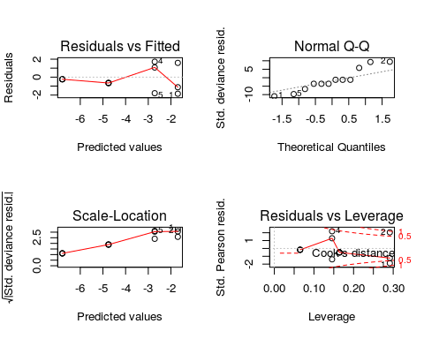

par(mfrow=c(1,2))  
rd=residuals(mod)  
plot(rd)  
qqnorm(residuals(mod, type="deviance"))  
abline(a=0,b=1)

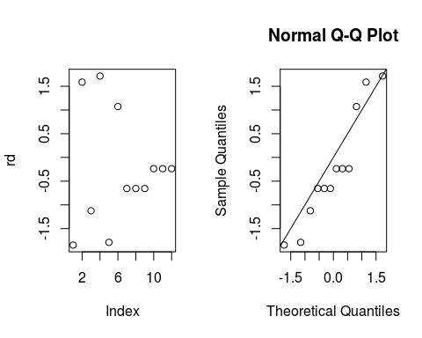

### Barplot

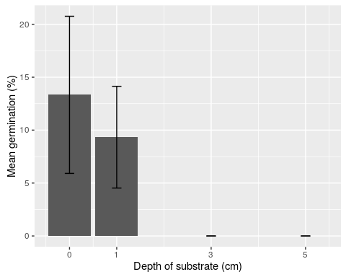

## Saving 7.5 x 6 in image

### Germination probability (%)

sumary.dev

## depth N succ sd se ci  
## 1 0 3 13.333333 12.858201 7.423686 31.94154  
## 2 1 3 9.333333 8.326664 4.807402 20.68458  
## 3 3 3 0.000000 0.000000 0.000000 0.00000  
## 4 5 3 0.000000 0.000000 0.000000 0.00000

rm(list=ls())

### THE END

## Germination under a layer of soil (glasshouse)

### Model:

* y = number of germinated seeds / number of fails
* treat = soil layer depth

## [1] 12

### Results

Effect of soil depth is statistically significant.

#put together some model  
m1=glm(y~treat, family=binomial)  
m1

##   
## Call: glm(formula = y ~ treat, family = binomial)  
##   
## Coefficients:  
## (Intercept) treat   
## 0.3516 -1.3576   
##   
## Degrees of Freedom: 11 Total (i.e. Null); 10 Residual  
## Null Deviance: 118.4   
## Residual Deviance: 9.667 AIC: 35.38

anova(m1, test="Ch")

## Analysis of Deviance Table  
##   
## Model: binomial, link: logit  
##   
## Response: y  
##   
## Terms added sequentially (first to last)  
##   
##   
## Df Deviance Resid. Df Resid. Dev Pr(>Chi)   
## NULL 11 118.404   
## treat 1 108.74 10 9.667 < 2.2e-16 ***  
## ---  
## Signif. codes: 0 '***' 0.001 '**' 0.01 '*' 0.05 '.' 0.1 ' ' 1

summary(m1)

##   
## Call:  
## glm(formula = y ~ treat, family = binomial)  
##   
## Deviance Residuals:   
## Min 1Q Median 3Q Max   
## -1.0936 -1.0812 -0.3000 -0.1792 1.4325   
##   
## Coefficients:  
## Estimate Std. Error z value Pr(>|z|)   
## (Intercept) 0.3516 0.2127 1.653 0.0983 .   
## treat -1.3576 0.2173 -6.248 4.15e-10 ***  
## ---  
## Signif. codes: 0 '***' 0.001 '**' 0.01 '*' 0.05 '.' 0.1 ' ' 1  
##   
## (Dispersion parameter for binomial family taken to be 1)  
##   
## Null deviance: 118.4043 on 11 degrees of freedom  
## Residual deviance: 9.6671 on 10 degrees of freedom  
## AIC: 35.382  
##   
## Number of Fisher Scoring iterations: 5

### Residuals

Residuals behave a bit different than expected, but could be considered normaly distributed.

#see what is going on with residuals  
par(mfrow=c(2,2))  
plot(m1)

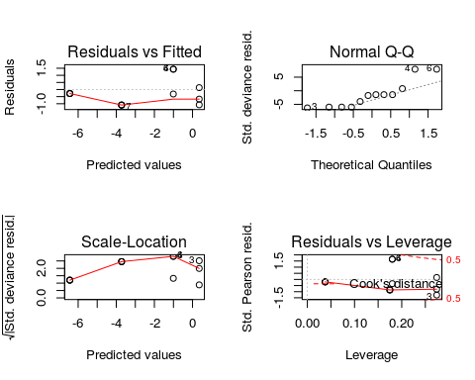

rd=residuals(m1,type = c("deviance"))  
par(mfrow=c(1,2))  
rd=residuals(m1)  
plot(rd)  
qqnorm(residuals(m1, type="deviance"))  
abline(a=0,b=1)

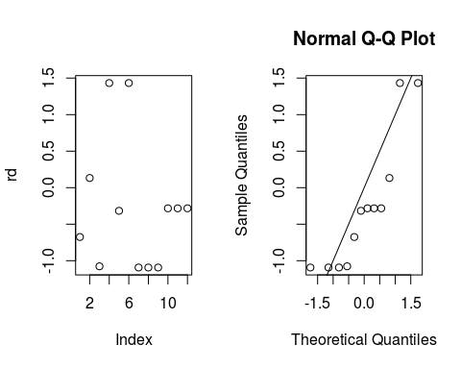

### Barplot

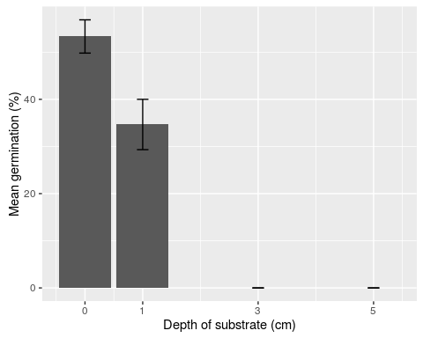

## Saving 7.5 x 6 in image

### Germination probability (%)

sumary.dev

## treat N germ sd se ci  
## 1 0 3 53.33333 6.110101 3.527668 15.17833  
## 2 1 3 34.66667 9.237604 5.333333 22.94748  
## 3 3 3 0.00000 0.000000 0.000000 0.00000  
## 4 5 3 0.00000 0.000000 0.000000 0.00000

rm(list=ls())