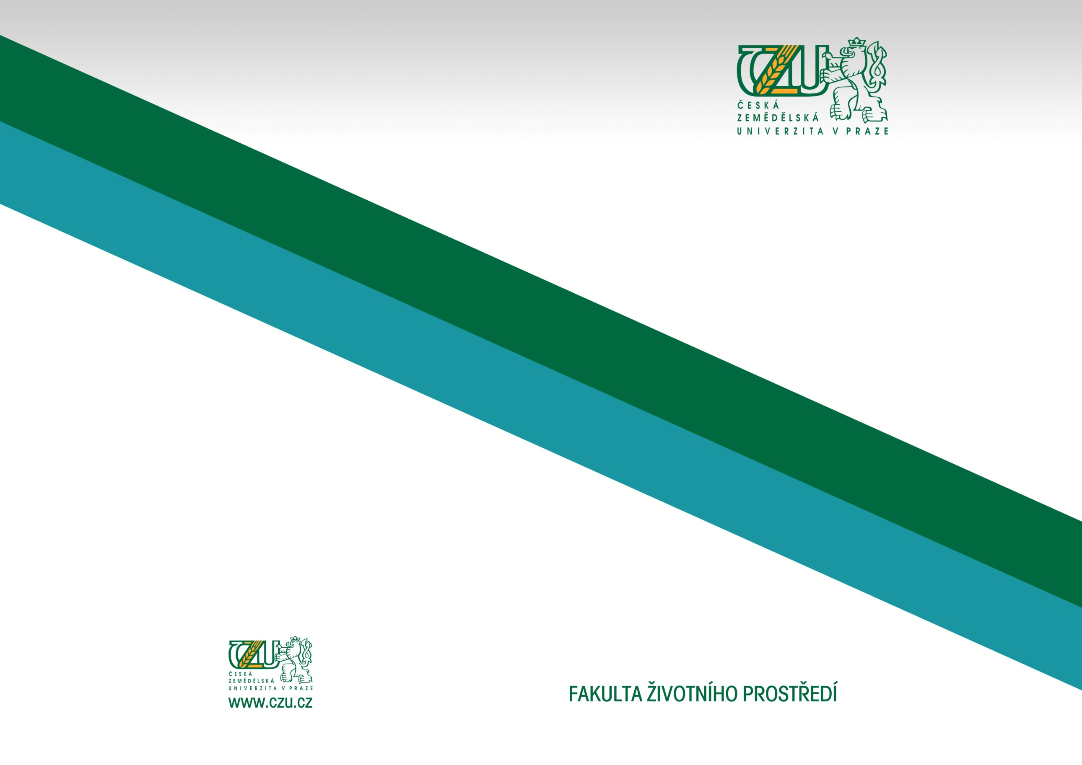
AUTHOR: Pavel Jakubec
SUPERVISOR: Jan Růžička
Department of Ecology

Ecological and evolution strategies of necrophagous beetles (Coleoptera)
thesis extended summary
PRAGUE 2015

