**Trends observed in the original dataset**

**Analysis A**

**Analysis B**

We found that a greater proportion of men voted Green than that of women. The Green party seems especially popular in the zip code areas of 2100 and 2200. There also appeared to be a clear trend of lower-educated people tending more towards Green, while those with higher educations tend more towards Red, maxing out with PhDs. Similarly, the Green party seems to be more popular among younger people, while the popularity of Red peaks between 50 and 60.

Looking at citizenship and marital status, the trends weren’t immediately clear. We however noticed that there aren’t enough samples in certain categories to viably consider their trends. Namely, this was true for non-Danish ethnicities and Widowed people. After grouping, we discovered clearer trends.

It turned out that there was no difference between the voting patterns of Danish nationals and foreigners.

By grouping people by whether they were ever married or not, we discovered the trend that those who were, were more likely to vote Red. This could potentially somewhat correlate with age.

**Analysis C**

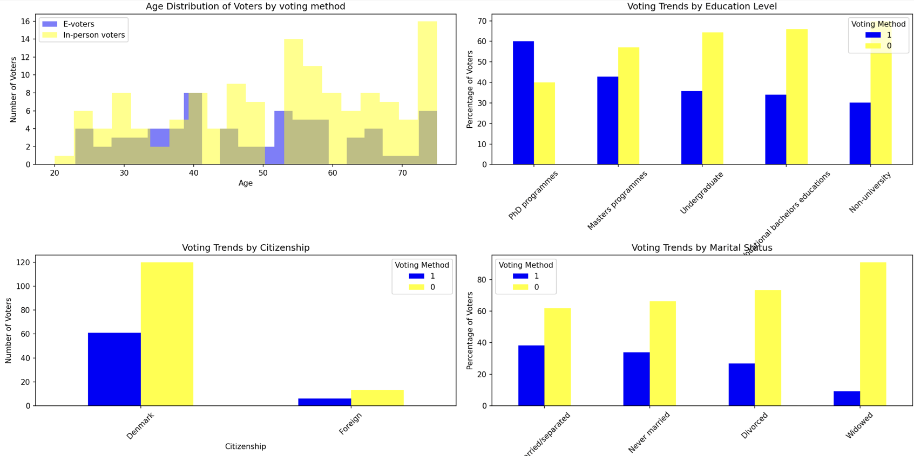

For the voting method, we noticed that those with higher educations were more likely to vote electronically. Other trends were not as clear to make conclusions from, besides the fact that in-person voting was overall more widespread.

**Steps taken to preserve respondents’ anonymity**

This data set has been treated to protect confidentiality. Several methods have been applied to protect the confidentiality: grouping, recoding and top/bottom-coding.

*Removing variables*

The modified dataset does not contain the respondents’ names like the original. The nationality has also been removed due to showing no voting pattern differences.

*Reducing detail in variables by recoding and top/bottom-coding*

Dates of birth were condensed into just the year of birth. Furthermore, they were rounded down to intervals of 3 years. Additionally, ages 75 and older were grouped into a single “75+” category and ages 25 and younger were grouped into “25”. 22 entries were affected by the date of birth cap, while every entry was affected by the general change.

*Reducing detail variables by grouping*

All non-stated and non-university educations were grouped into a new “Non-university” category, Bahelor’s and short cycle higher education were grouped into “Undergraduate”. Master’s and PhD were grouped into “Graduate and Post-graduate”. The rest were kept to preserve the data trends. 156 entries were modified by this change.

All non-Danish citizenships were grouped into a new “Foreign category”. 19 entries were modified by this change.

**Vulnerability analysis pre- and post-anonymisation**

Number of observations violating

2-Anonymity: 0 (PUF file: 0, unmodified data: 0)

3-Anonymity: 0 (PUF file: 0, unmodified data: 0)

5-Anonymity: 0 (PUF file: 0, unmodified data: 0)

Percentage of observations violating

2-Anonymity: 0.00% (PUF file: 0.00%, unmodified data: 5.15%)

3-Anonymity: 0.00% (PUF file: 0.91%, unmodified data: 11.45%)

5-Anonymity: 0.00% (PUF file: 4.67%, unmodified data: 24.45%)