1. SukhmanjeetSingh and John akujobi
2. Inputs:- F (0.25$), H(0.50$) , P(1.0$) outputs:- T (tomato) , H , F
3. States = 9 states

Flipflops = 4 D-flip flops to store 4 bits of states

1. State transition diagram

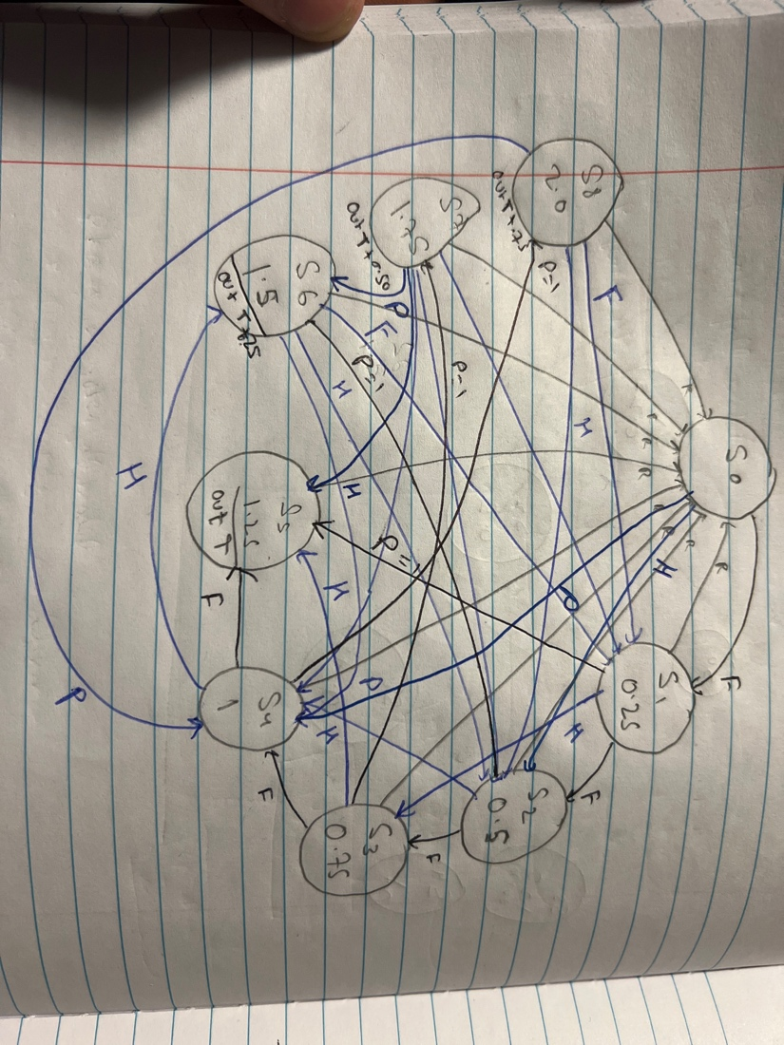

|  |  |  |  |  |  |
| --- | --- | --- | --- | --- | --- |
| Current state | Inputs  (P,H,F) | Next state | Output(T) | Output(F) | Output(H) |
| 0 IDLE | 000 | 0000 | 0 | 0 | 0 |
| 0 | 001 | 0001 | 0 | 0 | 0 |
| 0 | 010 | 0010 | 0 | 0 | 0 |
| 0 | 100 | 0100 | 0 | 0 | 0 |
| 1 Farth | 000 | 0001 | 0 | 0 | 0 |
| 1 | 001 | 0010 | 0 | 0 | 0 |
| 1 | 010 | 0011 | 0 | 0 | 0 |
| 1 | 100 | 0101 | 1 | 0 | 0 |
| 2 HaPenny | 000 | 0010 | 0 | 0 | 0 |
| 2 | 001 | 0011 | 0 | 0 | 0 |
| 2 | 010 | 0100 | 0 | 0 | 0 |
| 2 | 001 | 0110 | 1 | 1 | 0 |
| 3 Farh+Hap | 000 | 0011 | 0 | 0 | 0 |
| 3 | 001 | 0100 | 0 | 0 | 0 |
| 3 | 010 | 0101 | 1 | 0 | 0 |
| 3 | 100 | 0111 | 1 | 0 | 1 |
| 4 Penny | 000 | 0100 | 0 | 0 | 0 |
| 4 | 001 | 0101 | 1 | 0 | 0 |
| 4 | 010 | 0110 | 1 | 1 | 0 |
| 4 | 100 | 1000 | 1 | 1 | 1 |
| 5 Penn+Fath | 000 | 0000 | 0 | 0 | 0 |
| 5 | 001 | 0001 | 0 | 0 | 0 |
| 5 | 010 | 0010 | 0 | 0 | 0 |
| 5 | 100 | 0100 | 0 | 0 | 0 |
| 6 Penny + Ha | 000 | 0000 | 0 | 0 | 0 |
| 6 | 001 | 0001 | 0 | 0 | 0 |
| 6 | 010 | 0010 | 0 | 0 | 0 |
| 6 | 100 | 0100 | 0 | 0 | 0 |
| 7 | 000 | 0000 | 0 | 0 | 0 |
| 7 | 001 | 0001 | 0 | 0 | 0 |
| 7 | 010 | 0010 | 0 | 0 | 0 |
| 7 | 100 | 0100 | 0 | 0 | 0 |
| 8 | 000 | 0000 | 0 | 0 | 0 |
| 8 | 001 | 0001 | 0 | 0 | 0 |
| 8 | 010 | 0010 | 0 | 0 | 0 |
| 8 | 100 | 0100 | 0 | 0 | 0 |

IDLE -> Farthing 0.25-> 01 -> Penny 1.0 -> 04 ->

1. Sv modules

. encoder 4 to 2

Inputs : idle , Q , H ,O

Outputs : encoded

.decouncer

Inputs:CLK , CLK50

Outputs: DCLK

.decouncer_2

Inputs: RES, CLK50

Outputs: DRES

.Next_state_logic

Input: encoded , current_s

Output: next_s

.S_State_Memory

Input:next_s , DCLK , DRES

Output: current_s

.Output_Logic

Inputs: current_s

Output: item, change

.seven_seg

Input: current_s

Outpts: a0b,b0b,c0b,d0b,e0b,f0b,g0b

.seven_seg_2

Input:current_s

Output:a2b,b2b,c2b,d2b,e2b,f2b,g2b