Citi Bike Analysis

Jennifer Lawless

December 16, 2019

An analysis of the Citi bike data from June to October 2019 was conducted to determine if there were any unexpected trends and the following was found.

First, a look at the top ten used bikes in the area found that the most frequently used was Bikeid 26259, followed by 29233 and 29263. This is based on the number of starting points that these bikes were checked out of. The bike that was used for the longest period of time was bike 29263, which has accumulated over 38 hours of combined use over the time period observed. We can probably assume that these bikes will need either repair or replacement sooner than other bikes.

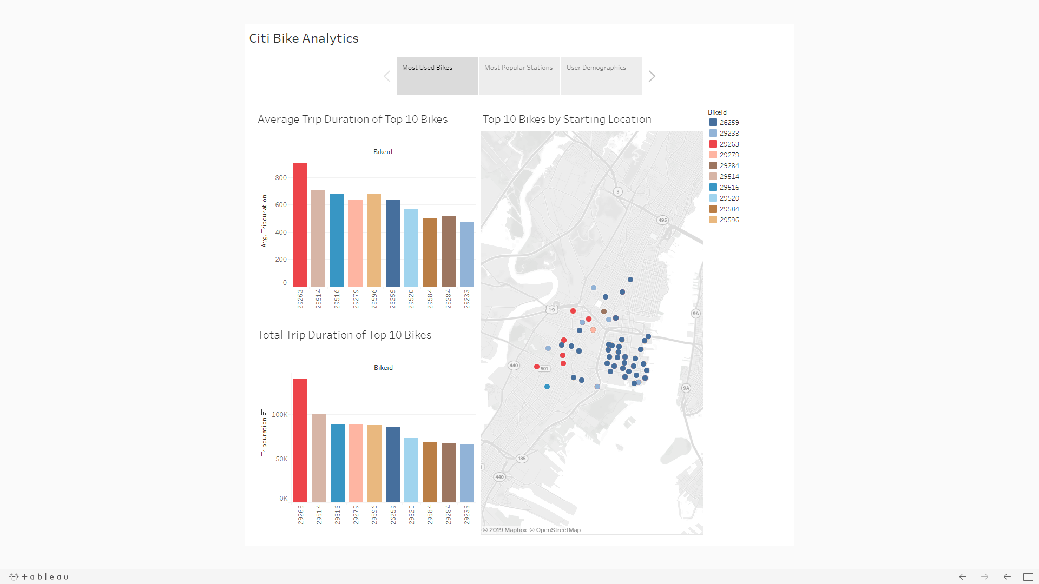

Second, a breakdown of the gender demographics of users indicates that the average user is a 31 year old male. In fact, the number of male users far surpass the number of female users, perhpas due to some women wearing skirts or high heels, which makes for a dangerous bike ride. One area where females surpassed males were in the average trip duration – females had slightly higher average trip durations than males, but both were surpassed in average trip duration by users that did not provide a gender. Still, in total, males took rides more frequently than females and unknowns.

