**Group 6 2ECE-B**

**REYES, John Emmanuel ECE 2112  
ZABALA, Jude Nico**

**MACHINE PROBLEM 2 (MATLAB)**

**CODE:**

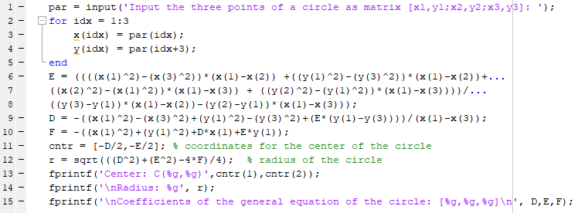

**SAMPLE OUTPUT:**

**Output 1:**

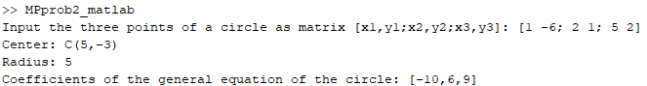

**Output 2:**

