**Group 6 2ECE-B**

**REYES, John Emmanuel ECE 2112  
ZABALA, Jude Nico**

**MACHINE PROBLEM 4 (MATLAB)**

**CODE:**

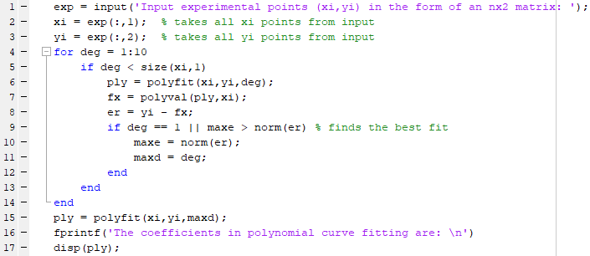

**SAMPLE OUTPUT:**

**Output 1:**

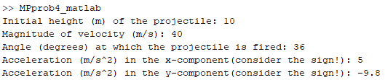

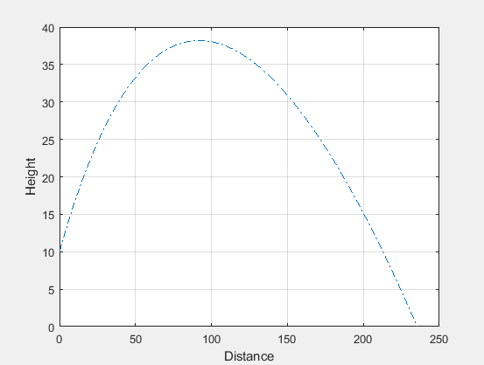

**Output 2:**

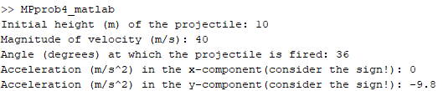

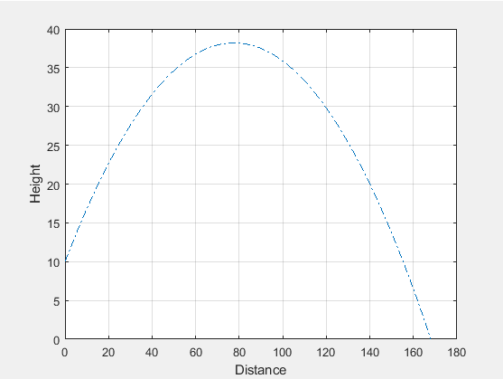

**Output 3:**

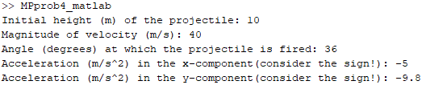

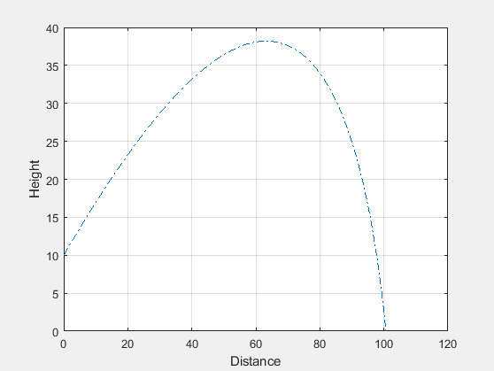

**Output 4:**

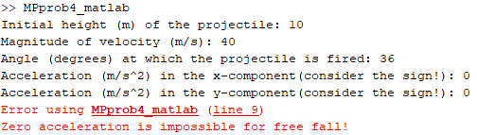

**Output 5:**

