**Group 6 2ECE-B**

**REYES, John Emmanuel ECE 2112  
ZABALA, Jude Nico**

**MACHINE PROBLEM 5 (MATLAB)**

**CODE:**

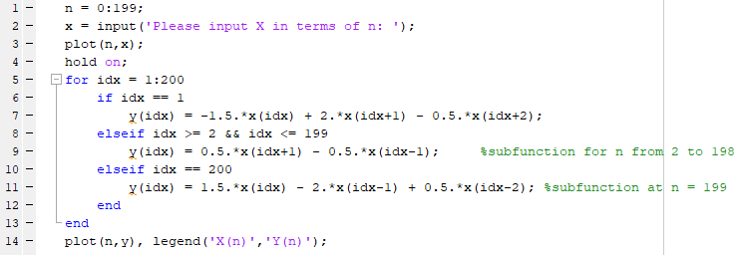

**SAMPLE OUTPUT (X(n) = sin(2*pi*n/100)):**

