EXPERIMENT 9: DATA WRANGLING IN PANDAS

PROBLEM 1

Merging of the 4 Datasets:

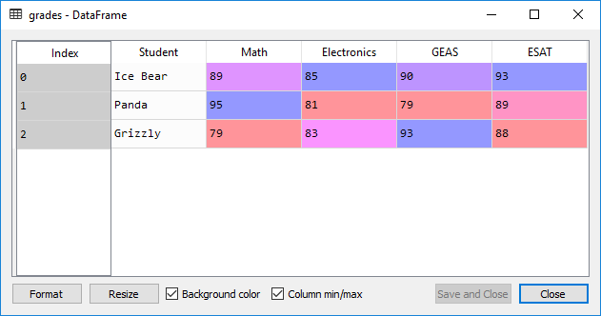

Long format:

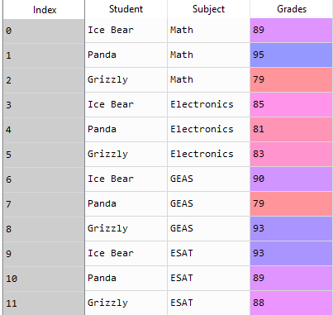

PROBLEM 2:

