EXPERIMENT 8: PANDAS

PROBLEM 1: Display the first five and last five rows of *cars*

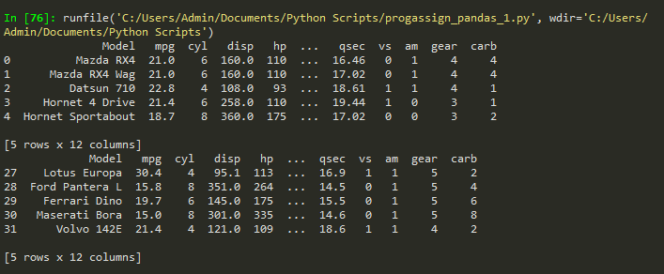

PROBLEM 2.a: First five rows with odd-numbered columns

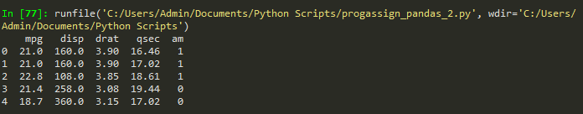

PROBLEM 2.b: Row of ‘Mazda RX4’



PROBLEM 2.c: Cylinder of Camaro Z28



PROBLEM 3.d: cylinders and gear type of the 3 Models:

