# Environment Set Up for Common (Document Management System) DMS application [Application CI - 1100335239]

## Physical Architecture

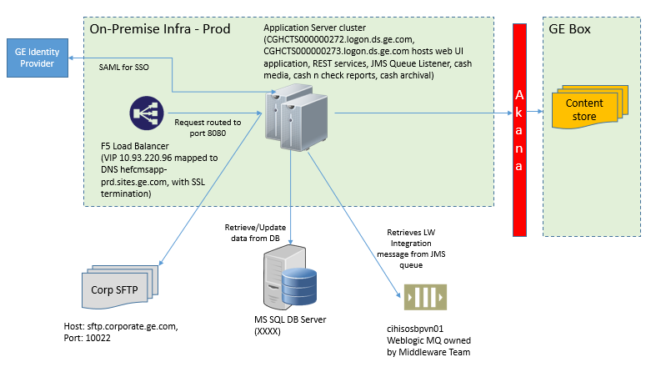

## Server List

|  |  |  |  |
| --- | --- | --- | --- |
| Environment | Server | Role | Software Required |
| UAT | ALPCTS000000401.logon.ds.ge.com | App Server | MS SQL Client tools, JDK 1.8, apache-tomcat-8.0.53 |
| UAT | ALPCTS000000402.logon.ds.ge.com | App Server | MS SQL Client tools, JDK 1.8, 7-Zip, PuttyGen, apache-tomcat-8.0.53 |
| UAT | ALPCTS000000490.logon.ds.ge.com  Port: 30229  Instance: ALPCTS000000490\HNSBOXOSTG01 | DB Server | MS SQL Server 2016 |
| PROD | CGHCTS000000272.logon.ds.ge.com | App Server | MS SQL Client tools, JDK 1.8, apache-tomcat-8.0.53 |
| PROD | CGHCTS000000273.logon.ds.ge.com | App Server | MS SQL Client tools, JDK 1.8, 7-Zip, PuttyGen, apache-tomcat-8.0.53 |
| PROD | CGHCTS000000342.logon.ds.ge.com  Port: 50157  Instance: CGHCTS000000342\HNSBOXOPRD01 | DB Server | MS SQL Server 2016 |

## F5 & DNS details

|  |  |  |  |  |  |
| --- | --- | --- | --- | --- | --- |
| Environment | Purpose | F5 Pool Members | Port | Virtual IP (VIP) | FQDN (Fully qualified domain name) |
| PROD | REST Services | CGHCTS000000272.logon.ds.ge.com  CGHCTS000000273.logon.ds.ge.com | 9191 | 10.93.220.98 | hefcmssvc-prd.sites.ge.com |
| PROD | SAML Auth | CGHCTS000000272.logon.ds.ge.com  CGHCTS000000273.logon.ds.ge.com | 7878 | 10.93.220.97 | authtokhefcms-prd.sites.ge.com |
| PROD | UI | CGHCTS000000272.logon.ds.ge.com  CGHCTS000000273.logon.ds.ge.com | 8080 | 10.93.220.96 | hefcmsapp-prd.sites.ge.com |
| UAT | REST Services | ALPCTS000000401.logon.ds.ge.com  ALPCTS000000402.logon.ds.ge.com | 9191 | 10.93.220.95 | commoncmssvc-uat.sites.ge.com |
| UAT | SAML Auth | ALPCTS000000401.logon.ds.ge.com  ALPCTS000000402.logon.ds.ge.com | 7878 | 10.93.220.94 | authtokcommoncms-uat.sites.ge.com |
| UAT | UI | ALPCTS000000401.logon.ds.ge.com  ALPCTS000000402.logon.ds.ge.com | 8080 | 10.93.220.19 | commoncmsapp-uat.sites.ge.com |

## Application URL

UAT - <https://commoncmsapp-uat.sites.ge.com/common-dms-app>

PROD - <https://hefcmsapp-prd.sites.ge.com/common-dms-app>

## Application Components

|  |  |  |  |  |
| --- | --- | --- | --- | --- |
| **Application Component** | **Technology** | **Artifact name** | **Server to be deployed to** | **Deployment Path** |
| Common DMS User Interface (UI) | Angular 6 | common-dms-app.war | CGHCTS000000272.logon.ds.ge.com  CGHCTS000000273.logon.ds.ge.com | <Tomcat Root>/ webapps/  Ex: **F:\Cornerstone-Box\Tomcat8.5\webapps** |
| DMS REST Services | Spring boot | saml-authentication-0.1.0-SNAPSHOP.jar | CGHCTS000000272.logon.ds.ge.com  CGHCTS000000273.logon.ds.ge.com | <Common DMS Application root folder/Services/>  Ex. **F:\Cornerstone-Box\REST-services** |
| SAML Auth Token Service | Spring Boot | saml-jwt-sample-1.0-SNAPSHOT.jar | CGHCTS000000272.logon.ds.ge.com  CGHCTS000000273.logon.ds.ge.com | <Common DMS Application root folder/Services/>  Ex. **F:\Cornerstone-Box\REST-services** |
| JMS Queue Implementation | Spring Boot | cornerstone-queue-implementation-0.0.1-SNAPSHOT.jar | CGHCTS000000272.logon.ds.ge.com  CGHCTS000000273.logon.ds.ge.com | Ex. **F:\Cornerstone-Box\REST-services** |
| Cash Media Ingestion | Windows Batch + Java standalone |  | CGHCTS000000273.logon.ds.ge.com | **F:\Cornerstone\CashMedia_Project** |
| Auto Ingestion (Check Transmission Reports + Cash reports) | Windows Batch + Java Standalone |  | CGHCTS000000273.logon.ds.ge.com | **F:\Cornerstone\AutoIngestion** |
| Cash Archival (PNC + Wires) | Windows Batch + Java Standalone |  | CGHCTS000000273.logon.ds.ge.com | **F:\Cornerstone\CashWireIngestion** |

**Common DMS User Interface (UI)** – This is an angular application deployed on Tomcat on port 8080. This application presents the user interface of the common DMS application. It connects to the backend REST services for managing content and metadata. User authentication takes by using GE SAML while authorization is managed by the application backend.

**DMS REST Services** – These set of Spring based services have been developed to upload content to Box, update content metadata in DB, perform search, download content, authorize users, etc…

**SAML Authentication Service** – This spring boot service implements the token generation and authentication part. It redirects the authentication request to GE SAML Identity Provider (IDP). After getting the successful authenticated response from GE IDP, it redirects to the requested page.

**JMS Queue Implementation** – This java utility acts as JMS listener which waits for LW Integration messages to arrive, reads and processes the messages. It points to the Weblogic JMS server hosted on middleware server.

**Cash Media Ingestion** – This Java standalone utility is scheduled using Windows Task Scheduler that runs once per day at 02:00 AM EST. This tool scans a Corp SFTP location to look for any check images files. If found, it downloads the files, processes the metadata and uploads the files to box. In order to access Corp SFTP, the application server SSH keys needs to be added to the SFTP server access.

**Auto Ingestion** – This standalone java utility is scheduled using Windows Task Scheduler and runs every two hours. This tool scans a Corp SFTP location to look for any cash and check transmission reports images files. If found, it downloads the files, processes the metadata and uploads the files to box. In order to access Corp SFTP, the application server SSH keys needs to be added to the SFTP server access.

**Cash Archival** - This standalone java utility is scheduled using Windows Task Scheduler and runs weekly once. This tool scans a Corp SFTP location to look for any PNC or Wires LB archived reports. If found, it downloads the files, processes the metadata and uploads the files to box. In order to access Corp SFTP, the application server SSH keys needs to be added to the SFTP server access.

## Operational Consideration

### Services Startup

Following services are specific to DMS User (UI) application:

Windows Scheduled Tasks:

* Queue_impl_task
* REST_services_task
* SML_services_task

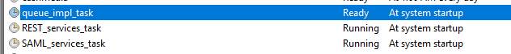

Windows Services:

* Apache Tomcat 8.5

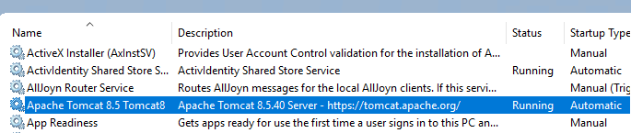

In order to start the scheduled tasks, please follow these steps -

* Go to the TaskScheduler

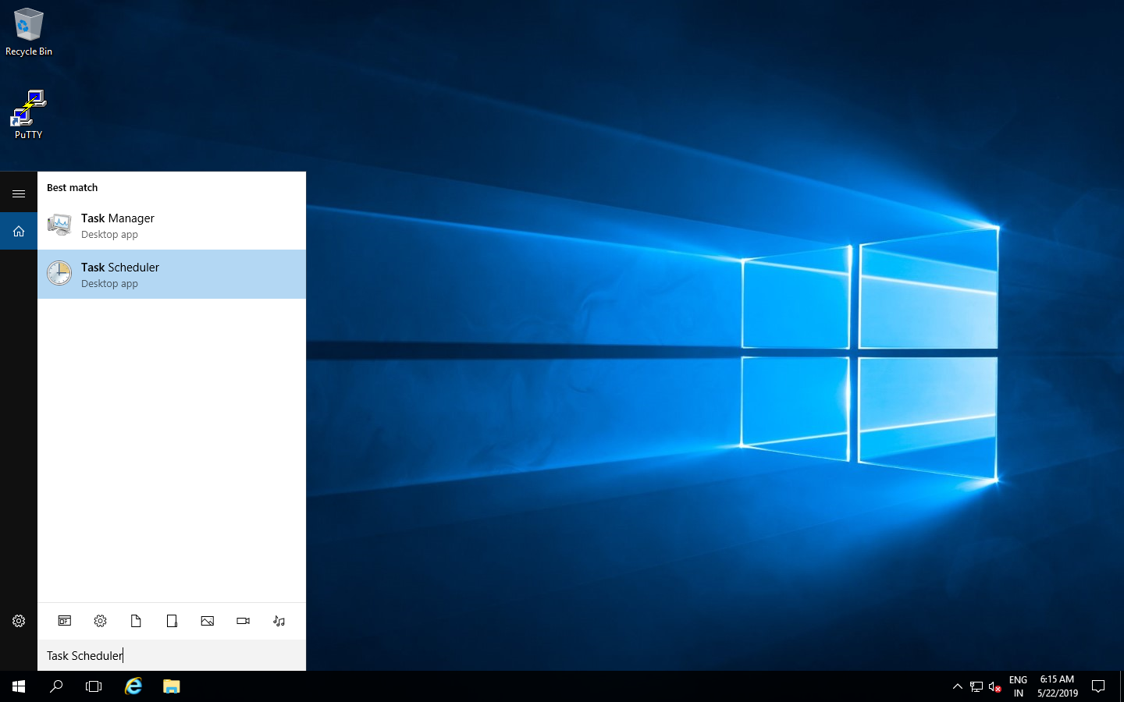

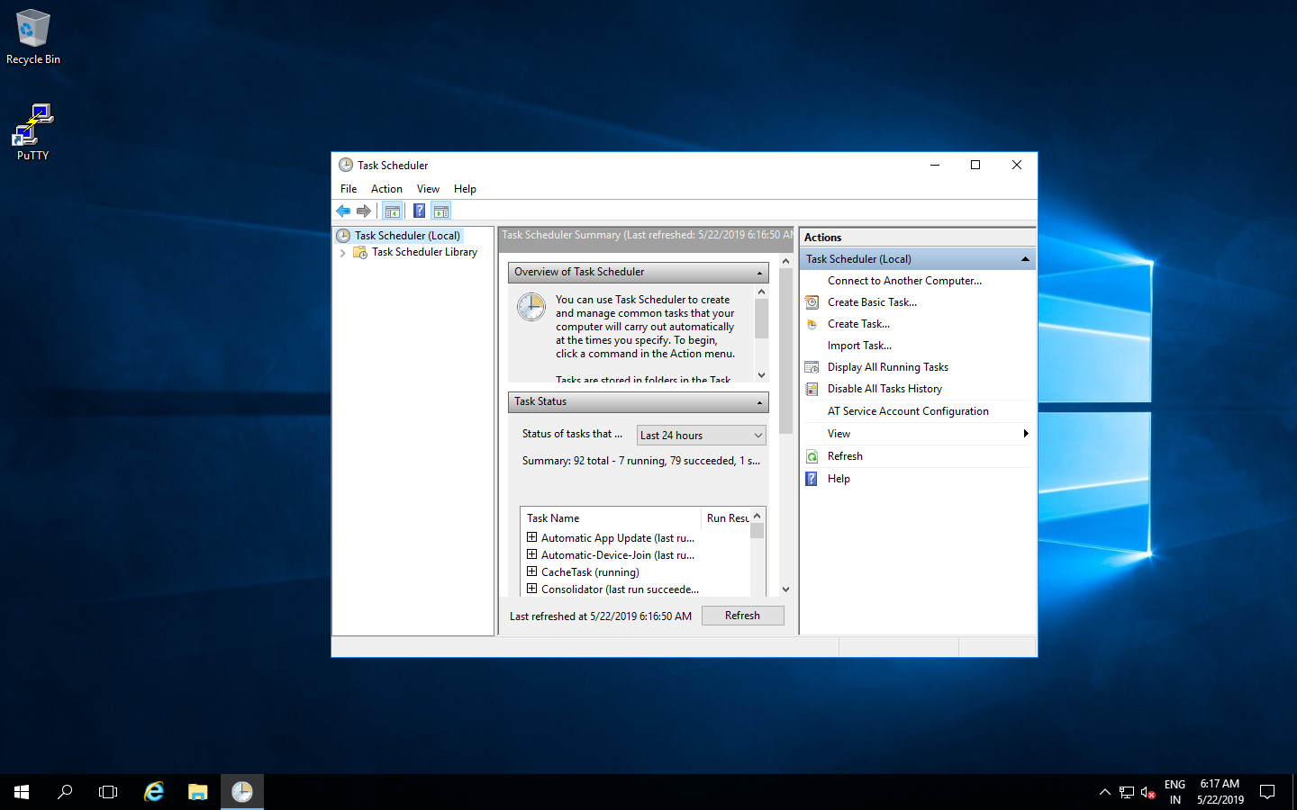

* Now click on “**Task Scheduler Library”** to view the list of all tasks.

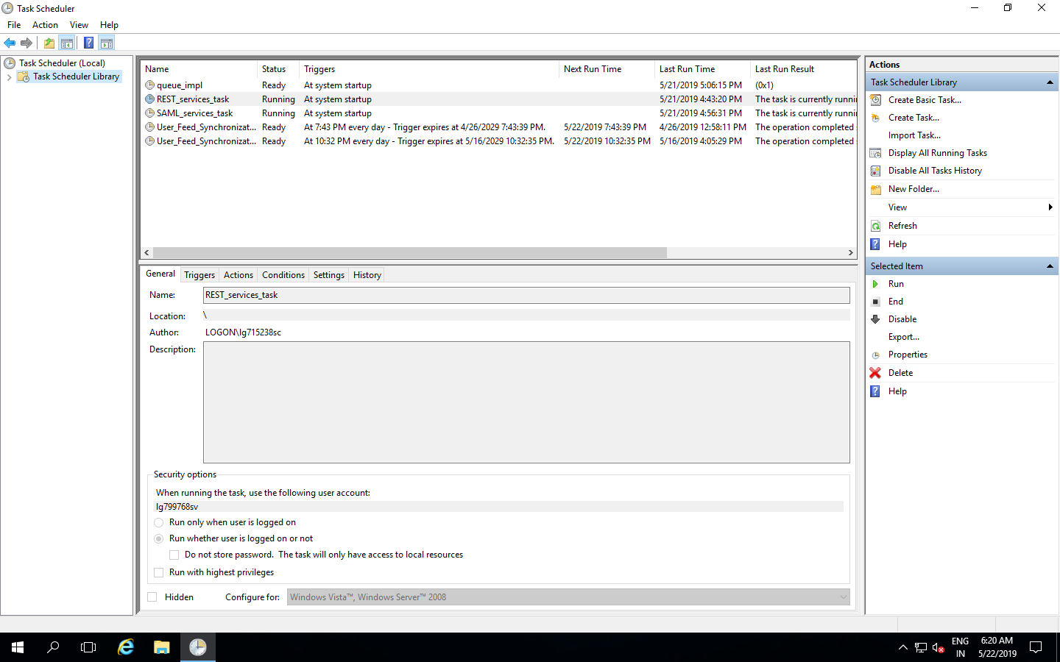

* To run the specific task, right click on it and press “**Run”.**

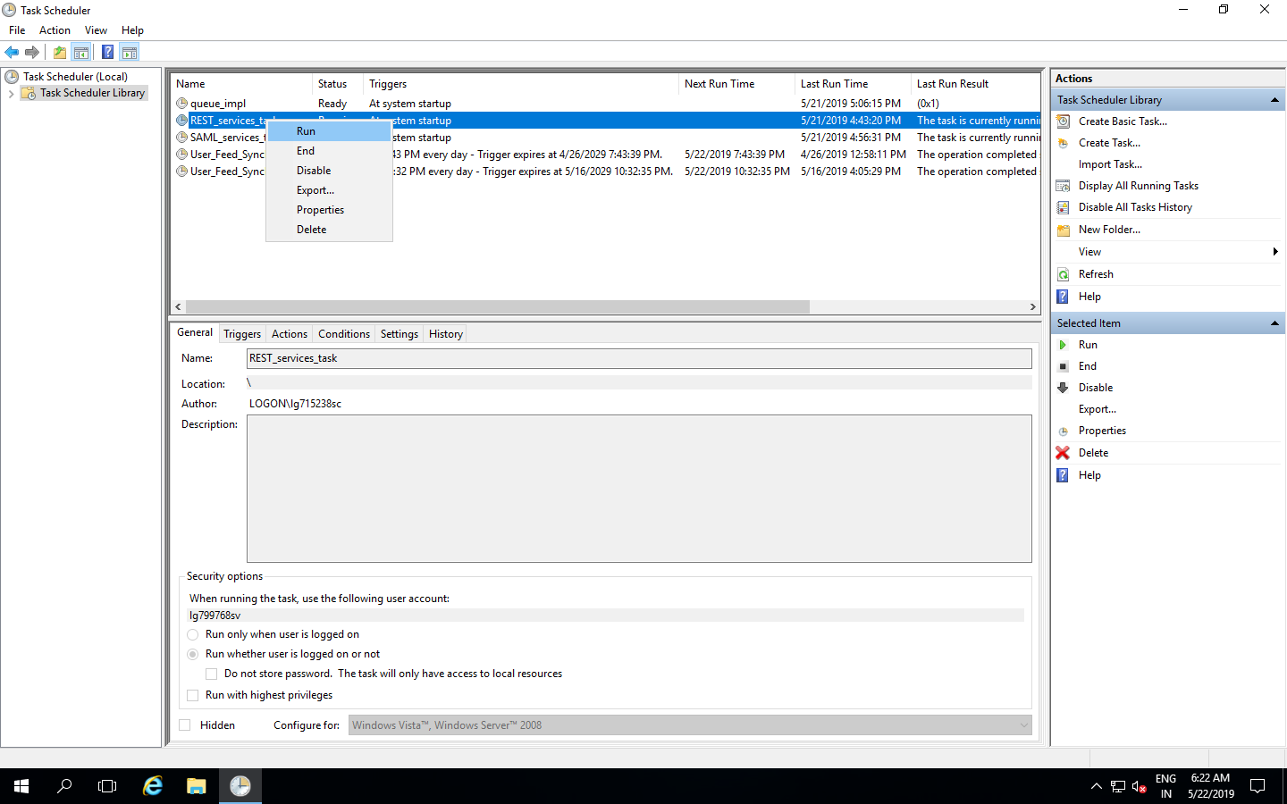

In order to start the Apache tomcat windows service, please open the Windows services, select **Apache Tomcat 8.5 Tomcat8** service and then select Start upon right click.



### Services Shutdown

For shutting down Scheduled Tasks, follow following steps.

* Go to the TaskScheduler





* Now click on “**Task Scheduler Library”** to view the list of all tasks.



* To stop the specific task, right click on it and press **“End”**

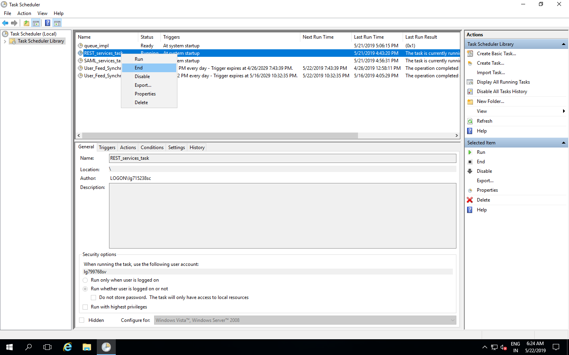

* To ensure the specific task has been successfully stopped, issue the below commands in the command prompt in sequence.,
* netstat -ano|findstr "<*PortNumber*>"
* taskill /f /PID <*PID from previous command*>

where PortNumber is 9191 in case of **REST_services_task**

PortNumber is 7878 in case of **SAML_services_task**

PortNumber is 6062 in case of **queue_impl** on node CGHCTS000000272.logon.ds.ge.com

PortNumber is 6063 in case of **queue_impl** on node CGHCTS000000273.logon.ds.ge.com

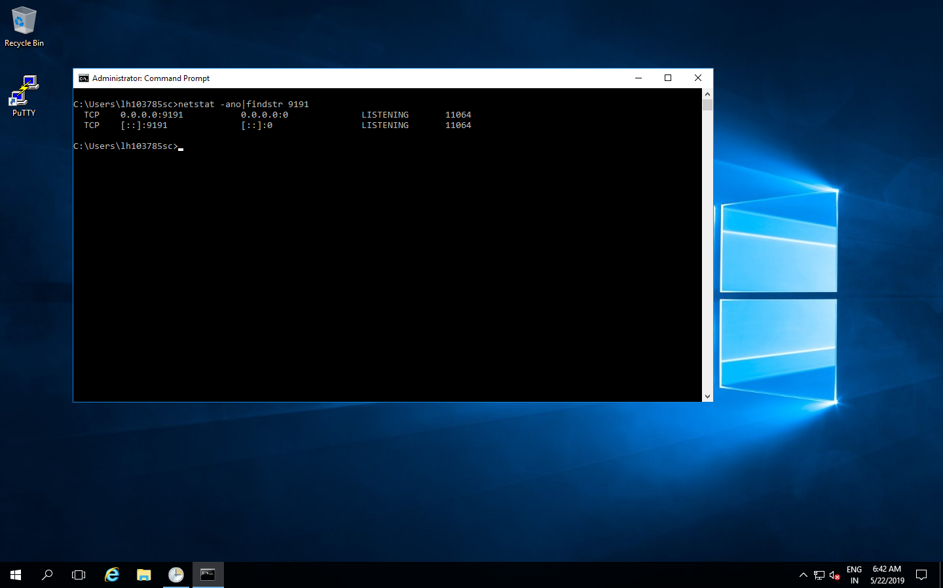

* It takes some time for the process to get stopped on those ports…we should consider the process gets stopped only when once executing the netstat command for that respective port does not yield any result.