**POD**

In Virtualization, basic scheduling unit is Virtual Machine(VM)

In Containerization, basic scheduling unit is Containerization

In Kubernetes, what is basic scheduling unit?

**PODS**

What are pods on kubernetes?

What is difference between container and pods?

How to create PODS in kubernetes?

**Objective:**

**----------**

1. What is pod?

2. POD deployment (how pods are deployment in kubernetes)

3. Multi-container (how to use multiple container in single pod)

4. POD networking (How does pod networking works)

5. Inter & Intra pod communication (what is Inter-pod networking && what is Intra-pod networking)

6. POD Lifecycle (stages of pod lifecycle)

7. POD Manifest file (how to write pod manifest file)

# What is Pod?

-- Pod is known as Atomic unit of scheduling

{

In virtualization Environment, virtual machine is the Atomic unit of scheduling

In Containerization Environment, Dockeris the Atomic unit of scheduling

In kubernetes Environment, Pod is the Atomic unit of scheduling

}

Docker

Virtualization

VM

Container

POD

Kubernetes

**POD Deployment:**

How the pod is deployed and scaled inside kubernetes?

TO deploy the pod, 🡪 first we have to write pod manifest file that contain container images that we have to write and deploy to the API server on the **master node**

**API server and scheduler components** on the master node 🡪 decides and deploy the PODS on the **worker nodes** respectively

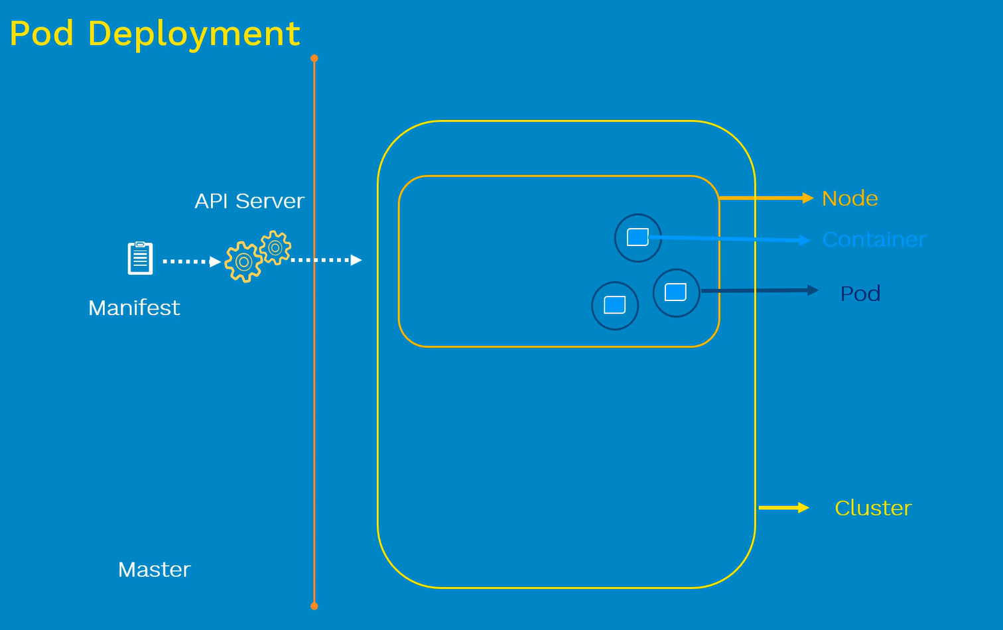

Kubernetes doesn’t deploy the containers directly on the worker nodes -🡪 containers are encapsulated inside the pods

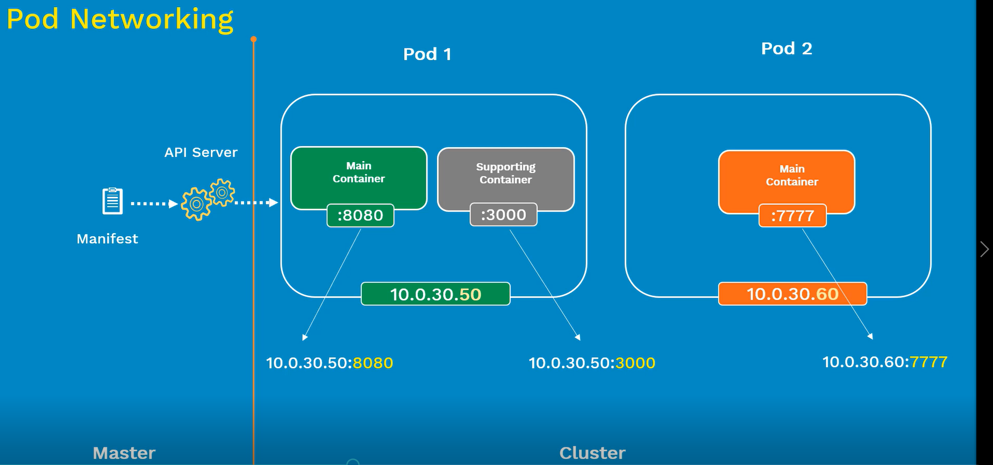

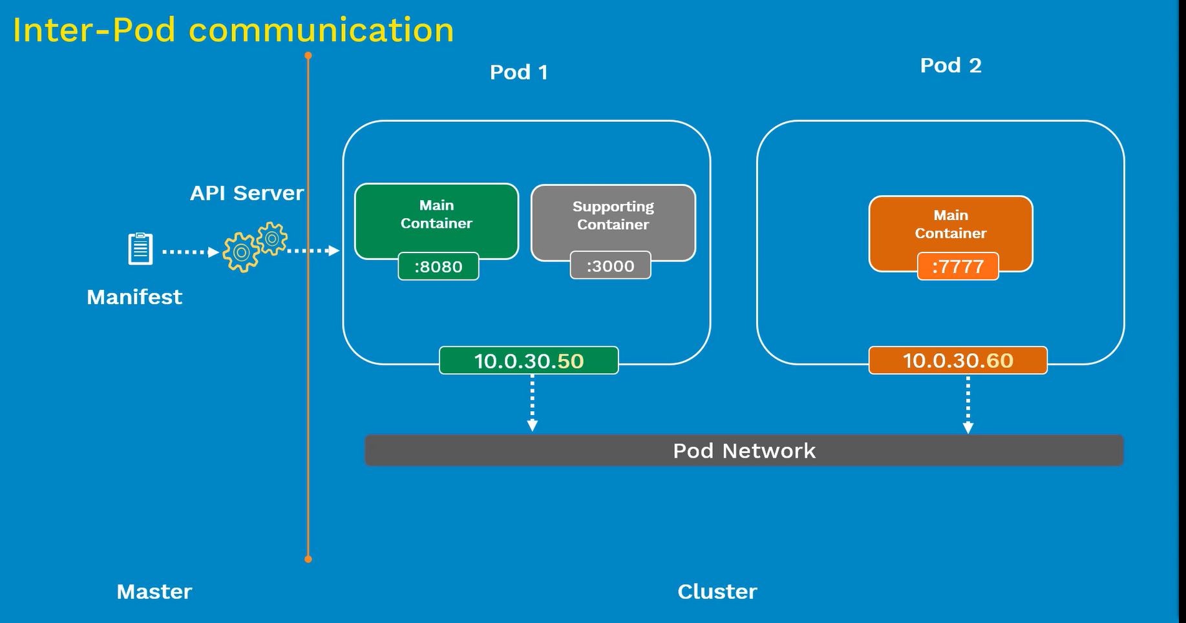

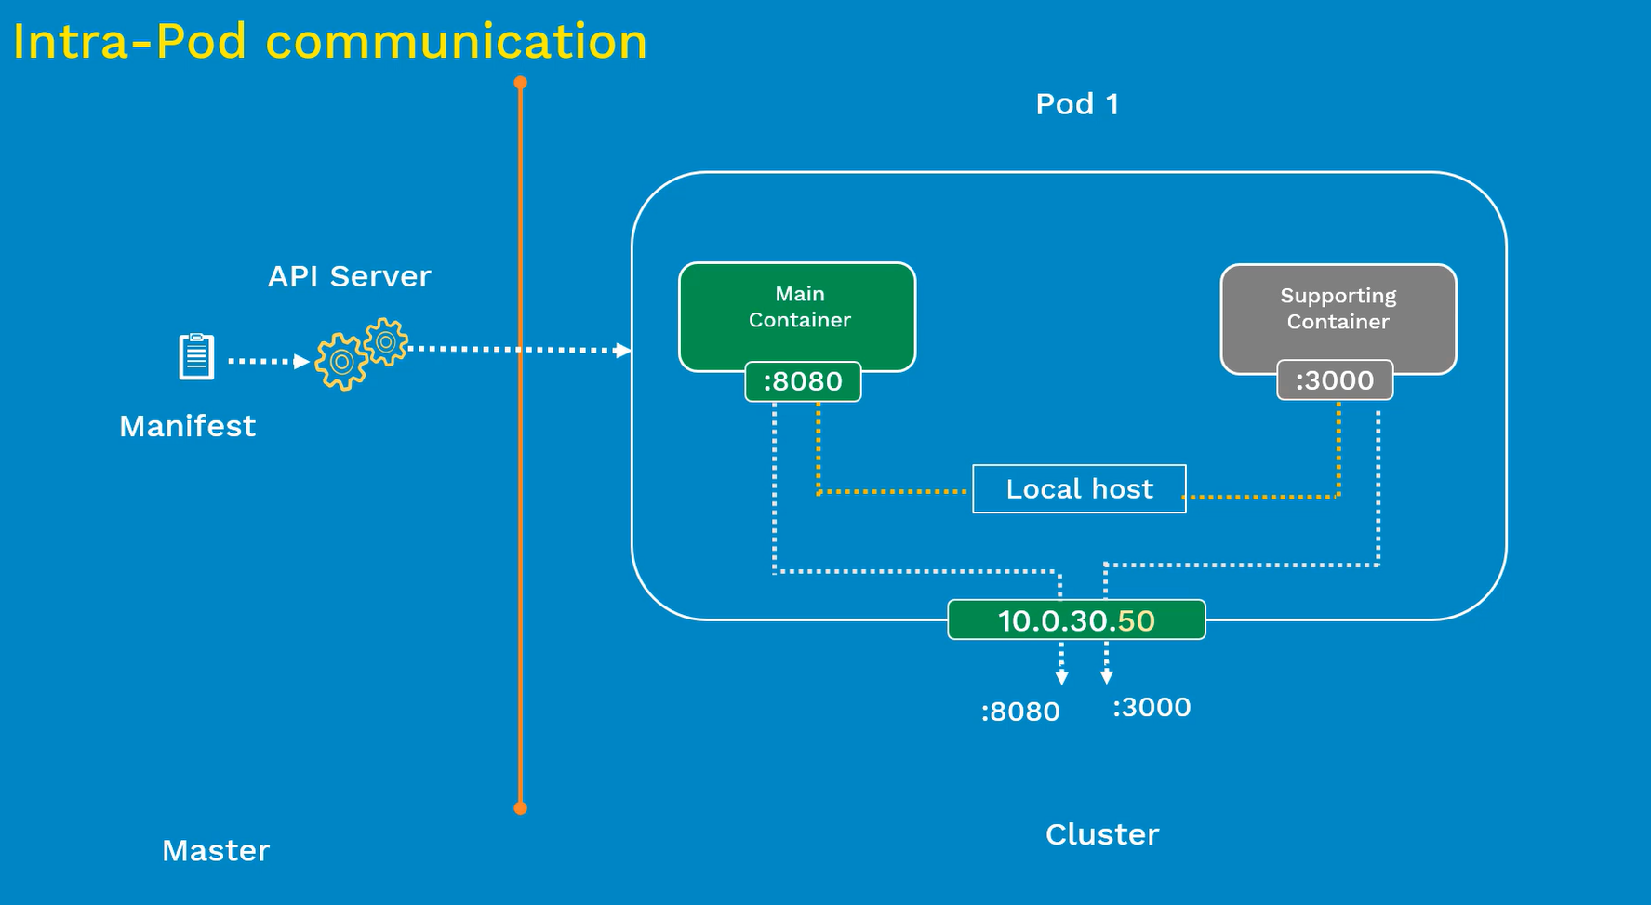

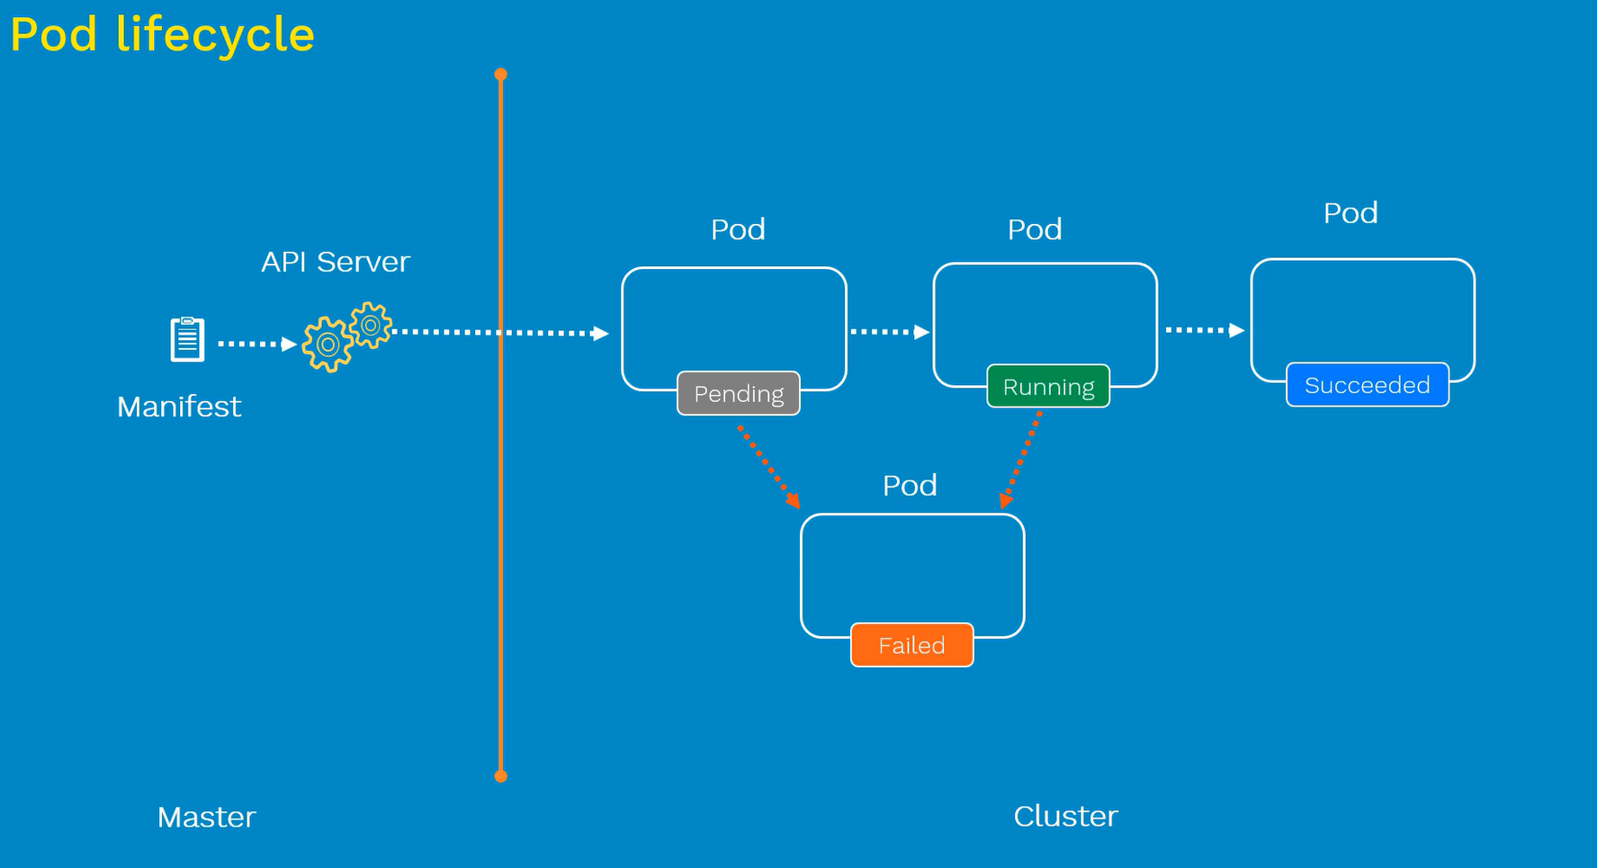

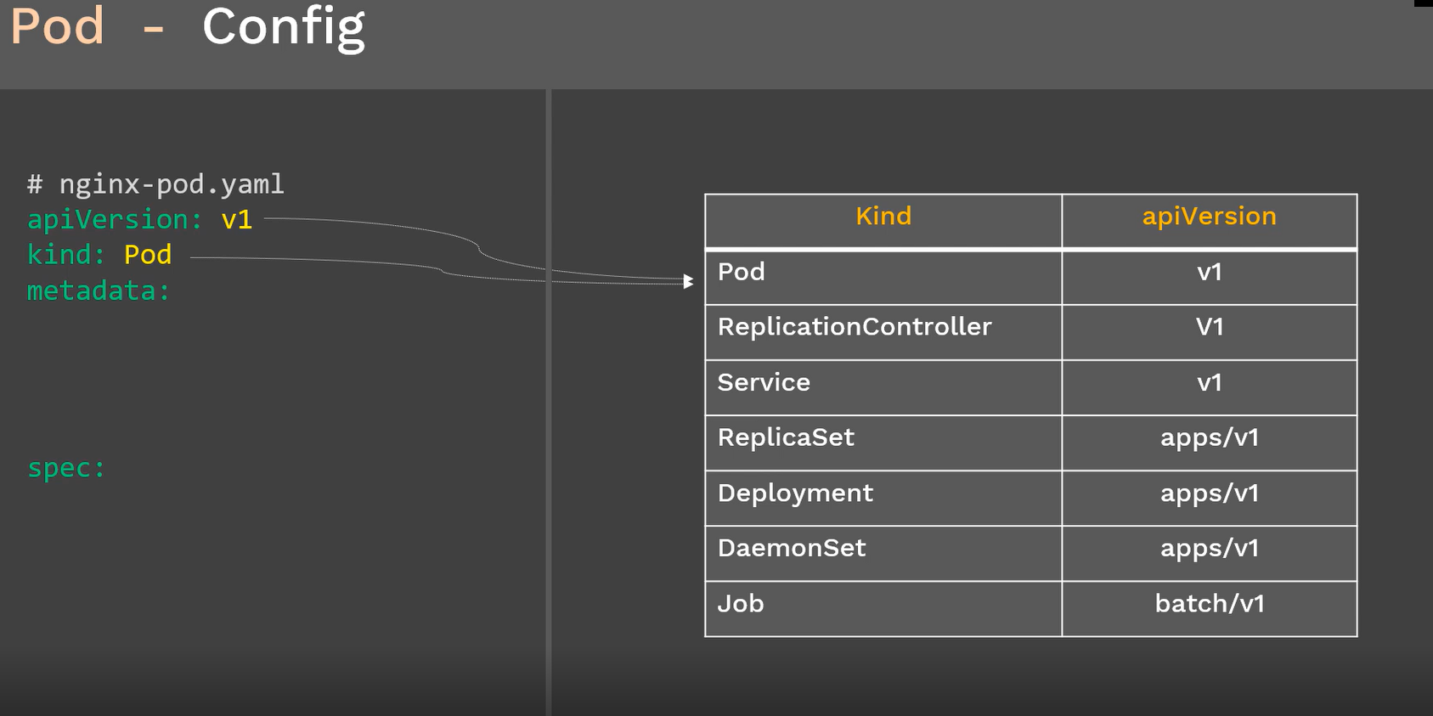

**Pod Manifest file:**

