EcoScan AI
Multimodal AI Platform for Cradle-to-Gate Supply Chain Traceability & Anti-Greenwashing Intelligence

Prepared by:
Jalaja Sunil Borkar
Department of Artificial Intelligence & Data Science
Datta Meghe College of Engineering, Mumbai University
Project Category: AI-Powered Climate Tech & Enterprise ESG Compliance
Domain: Multimodal NLP, Supply Chain Intelligence & B2B/B2C SaaS
AICTE | IBM SkillsBuild Machine Learning & Applied AI Internship Program 2026 | BharatCares
Executive Summary
In today's global market, environmental sustainability has shifted from an optional marketing narrative to a core regulatory and consumer mandate. However, widespread greenwashing—where companies make unverified or misleading environmental claims—has created a crisis of trust, deceiving an estimated 68% of eco-conscious consumers. Simultaneously, enterprise organizations struggle to gain real-time visibility into the Scope 3 carbon footprint and environmental compliance of their multi-tier supply chains (Tier 2 and Tier 3 raw material suppliers).
EcoScan AI bridges this trust and compliance gap through a multimodal AI platform providing cradle-to-gate environmental traceability. By pairing an automated Natural Language Processing (NLP) document parsing engine with a predictive Machine Learning regression model, EcoScan AI converts raw, unstructured logistics files—customs declarations, bills of lading, and vendor compliance records—into a dynamic Predictive Eco-Verity Score (1–100). The platform serves both B2B enterprise procurement teams via real-time auditing dashboards and B2C shoppers via a lightweight browser extension that overlays verified sustainability metrics directly onto e-commerce product listings.

🌿 HIGH-LEVEL CONCEPT & UVP
EcoScan AI acts as 'The Moody's / Credit Score framework for dynamic global product sustainability', reducing corporate ESG audit time from 4 weeks down to 5 minutes while empowering consumers with transparent, data-backed green choices.

1. Problem Statement & Market Pain Points
1.1 The Greenwashing Epidemic
Consumer demand for sustainable products has surged, yet trust is at an all-time low. Approximately 68% of eco-conscious consumers report feeling misled by vague brand claims such as 'eco-friendly', 'carbon-neutral', or 'ethically sourced' due to a complete absence of verifiable, traceable data behind these labels.
1.2 Opaque Multi-Tier Supply Chains
Primary brand manufacturers (Tier 1) often lack visibility beyond their immediate suppliers. Tier 2 (component processors) and Tier 3 (raw material extractors and agricultural producers) account for up to 80% of a product's overall environmental impact, yet their emissions and compliance status remain entirely obscured in traditional reporting structures.
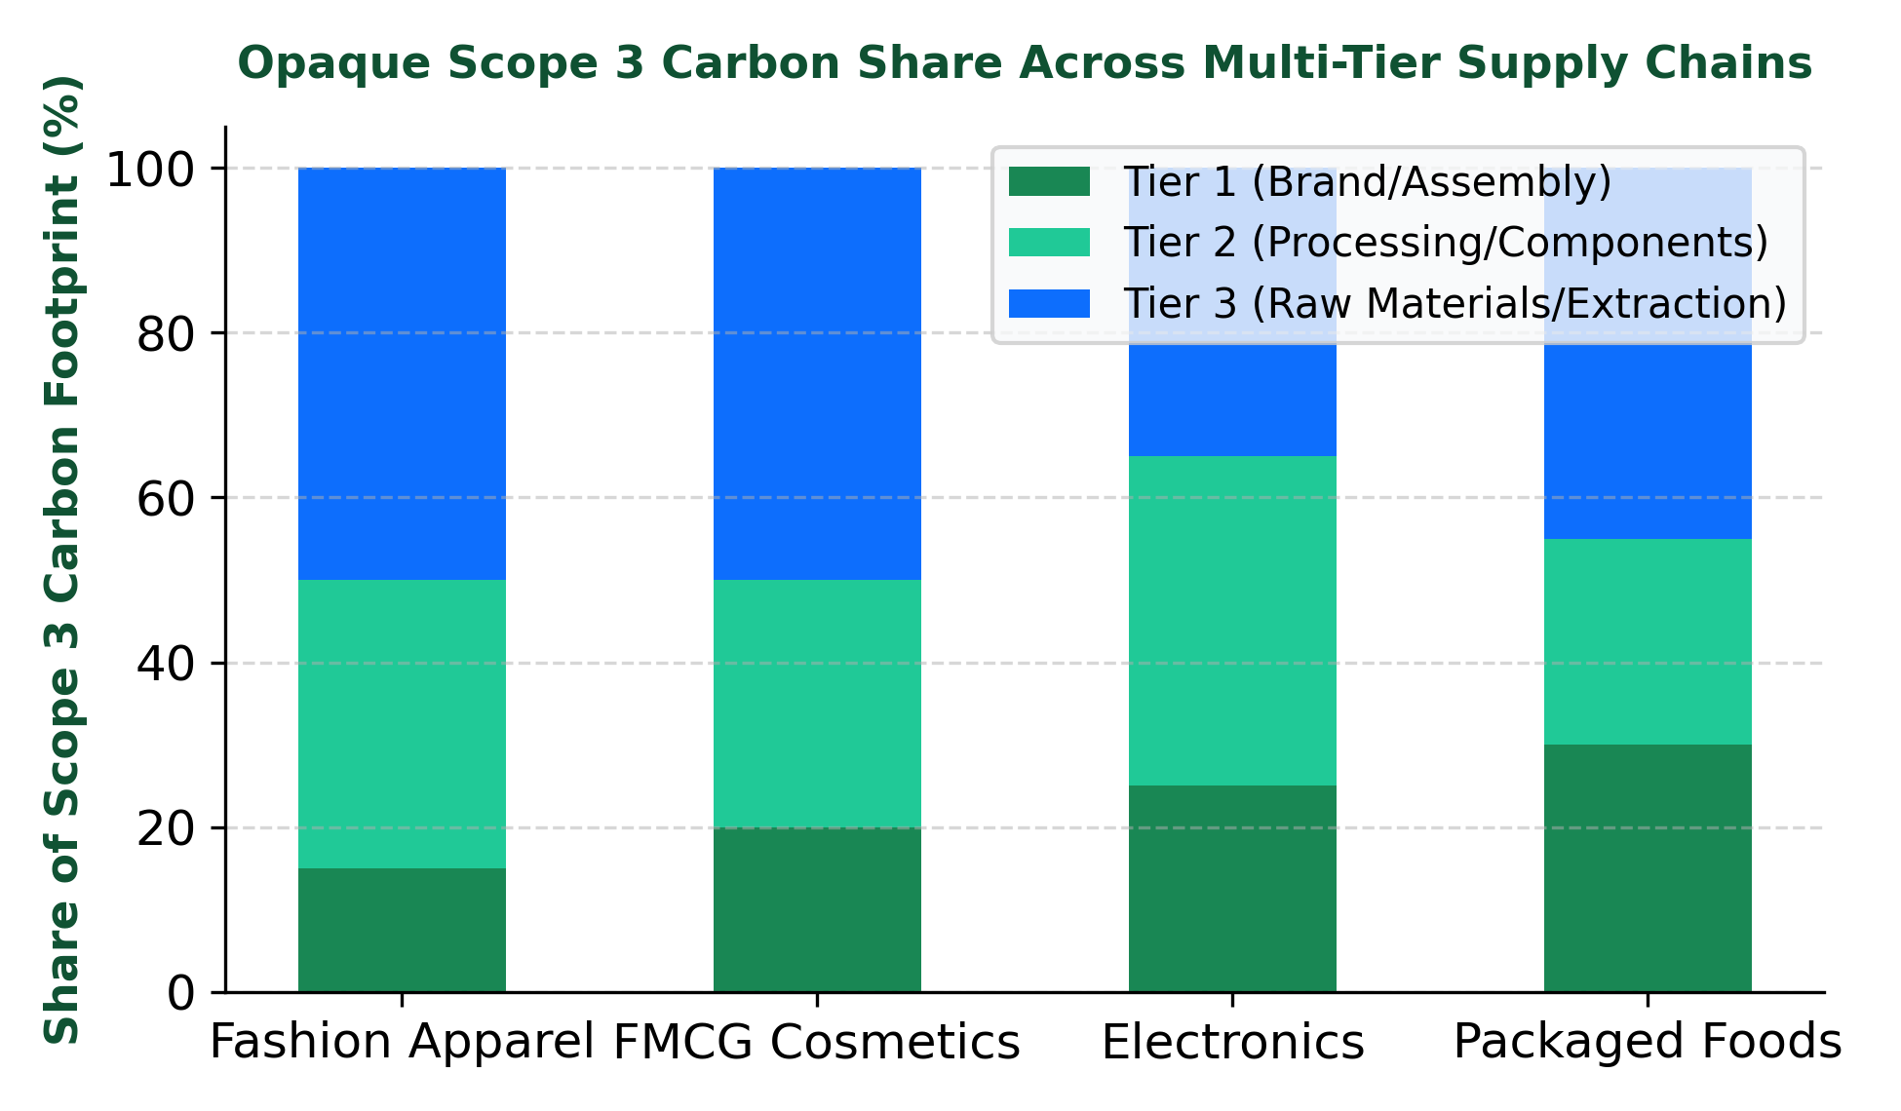

Figure 1: Scope 3 Carbon Footprint Breakdown Across Multi-Tier Supply Chains
1.3 Manual & Costly Audits
Corporate ESG compliance currently relies on manual auditing by expensive consulting agencies. Procurement officers manually inspect PDF invoices, shipping manifests, and vendor self-reports—a process that is slow (taking 4–6 weeks per supplier), expensive, and prone to human error or intentional fraud.
1.4 Inadequacy of Existing Alternatives
- Corporate ESG Consulting Agencies: Expensive, slow, and produce static, retrospective reports that fail to offer real-time supply chain monitoring.
- Self-Reported Eco-Labels: Static badges (e.g., Energy Star, Fair Trade) that reflect one-time point-in-time certifications without ongoing lifecycle or transit data tracking.
2. Customer Segments & User Personas
EcoScan AI deploys a dual-sided strategy serving both enterprise B2B compliance buyers and B2C end consumers.
Customer Segment | Target Profile & Behavioral Triggers | Primary Pain Point Solved
B2C Early Adopters | Climate-conscious Gen-Z and Millennial online shoppers actively filtering e-commerce stores. | Eliminates skepticism by providing real-time Eco-Verity scores and sustainable alternatives.
B2B Brands & Retailers | FMCG corporations & D2C fashion/cosmetics brands subject to global ESG mandates. | Automates supply-chain compliance tracking and protects brand reputation against greenwashing fines.
Supply Chain Operations | Corporate compliance managers & procurement officers vetting overseas suppliers. | Replaces 4-week manual PDF audits with instant 5-minute automated document parsing.
D2C Early Adopters | Sustainable fashion & organic beauty brands competing against larger greenwashed legacy brands. | Provides a verifiable, data-backed competitive edge to prove authentic sustainability claims.

3. Product Solution & System Architecture
EcoScan AI integrates three technological modules into a unified data processing pipeline:
3.1 Automated Document Parsing Engine (NLP/OCR)
Using multimodal Transformer architectures, the engine automatically extracts, structures, and cross-references data from heterogeneous logistics documents including customs declarations, bill-of-lading forms, factory energy logs, and material safety data sheets (MSDS).
3.2 Predictive Eco-Verity Score Model (ML Regression)
The core Machine Learning model aggregates extracted multi-tier supplier data, transit mileage, power grid carbon intensities, and material sustainability indices to generate a standardized Predictive Eco-Verity Score on a 1–100 scale.
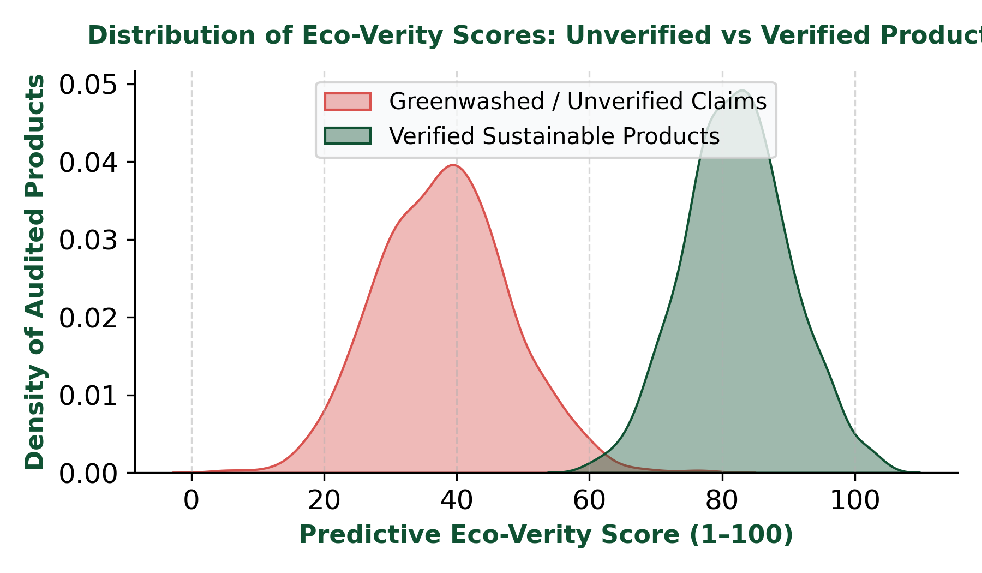

Figure 2: ML Model Discrimination Between Verified and Greenwashed Product Scores

# EcoScan AI Feature Vector Schema for Predictive Eco-Verity Regression Model
feature_vector = {
'tier1_energy_kwh_per_unit': 12.4, # Direct assembly energy
'tier2_processed_material_index': 0.82, # Recycled content %
'tier3_raw_extraction_footprint_kgco2e': 4.1, # Agricultural/mining impact
'logistics_transit_distance_km': 8420, # Multimodal shipping distance
'freight_transport_mode': 'maritime_heavy', # Air vs Maritime vs Rail
'vendor_compliance_certificate_status': 1, # Binary verified token
'power_grid_renewable_share': 0.65 # Supplier regional grid factor
}
# Machine Learning Scoring Pipeline Execution
predicted_eco_verity_score = eco_verity_model.predict(feature_vector)
# Output: Eco-Verity Score = 84.5 / 100 [VERIFIED SUSTAINABLE]

3.3 Consumer Browser Extension
A lightweight browser plug-in overlays Eco-Verity scores onto product pages during online shopping. If a product scores below threshold, the extension recommends lower-carbon, fully verified alternative products dynamically.
4. Business Model & Go-To-Market Strategy
4.1 Revenue Streams
EcoScan AI executes a diversified monetization strategy across B2B SaaS, developer APIs, and consumer affiliate commissions.

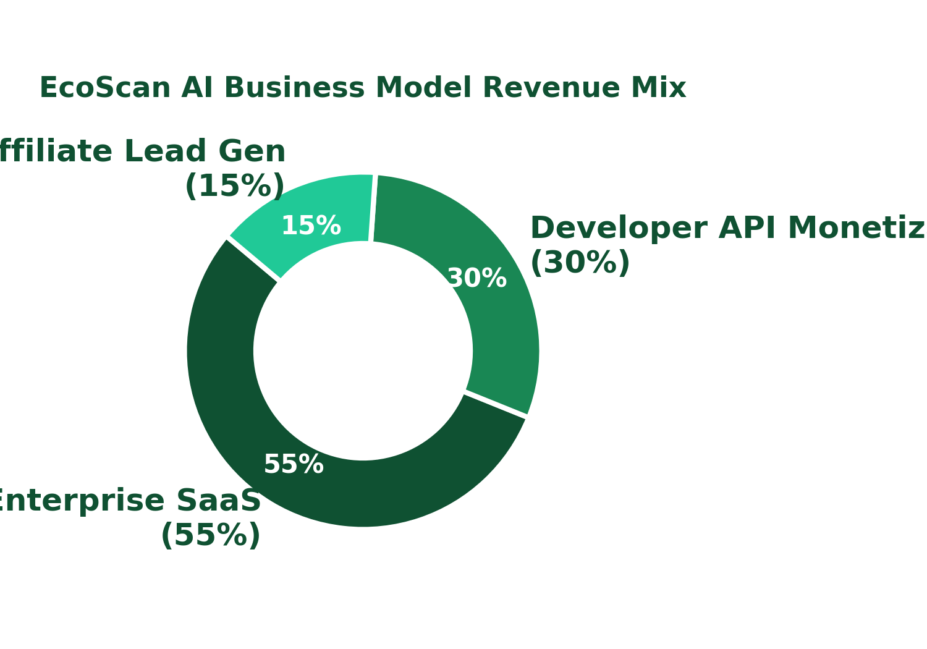

Figure 3: EcoScan AI Projected Revenue Distribution Across Monetization Channels
- B2B Enterprise SaaS License (55%): Tiered monthly subscription tiers (Starter, Growth, Enterprise) for consumer brands to access internal supply-chain auditing dashboards.
- Developer API Monetization (30%): Pay-per-call structure charging large e-commerce marketplaces to display Eco-Verity scores at checkout.
- Affiliate Lead Generation (15%): Affiliate lead generation commissions earned when B2C extension users switch from low-scoring products to sustainable alternatives.
4.2 Go-To-Market Channels
- Direct-to-Consumer (D2C): Organic SEO campaigns built around sustainable shopping keywords and browser extension marketplace listings.
- B2B Enterprise Sales: Inbound content marketing and direct outreach targeting corporate compliance and procurement officers via LinkedIn.
- Developer API Ecosystem: Integration listings on popular e-commerce platform marketplaces (e.g., Shopify App Store, Salesforce AppExchange).
5. Operations, Key Metrics & Competitive Advantage
5.1 Cost Structure
- Compute & Infrastructure: Hosting and inference costs for training NLP models and maintaining real-time databases (IBM Cloud / AWS).
- Third-Party Data Acquisitions: Licensing fees for global environmental indices, real-time cargo tracking feeds, and emissions registries.
- Customer Acquisition & Sales: Marketing expenses for enterprise B2B outreach and B2C privacy campaigns.
5.2 Key Performance Indicators (KPIs)

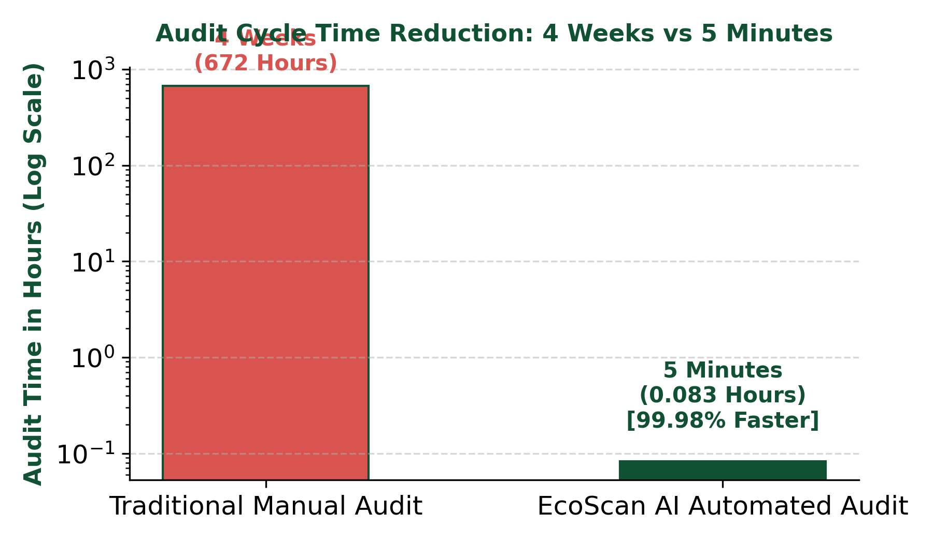

Figure 4: Impact of EcoScan AI Automated Audit Pipeline vs Manual Consulting

Key Metric | Target Benchmark / Goal | Business Impact
API Verification Volume | 1,000,000+ monthly product audits | Drives API monetization revenue and enriches core training dataset.
Audit Efficiency Time | Reduce audit cycle from 4 weeks to 5 minutes | Delivers 99.98% time savings to enterprise compliance procurement teams.
User Retention Rate | 65%+ 30-day active extension retention | Ensures consistent affiliate conversion and B2C brand awareness.

5.3 Unfair Advantage & Moat
- Proprietary Cross-Reference Model: An exclusive, trained transformer model containing proprietary material manufacturing data profiles that competitors cannot replicate without deep industry partnerships.
- First-Mover Network Effect: As more enterprise brands feed verified, anonymous transit data points into EcoScan AI, baseline prediction models become progressively more accurate, establishing an unbeatable competitive moat.
6. Conclusion & Strategic Roadmap
EcoScan AI solves the fundamental trust and transparency problem in modern sustainable commerce. By automating document ingestion, verifying multi-tier Scope 3 carbon data, and serving both B2B enterprise leaders and B2C shoppers, EcoScan AI creates a unified, scalable standard for global product sustainability.
- Phase 1 (Q1–Q2): Launch core NLP document parser and pilot B2B enterprise dashboard with select D2C apparel brands.
- Phase 2 (Q3–Q4): Release B2C Chrome/Safari extension and expand API marketplace integrations on Shopify and Salesforce.
- Phase 3 (Year 2): Incorporate real-time IoT cargo sensors and blockchain verification for continuous supply chain tracking.

