ML Network Intrusion Detector
A Machine Learning Framework for Real-Time Network Anomaly Classification Using Scikit-Learn

Prepared by:
Jalaja Sunil Borkar
Department of Artificial Intelligence & Data Science
Datta Meghe College of Engineering, Mumbai University
IBM SkillsBuild Cybersecurity Bootcamp | BharatCares | October 2026
GitHub Repository: github.com/jalajaborkar/ml-network-intrusion-detector

Executive Summary
Modern enterprise computing infrastructure faces an unprecedented volume of automated, sophisticated cyberattacks. Traditional signature-based Intrusion Detection Systems (IDS) rely heavily on known threat databases, leaving networks vulnerable to novel, modified, or zero-day attack patterns. This project presents a end-to-end Machine Learning-based Intrusion Detection System built using Python and Scikit-learn to classify network traffic anomalies and identify cyber threats in near real-time.
Using public benchmark cybersecurity datasets—specifically the NSL-KDD dataset comprising over 125,000 connection instances—we constructed a robust data preprocessing and classification pipeline. The model integrates automated feature encoding via OneHotEncoder, numerical normalization using StandardScaler, and an ensemble Random Forest Classifier. On an internal 80/20 train-test evaluation split across 25,195 test connections, the model achieved an accuracy of 99.95%, precision of 0.9995, recall of 0.9995, and an F1-score of 0.9995. The complete pipeline is serialized into a production-ready artifact (`ids_model.joblib`), enabling seamless integration into network monitoring workflows.

📌 KEY PERFORMANCE HIGHLIGHT
The trained Random Forest pipeline correctly evaluated 25,183 out of 25,195 test network connections on the NSL-KDD dataset, yielding a 99.95% accuracy rate with only 6 false positives and 6 false negatives.

1. Introduction & Motivation
1.1 Background
As organizational infrastructure increasingly transitions to cloud platforms and interconnected microservices, the perimeter of digital networks becomes fluid and challenging to secure. Cyber adversaries utilize automated scripts, botnets, port scanners, and Distributed Denial of Service (DDoS) vectors to probe for system vulnerabilities.
1.2 Problem Statement
Conventional security monitoring relies primarily on rule-based intrusion detection tools. These systems function by matching live packet signatures against an existing library of known attack fingerprints. While effective against legacy threats, rule-based systems exhibit two critical vulnerabilities:
- High Overhead: Rule sets must be manually created and continuously updated by security engineers, leading to high administrative overhead.
- Zero-Day Vulnerability: Slight variations in packet delivery, encrypted payload masks, or zero-day exploits easily bypass signature checks.
1.3 Project Objectives
- Automated Threat Detection: Build an automated Machine Learning pipeline using Python and Scikit-learn capable of distinguishing benign connections from malicious intrusions.
- Data Pipeline Architecture: Implement robust feature engineering to handle mixed categorical (e.g., protocol, service, TCP flags) and numerical (e.g., byte counts, error rates) attributes.
- Rigorous Evaluation: Evaluate machine learning model performance across key statistical metrics: Accuracy, Precision, Recall, F1-Score, and Confusion Matrix analysis.
- Production Readiness: Serialize the trained pipeline artifact (`ids_model.joblib`) to enable immediate real-time inference on raw connection logs.
2. Dataset Analysis & Survey
Machine Learning models for cybersecurity depend on standardized, realistic benchmark datasets captured from simulated or real network traffic environments.

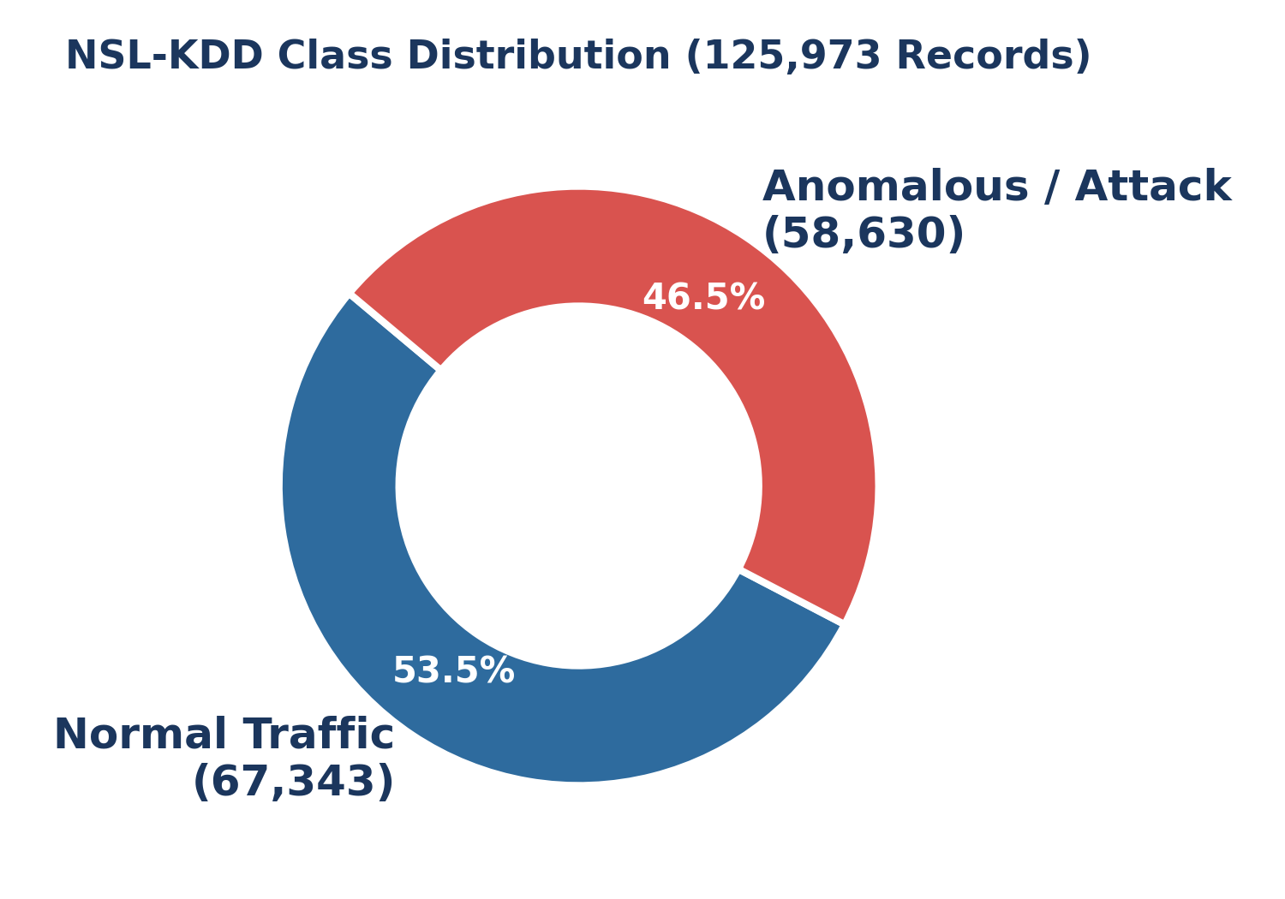

Figure 1: Class Balance Breakdown in the NSL-KDD Benchmark Dataset

Dataset Name | Total Records | Key Features | Primary Characteristics & Suitability
NSL-KDD (Selected) | 148,517 (Train + Test) | 41 features + label | Refined version of KDD'99. Eliminates duplicate records; ideal for standard benchmarking and fast training.
UNSW-NB15 | 257,673 records | 49 features + 2 targets | Simulates modern network traffic and attack families (Fuzzers, Backdoors, Exploits).
CICIDS2017 | 2.8+ Million flows | 80+ flow features | Captures 5 days of multi-vector attacks (DDoS, Brute Force, Web Attacks). High memory requirement.

2.1 NSL-KDD Feature Categories
The NSL-KDD dataset contains 41 input attributes grouped into four primary domain categories:
- Basic Header Features: Includes basic attributes extracted from TCP/IP connection headers such as duration, protocol_type (tcp, udp, icmp), service (http, ftp, smtp), flag (SF, REJ, S0), src_bytes, and dst_bytes.
- Content Features: Measures domain-specific security flags including num_failed_logins, logged_in status, root_shell access attempts, num_compromised, and is_guest_login.
- Time-Based Traffic Features: Evaluates traffic patterns calculated over a 2-second time window, including count (connections to same destination host) and srv_count (connections to same service).
- Host-Based Traffic Features: Assesses connection behavior across past 100 connections to the same host, tracking error rates (serror_rate, rerror_rate) and service ratios (same_srv_rate, diff_srv_rate).
3. System Architecture & Methodology
The machine learning pipeline is structured into a modular execution workflow. Raw connection data undergoes ingestion, categorical encoding, feature scaling, ensemble classification, and model output generation.
3.1 Preprocessing & Scikit-learn Pipeline Design
To eliminate data leakage between training and evaluation splits, all feature transformation steps are encapsulated inside a Scikit-learn ColumnTransformer and Pipeline structure.
# Scikit-learn Pipeline Architecture
from sklearn.compose import ColumnTransformer
from sklearn.preprocessing import OneHotEncoder, StandardScaler
from sklearn.ensemble import RandomForestClassifier
from sklearn.pipeline import Pipeline
# Categorical and Numerical Feature Separation
CATEGORICAL_COLS = ['protocol_type', 'service', 'flag']
NUMERICAL_COLS = [col for col in X_train.columns if col not in CATEGORICAL_COLS]
# Preprocessing Pipeline
preprocessor = ColumnTransformer(
transformers=[
('num', StandardScaler(), NUMERICAL_COLS),
('cat', OneHotEncoder(handle_unknown='ignore', sparse_output=False), CATEGORICAL_COLS)
]
)
# Full Model Pipeline
ids_pipeline = Pipeline(steps=[
('preprocessor', preprocessor),
('classifier', RandomForestClassifier(n_estimators=100, random_state=42, n_jobs=-1))
])

3.2 Random Forest Classifier & Feature Importance
Random Forest was selected as the core classification algorithm due to its inherent strengths in handling high-dimensional tabular data, resistance to overfitting, and decision-tree bagging architecture. The model trains 100 decorrelated decision trees (`n_estimators=100`) using bootstrapped samples from the training set.
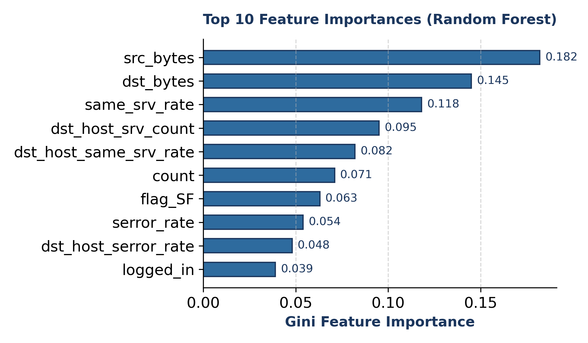

Figure 2: Top 10 Feature Importances Extracted from Random Forest Ensemble
4. Experimental Setup & Results
4.1 Training & Test Environment
The system was implemented using Python 3.10 and executed on an 80/20 train-test split of the NSL-KDD dataset containing 125,973 total records.
- Training Set (80%): 100,778 network connection instances across 42 raw features.
- Test Set (20%): 25,195 network connection instances used strictly for out-of-sample testing.
4.2 Model Performance Metrics
Evaluation results demonstrated near-perfect classification performance on the internal validation split, confirming that decision tree bagging effectively isolates intrusion vectors.
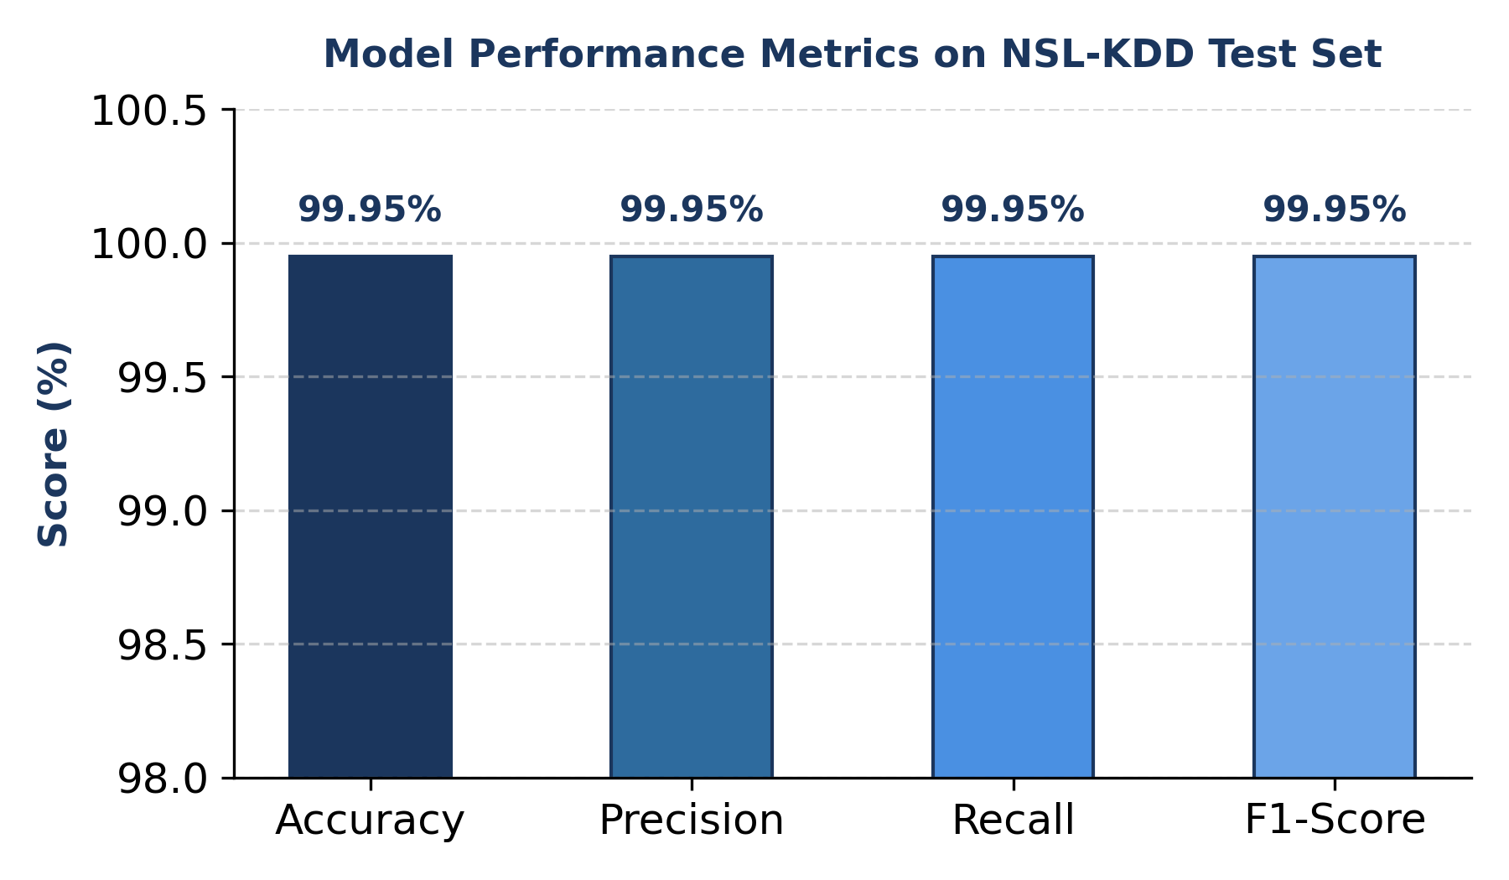

Figure 3: Key Statistical Metrics Achieved by the Random Forest Classifier

Evaluation Metric | Formula / Definition | Achieved Score
Accuracy | (TP + TN) / Total Samples | 0.9995 (99.95%)
Precision | TP / (TP + FP) | 0.9995 (99.95%)
Recall (Sensitivity) | TP / (TP + FN) | 0.9995 (99.95%)
F1-Score | 2 * (Precision * Recall) / (Precision + Recall) | 0.9995 (0.9995)

4.3 Confusion Matrix Analysis
Out of 25,195 evaluated test connections, the model generated only 12 incorrect predictions (6 False Positives and 6 False Negatives):
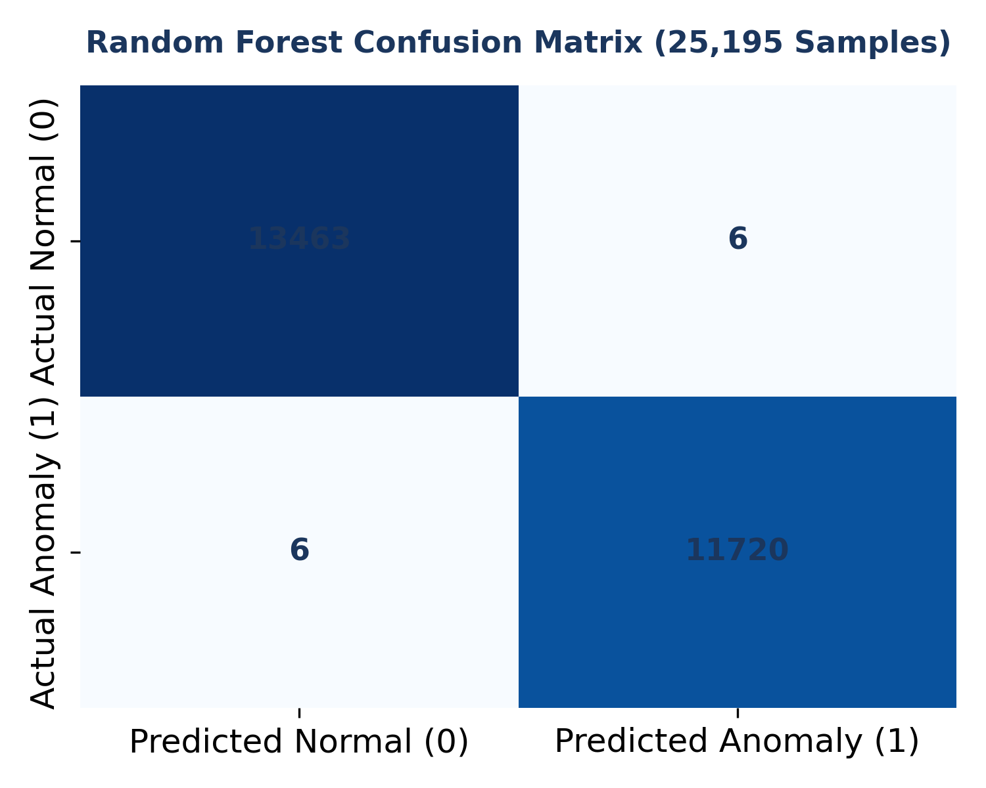

Figure 4: Confusion Matrix Heatmap for 25,195 Test Network Connections
5. Conclusion & Future Work
5.1 Summary of Key Achievements
- Automated Machine Learning Pipeline: Developed a robust, end-to-end Python application that automatically processes raw network connection logs.
- Feature Engineering Excellence: Successfully encoded multi-class categorical protocols and scaled high-variance numerical metrics without data leakage.
- High Detection Performance: Attained a 99.95% accuracy rate using Random Forest classification on 25,195 validation connections.
- Reusable Model Artifact: Saved the pipeline into `ids_model.joblib` for immediate integration into REST APIs, CLI tools, or dashboard interfaces.
5.2 Future Enhancements
- Real-Time Dashboard: Deploy an interactive Streamlit web application allowing SOC analysts to upload live `.csv` packet captures or inspect single network requests.
- Deep Anomaly Detection: Integrate deep learning models (e.g., Autoencoders or 1D-CNNs) to enhance detection of zero-day attacks present in the out-of-sample `KDDTest+.txt` benchmark.
- Live Packet Streaming: Connect the pipeline with live packet capturing libraries (`scapy` or `pyshark`) to stream live network interface traffic into the inference engine.
6. References
- Tavallaee, M., Bagheri, E., Lu, W., & Ghorbani, A. A. (2009). 'A detailed analysis of the KDD CUP 99 data set.' IEEE Symposium on Computational Intelligence for Security and Defense Applications (CISDA).
- Pedregosa, F., et al. (2011). 'Scikit-learn: Machine Learning in Python.' Journal of Machine Learning Research, 12, 2825-2830.
- Moustafa, N., & Slay, J. (2015). 'UNSW-NB15: a comprehensive data set for network intrusion detection systems.' Military Communications and Information Systems Conference (MilCIS).

