Practical 7
7. For the given input values of x and y, compute coefficient values to build linear regression model and plot it. Use this model to predict the value of y for the new value of x. Also compute MSE and RSS. (Note: Use only numpy library)
import numpy as np
import matplotlib.pyplot as plt
x = np.array([1, 2, 3, 4, 5])
y = np.array([2, 4, 8, 8, 10])
x_mean = np.mean(x)
y_mean = np.mean(y)
m = np.sum((x - x_mean)*(y - y_mean)) / np.sum((x - x_mean)**2)
c = y_mean - m*x_mean
print("Slope:", m)
print("Intercept:", c)
y_pred = m*x + c
mse = np.mean((y - y_pred)**2)
rss = np.sum((y - y_pred)**2)
print("MSE:", mse)
print("RSS:", rss)
x_new = 6
print("Predicted y for x=6:", m*x_new + c)
plt.scatter(x, y)
plt.plot(x, y_pred)
plt.show()
Output
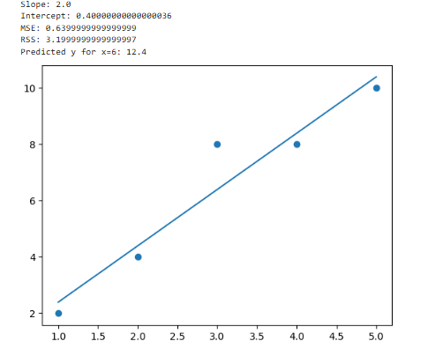

Practical 8
8. For the given input values of x and y, build a linear regression model using scipy library and plot it. Also find co-relation coefficient (R-value), Probability value (P-value), and standard error. Try to modify the values in (X, Y) and identify its effect on

the R-value, P-value and standard error.
import numpy as np
import matplotlib.pyplot as plt
from scipy.stats import linregress
x = np.array([1,2,3,4,5,6,7,8,9,10])
y = np.array([2,5,7,10,11,13,14,17,19,20])
slope, intercept, r, p, std_err = linregress(x, y)
print("Slope:", slope)
print("Intercept:", intercept)
print("R-value:", r)
print("R-squared:", r**2)
print("P-value:", p)
print("Standard Error:", std_err)
plt.scatter(x, y)
plt.plot(x, slope*x + intercept)
plt.show()

Output:
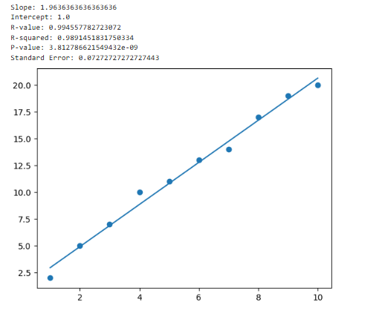

Practical 9
9. Build a linear regression model that predicts house prices based on square footage(For your own dataset).
import numpy as np
import matplotlib.pyplot as plt
from scipy.stats import linregress
sqft = np.array([500, 800, 1000, 1200, 1500, 1800, 2000, 2200])
price = np.array([100, 150, 200, 230, 300, 350, 400, 420])
slope, intercept, r, p, std_err = linregress(sqft, price)
print("Slope:", slope)
print("Intercept:", intercept)
print("R-value:", r)
print("P-value:", p)
print("Standard Error:", std_err)
new_sqft = 1600
print("Predicted Price:", slope*new_sqft + intercept)
plt.scatter(sqft, price)
plt.plot(sqft, slope*sqft + intercept)
plt.show()

Output:
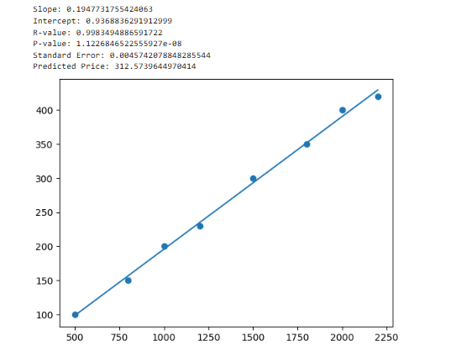

Practical 10
10. Build a linear regression model using SKlearn library for the following :
a. Take input values in terms of lists (X,Y).
b. Generate training dataset and testing dataset from the input lists using
train_test_split() from SKlearn.
c. Train the model using training dataset.
d. Predict Y for test dataset.
e. Draw the plot.
f. Repeat step (b)-(e) for random pairs of (X,Y).
import numpy as np
import matplotlib.pyplot as plt
from sklearn.model_selection import train_test_split
from sklearn.linear_model import LinearRegression

x = [5,7,8,7,2,17,2,9,4,11,12,9,6]
y = [99,86,87,88,111,86,103,87,94,78,77,85,86]

# convert list to array as LinearRegression model of SKlearn can work with array only
Train_x = np.array(x)
print("Train_x Before Reshaping: ", Train_x)

# Reshape X for sklearn
# To convert x list into one column vector
# reshape(-1,1) - No. of rows-unknown, no. of cols-1
Train_x = Train_x.reshape(-1,1)
print("Train_x After Reshaping: ", Train_x)

# Train model
Model = LinearRegression()
Model.fit(Train_x,y)

# use the same data for testing
Test_x = np.array([5,7,8,7,2,17,2,9,4,11,12,9,6])
Test_y = np.array([99,86,87,88,111,86,103,87,94,78,77,85,86])

print("Test_x Before Reshaping: ", Test_x)

# Reshape X for sklearn
Test_x = Test_x.reshape(-1,1)
print("Test_x After Reshaping: ", Test_x)

# Make predictions
y_pred = Model.predict(Test_x)
print(y_pred)

# Create visualization
plt.figure(figsize=(10, 6))
plt.scatter(Test_x, Test_y, color='blue', label='Test_x')
plt.plot(Test_x, y_pred, color='red', label='Regression Line')
plt.xlabel('X')
plt.ylabel('Y')
plt.title('X vs Y')
plt.legend()
plt.show()

# using train_test_split() and static data
x = np.array([5,7,8,7,2,17,2,9,4,11,12,9,6])
y = np.array([99,86,87,88,111,86,103,87,94,78,77,85,86])

X_train, X_test, y_train, y_test = train_test_split(
x, y, test_size=0.2, random_state=42)

print(X_train)
print(X_test)

# Reshape X for sklearn
X_train = X_train.reshape(-1, 1)
y_train = y_train.reshape(-1, 1)
X_test = X_test.reshape(-1,1)

# Create and train the model
model = LinearRegression()
model.fit(X_train, y_train)

# Make predictions
y_pred = model.predict(X_test)

# Create visualization
plt.figure(figsize=(10, 6))
plt.scatter(X_test, y_test, color='blue', label='Test_x')
plt.plot(X_test, y_pred, color='red', label='Regression Line')
plt.xlabel('X')
plt.ylabel('Y')
plt.title('X vs Y')
plt.legend()
plt.show()

# using train_test_split() and dynamic data

# Set random seed for reproducibility
np.random.seed(42)

# Generate sample data
def generate_sample_data(n=100):
xdata = np.random.uniform(1000, 5000, n) # Uniform distribution
print("No of Points = {}\nPoints = {}".format(xdata.size, xdata))

# Normal distribution (bell-shaped)
ydata = xdata * 100 + np.random.normal(0, 25000, n)
return xdata, ydata

# Generate the data
X, y = generate_sample_data()

# Prepare datasets training-testing
X_train, X_test, y_train, y_test = train_test_split(
X, y, test_size=0.2, random_state=42)

print("\n\nTraining Dataset: {}\n\nTest Dataset: {}".format(X_train, X_test))

# Reshape X for sklearn
X_train = X_train.reshape(-1, 1)
y_train = y_train.reshape(-1, 1)
X_test = X_test.reshape(-1,1)

# Create and train the model
model = LinearRegression()
model.fit(X_train, y_train)

# Make predictions
y_pred = model.predict(X_test)

# Create visualization
plt.figure(figsize=(6, 6))
plt.scatter(X_test, y_test, color='blue', label='Test_x')
plt.plot(X_test, y_pred, color='red', label='Regression Line')
plt.xlabel('X')
plt.ylabel('Y')
plt.title('X vs Y for Random Data')
plt.legend()
plt.show()

Output:
Train_x Before Reshaping: [ 5 7 8 7 2 17 2 9 4 11 12 9 6]
Train_x After Reshaping: [[ 5]
[ 7]
[ 8]
[ 7]
[ 2]
[17]
[ 2]
[ 9]
[ 4]
[11]
[12]
[ 9]
[ 6]]
Test_x Before Reshaping: [ 5 7 8 7 2 17 2 9 4 11 12 9 6]
Test_x After Reshaping: [[ 5]
[ 7]
[ 8]
[ 7]
[ 2]
[17]
[ 2]
[ 9]
[ 4]
[11]
[12]
[ 9]
[ 6]]
[94.34952171 90.84694628 89.09565857 90.84694628 99.60338484 73.33406917
99.60338484 87.34437086 96.10080942 83.84179544 82.09050773 87.34437086
92.598234 ]
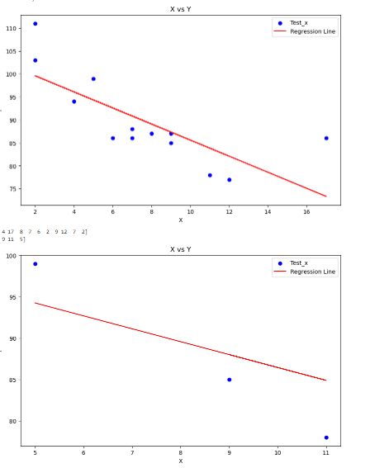
No of Points = 100
Points = [2498.16047539 4802.85722564 3927.97576725 3394.63393679 1624.07456177
1623.97808134 1232.33444867 4464.7045831 3404.46004697 3832.29031118
1082.33797718 4879.63940865 4329.7705632 1849.35644271 1727.29986883
1733.61803941 2216.96897184 3099.02572653 2727.78007457 2164.91656079
3447.41157889 1557.97544261 2168.57859414 2465.44737317 2824.27993687
4140.70384557 1798.69512863 3056.93775365 3369.65827545 1185.80165088
3430.17940761 1682.09649475 1260.20637194 4795.54214901 4862.5281323
4233.58939247 2218.45507669 1390.68845603 3736.93210605 2760.60997496
1488.15293938 2980.70764045 1137.55408446 4637.28160832 2035.1199264
3650.08913742 2246.84430436 3080.27208471 3186.84111737 1739.4178221
4878.33851106 4100.53129344 4757.99576626 4579.30940171 3391.59991524
4687.49694009 1353.97000821 1783.93144968 1180.90915564 2301.32132305
2554.70915876 2085.3961271 4314.95003661 2427.01330677 2123.73803875
3170.78433263 1563.6968999 4208.78792302 1298.20257472 4947.5477464
4088.97907719 1794.86272614 1022.08846849 4261.84571382 3827.42937539
3916.02867216 4085.08138674 1296.17860694 2433.86291418 1463.4762381
4452.4137035 3493.19250731 2323.59209941 1254.23340114 2243.92928686
2300.73328811 3918.42471335 3550.22988542 4548.85097031 2888.85970065
1478.37698375 3852.97914889 4043.14019447 3245.10879028 4083.86871982
2975.18238546 3090.93131753 2710.16407343 1101.67650698 1431.56570797]

Training Dataset: [4687.49694009 4548.85097031 1798.69512863 1137.55408446 4947.5477464
1733.61803941 1488.15293938 3090.93131753 3832.29031118 1022.08846849
4879.63940865 3080.27208471 2300.73328811 3369.65827545 3245.10879028
1623.97808134 1563.6968999 3170.78433263 4233.58939247 2216.96897184
1739.4178221 4862.5281323 4464.7045831 2975.18238546 3056.93775365
2164.91656079 3493.19250731 4140.70384557 4314.95003661 1849.35644271
2824.27993687 3394.63393679 3099.02572653 3736.93210605 3404.46004697
2433.86291418 1232.33444867 2123.73803875 2218.45507669 2888.85970065
1353.97000821 1431.56570797 3391.59991524 4637.28160832 4878.33851106
4208.78792302 2246.84430436 1298.20257472 2085.3961271 2710.16407343
1463.4762381 2980.70764045 1180.90915564 3186.84111737 1101.67650698
1783.93144968 3916.02867216 1260.20637194 4083.86871982 2301.32132305
2427.01330677 2243.92928686 1390.68845603 1185.80165088 4802.85722564
4757.99576626 1557.97544261 3927.97576725 2465.44737317 3550.22988542
3852.97914889 3827.42937539 3918.42471335 2323.59209941 3447.41157889
2554.70915876 1794.86272614 1727.29986883 4043.14019447 4100.53129344]

Test Dataset: [1254.23340114 4579.30940171 4088.97907719 3650.08913742 2035.1199264
2760.60997496 2168.57859414 4452.4137035 1082.33797718 2498.16047539
2727.78007457 3430.17940761 4261.84571382 4795.54214901 1478.37698375
1624.07456177 4085.08138674 1296.17860694 4329.7705632 1682.09649475]
