Practical1
1. Create .xls file as dataset containing student records. Dataset should contain following
information.
a. Sr. No.
b. Enrolment Number
c. Department Name
d. Student Name
e. Current semester
f. Email ID
g. Mobile Number
h. Current SPI
i. CPI
j. Professional Elective
k. TOE Name
l. CNS Marks
m. SE Marks
n. DMBI Marks
o. WT Marks
p. EO Marks
Create at least 20 records for the dataset and perform following operations.
a. Use Sum function to get Grand Total of all subject marks.
b. Find percentage with your formula for all 5 subjects.
c. Find students is PASS or FAIL with appropriate function from percentage.
d. Find Class with Nested if function (use marks > 75 = “distinction”, >=60=”
FirstClass”, >=35 = “Second Class” else “Fail”

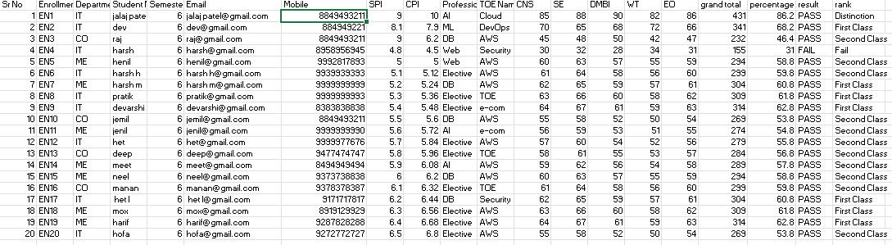

Formulas use for this:
2. Equations Used To perform the required operations, the following Excel formulas were
query
a. Grand Total:
=SUM(L2:P2) (Calculates the sum of CNS, SE, DMBI, WT, and EO marks)

b. Percentage:
= =Q2/500*100

c. Result (PASS/FAIL):
=IF(R2>=35,"PASS","FAIL")

d. Class (Nested IF use):
=IF(R2>75,"Distinction",IF(R2>=60,"First Class",IF(R2>=35,"Second Class","Fail")))

Practical-1 (part 2) Use if function to display grade of total marks and cns marks and also give the color
B-PART
SHEET2:
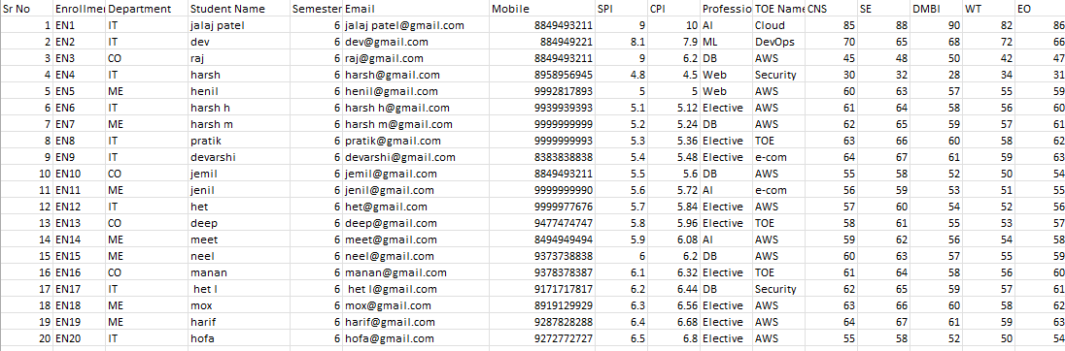

Sheet1:
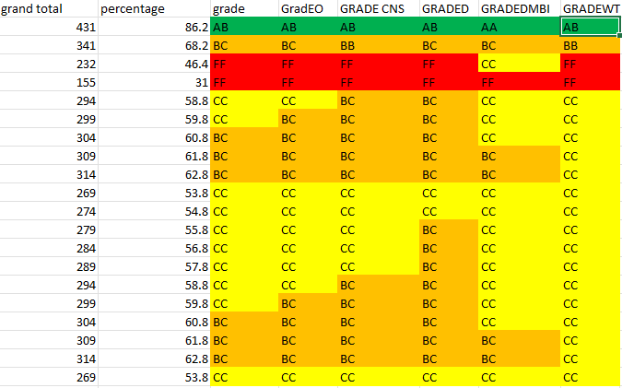

1. Grand Total (Column Q)

“transferring data of sheet 2 to sheet1”
- Formula: =SUM(Sheet2!L2:P2)

2. Percentage (Column R)
- Formula: = =A2/500*100

3. Grade

Formula:=IF(B2>=90,"AA",IF(B2>=80,"AB",IF(B2>=70,"BB",IF(B2>=60,"BC",IF(B2>=50,"CC","FF")))))

4. Grade of all subjects EO,WT,CNS,SE,DMBI (Column T)
Formula:=IF(Sheet2!L2>=F19,"AA",IF(Sheet2!L2>=80,"AB",IF(Sheet2!L2>=70,"BB",IF(Sheet2!L2>=60,"BC",IF(Sheet2!L2>=50,"CC","FF")))))
“For using colour =B2:h22="AB" change colour to green”
“IN THIS JUST CHANGE CELL L2: OTHER CELL TO GET GRADE OF OTHER SUBJECTS”

