Name: Jalak Gevariya

Application Name: Gevariya

Subject: Mobile application development

Description: Created mobile application with navigation to 2 different screen. Having 1 main screen with self introduction. For navigation I have used buttons and on that button’s click event it redirect us to the different screen like contact and hobbies.

1. Application Name 2. Home screen

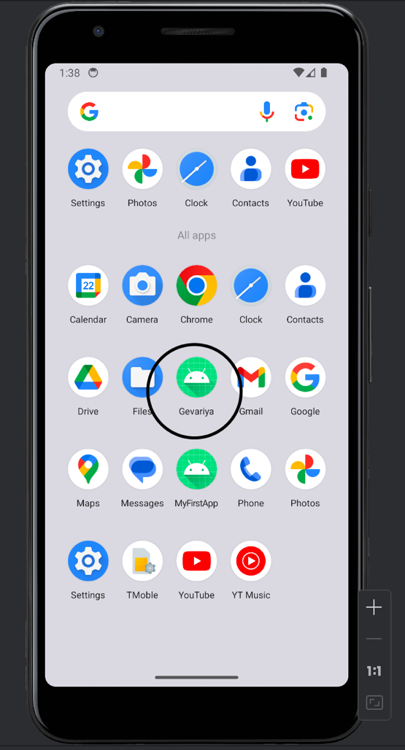 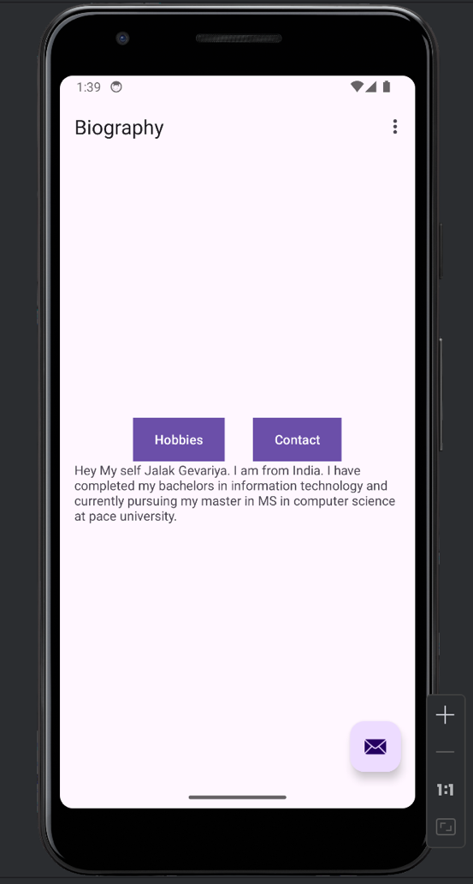

3.Hobbies. 4. Contact

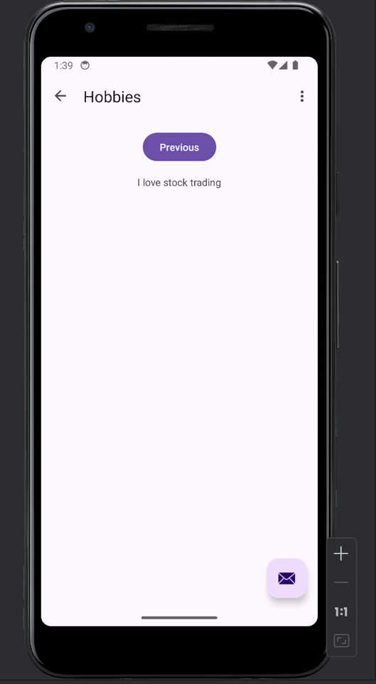 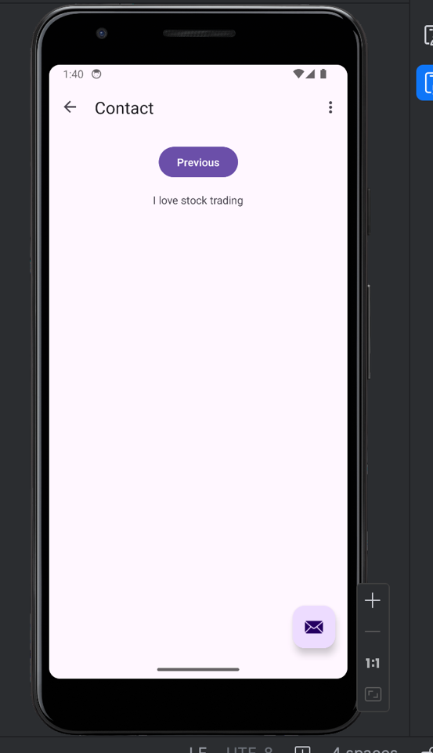

5. Floating 6. Click on Email

