**MANAGEMENT OF A PATIENT WITH TRIPLE VESSEL CORONARY ARTERY DISEASE AND A LARGE MORGAGNI HERNIA: A CASE REPORT**

**ABSTRACT**

**background**:Morgagni hernia is defined as a diaphragmatic defect that occurs rarely in adults. Characterized by herniation of the abdominal content into the thoracic cavity, typically in the right side of the chest, this case report highlights the coexistence of large Morgagni hernia and severe triple vessel coronary artery disease, which was successfully treated through a combined surgical approach.

**Case presentation:** A 78-year-old female patient with ischemic heart disease and a history of nephrectomy with severe chest pain radiating to her neck, despite being on medications her symptoms persisted. Imaging revealed a large right-sided Morgagni hernia (18x18x12 cm) and severe cardiac dysfunction, including an ejection fraction of 33%, moderate to severe left ventricular systolic dysfunction, severe stenosis of left main coronary artery and right coronary artery along with dilation of the left atrium. The patient underwent traditional coronary artery bypass grafting (CABG) and concurrent hernia repair, resulting in significant clinical improvement.

**Conclusion:** This case demonstrates that a combined surgical approach can successfully manage concurrent triple vessel coronary artery disease and large Morgagni hernia, and reinforces the importance of a multidisciplinary approach and careful perioperative planning in complex case that involves both cardiac and thoracic pathologies.

**Introduction**

Morgagni hernia (MH) is an anterior retrosternal diaphragmatic defect which result from incomplete ingrowth of the cervical myotomes during the embryogenic development (1). With a reported incidence of only 3%, MH considered to be the least common type of all diaphragmatic hernias (2). MH patients usually present with herniation of the abdominal content into the thoracic cavity, typically on the right side due to the coverage of the left side by the pericardium (3). We present a rare case of MH in a 78-years-old female patient with a history of ischemic heart disease who underwent off-pump direct coronary artery bypass graft (OPCAB).

**CASE PRESENTATION**

A 78-year-old female patient presented to our hospital with a 7-month history of progressive shortness of breath on exertion. the patient underwent coronary angiography on February 12th and was diagnosed with ischemic heart disease, specifically triple vessel disease. She experienced exertional chest pain, classified as New York heart association (NYHA class III) radiating to the neck, and was recommended to undergo coronary artery bypass grafting 5 months prior to the surgery. Despite being on medication, the patient has not experienced symptom relief, and had been hospitalized four times previously for similar symptoms. The patient has no history of diabetes, smoking or alcohol use. In addition, the Patient underwent nephrectomy in 1970.

On physical examination, the vital signs were stable with a heart rate of 72 bpm, blood pressure of 126/71 mmHg, respiratory rate of 24 breaths per minute and temperature of 36.6°C. Cardiac and lung auscultation were normal, and abdominal examination was unremarkable. Due to deteriorated cardiac condition, the patient was scheduled for OPCAB to address her triple vessel disease.

Preoperative echocardiography revealed an ejection fraction of 33%, with moderate to severe left ventricular systolic dysfunction, and grade-one left ventricular diastolic dysfunction. The left atrium was dilated, while other chambers were normal in size. Mild mitral and tricuspid regurgitation were present, and apical septal and anterolateral akinesia with apical aneurysmal motion were observed. A chest X-ray (Fig. 1) revealed large heterogeneous opacities with mixed radiolucent areas, predominantly in the mid and lower right lung zones, blurring the right costophrenic angle and diaphragm. A chest CT (Fig. 2) scan revealed a large right-sided Morgagni hernia with dimensions of 18 x 12 x 12 cm. the hernia contained omental fat and a portion of the transverse colon, both of which had herniated into the right thoracic cavity. This displacement resulted in considerable volume loss in the right lower lobe of the lung. Additionally, a CT coronary angiography revealed severe stenosis in the proximal right coronary artery (RCA) and left main artery (LMA), findings were classified as CAD-RADS 4, indicating coronary artery disease with high-degree stenosis. The scan also showed severe stenosis in the proximal left anterior descending artery (LAD) and the first obtuse marginal branch of the left circumflex artery (LCX), along with focal total occlusion of the middle segment of the LAD. In addition, ostial calcified plaque and severe stenosis in the first obtuse marginal (OM1) branch were observed. The coronary calcium Agatston score was calculated at 86.5. Abdominal ultrasound revealed a mildly enlarged liver (16.5 cm) with two hyperechoic lesions in segments I and VIII and a contracted gallbladder.

Preoperative laboratory investigations revealed a white blood cell count of 12.3 x 10⁹/L, hemoglobin of 12 g/dL, and platelet count of 230 x 10⁹/L. Serum electrolytes were within normal limits, with sodium at 140 mmol/L, potassium at 3.8 mmol/L, and calcium at 9.8 mg/dL. Lipid profile analysis revealed total cholesterol of 268 mg/dL, triglycerides of 244 mg/dL, low-density lipoprotein (LDL) of 175.9 mg/dL, and high-density lipoprotein (HDL) of 43.3 mg/dL. Renal function was mildly impaired with a serum creatinine level of 1.8 mg/dL and blood urea of 81 mg/dL. Inflammatory markers were elevated, with an erythrocyte sedimentation rate of 40 mm/hr., and her cardiac profile showed a troponin level of 6.5 ng/L, indicative of ongoing myocardial stress. Glycated hemoglobin (HbA1c) was mildly elevated at 6.6%, suggesting prediabetes. Abdominal ultrasound revealed a mildly enlarged liver (16.5 cm) with two hyperechoic lesions in segments I and VIII and a contracted gallbladder.

The patient underwent an OPCAB procedure, which lasted 4 hours and 30 minutes and began at 5:00 PM on October 4th, stable vital signs were maintained throughout the surgery, by using Intraoperative support including Noradrenaline, Dobutamine, Adrenaline, and Cordarone.

First, a median sternotomy was performed to reveal the large Morgagni Hernia, which occupied two thirds of the right hemithorax. The hernia was Accompanied with collapse and fibrosis of the middle and lower lobes of the right lung. Any adhesions around the hernia were carefully released using monopolar electrocautery to improve surgical access, facilitating hernia reduction and restoring normal anatomy, without opening the hernial sac.

the diaphragmatic defect was detected at the costosternal junction, anteriorly. The herniated abdominal contents were returned to the abdominal cavity, and the defect, which was 6cm x 7cm, was closed using a double layer of polypropylene mesh and secured with interrupted nylon stitches.

Following hernia repair, OPCAB was conducted. The presence of defect caused posterior displacement of the heart, obstructing access to left anterior thoracic artery (LITA). Therefore, harvesting the LITA for grafting to LAD was not possible. Therefore, the radial artery was utilized to graft the LAD artery, while the saphenous vein graft (SVG) was used for obtuse marginal branch bypass.

Postoperatively, the patient was transferred to the intensive care unit (ICU) for further management, where she remained for 10 hours and 30 minutes. During her ICU stay, she received noradrenaline, adrenaline, and dobutamine infusions, along with insulin, electrolyte supplementation (210 cc of sodium bicarbonate and 100 mEq of potassium chloride). Pain management medications including paracetamol, Tramal and plasil were utilized. The patient had three drains with a total output of 550 mL and urine output of 1750 mL during her ICU stay.

Upon transfer to the ward, her drain outputs over the next three days were 400 mL, 650 mL, and 500 mL, respectively. daily laboratory investigations are shown in Table 1, revealing leukocytosis peaking on day 3 then improving by day 5, renal function tests, serum creatinine and blood urea worsened reaching its peak on the 3rd day and then started improving. The levels of C-reactive protein decreased significantly, indicating reduced inflammation. echocardiography showed an ejection fraction of 34%, with moderate to severe left ventricular systolic dysfunction and a small posterior pericardial effusion measuring 8 mm in forth day. Vitamin D levels were low at 16.3 ng/mL, with high uric acid levels at 11.8 mg/dL. The patient's condition improved progressively, with her shortness of breath markedly alleviated following the surgery. Patient was weaned from mechanical ventilation 8 hours postoperatively, and was transferred to the ward on postoperative day one and discharged in day 6.

|  |  |  |  |  |  |  |
| --- | --- | --- | --- | --- | --- | --- |
| **Table 1**: Postoperative Blood Investigations | | | | | | |
|  | Complete blood count | | |  | Renal function test | |
| Day | WBC (x109/L) | Hemoglobin (g/dL) | platelet (x109/L) | CRP (mg/L) | S. Creatinine (mg/dL) | Blood urea (mg/dL) |
| 2 | 19.1 | 9.8 | 205 | 224 | 3.0 | 125 |
| 3 | 19.4 | 9.0 | 153 | 214 | 3.4 | 148 |
| 4 | 12.8 | 8.7 | 160 | 160 | 3.2 | 145 |
| 5 | 9.1 | 9.2 | 226 | 93 | 3.2 | 95 |
| 6 | 9.7 | 9.4 | 221 | - | 2.7 | 112 |
| WBC= white blood cell, CRP= c-reactive protein | | | | | | |

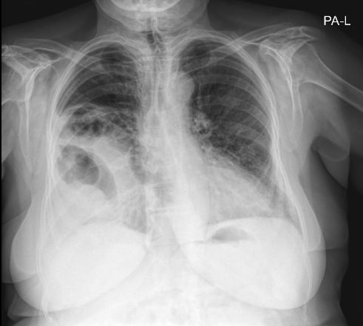

Fig. 1 x-ray of the chest revealing heterogenous opacities predominantly localized in the mid and lower right lung zones.

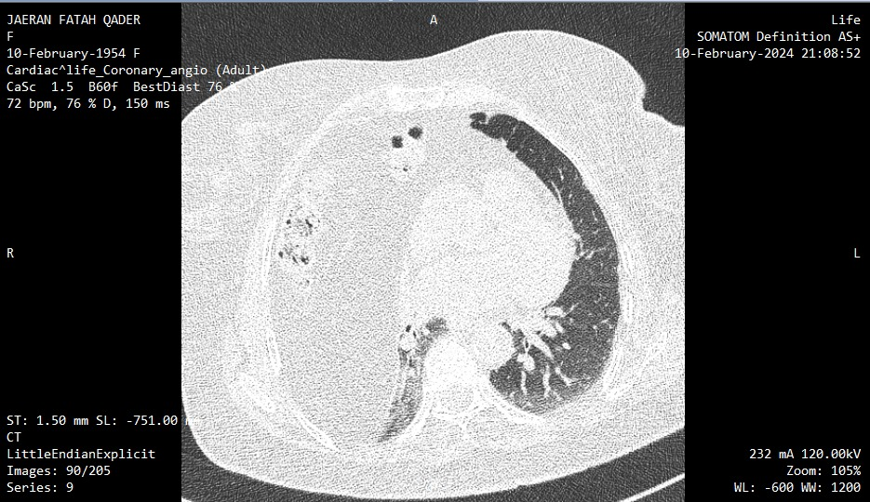

Fig. 2 CT scan demonstrating a large Morgagni hernia containing abdominal content with the displacement of the organs and structures

|  |  |  |
| --- | --- | --- |
| Date | Event | Description |
| 1970 | Right Nephrectomy | For unspecified condition. |
| March of 2024 | Onset of symptoms | Chest pain along with progressive shortness of breath. |
| 12th and 13th of August 2024 | CT scan and chest X-ray | Revealing large hernia and opacities was revealed by imaging techniques |
|  |  |  |
| October of 2024 | Surgical intervention | OPCAB and hernia repairing performed. |

**DISCUSSION**

Morgagni hernia is a rare congenital defect, accounting for nearly 3% of diaphragmatic hernias in adults. Typically, these hernias are discovered incidentally, as many patients remain asymptomatic for long periods. In our case, the patient was present with symptomatic triple vessel CAD which was complicating the diagnosis and management of the Morgagni hernia. The case was similar to another case which was reported previously with Morgagni hernia, and managed with coronary artery bypass grafting (4).

a surgical repair of Morgagni hernias is essential to prevent life-threatening complications such as strangulation, obstruction, or cardiopulmonary compromission. in this case, the hernia involved a large portion of the Omentum and transverse colon, causing volume loss in the right lung, which further complicated the patient’s preexisting cardiac condition. The presence of abdominal contents affecting the cardiopulmonary system has been reported in another case where Morgagni hernia repair was necessitated during cardiac surgery (5).

In our case, an OPCAB approach was selected to manage CAD accompanied with hernia repair, this decision was based on the ability that, through a median sternotomy it would allow us to directly contact with both the heart and the diaphragmatic defect, allowing simultaneous management. Additionally, OPCAB reduces the risks associated with cardiopulmonary bypass(6). this decision slightly differs with the literature suggesting that open surgery remains the preferred option in patients with concurrent cardiac disease, especially in cases involving hernias (4, 7).

The patient’s postoperative course in our case was relatively uncomplicated, with improvement in cardiac function and resolution of her respiratory symptoms. A similar case was reported by brookes et al. where simultaneous repair of Morgagni hernia and coronary artery disease led to favorable recovery, and the patient’s condition improved without major postoperative complication (8). The outcomes in our case are in line with those seen in the literature, underscoring the importance of addressing both conditions simultaneously to enhance patient prognosis.

In conclusion this study highlights that OPCAB serves as a reliable approach for simultaneous management of triple vessel (CAD) along with Morgagni hernia, which reduces the need for multiple surgical interventions. This results further highlights that Multidisciplinary approach and careful perioperative planning in complex cases such that are required.

**Reference**

1. Nasr A, Fecteau A. Foramen of Morgagni Hernia: Presentation andTreatment. Thorac Surg Clin. 2009;19:463-8.

2. Horton JD, Hofmann LJ, Hetz SP. Presentation and management of Morgagni hernias in adults: a review of 298 cases. Surgical endoscopy. 2008;22:1413-20.

3. Maish MS. The Diaphragm. Surgical Clinics of North America. 2010;90(5):955-68.

4. Gopalakrishnan M, Kodhandapani C, Sairam A, Abraham J, Periappuram J. Morgagni’s hernia, repair during coronary bypass surgery. Indian Journal of Thoracic and Cardiovascular Surgery. 2007;23:151-2.

5. Ciancarella P, Fazzari F, Montano V, Guglielmo M, Pontone G. A huge Morgagni hernia with compression of the right ventricle. Journal of the Saudi Heart Association. 2018;30(2):143-6.

6. Bull DA, Neumayer LA, Stringham JC, Meldrum P, Affleck DG, Karwande SV. Coronary artery bypass grafting with cardiopulmonary bypass versus off-pump cardiopulmonary bypass grafting: does eliminating the pump reduce morbidity and cost? The Annals of thoracic surgery. 2001;71(1):170-5.

7. Wilimski R, Krauz K, Dudek K, Wondołkowski M, Kuśmierczyk M. An anterior diaphragmatic hernia incidentally found during coronary artery bypass graft surgery: a rare case report and review of the literature. Kardiochirurgia i Torakochirurgia Polska/Polish Journal of Thoracic and Cardiovascular Surgery. 2023;20(1):50-2.

8. Brookes JD, Munasinghe CP, Croagh D, Goldstein JG. Approach to a large rare diaphragmatic hernia in a patient undergoing cardiac surgery. Journal of Surgical Case Reports. 2019;2019(2):rjz038.