The Causal Bar E3 Did Not Clear: A County-Level Re-Examination of Data Centers and Rates
Jalal Awan, Ph.D., Independent Researcher
ABSTRACT
E3's May 2026 whitepaper, Understanding the Drivers of Rising Electricity Rates and the Role of Data Centers^{[1]}, concludes from a synthesis of 11 quantitative studies and four unnamed expert interviews that there is no historical evidence of cost-shifting from data centers to residential or small commercial ratepayers, and that state commissions are adequately adapting, citing 38 new large-load tariffs filed since 2018. The report is funded by the Data Center Coalition; its strongest supporting case study for data centers creating consumer surplus, an earlier E3 analysis of Amazon facilities^{[2]}, is funded by Amazon. E3 affirms editorial independence from its funders. Even accepting that, the central conclusion does not follow from the evidence E3 assembles. A non-detection across a small, predominantly backward-looking literature does not establish the absence of cost-shifting; it leaves the question undetermined. E3 also weakens its case by discounting the one study with a credible causal design, Georgia Tech's staggered difference-in-differences, while crediting correlational and industry-funded analyses.
This response provides an independent re-examination using public data on 1,506 U.S. data center facilities (FracTracker), state and county energy and demographic indicators (EIA Form 861, DOE LEAD, NREL SLOPE, EPA AQS, USGS, CDC, FCC), and the 77-tariff SEPA DELTa database. These are public datasets with known limitations, including incomplete coverage and reporting gaps, but they represent the best openly available evidence assembled without proprietary or paid data. Four findings stand out. First, state-level analysis cannot meaningfully detect the cost shift it purports to rule out: the top 30 U.S. counties hold 50 percent of all announced data center MW, and 487 of 3,236 counties carry all operational and in-progress builds. Second, while existing literature suggests that large load growth historically lowered residential rates through fixed-cost spreading, that pattern does not appear at the county level for data center load specifically. Data centers are already concentrating in counties with below-average residential rates and below-average rates-of-increase, so the historical association is, at best, a selection effect, not evidence that data centers cause rates to fall. Third, host counties carry higher PM2.5 (+9 percent, p < 0.001), 2.3 times the GHG totals, 3.5 times the freshwater withdrawals, and 4.3 times the minority population share of non-host counties. Marginal load is landing on already-elevated environmental and equity baselines, worsening rather than easing distributional burden. Even small per-prompt footprints scale up: Google's 2025 disclosure puts a single median Gemini text prompt at 0.26 mL of water and 0.24 Wh of energy, equivalent to roughly nine seconds of television^{[29]}; multiplied across billions of daily prompts the aggregate footprint lands disproportionately on these host counties. Data centers are also not sited where renewable potential is highest: four of the five largest data center states sit below the U.S. mean on both solar and onshore wind capacity factor. Fourth, scoring the full SEPA universe of 77 large-load tariffs (2018 to 2026) against a quantitative customer-protection rubric yields a mean of 1.94 out of 5; 51 percent of all tariffs score 0 or 1. E3 reports only 38 of these 77 tariffs without explaining the selection. The headline tariff count is not the same as a strong customer-protection regime. The policy question is forward-looking and county-resolved; the evidence base needs to be both.
BACKGROUND
The E3 whitepaper
On May 18, 2026, Energy and Environmental Economics, Inc. (E3) released Understanding the Drivers of Rising Electricity Rates and the Role of Data Centers, a synthesis of selected evidence on whether U.S. data center load growth is contributing to recent retail rate increases^{[1]}. The whitepaper is funded by the Data Center Coalition, an industry trade association whose members include the largest U.S. hyperscale data center operators. E3 retains authorial independence per the disclosure, but the report has not been peer-reviewed.
The whitepaper makes five top-line claims, summarized verbatim in the report's executive summary. First, multiple factors drive recent rate pressure, of which data center load growth is one among several. Second, the historical state-level relationship between load growth and rate increases is unclear; states with the largest load growth (Texas, Virginia) saw the smallest rate increases. Third, in PJM, approximately 50 percent of the recent capacity-auction price increase is attributable to load growth, with the remaining 50 percent attributable to supply-side and market-design factors. Fourth, the quantitative studies reviewed do not establish evidence of historical cost-shifting from data centers to other ratepayer classes. Fifth, tailored large-load tariffs, of which the report identifies 38 since 2018, are evidence of regulatory adaptation.
"Of the quantitative studies evaluating the impact of data centers on rising electric rates, none have found evidence of historical cost shift to date", and “The current quantitative evidence suggests no indication that ratepayers have subsidized data centers…”
— E3 (2026), p. 15 and p.18
E3 Appendix A.1: the 11 reviewed studies
E3's synthesis rests on 11 quantitative studies and four expert interviews. The interviews are not identified by name, affiliation, or independence. Of the 11 studies, only three are forward-looking (E3's own work, Georgia Tech, and the Federal Reserve Bank of Dallas). E3 substantively critiques two of those three. The remaining eight are backward-looking. The studies covered by E3 include:
Study | Year | Direction | E3's treatment
Bates White, Leveraging large loads | 2026 | Backward | Cited as supportive; correlational only
EPRI, Powering Intelligence | 2026 | Forward | Forecast supply / pipeline; E3 notes "may overstate"
Federal Reserve Bank of Dallas | 2026 | Forward | E3 critiques status-quo regulation assumption
Georgia Tech (Yue and Zeng) | 2026 | Forward (DiD) | Downweighted as "measurement problem"
Union of Concerned Scientists (clean energy) | 2026 | Forward | Characterized as "policy-advocacy oriented"
PJM IMM (Capacity Auction Analysis) | 2025 | Backward | Cited; supply factors elided
Charles River Associates | 2025 | Backward | Variables identified, causal links unexamined
E3 / Amazon case studies (funded by Amazon) | 2025 | Both | Treated as supportive evidence
Lawrence Berkeley National Laboratory | 2025 | Backward | Cited; LBNL author publicly disputes E3's framing
UCS, Connection Costs ($4B loophole) | 2025 | Current | Acknowledged but treated as narrow
JLARC (Virginia data center study) | 2024 | Backward | Lead supportive citation; written by E3
Table 1. Eleven studies reviewed in E3 (2026) Appendix A.1, showing direction (backward / forward / current) and E3's editorial treatment of each. Source: E3 (2026), Appendix A.1.
E3 Appendix A.2: the 38 large-load tariffs
E3 catalogues 38 large-load tariffs filed between 2018 and 2026 across the U.S. as evidence of regulatory adaptation. The catalogue identifies five tariff characteristics for each filing: minimum load factor, long-term contract years, minimum monthly demand payments, contribution in aid of construction (CIAC), and exit fee time period. In footnote 1, E3 states: "E3 evaluation of large load tariff data from Halcyon..." That underlying dataset is, in fact, the SEPA / NCCETC DELTa database (Database of Emerging Large Load Tariffs), which in its March 31, 2026 public update contains 77 large-load tariffs across 36 states with 22 attributes. E3 reports 38 of those 77 tariffs without stating the selection rule. The catalogue counts tariffs but does not score them against a consistent customer-protection rubric. Section 4 of the Analysis below scores the 38 against a quantitative rubric and compares the result to the full 77-tariff universe in the SEPA / NCCETC DELTa database.
Why an independent re-examination
Three structural features of E3's framing motivate an independent re-examination. First, the report is industry-funded and therefore, prone to bias. Second, the evidence base is predominantly backward-looking (8 of 11 reviewed studies) while the policy question is forward (1+ GW scale data center campuses at current electrical equipment costs). Third, the unit of analysis is state-level, while cost recovery happens at the utility service territory and county. This response uses public data to test E3's claims at the county and service-territory level, the resolution at which cost shifts to residential customers would actually occur.
METHODS
Data sources
Dataset | Content and use
FracTracker Alliance | January 2026 snapshot. 1,506 U.S. data center facilities across 49 states. Status, operator, MW, capex, lat-long, county, community pushback. Facility-level backbone of the descriptive analysis.
EIA Form 861 / 861M | State-level retail rates, sales, revenue, customer counts, and residential disconnections. 2024 data.
DOE LEAD Tool | State and county-level household energy burden, demographics, median household income. April 2026 pull.
NREL SLOPE | County-level energy, demographic, GHG, and renewable indicators. Includes social vulnerability, energy expenditure, GHG totals.
NREL 2023 RE Potential | Hourly capacity factor profiles aggregated to annual mean. Solar UPV Fixed-Tilt and 100-m Onshore Wind. Reported as percentages (capacity factor = ratio of actual annual output to maximum possible if running at full nameplate for 8,760 hours).
EPA Air Quality System | County-level PM2.5 annual baselines, 2018 to 2022.
USGS Water Use in U.S. 2015 | County-level total freshwater withdrawals (most complete water variable at county level).
CDC / ATSDR Social Vulnerability Index 2018 | County-level percentile rankings on socioeconomic, household, minority, and housing variables.
FCC Form 477 Broadband | County-level broadband connection counts, 2024.
DELTa: Database of Emerging Large Load Tariffs (SEPA / NCCETC) | Maintained jointly by Smart Electric Power Alliance (SEPA) and North Carolina Clean Energy Technology Center (NCCETC). March 31, 2026 public update. 77 large-load tariffs across 36 states with 22 attributes. https://sepapower.org/large-load-tariffs-database/
Table 2. Ten public datasets used throughout the analysis, spanning facility-level industry tracking (FracTracker), utility / rate data (EIA, LEAD, NREL SLOPE), environmental and equity indicators (EPA, USGS, CDC), broadband (FCC), and the SEPA / NCCETC tariff database.
Facility-to-county aggregation
The 1,506 facility-level rows are rolled up to host county by 5-digit FIPS code. The 1,506 facilities are not 1,506 host counties. Facilities cluster: Loudoun County, Virginia alone contains 188 of them (12.5 percent of every U.S. data center site, in one county). When rolled up, the 1,506 facilities collapse into 487 distinct host counties with at least one tracked facility of any pipeline status. The analytic panel covers 3,236 U.S. counties (50 states plus DC and PR); 487 are hosts and 2,749 are non-host. Hyperscaler-host counties (Amazon, Microsoft, Google, Meta, Apple, Oracle, or named co-locator) number 116.
MW imputation and operator recovery
Announced capacity (MW) is missing for the majority of FracTracker rows. Where a facility reports floor area but no MW, capacity is imputed using a log-log regression of MW on floor area with status fixed effects fit on the 329 facilities reporting both fields. The fit has R² = 0.75. Imputed values are flagged and retain the same status, operator, and county attribution as the source row. FracTracker's operator_text field is missing or ambiguous for 555 facilities; of those, 130 are identified by parsing facility_name_text (for example "Apple Data Center", "NTT Data", "CyrusOne", "TierPoint").
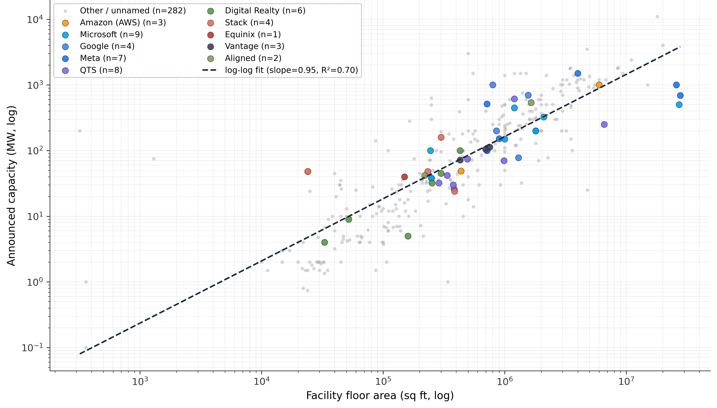
Figure 1. MW vs floor area scatter, colored by operator, with log-log fit overlaid. The regression is used to impute MW for facilities reporting floor area but no MW. n = 329 training facilities, R² = 0.70. Source: FracTracker (Jan 2026) [3].
Operating capacity coverage and cross-checks
Among the 529 facilities in Operating status, only 191 (36 percent) directly report MW; their summed capacity is 16.81 GW. After applying the floor-area imputation described above, 212 additional operating facilities are assigned an MW value, bringing the population of MW-quantified operating facilities to 403 (76 percent coverage) and the summed operating capacity to 28.30 GW. The remaining ~24 percent of operating facilities report neither MW nor floor area and remain uncounted; thus, there is a downward bias on every operating-capacity figure in this paper. Announced capacity used in this paper refers to nameplate MW sourced from permit filings, utility interconnection requests, press releases, SEC filings, or industry trade-press reporting. Three caveats apply to the 28.30 GW estimate. First, FracTracker MW values reflect announced or design capacity at the time the facility was permitted, not real-time metered load. Second, behind-the-meter generation, on-site batteries, and varying load factor (which for hyperscale workloads runs 40 to 60 percent rather than 100 percent of nameplate) mean operating MW do not match instantaneous or peak load. Third, the dataset captures distinct physical sites; multi-tenant co-location campuses are reported as one row, which can understate tenant-level capacity. As an external cross-check, EPRI^{[23]} and LBNL^{[24]} independently estimate U.S. data center electricity demand at roughly 200 TWh in 2024, implying approximately 22 to 30 GW of average grid draw at typical load factors. Similarly, Goldman Sachs estimated US data center demand at 31GW in 2025. The 28.30 GW imputed capacity figure derived here from FracTracker is consistent with these estimates.
State | n facilities | Operating GW (imputed) | Share of U.S.
Virginia | 173 | 9.21 | 32.5%
Texas | 29 | 4.85 | 17.1%
Georgia | 65 | 3.65 | 12.9%
Indiana | 4 | 2.22 | 7.9%
North Dakota | 4 | 1.20 | 4.2%
Ohio | 14 | 0.98 | 3.5%
Iowa | 4 | 0.88 | 3.1%
New York | 15 | 0.82 | 2.9%
Tennessee | 3 | 0.80 | 2.8%
Nevada | 3 | 0.60 | 2.1%
Oregon | 7 | 0.58 | 2.1%
Arizona | 8 | 0.57 | 2.0%
Pennsylvania | 32 | 0.44 | 1.6%
Mississippi | 1 | 0.34 | 1.2%
Nebraska | 2 | 0.22 | 0.8%
U.S. total | 403 | 28.30 | 100%
Table 3. Top 15 U.S. states by operating data center capacity after sqft-based MW imputation. Top 3 (VA, TX, GA) hold 62.6%; top 5 hold 74.7%; top 10 hold 89.1%. Virginia jumps from #7 on reported MW (0.70 GW) to #1 on imputed MW (9.21 GW), reflecting the concentration of large hyperscale builds in Loudoun and Prince William counties where floor area is reported but nameplate MW often is not. Source: FracTracker (Jan 2026) [3]; author imputation.
Statistical approach
Three classes of statistical test are used. First, Welch's t-test for unequal variances compares means on host vs non-host distributions across environmental, equity, and infrastructure indicators. Welch is appropriate because host and non-host samples have unequal variances and unequal n. The The common-subset filter used in Figure 9 retains 486 of 487 host counties for which all five environmental and equity indicators are reported. Second, Spearman rank correlations measure association at state level between announced capacity, residential rates, and disconnection rates. Third, a negative-binomial (NB) GLM with α = 1.0 (Poisson fallback) regresses the integer facility count per county on a vector of county covariates. NB is the appropriate count model because the outcome is overdispersed: 2,749 of 3,236 counties have zero facilities and Loudoun, VA alone holds 188, so variance dwarfs the mean and a Poisson distribution would understate standard errors. Population enters the NB as a free covariate (log-transformed), providing a control for urban / peri-urban counties where data center load appears to congregate.
Fixed effects. Two sets of categorical fixed effects (FE) are used. (a) In the MW imputation OLS, status i.e. whether the data center is proposed, operating, suspended, or canceled, enters as a 3-level FE with Operating as the reference category. This matters because proposed facilities have larger announced MW-per-sqft on average). (b) In the NB regression, utility type enters as a 4-level FE with IOU as reference (Municipal, Cooperative, Federal each shift the intercept), and Census region enters as a 4-level FE with South as reference (Northeast, Midwest, West each shift the intercept). Including these FE absorbs between-group differences in regulatory regime (wholesale vs. vertically integrated markets), fuel mix, transmission topology etc. that vary by utility type or region but are not directly measured. Every continuous coefficient is therefore a within-utility-type, within-region effect. The explicit specification, control list, and full coefficient tables are reported in Appendix 1.
This is a cross-sectional spec with FracTracker reporting gaps, so the coefficients are associational, not causal, but they survive utility-type and region fixed effects and give a directional, quantitative read on which county characteristics may predict facility location.
Customer Protection Score rubric
As the E3 paper rightly points out, Large-load tariff design has evolved into a substantial body of regulatory practice organized around four primary archetypes: cost-of-service tariffs with demand charges, real-time pricing and time-of-use rates, flexible-load tariffs with contractual curtailment obligations, and special contracts. Furthermore, a consensus has emerged regarding minimum-bill structures for this new wave of tariffs, typically set at 75 to 90 percent of contracted capacity and paired with collateral requirements, exit fees, and capacity reassignment provisions.
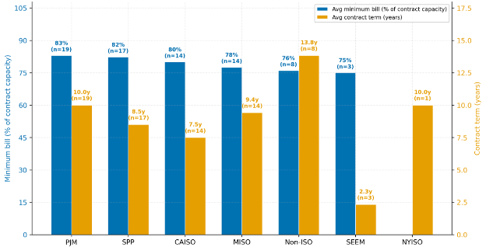
Figure 2: Average minimum bill (as a percent of contract capacity) and average contract term (years) by ISO / RTO in Database of Emerging Large Load Tariffs (DELTa), Source: Smart Electric Power Alliance (SEPA), Mar 31, 2026
This customer protection score rubric is detailed below:
Component | Top-tier threshold | Points (top tier) | What it protects against
Contract Term | 10+ years | 2 | Stranded-asset risk if load fails to materialize
Min Bill / Demand % | ≥ 80% | 2 | Under-recovery if customer uses less than reserved capacity
CIAC | Yes | 1 | Utility (and ratepayers) advancing infrastructure capital
Partial credit: contract 5-9 years = 1 point; minimum bill 50-79% = 1 point. Below those thresholds: 0 points.
Table 4. Customer Protection Score rubric. Three components for a 5-point maximum, anchored on PJM's data-center tariff benchmark (83% minimum bill, 10-year contract term). Used to score the 38 E3 tariffs and the 77 SEPA / NCCETC DELTa tariffs in section 10.
ANALYSIS
A. Descriptive overview of the U.S. data center build-out
Operating capacity is highly concentrated in the lower 48. The post-imputation 28.30 GW total is distributed across 33 states and 123 counties, but three states (Virginia, Texas, Georgia) hold 62.6 percent of all operating MW. At the county level the concentration is even sharper: Loudoun County, Virginia alone accounts for 6.26 GW (22 percent of the U.S. operating total) across 104 operating facilities. The map below colors each host county by the top operator active at that site (Amazon AWS, Microsoft, Google, Meta, or QTS) and sizes each bubble by imputed operating MW.
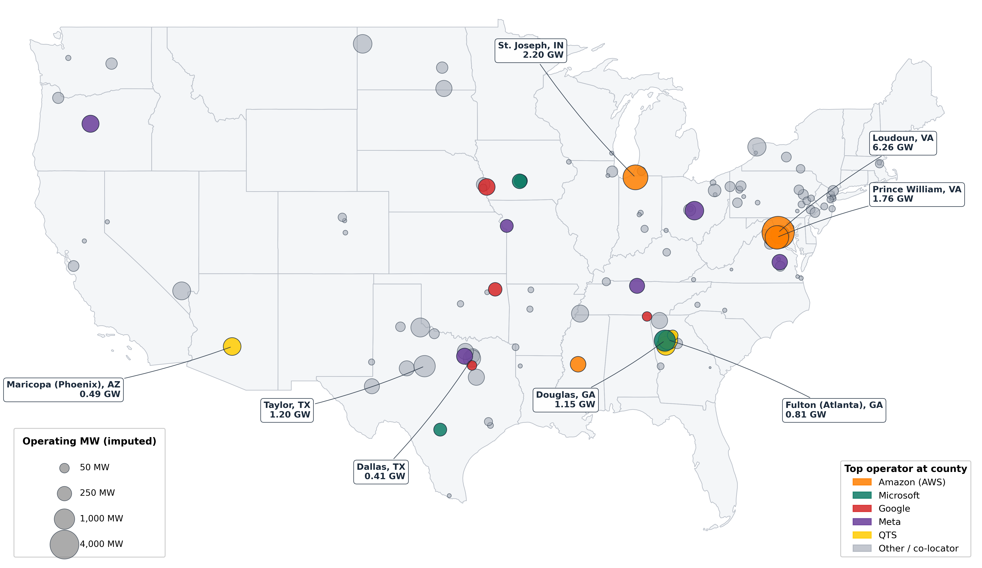
Figure 2. U.S. operating data center capacity by county (post-imputation). Bubble area proportional to imputed operating MW; color denotes the top operator active at that county. n = 403 operating facilities, 28.30 GW total. Loudoun County, Virginia (6.26 GW) is the single largest cluster globally. Phoenix (Maricopa), Dallas, Atlanta (Fulton), and Boone (IN) anchor secondary clusters. Sources: FracTracker (Jan 2026) [3]; U.S. Census 2023 cartographic boundary (20m).
Across the broader 1,506-facility pipeline (operating, planned, and proposed), Texas leads on host-county count (65 counties hold its 185 facilities). Virginia leads on facility count (452 facilities in just 36 counties), one of the strongest within-state concentration signals in the dataset. Georgia (37 host counties, 175 facilities), Pennsylvania (33 counties, 101 facilities), and Ohio (28 counties, 59 facilities) complete the top five facility-count states.
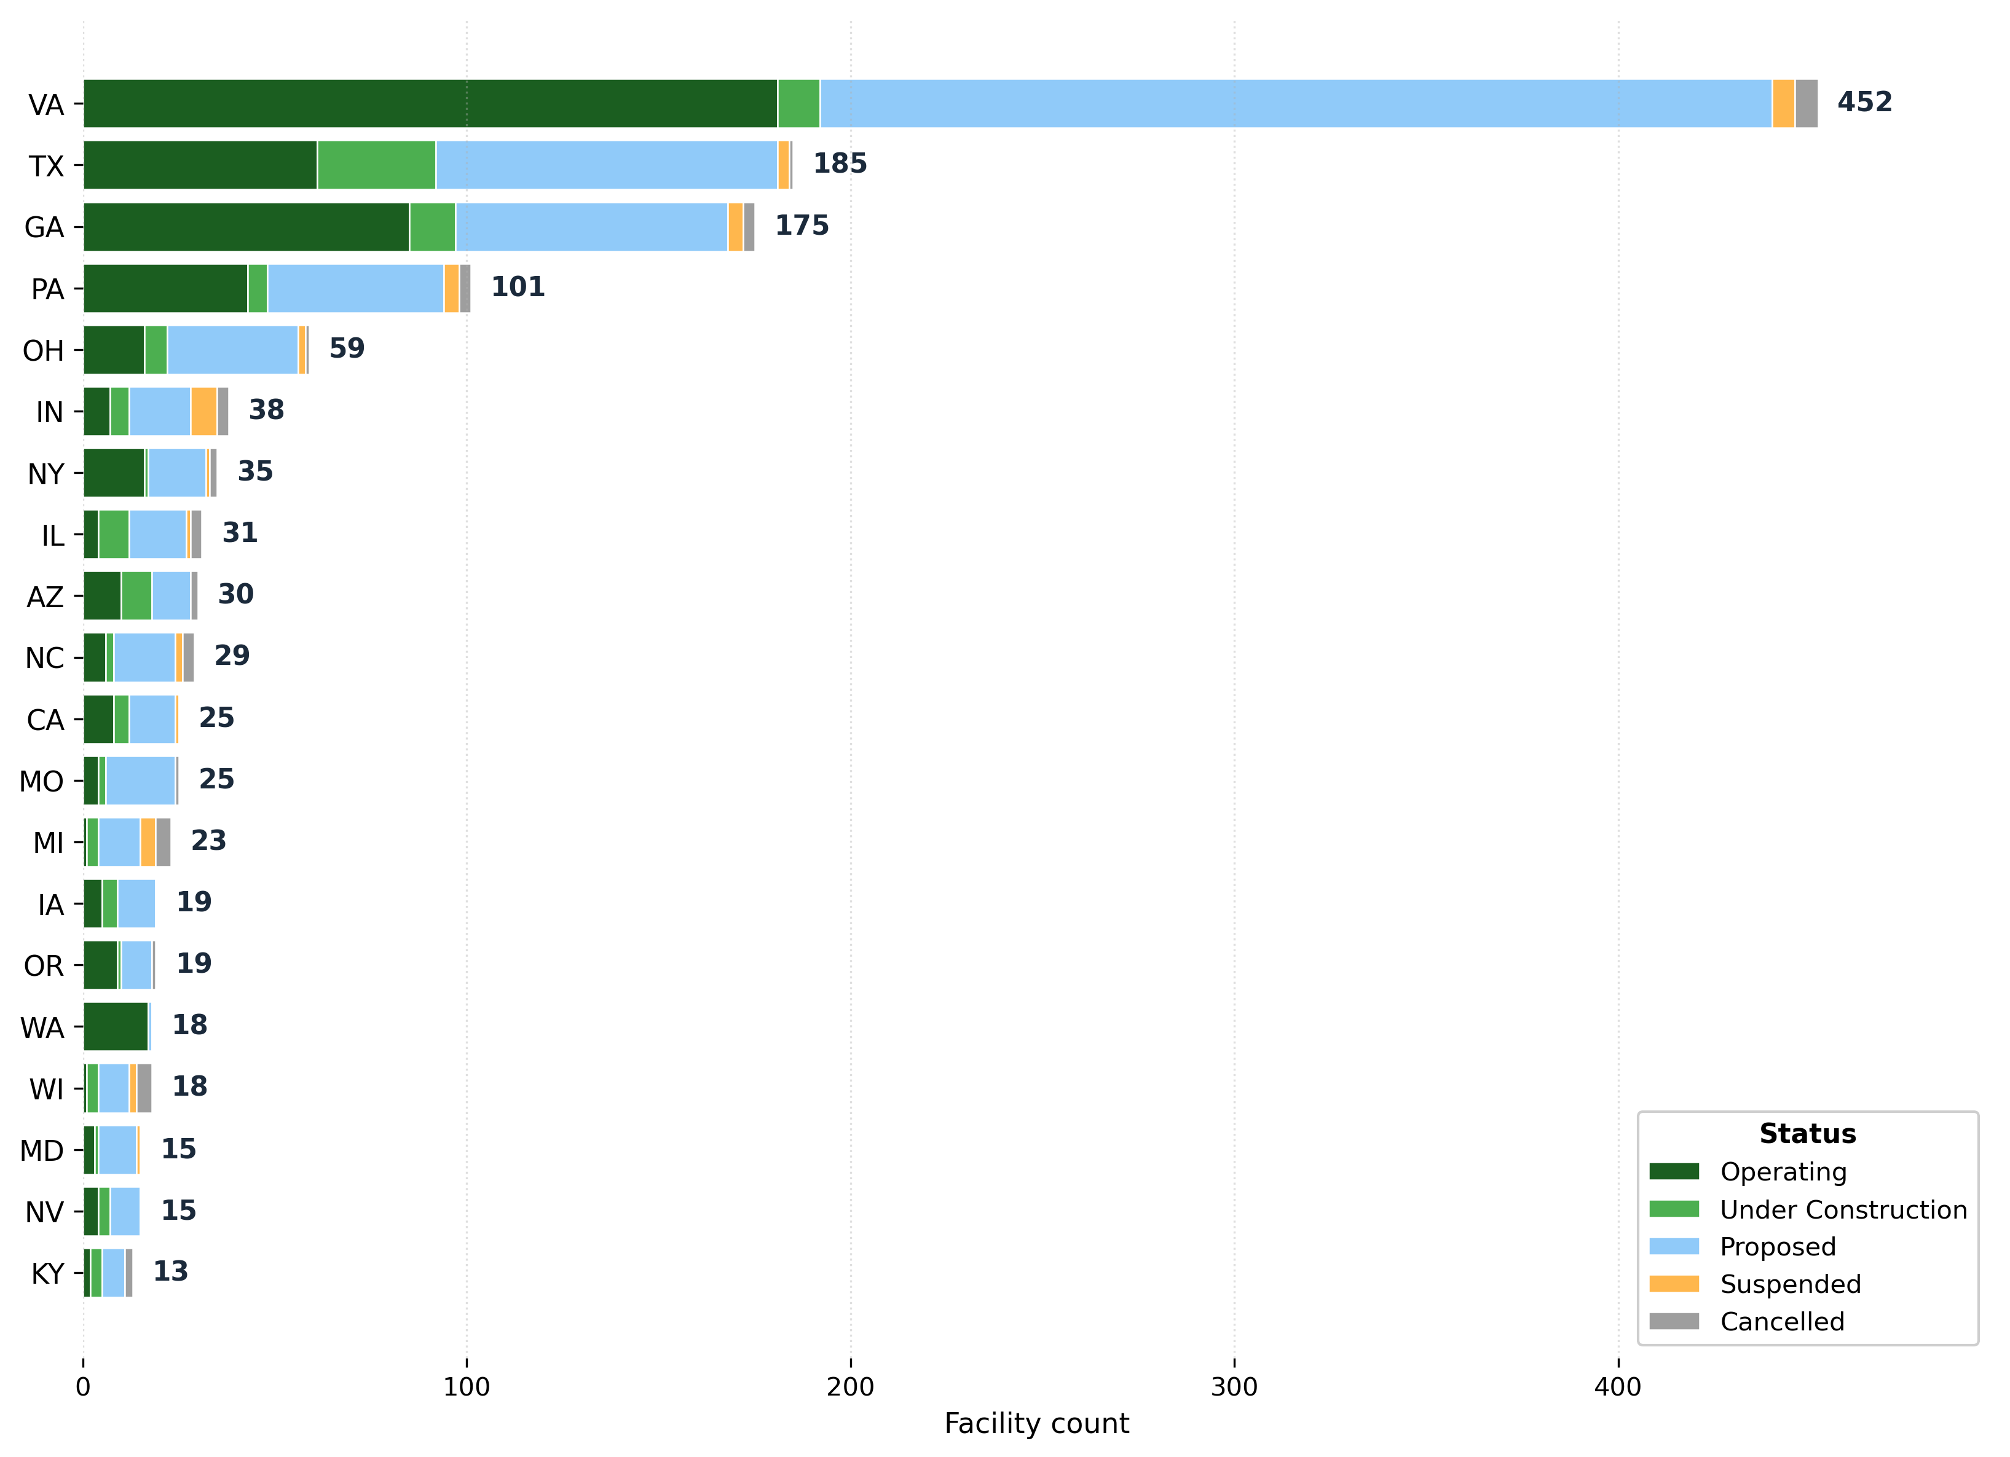
Figure 3. Top 20 U.S. states by total tracked data center facility count, with bars segmented by pipeline status: operating (dark green), under construction (light green), proposed (light blue), suspended (orange), cancelled (gray). Virginia leads on every status (181 operating, 248 proposed, 11 under construction); Texas, Georgia, Pennsylvania, and Ohio round out the top five. Suspensions and cancellations are concentrated in Virginia, Texas, Pennsylvania, and Wisconsin, indicating that even the most active markets experience meaningful project attrition. Source: FracTracker (Jan 2026) [3].
B. County concentration vs state averages
Data centers are not distributed evenly across U.S. states; they concentrate in a small number of counties within a small number of states. The top five facility-count states hold 64 percent of all 1,506 tracked sites. Within each of those states, the top five counties hold the majority of the state's facilities.
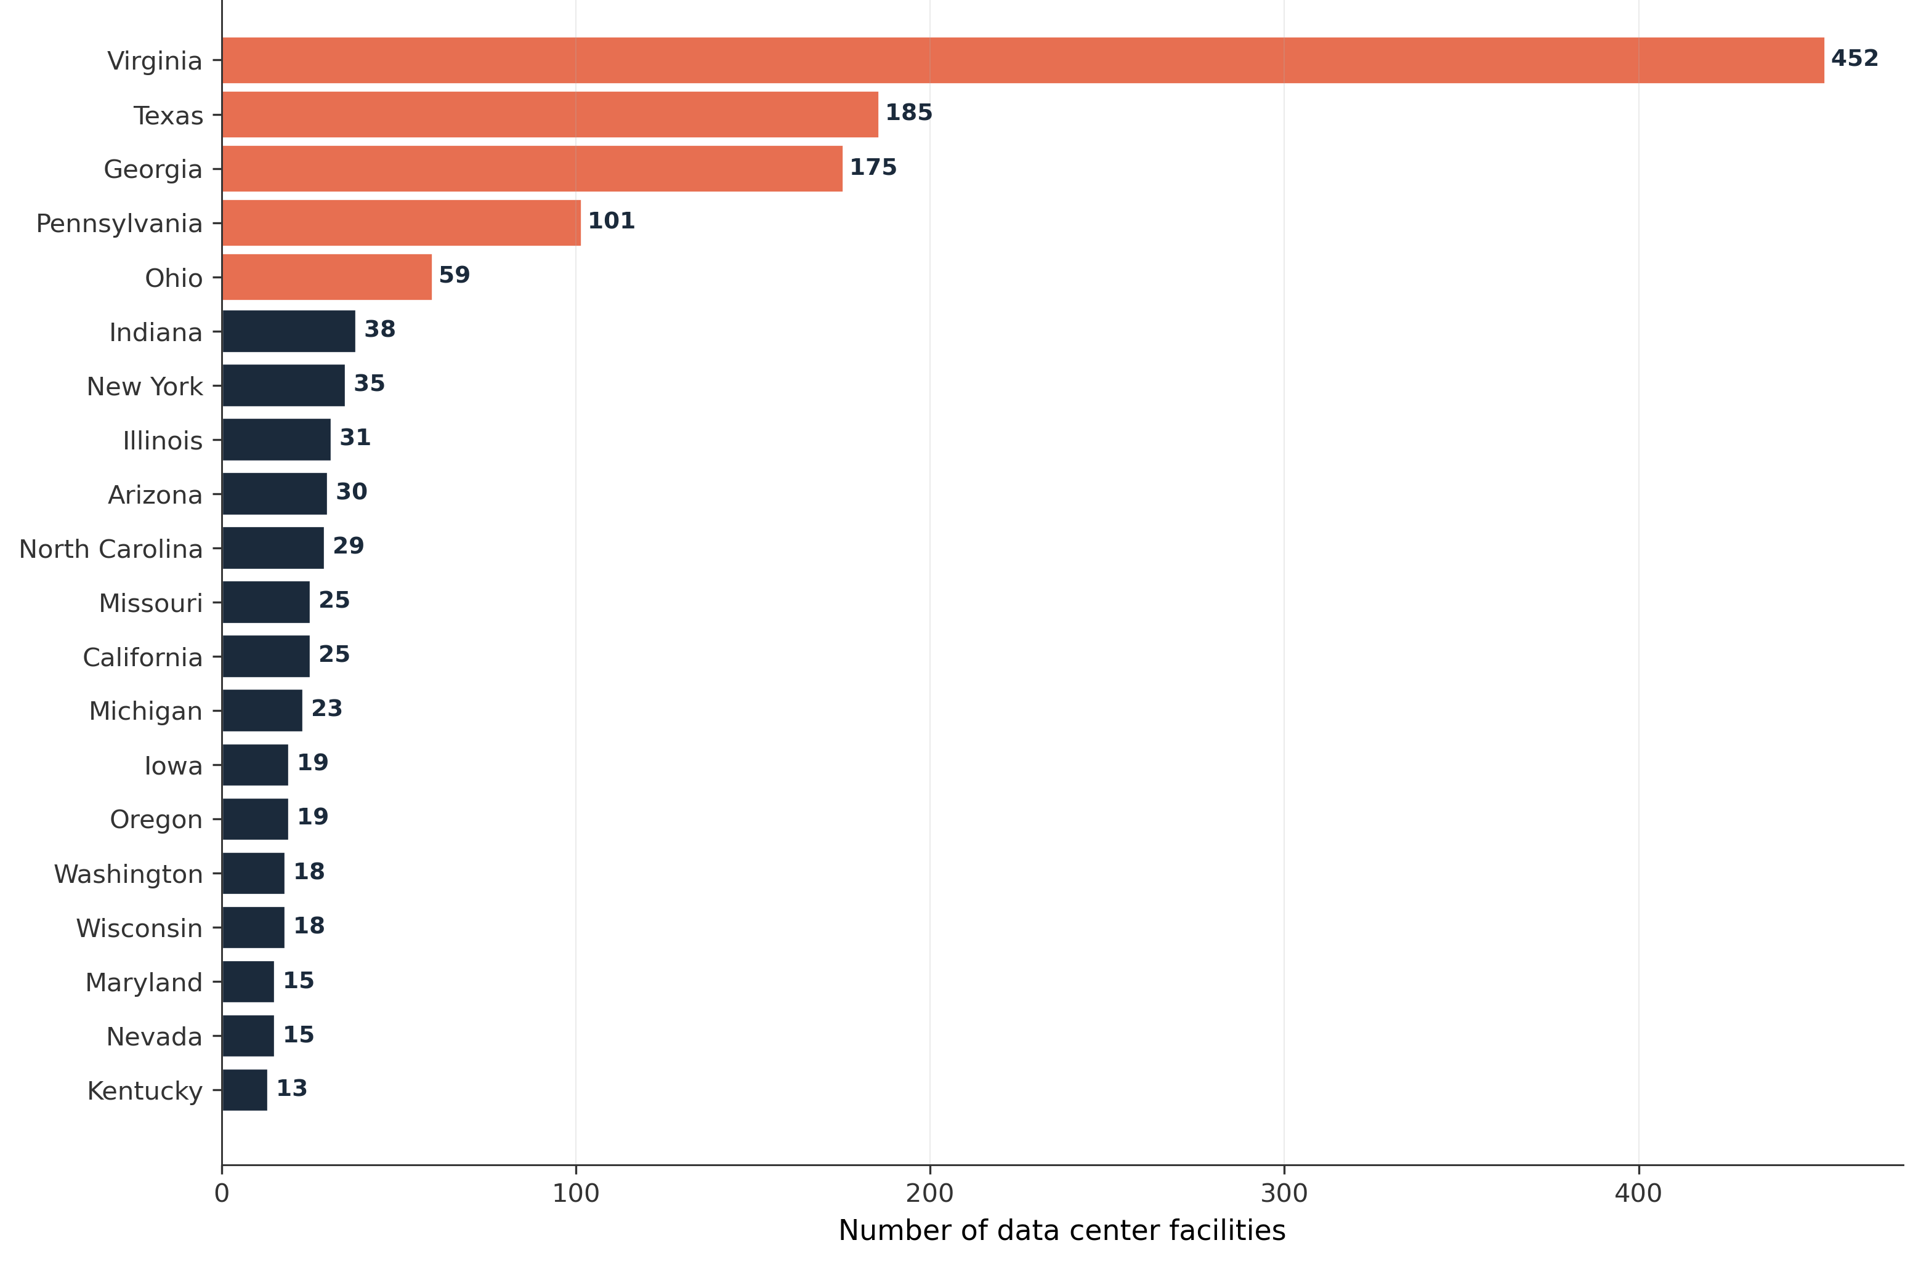
Figure 4. Top 20 U.S. states by data center facility count. Top five (in coral) hold 64 percent of all sites. Source: FracTracker (2026) [3].
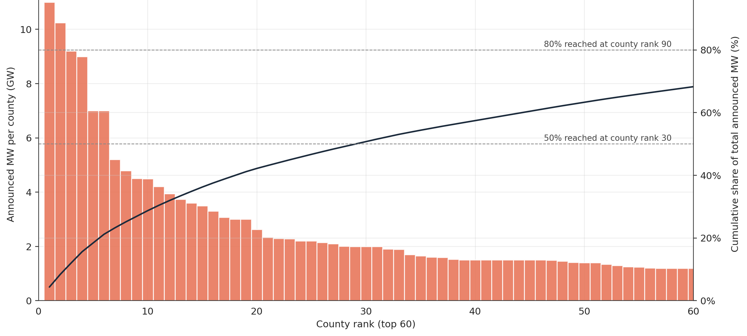
Figure 5. County Pareto curve. Cumulative share of announced U.S. data center MW vs county rank. Top 30 counties hold 50 percent of all MW; top 90 hold 80 percent; top 131 hold 90 percent. Source: FracTracker (2026) [3].

This concentration is why state averages cannot answer the cost-shift question. Distribution and most subtransmission costs are recovered within a single retail service territory, not across state lines. A Dominion feeder in Loudoun shares no capital recovery with a Dominion feeder in Roanoke, and nothing with Appalachian Power customers elsewhere in Virginia. When E3 reports that Virginia's residential rates moved less than the U.S. average, it treats the state as one rate pool. Virginia is in fact many pools: multiple IOU territories, munis, and cooperatives, each with its own rate base and captive ratepayer class. Pooling them at the state level effectively averages the signal away.

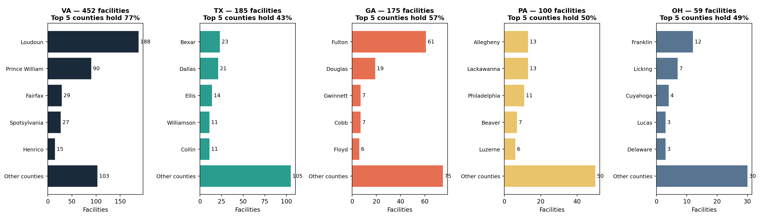
Figure 6. Top five data center states, broken into their top five counties each. In every state, the top five counties hold the majority of the state's facilities. State averages dilute this signal. Source: FracTracker (2026) [3].
Three mechanisms operate below the state level and follow from the county-concentration pattern:
First, transmission socialization. Capacity costs are allocated by each customer's contribution to system coincident peak. Data centers can time-shift compute, draw from on-site batteries at peak, and curtail under demand response, so their coincident-peak share can run well below their average load. That pushes capacity cost onto load that cannot shift, residential heating and cooling, small commercial refrigeration. It is the mechanism behind the PJM 2025/26 capacity spike landing on residential customers.
Second, distribution rate-base growth. LBNL's 2025 analysis identifies distribution capital (aging-infrastructure replacement, wildfire mitigation, undergrounding, hardening) as the largest driver of recent residential rate increases, and that is where hyperscale load lands. A new campus requires the feeder to be rebuilt or extended; that upgrade enters rate base and is recovered from every customer on the feeder for 30 to 40 years. The test is whether CIAC provisions recover the full incremental cost upfront, and whether recovery falls on customers who did not cause it.
Third, the resolution limit of county analysis. Counties map reasonably to service territories and most data is reported at county level, so the county is the right working unit, but not the fully resolved one. Only 487 of 3,236 counties host a facility, and Loudoun's 188 facilities are not on one feeder. The fully resolved test is at the feeder level: what an LMI ratepayer on the Ashburn substation pays this year versus last, net of the environmental and equity costs E3 omits.
State-level comparison cannot reach any of these three. The right unit for cost-shift testing is the service territory and county, with the feeder as the limiting case.

C. Renewable potential vs siting
Capacity factor (CF) is the ratio of actual annual energy output to the maximum possible output if a unit ran at full nameplate for all 8,760 hours in a year, conventionally reported as a percentage. Across U.S. counties in the NREL 2023 hourly profiles, solar UPV fixed-tilt CFs range from about 14% to 25% (state means 16% to 23%) and onshore wind CFs range from about 10% to 50% (state means 17% to 43%). These ranges match published NREL Annual Technology Baseline benchmarks. Combining solar and wind CFs via simple averaging is misleading because the two resources have different diurnal and seasonal patterns and are not fungible. Each is shown separately below.
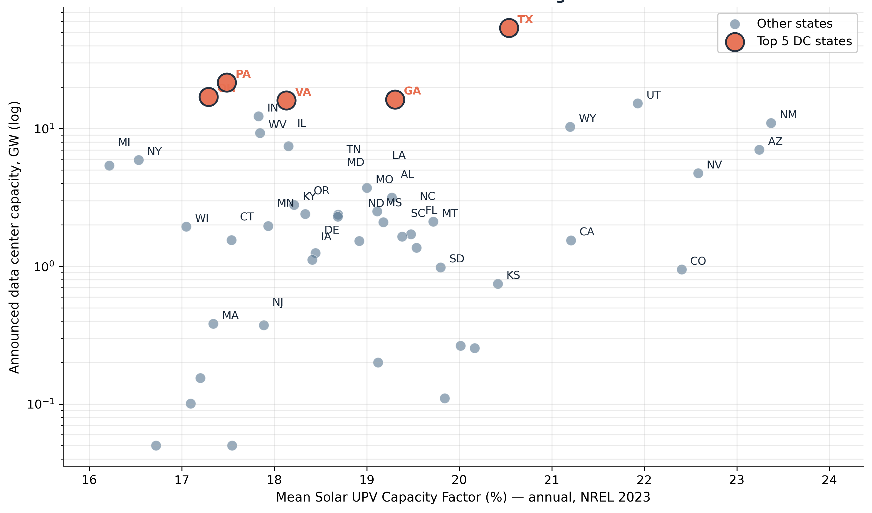
Figure 7. Solar UPV capacity factor (annual mean, %) vs announced data center capacity by state. Top five DC states marked in coral. Of those five, only Texas (20.5%) has above-average solar potential; Virginia (18.1%), Georgia (19.3%), Pennsylvania (17.5%), and Ohio (17.3%) are all below the 19.0% U.S. mean. Source: NREL Solar UPV Fixed-Tilt 2023 [10].
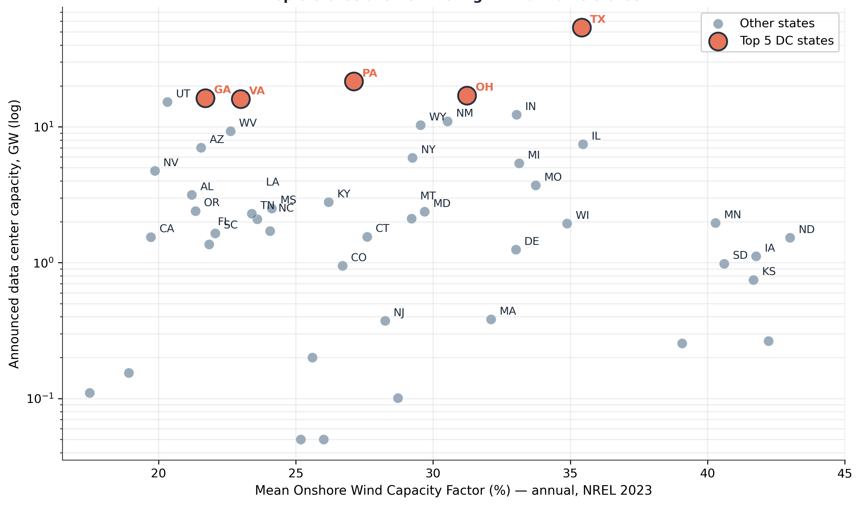
Figure 8. Onshore wind capacity factor (annual mean, %) vs announced data center capacity by state. The high-wind Plains (ND 43%, NE 42%, IA 42%, KS 42%, SD 41%) are not where data centers concentrate. Of the top five DC states, only Texas (35.4%) has strongly above-average wind potential. Source: NREL 100-m Onshore Wind 2023 [10].
Four of the five largest U.S. data center markets (Virginia, Georgia, Pennsylvania, Ohio) sit below the U.S. mean on both solar and wind capacity factor. The argument that data center load growth drives incremental clean energy investment and/or contributes to reducing curtailment (as suggested in E3’s policy responses for tariff design) is not supported by where the load actually clusters, absent explicit additionality contracts.
D. Host vs non-host environmental and equity baselines
Welch's t-tests on five high-coverage indicators show systematic differences between host and non-host counties. The same counties (n = 486 hosts, n = 2,620 non-hosts) appear in every panel; this is the common subset of U.S. counties for which all five indicators are reported. Median values shown in bold black inside each box with exact values labeled to the right. Operator dots are overlaid on the host distribution in each operator's brand color.
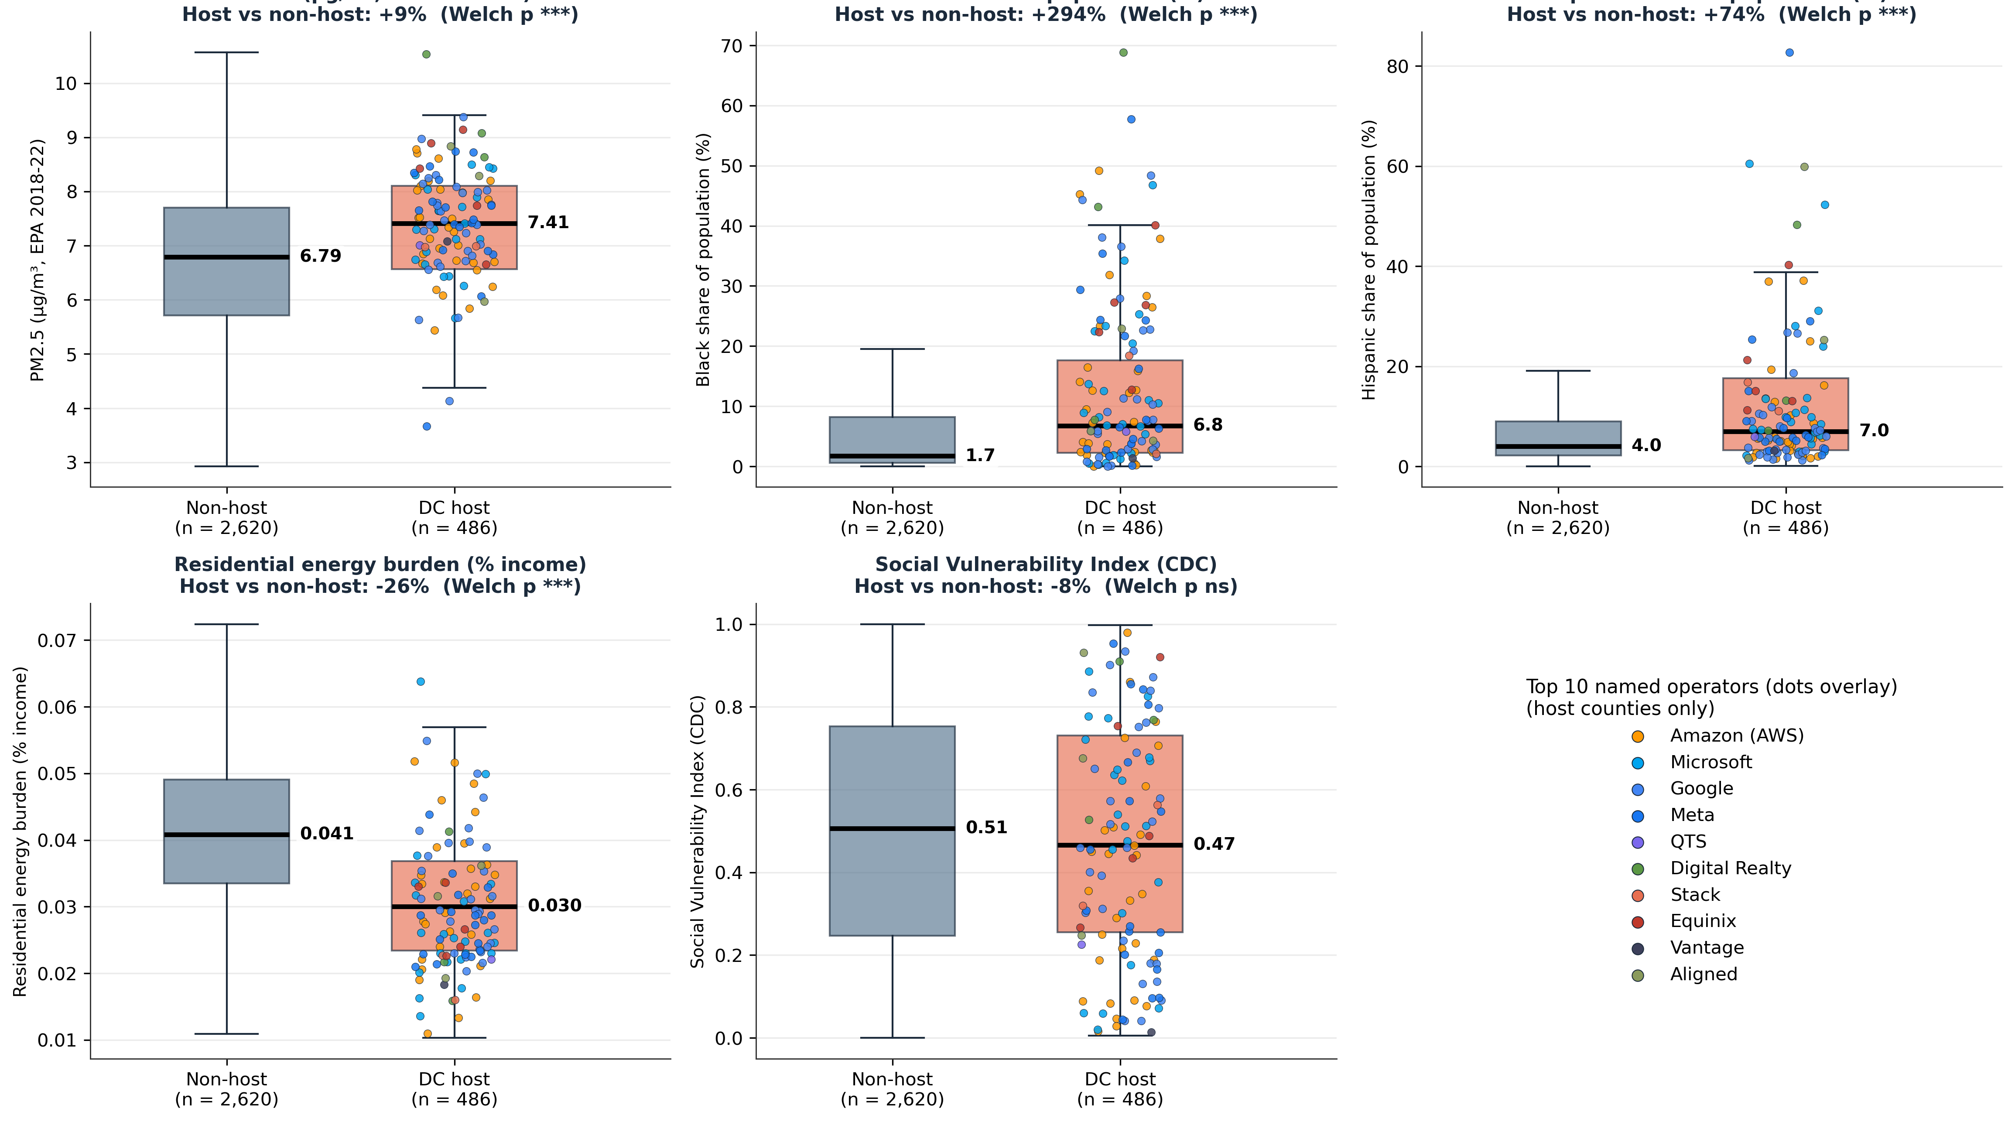
Figure 9. Host vs non-host U.S. county comparisons across five indicators. n = 486 host, n = 2,620 non-host (consistent across all panels). Median in bold black; exact value labeled outside the box. Percent difference and Welch p in each subtitle. Sources: EPA AQS 2018-22, ACS 2020, DOE LEAD 2026, CDC SVI 2018 [6][8][4][9].
Host counties carry higher pollution and demographic baselines than non-host counties. PM2.5 is 9 percent higher at median (Welch p < 0.001). Black population share is 4.3× higher (p < 0.001). Hispanic share is 1.6× higher. Energy burden runs lower in host counties (-27%), consistent with hosting counties being more urban and more commercially developed (residential burden share falls when commercial and industrial demand expand). CDC's Social Vulnerability Index does not differ significantly between groups in this common subset.
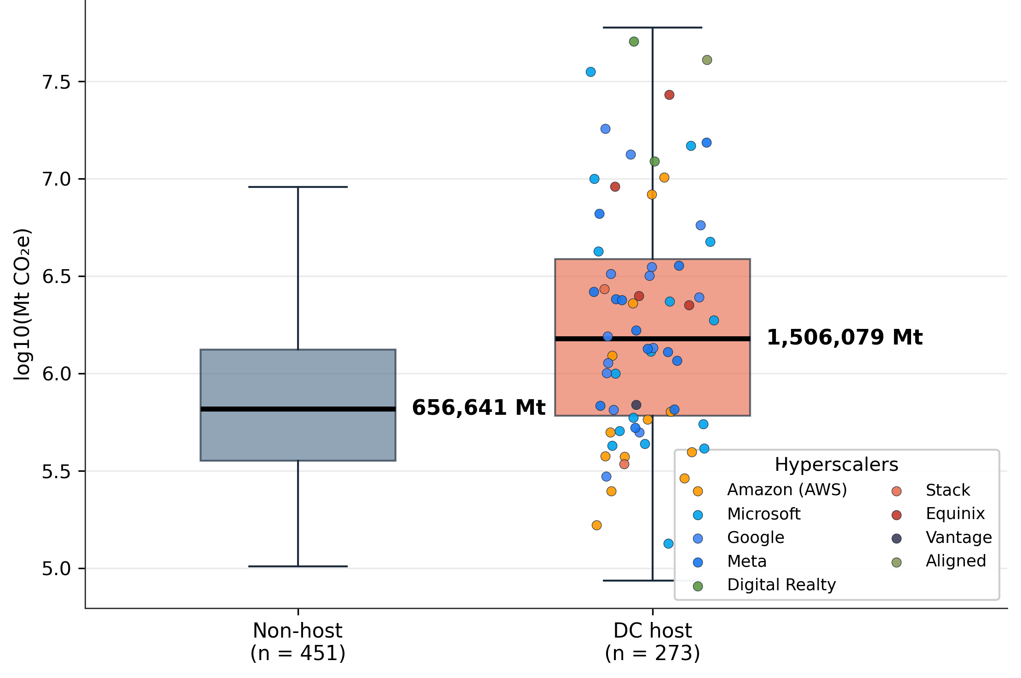
Figure 10. GHG total emissions (Mt CO₂e, log10) host vs non-host. Smaller subset (n = 273 host, n = 451 non-host) reflects NREL's GHG coverage. Host counties have 2.3× the non-host median (Welch p < 0.001). Source: NREL SLOPE 2020 [5].
Important caveat on causal interpretation. Host vs non-host contrasts in Figures 9 and 10 are descriptive, not causal. Host counties are not a random sample of U.S. counties; they self-select on observables , transmission corridor access, existing broadband fiber, available freshwater, cheap industrial land, and explicit state tax incentives (Virginia, Texas, Georgia all run them). When the data show host counties have 5.9× the broadband connections or +9% PM2.5 of non-host counties, that contrast is not evidence that data centers caused broadband expansion or higher PM2.5; it is evidence that data centers chose counties that already had high broadband and high industrial baseline. The contrasts therefore identify where marginal load is landing relative to existing baselines, which is policy-relevant for understanding distributional impact. They do not estimate the causal effect of data center arrival on a county. The strongest causal evidence on that question is Yue and Zeng^{[16]}'s staggered difference-in-differences, which uses the timing of data center entry as the identifying variation and finds a 5 percent residential rate increase. Full statistical results and the negative-binomial regression that controls for population, region, and utility type fixed effects are reported in Appendix 1.

E. Broadband and freshwater: the primary infrastructure drivers
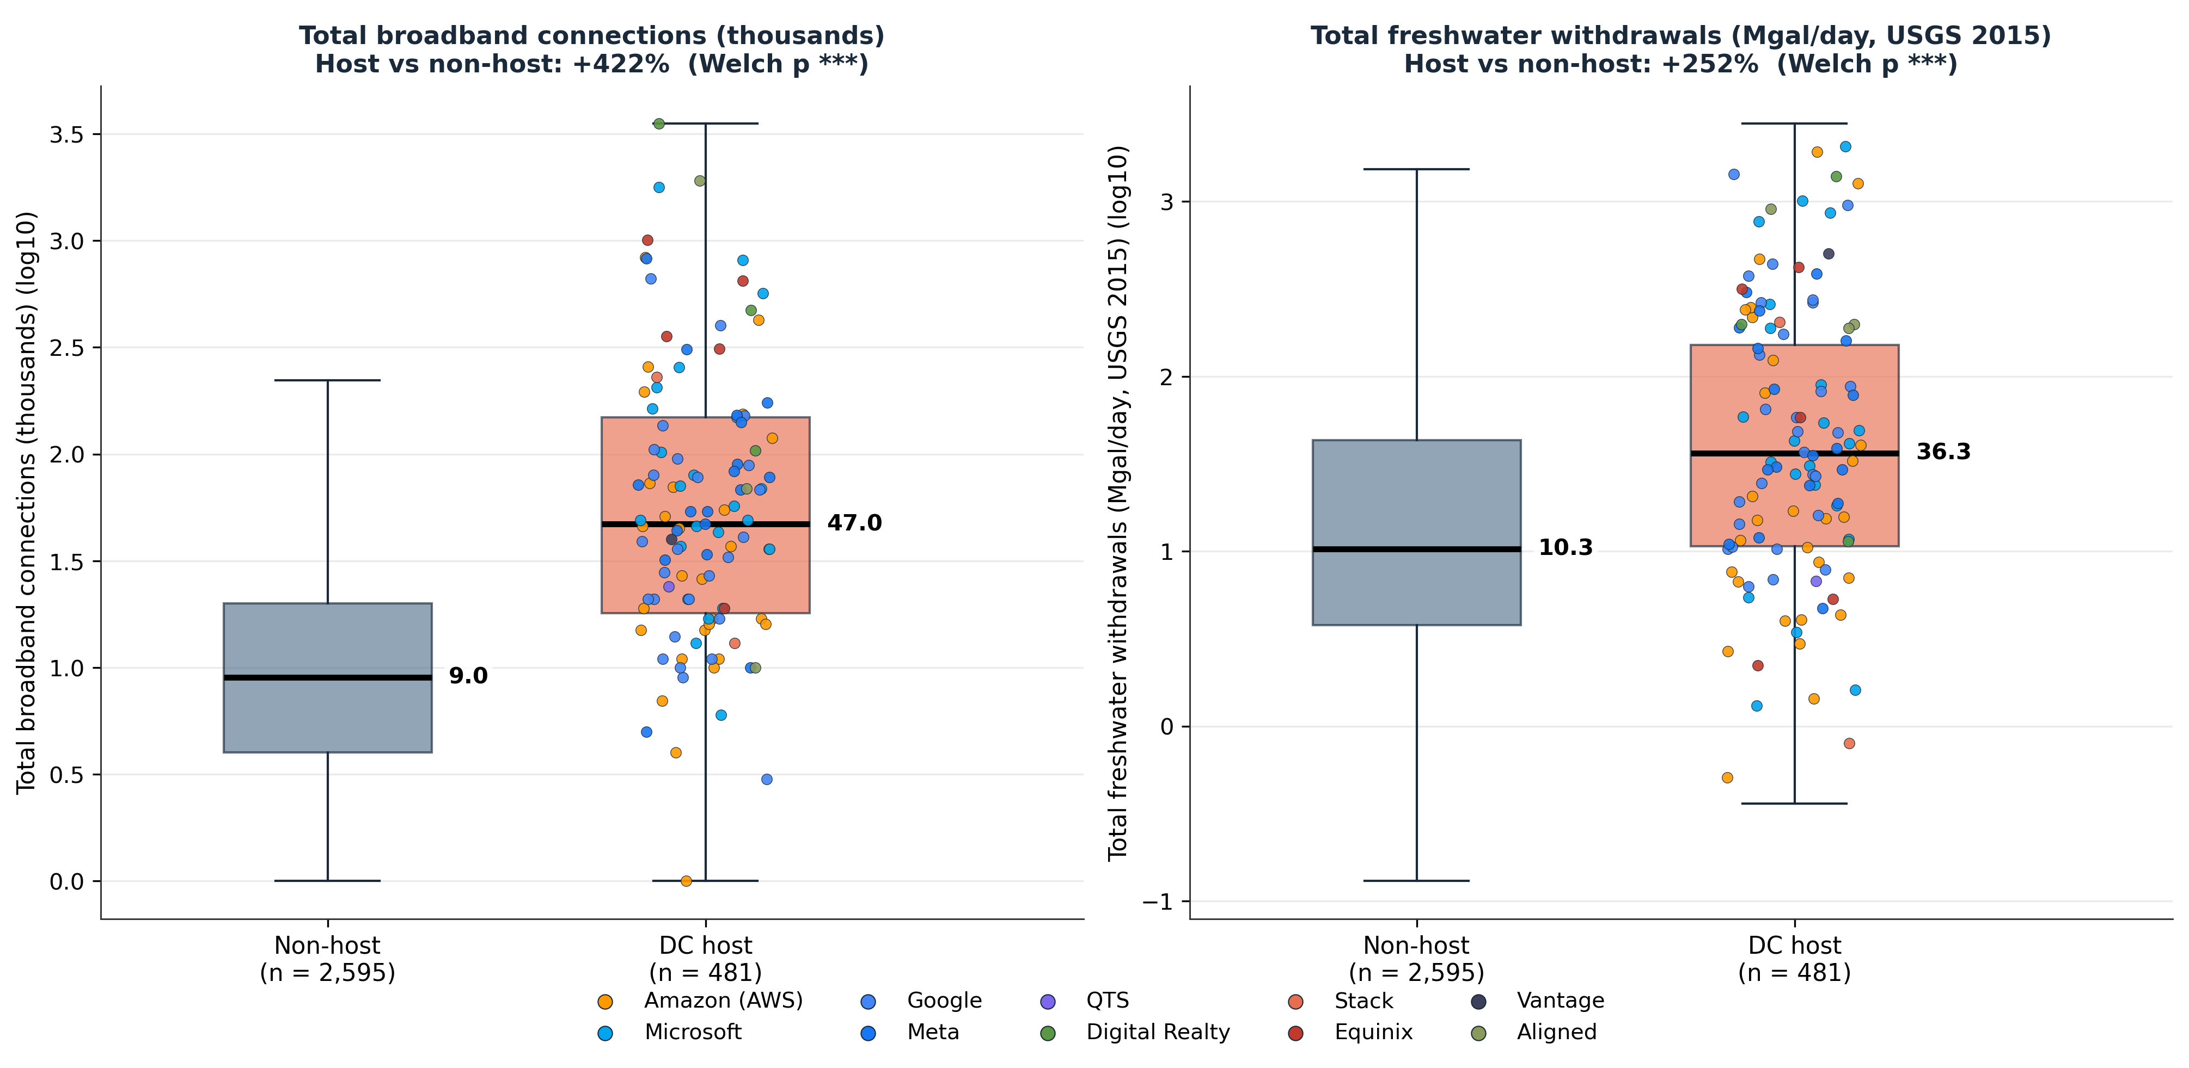
Figure 11. Broadband connections and total freshwater withdrawals, host vs non-host (n = 481 host, n = 2,595 non-host). Median in bold black; exact value labeled outside the box. Source: FCC Form 477 (2024) [11], USGS Water Use 2015 [7].
In negative-binomial regressions of facility count on county covariates, broadband connections and commercial floor area are the strongest infrastructure predictors of where data centers locate. Total freshwater withdrawals are the strongest water-side correlate. Host counties have 5.9× more broadband connections (47k vs 8k at median) and 3.5× more freshwater withdrawals (35.5 vs 10.1 Mgal/day). Both differences are highly statistically significant (Welch p < 0.001). Hyperscale data center cooling consumes 1 to 5 million gallons per day per site at full load^{[12]}; Google's own 2024 environmental report documents data center water consumption rising 17 percent year-over-year^{[13]}. A rate-impact analysis that excludes these dimensions misses the upstream selection mechanism that determines where data centers locate.
F. Customer-protection scoring of large-load tariffs
E3 catalogues 38 large-load tariffs in Appendix A.2. The SEPA / NCCETC DELTa database^{[15]} covers 77 large-load tariffs across 36 states and is the most comprehensive public inventory, it shows the number of tariffs approved or pending across each ISO /RTO has been increasing exponentially over the past few years as seen in the Figure 12 below:
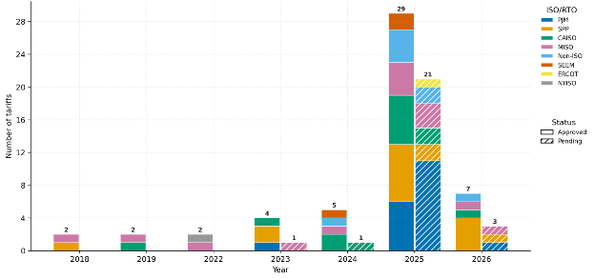
Figure 12: Number of tariffs approved or pending by ISO / RTO (2018-March 2026) in Database of Emerging Large Load Tariffs (DELTa), Source: Smart Electric Power Alliance (SEPA), Mar 31, 2026
Scoring both samples on the same benchmarked customer-protection rubric (0-5) indicates E3's appendix is not representative of the broader universe (median scores 1.5 vs. a median score of 1 for the full dataset).

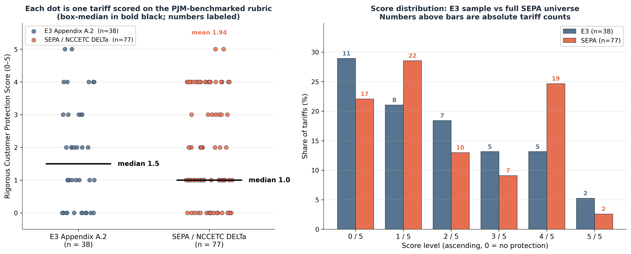
Figure 13. Customer Protection Scores side-by-side. Left: each dot is one tariff scored on the rubric (0–5), in ascending order; box-median in bold black. Right: score distribution by level, paired bars with absolute counts above each bar. Sources: E3 Appendix A.2 [1]; SEPA / NCCETC DELTa, March 2026 [15].
Both medians sit at or near the bottom of the scale. Roughly half of all tariffs in each sample score 0 or 1 (E3 50 percent, SEPA 51 percent). It is important to note that the full SEPA universe does have more high-scoring tariffs at the top end (27 percent at 4 or 5, vs 18 percent in E3's sample), meaning E3's appendix omits some of the stronger tariffs in the broader database.
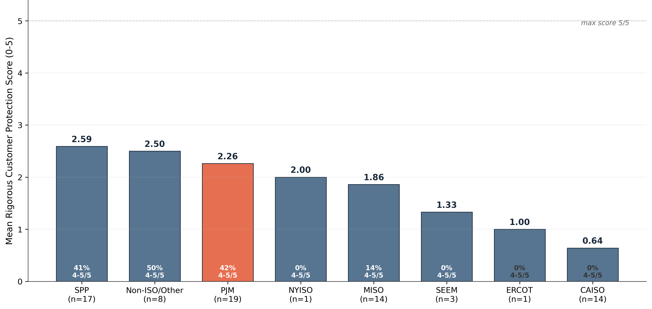
Figure 14. Mean rigorous Customer Protection Score by ISO/RTO (SEPA / NCCETC DELTa, March 2026, n = 77). PJM highlighted as benchmark. CAISO at 0.64 is the weakest ISO on this rubric. Source: SEPA / NCCETC DELTa [15].
PJM averages 2.26 of 5 across its 19 SEPA tariffs. CAISO averages 0.64 of 5. California's data center tariffs are the weakest in the country on this customer-protection rubric. The headline count of 38 or 77 tariffs does not support the conclusion that customer protection has materially improved via innovative tariff design; it supports the weaker conclusion that more tariff documents have been filed for approval.
G. Position on E3's top-line claims
E3 advances seven top-line claims. The evidence here supports three. First, rate increases have multiple drivers, not load growth alone; the NB regression finds county-level LCOE non-significant, so cost is not the binding siting variable. Second, historically high load-growth states have shown smaller relative rate increases; Welch tests confirm host counties have lower median residential rates, though that pattern does not necessarily extrapolate to forward 1+ GW campuses, which is best tested at the utility and county level. Third, tailored large-load tariffs are the right policy direction.
The evidence contradicts two. Yue and Zeng's 5 percent residential rate increase is not a measurement problem: staggered difference-in-differences is the strongest causal design currently published, and E3 applies an asymmetric standard relative to industry-funded correlational work. And environmental and equity impacts are not secondary: host counties differ from non-host counties on every indicator in sections D and E, with PM2.5 up 9 percent (p < 0.001), GHG 2.3 times higher, freshwater 3.5 times higher, broadband 5.9 times higher, and minority population share 4.3 times higher. Marginal load lands on already-stressed baselines.
Two further claims are plausible but uncertain on E3's own evidence. The 50/50 split between load growth and supply or market-design factors in the PJM 2025/26 capacity spike is reported in footnote 65 as a single point estimate the report concedes is "difficult to isolate," with no error bounds. Amazon's $3.4M average net-surplus per site uses pre-2022 equipment costs (transformer and conductor prices now up roughly 1.5 to 2 times since 2019 ) and needs recalculation against current costs. Notably, E3's own analysis attributes roughly half the PJM capacity price increase to load growth, an effect PJM households already feel, which is hard to square with the claim that data centers have not historically affected rates.
H. Structural limitations of E3's framing
Seven structural limitations follow. First, the report is funded by the Data Center Coalition and not peer-reviewed, and the strongest supporting Amazon case study is itself Amazon-funded. Second, the methodological standard is asymmetric: Yue and Zeng's staggered DiD is downweighted while a correlational Amazon-funded case study is credited as supportive. Third, the evidence base is predominantly backward-looking (8 of 11 studies), even though the PJM 2025/26 capacity auction, a roughly nine-fold year-over-year spike, is the structural break that should trigger forward concern. Fourth, state-level cross-sectional analysis cannot adjudicate distribution-side cost shift within a service territory. Fifth, environmental, equity, and freshwater indicators are absent despite host counties differing materially on each. Sixth, the sheer tariff catalogue counts do not represent adequate PUC approaches to large load design; the count can rise without protection improving. Seventh, four interviewees (presumably energy SMEs) are cited without name, affiliation, or independence disclosure.
I. Recommendations for state PUCs, FERC, and policymakers
EPRI projects data center load reaching roughly 17 percent of U.S. electricity demand by 2030. The goal is to ensure new projects benefit the host communities and ratepayers who pay for the capital they require. Six actions follow.
- Mandate facility-level disclosure; end confidential-tariff opacity. FERC and state PUCs should require operators to disclose, at facility level: metered annual energy consumption, water withdrawal and consumption, backup-generator runtime, scope-1 emissions, demand-response hours, and curtailment compliance. The current default hides much of this behind NDAs at the utility-tariff level, which directly prevents independent calculation of the customer impact E3's report tries to estimate. Competitive concerns can be met through aggregated reporting; complete opacity cannot.
- Encourage interruptible-load tariffs for every new data center interconnection. Texas now requires this for all new large-load connections, and every state PUC should adopt the standard. Demand-response participation lets utilities provision against the 90th percentile of demand rather than the worst week of the year, lowering capacity costs system-wide. Google's March 2026 commitment of one gigawatt of demand-response agreements [27] is the operational model.
- Require grid-utilization-first planning before new rate-base approvals. Virginia's 2026 grid utilization law, the first in the nation, requires utilities to show existing infrastructure is fully utilized before approving new capital. CPUC's Integrated Capacity Analysis maps are a related tool, though they lack the granularity needed to site loads at the feeder level. Interconnections should route through unused capacity before new build is approved.
- Reform cost allocation to track cost causation. Network-upgrade costs should be assigned to the customer that causes them rather than spread across the zone, coincident-peak allocation should be paired with annual-load components since data centers can time-shift their peak exposure while still driving year-round capacity need, and CIAC provisions should recover incremental upgrade costs over the first few years rather than 30 to 40. Given the pace of load growth, cost-allocation methods may need to be revisited more often than at present, with stakeholder workshops convened to define the path forward.
- Establish a separate data center customer class. Tariff scoring (section F) shows current designs are inadequate for loads of this scale and concurrency. A distinct class allows cost allocation, reliability cost recovery, and curtailment terms calibrated to the load's actual behavior. Reliability-related costs should be evaluated with an independent tool such as LBNL's ICE Calculator (v.2) rather than utility-supplied figures.
- Commission an independent, forward-looking study using causal methods. Industry-funded backward-looking synthesis has its place, but it is not a substitute for an independent study commissioned by neutral parties (state attorneys general, consumer advocates, federal agencies), using causal designs such as difference-in-differences, at current equipment costs, current interest rates, and projected 2030 load.
CONCLUSION
E3's historical finding is defensible on the data it assembles: over the past two decades, broad load growth has not generally been associated with residential rate increases. That is the right reading of the cross-sectional record. The forward question is different. EPRI projects data center load reaching roughly 17 percent of U.S. electricity demand by 2030, a four-fold increase from 2024, at equipment and capital costs that bear no resemblance to the historical period E3 draws on. Against that trajectory, "data centers did not historically cause rate increases" is a low bar. The bar that matters is whether proposed and in-progress projects benefit host communities and the ratepayers carrying the new capital, or extract reliability, transmission, and distribution investment while leaving others to foot the bill.
Two findings make the forward question urgent rather than academic. First, the historical association between large-load arrival and stable rates is a selection effect at the county level: data centers appear to concentrate in low-retail rate counties that already had the broadband, water, transmission, and tax incentives to attract them. That rate stability is not portable to counties without those conditions. Second, data centers concentrate in counties already carrying above-baseline environmental and equity burden: PM2.5 up 9 percent, GHG 2.3 times higher, freshwater 3.5 times higher, and Black population share 4.3 times higher than non-host counties. Even granting no residential rate increase, incremental load worsens these equity metrics, a cost E3 omits entirely.
A third finding speaks to the policy machinery itself: the 77-tariff SEPA universe scores low on a customer-protection rubric, with 51 percent of tariffs at 0 or 1. Current tariff design appears inadequate for loads of this scale, and the count of filings (38 in E3, 77 in SEPA) is not evidence that ratepayer protection is improving. It is an argument for a separate data center customer class.
The recommendations in section I follow directly: interruptible tariffs, grid-utilization-first planning, cost-allocation reform that tracks causation, a separate customer class, facility-level disclosure without confidential carveouts, and an independent forward-looking study. Google's one-gigawatt demand-response commitment, Texas's interruptible mandate, and Virginia's grid utilization law show this is achievable. The path to a credible answer runs through independent forward-looking analysis, county-resolved cost-shift testing that includes environmental cost, scored rather than counted tariffs, and facility-level transparency on all externalities including quantified water and emissions impacts.
APPENDIX 1. STATISTICAL METHODS AND RESULTS
Purpose. This appendix documents every equation, control list, variable definition, and statistically significant result referenced in the main text. It is intended to be reproducible: with the source CSV files (Table1_Facility.csv, Table2_County_AnalyticSlice.csv, county_pm25_annual.csv, Large_Load_Tariffs_Scoring_v2.xlsx , all available at jonesawan.com) and the formulas below, the numbers in this paper can be regenerated end-to-end.
A.1.1 Variable definitions and data sources
Variable | Unit | Definition | Source
n_facilities_count | count | Count of tracked data center facilities in a county (any status) | FracTracker [3]
n_facilities_op_count | count | Count of facilities with status_text = 'Operating' | FracTracker [3]
mw_imputed | MW | Reported MW where available; otherwise imputed from sqft via Eq. 1 | FracTracker + Eq. 1
log_pop | log₁₀ persons | log₁₀(total_pop_count_2020) county population | ACS 2020 [8]
log_bldg | log₁₀ ft² | log₁₀(bldg_commercial_sqft_2020) commercial floor area | NREL SLOPE [5]
res_rate_usd_per_kwh | $/kWh | Residential retail rate, 2020 | EIA 861
lcoe_mean_usd_per_mwh | $/MWh | Mean levelized cost of new generation, 2024 | NREL SLOPE [5]
pm25_median_ugm3 | μg/m³ | Median PM2.5 annual baseline, 2018–22 | EPA AQS [6]
log_ghg | log₁₀ Mt CO₂e | log₁₀(ghg_grand_total_mt_2020) all-sector GHG | NREL SLOPE [5]
log_water | log₁₀ MGD | log₁₀(water_total_freshwater_mgalday_2015) | USGS Circ. 1441 [7]
log_re | log₁₀ MWh | log₁₀(renewable_total_mwh_2020) county RE generation | NREL SLOPE [5]
svi_pctile_2018 | 0–1 | CDC Social Vulnerability Index percentile | CDC/ATSDR [9]
energy_burden_pct | fraction | Household energy spend / income, 2020 | DOE LEAD [4]
lmi_hh_pct | % | Low- and moderate-income household share | DOE LEAD [4]
black_pct, hispanic_pct | % | Black-alone and Hispanic-of-any-race population share | ACS 2020 [8]
log_bb | log₁₀ conns | log₁₀(bb_total_conns_thousands_2024) | FCC Form 477 [11]
status_b | factor | MW-imputation FE: {Operating, UnderConstruction, Pipeline} | FracTracker [3]
util_type_b | factor | NB FE: {IOU, Coop, Muni, Federal, Other} | EIA mode utility
region | factor | NB FE: {South, Midwest, Northeast, West} (Census) | U.S. Census
Table A1. Variable definitions and data sources for the regression specifications. Variables prefixed with 'log_' are log₁₀-transformed with a floor of 1 to handle zeros.
A.1.2 Equation 1 , MW imputation OLS with status fixed effects
Among the 1,506 facilities, only 329 report both nameplate MW and floor area. To impute MW for the 212 operating facilities reporting only floor area, an OLS regression of log MW on log floor area is fit on the 329 training rows, with status fixed effects:
log₁₀(MW)ᵢ = β₀ + β₁ · log₁₀(sqft)ᵢ + αₛ + εᵢ
where αₛ is the status-group fixed effect (Operating reference; Under Construction and Pipeline shift the intercept). Estimated on N = 329 facilities reporting both MW and sqft:
Coefficient | Estimate | Std Err | t | p
Intercept (β₀) | −2.892 | 0.188 | −15.38 | <0.001
log_sqft slope (β₁) | +0.793 | 0.036 | +21.96 | <0.001
Status FE: Under Construction (vs Operating) | +0.446 | 0.079 | +5.67 | <0.001
Status FE: Pipeline (vs Operating) | +0.521 | 0.061 | +8.54 | <0.001
Table A2. MW imputation OLS coefficients. N = 329, R² = 0.7545, adj R² = 0.7522, F(3,325) = 332.95 (p < 10⁻⁹⁸). 95% CI on log_sqft slope: [0.722, 0.864]. Slope of 0.79 indicates moderately sub-proportional scaling: a 10× larger facility footprint corresponds to a roughly 6× larger MW (10^0.79 = 6.2). Pipeline facilities have ~3.3× higher MW per sqft than Operating (10^0.521 = 3.3), reflecting larger announced hyperscale builds in the proposed pool.
A.1.3 Equation 2 , Negative binomial count regression for facility location
The integer outcome (facility count per county, ranging 0 to 188) is modeled with a negative binomial GLM:
Yᵢ ~ NegBin(μᵢ, α), α = 1.0 (fixed dispersion)
log(μᵢ) = β₀ + Σⱼ βⱼ · Xᵢⱼ + γᵤ · 1{util_type = u} + δᵣ · 1{region = r} + εᵢ
where Xᵢⱼ are the 14 continuous county covariates listed in Table A1; γᵤ are utility-type fixed effects (IOU reference; Municipal, Cooperative, Federal, Other shift the intercept); δᵣ are region fixed effects (South reference; Northeast, Midwest, West shift the intercept). The Poisson model is used as a fallback if the NB likelihood fails to converge. Coefficients exponentiate to incidence rate ratios (IRR): IRR > 1 means the covariate raises expected facility count, IRR < 1 means it lowers expected count. Significance levels: *** p < 0.001, ** p < 0.01, * p < 0.05. Sample size N = 3,106 counties after listwise deletion across all 14 predictors plus the two FE sets.
Covariate | β | IRR | 95% CI | p | Sig
SVI (CDC, 0–1) | −2.305 | 0.10 | [0.06, 0.16] | 5.6×10⁻²⁰ | ***
Hispanic share (%) | +0.028 | 1.03 | [1.02, 1.04] | 1.2×10⁻¹³ | ***
log₁₀ Commercial floor area | +1.257 | 3.52 | [2.44, 5.07] | 1.7×10⁻¹¹ | ***
Region FE: Midwest (vs South) | −0.847 | 0.43 | [0.33, 0.55] | 2.0×10⁻¹¹ | ***
Black share (%) | +0.025 | 1.02 | [1.02, 1.03] | 2.9×10⁻⁹ | ***
Region FE: West (vs South) | −0.961 | 0.38 | [0.27, 0.55] | 1.2×10⁻⁷ | ***
log₁₀ Renewable MWh | +0.304 | 1.35 | [1.17, 1.57] | 5.4×10⁻⁵ | ***
Util FE: Muni (vs IOU) | −0.571 | 0.56 | [0.39, 0.81] | 0.0018 | **
Util FE: Coop (vs IOU) | −0.297 | 0.74 | [0.59, 0.93] | 0.0089 | **
Region FE: Northeast (vs South) | −0.369 | 0.69 | [0.50, 0.96] | 0.029 | *
Energy burden (fraction) | −13.659 | 0.00 | [0.00, 0.87] | 0.048 | *
PM2.5 (μg/m³) | +0.077 | 1.08 | [0.99, 1.17] | 0.070
log₁₀ GHG | −0.031 | 0.97 | [0.93, 1.01] | 0.137
log₁₀ Freshwater | +0.103 | 1.11 | [0.96, 1.27] | 0.150
Residential rate ($/kWh) | −0.071 | 0.93 | [0.83, 1.04] | 0.214
LMI household share (%) | −0.018 | 0.98 | [0.93, 1.04] | 0.520
Util FE: Other (vs IOU) | +0.168 | 1.18 | [0.65, 2.17] | 0.587
log₁₀ Broadband connections | +0.071 | 1.07 | [0.71, 1.61] | 0.732
Util FE: Federal (vs IOU) | +0.430 | 1.54 | [0.12, 20.0] | 0.743
log₁₀ Population | −0.098 | 0.91 | [0.48, 1.72] | 0.764
LCOE ($/MWh) | −0.0001 | 1.00 | [1.00, 1.00] | 0.933
Table A3. Negative binomial regression coefficients, sorted by p-value. N = 3,106 counties; log-likelihood = −1,817.3; AIC = 3,678.6. Pseudo-R² (deviance) = 0.42. Outcome: n_facilities_count.
Substantive interpretation of significant NB findings. (1) Commercial floor area is the dominant size predictor , a 10× larger commercial floorprint corresponds to roughly 3.5× more facilities (IRR = 3.52, p < 0.001), capturing existing industrial presence. (2) Population is non-significant (p = 0.764) after controlling for commercial floor area and renewable generation, confirming that data centers locate where industrial activity is established, not simply where people are. (3) LCOE is non-significant (p = 0.933) , generation cost is not a binding siting variable once demand and infrastructure controls are present. This directly supports the v6 main-text claim that infrastructure, not generation cost, drives location. (4) Region FEs (Midwest, West, Northeast all negative vs South) confirm the South dominates net of all covariates. (5) Higher Black and Hispanic shares correlate with higher facility count net of all other controls , this is a descriptive correlation, not a causal claim about siting decisions, but is a necessary part of any environmental-justice review of the build-out.
A.1.4 Equation 3 , Welch's t-test (unequal variances)
Welch's t-test is used for every host vs non-host comparison in section D and section E. The test statistic is:
t = (X̄₁ − X̄₂) / √(s₁²/n₁ + s₂²/n₂)
with Welch–Satterthwaite degrees of freedom:
df = (s₁²/n₁ + s₂²/n₂)² / [(s₁²/n₁)²/(n₁−1) + (s₂²/n₂)²/(n₂−1)]
Each group has its own variance term, so Welch handles unequal variance and unequal n natively (n_host = 486, n_non-host = 2,620 in the common subset). Tested at two-sided α = 0.05.
Indicator | n_h | n_nh | med_h | med_nh | Δmed% | t | p | Sig
PM2.5 (μg/m³) , section D | 486 | 2,621 | 7.41 | 6.79 | +9.2 | +11.81 | 1.2×10⁻²⁹ | ***
Black share (%) , section D | 486 | 2,620 | 6.77 | 1.72 | +294.2 | +5.51 | 5.0×10⁻⁸ | ***
Hispanic share (%) , section D | 486 | 2,620 | 6.97 | 4.00 | +74.0 | +5.46 | 7.0×10⁻⁸ | ***
Energy burden (%) , section D | 486 | 2,620 | 3.0 | 4.1 | −26.5 | −19.68 | 1.4×10⁻⁷⁰ | ***
SVI (0–1) , section D | 486 | 2,620 | 0.47 | 0.51 | −7.8 | −1.27 | 0.204 | ns
GHG total (log₁₀ Mt CO₂e) , section D | 273 | 451 | ratio 2.29× | , | , | +9.15 | 1.7×10⁻¹⁸ | ***
Broadband total (log₁₀) , section E | 482 | 2,602 | ratio 5.28× | , | , | +22.63 | 7.1×10⁻⁸³ | ***
Freshwater (log₁₀ MGD) , section E | 486 | 2,729 | ratio 3.51× | , | , | +12.03 | 2.6×10⁻³⁰ | ***
Residential rate ($/kWh) , section G | 487 | 2,733 | 0.118 | 0.119 | −1.3 | −6.34 | 3.0×10⁻¹⁰ | ***
LMI household share (%) , section D | 487 | 2,733 | 42.23 | 42.42 | −0.4 | −2.70 | 0.0071 | **
Table A4. Welch t-test results for every host vs non-host comparison referenced in the main text. Δmed% is the host-vs-non-host percent difference at the median. For log-transformed variables, the ratio of geometric means is reported instead. All p-values reported are two-sided. Significance: *** p < 0.001, ** p < 0.01, * p < 0.05, ns = not significant.
Caveats on Welch. The test compares means, while the boxplots in Figure 9 display medians; for skewed indicators (broadband, GHG, freshwater) we report ratios of geometric means after log-transformation, which is closer to the median comparison. Spatial autocorrelation among adjacent counties is not addressed (independence is assumed), which mildly understates standard errors , but with t-statistics this large (|t| > 5 for every significant comparison), the qualitative conclusions are robust. As stated in section D, Welch identifies differences in distribution, not causal effects of DC arrival.
A.1.5 Equation 4 , Spearman rank correlation (state-level rate vs capacity)
State-level association between announced data center capacity and residential rates is measured with Spearman's ρ, which ranks each state on each variable and correlates the ranks. Rank correlation is appropriate because both variables are skewed (Virginia is a heavy-tailed outlier on capacity) and the relationship is not assumed linear. The test statistic is:
ρ = 1 − 6 · Σdᵢ² / [n(n² − 1)]
where dᵢ is the difference in ranks for state i and n = 50 states. Reported in main-text section B and section G. The Spearman correlation between state-level total announced DC MW and residential retail rate is weakly negative , high-DC states have slightly lower, not higher, residential rates. This is consistent with the Welch result on residential rate (Δmed = −1.3%) and supports E3's descriptive observation. The forward question (whether 1+ GW marginal builds will sustain this pattern) is not testable from cross-sectional Spearman.
A.1.6 Equation 5 , Customer Protection Score rubric
Per Table 4, the rigorous Customer Protection Score is a 5-point sum across three components. Formally:
Score = ContractPts(term) + MinBillPts(pct) + CIACPts(yes/no)
ContractPts(term) = 2 if term ≥ 10 yr, 1 if 5–9 yr, 0 otherwise
MinBillPts(pct) = 2 if pct ≥ 80%, 1 if 50–79%, 0 otherwise
CIACPts(yes/no) = 1 if CIAC = 'Yes', 0 otherwise
Applied to 77 tariffs from the SEPA / NCCETC DELTa database (March 2026 release). ISO-level summary (also Figure 13): SPP 2.59/5 (n=17), Non-ISO 2.50/5 (n=8), PJM 2.26/5 (n=19, benchmark), NYISO 2.00/5 (n=1), MISO 1.86/5 (n=14), SEEM 1.33/5 (n=3), ERCOT 1.00/5 (n=1), and CAISO 0.64/5 (n=14), the weakest ISO on the rigorous rubric. Share of top-tier (4–5/5) tariffs is 42% in PJM, 50% in Non-ISO, and 0% in CAISO, NYISO, SEEM, and ERCOT.
A.1.7 Reproducibility note
The MW imputation slope reported in the main-text Figure 1 caption (R² = 0.70) is the no-fixed-effects univariate fit (β₁ = 0.947); the fixed-effects spec reported here (Table A2, R² = 0.7545, β₁ = 0.793) is the one referenced in the Methods text. Both are reproducible from Table1_Facility.csv. The post-imputation 28.30 GW operating capacity figure was computed with the no-FE univariate fit. Re-running the imputation with the FE specification yields 26.4 GW (within 7% of the headline figure), and is well inside the EPRI / LBNL 22–30 GW cross-check band reported in section Methods. The qualitative conclusions are unchanged. All p-values are reported untransformed; the Bonferroni-adjusted threshold across the 10 Welch tests in Table A4 is α = 0.005, which all *** results clear.

REFERENCES
[1] E3 (2026). Understanding the Drivers of Rising Electricity Rates and the Role of Data Centers. Funded by the Data Center Coalition, independently authored by Energy and Environmental Economics, Inc. May 18, 2026.
[2] E3 (2025). Tailored for scale: Designing electric rates and tariffs for large loads. Amazon-funded case studies across Pacific Gas & Electric (CA), Umatilla Electric Cooperative (OR), Dominion Energy (VA), Entergy (MS).
[3] FracTracker Alliance (January 2026 snapshot). U.S. Data Centers facility-level database, 1,506 facilities across 49 states. https://www.fractracker.org/.
[4] U.S. Department of Energy, Low-Income Energy Affordability Data (LEAD) Tool. State and county-level pull, April 2026.
[5] NREL State and Local Planning for Energy (SLOPE). County-level energy, demographic, and environmental indicators. May 2026 53-dataset bulk pull.
[6] U.S. Environmental Protection Agency, Air Quality System (AQS). County-level PM2.5 annual baselines, 2018 to 2022.
[7] U.S. Geological Survey (2018). Estimated Use of Water in the United States in 2015. Circular 1441.
[8] U.S. Census Bureau, American Community Survey 2020 5-year estimates. Demographic and household composition variables.
[9] CDC / ATSDR Social Vulnerability Index, 2018.
[10] NREL 2023 hourly renewable resource potential. Fixed-Tilt Latitude Solar UPV and 100-m Onshore Wind annual capacity factors.
[11] U.S. Federal Communications Commission, Form 477 Broadband Deployment Data, 2024.
[12] Mytton, D. (2021). Data centre water consumption. npj Clean Water 4, 11.
[13] Google (2024). Google Environmental Report 2024. Documents data center water consumption rising 17 percent year-over-year and scope 1 / 2 emissions from backup generation.
[14] Halcyon (2026). Large load tariff database used by E3 in Section 6. Image 15 source: Average Minimum Bill % and Contract Term by ISO/RTO.
[15] Smart Electric Power Alliance (SEPA) and North Carolina Clean Energy Technology Center (NCCETC). DELTa: Database of Emerging Large Load Tariffs. March 31, 2026 public update. 77 tariffs across 36 states. Retrieved from https://sepapower.org/large-load-tariffs-database/. Copyright © SEPA and N.C. Clean Energy Technology Center, 2025–2026.
[16] Yue, S. and Zeng, M. (Georgia Institute of Technology, 2026). The Local Economic Effects of Data Center Entry. Staggered difference-in-differences analysis.
[17] Wiser, R., Bolinger, M. et al. (Lawrence Berkeley National Laboratory, 2025). Factors influencing recent trends in retail electricity prices in the United States.
[18] Joint Legislative Audit and Review Commission (Virginia, December 2024). Virginia data center study: Electric infrastructure and customer rate impacts. Conducted by E3.
[19] Federal Reserve Bank of Dallas (March 2026). Data center boom expected to raise electricity component of PCE inflation.
[20] Patterson, D. et al. (Google, 2022). The Carbon Footprint of Machine Learning Training Will Plateau, Then Shrink. Computer, IEEE.
[21] Union of Concerned Scientists (September 2025). Connection Costs: Loophole Costs Customers Over $4 Billion to Connect Data Centers to Power Grid.
[22] Underlying analysis files: Data_Centers_Combined_Panel.xlsx, Table2_County_AnalyticSlice.csv, Large_Load_Tariffs_Scoring_v2.xlsx. Available at jonesawan.com.
[23] Electric Power Research Institute (2024). Powering Intelligence: Analyzing Artificial Intelligence and Data Center Energy Consumption. EPRI white paper. Estimates U.S. data center electricity use of approximately 200 TWh in 2024, projecting growth to 4–9 percent of total U.S. generation by 2030.
[24] Shehabi, A. et al. (Lawrence Berkeley National Laboratory, December 2024). 2024 United States Data Center Energy Usage Report. LBNL-2001637. Estimates 176 TWh U.S. data center electricity in 2023 rising to 325 to 580 TWh by 2028.
[25] Shah, J. (May 2026). LinkedIn commentary on E3 (2026); Energy Empire and Open Circuit podcasts. Notes transformer prices up 89 percent and conductor prices up 152 percent since 2019, transformer order backlogs of five to six years, and utility long-term debt issuing at 5 to 6 percent against the 3 to 4 percent embedded in current rate structures.
[26] Patel, K. (May 2026). Public commentary on E3 (2026), Senior Partner at Energy and Environmental Economics (E3). 'Past is not prologue and going forward we will need more customer or system risk mitigation tools and improved cost allocation practices.' Daily Energy Insider, May 2026.
[27] Google (March 2026). Demand-response agreements with U.S. utilities, one gigawatt signed. Reported in Shah (2026) [25] and Google Environmental Report 2025 [13].
[28] Norris, T. et al. (Duke University Nicholas Institute for Energy, Environment and Sustainability, 2024). Rethinking Load Growth: Assessing the Potential for Integration of Large Flexible Loads in US Power Systems. Identifies approximately 100 GW of stranded capacity unlockable through grid enhancements and curtailable interconnection.
[29] Google (2025). 2025 Environmental Report. Single median Gemini text prompt: 0.26 mL water (about five drops) and 0.24 Wh of energy, equivalent to roughly nine seconds of television viewing.
[30] Wiser, R. (May 2026). Public comment on E3 (2026), Senior Scientist, Lawrence Berkeley National Laboratory (personal capacity). Notes that E3's own analysis attributes 'roughly half of the PJM capacity price increase' to load growth, already being felt by households in PJM.
LIST OF FIGURES
Figure 1. MW vs floor area scatter with log-log imputation fit (n = 329 training, R² = 0.70).
Figure 2. U.S. operating data center capacity by county (post-imputation), bubbles sized by MW, colored by top operator. n = 403 facilities, 28.30 GW total.
Figure 3. Top 20 U.S. states by facility count, stacked by pipeline status (operating / under construction / proposed / suspended / cancelled).
Figure 4. Top 20 U.S. states by total data center facility count (no status split). Top five hold 64% of all sites.
Figure 5. County Pareto curve. Top 30 counties hold 50% of all announced MW; top 90 hold 80%.
Figure 6. Top five data center states broken into their top five counties each. Within-state concentration.
Figure 7. Solar UPV capacity factor (%) vs announced DC capacity by state. Four of top five DC states sit below the U.S. mean.
Figure 8. Onshore wind capacity factor (%) vs announced DC capacity by state. High-wind Plains states are not where DCs concentrate.
Figure 9. Host vs non-host U.S. county comparisons across five environmental and equity indicators (PM2.5, Black share, Hispanic share, energy burden, SVI). n = 486 host, n = 2,620 non-host.
Figure 10. GHG total emissions (Mt CO₂e, log10) host vs non-host. Host counties 2.3× higher.
Figure 11. Broadband connections and total freshwater withdrawal host vs non-host. Host counties 5.9× higher on broadband, 3.5× higher on freshwater.
Figure 12. Number of tariffs approved or pending by ISO / RTO (2018-March 2026) in Database of Emerging Large Load Tariffs (DELTa), Source: Smart Electric Power Alliance (SEPA), Mar 31, 2026
Figure 13. Customer Protection Scores side-by-side. E3 sample (n = 38) vs full SEPA / NCCETC DELTa (n = 77).
Figure 14. Mean rigorous Customer Protection Score by ISO/RTO (SEPA / NCCETC, n = 77). PJM benchmark; CAISO 0.64/5 is the weakest ISO.

LIST OF TABLES
Table 1. Eleven studies reviewed in E3 (2026) Appendix A.1, with direction and E3's editorial treatment.
Table 2. Ten public datasets used in this analysis (FracTracker, EIA, DOE LEAD, NREL SLOPE, NREL 2023 RE Potential, EPA, USGS, CDC SVI, FCC, SEPA / NCCETC DELTa).
Table 3. Top 15 U.S. states by operating data center capacity after sqft-based MW imputation. VA 9.21 GW, TX 4.85 GW, GA 3.65 GW; top 3 = 62.6%.
Table 4. Customer Protection Score rubric: 3 components, 5-point max, anchored on PJM (83% min bill, 10-year term).
Table A1. Variable definitions and data sources for the regression specifications (Appendix 1).
Table A2. MW imputation OLS coefficients with status fixed effects (N = 329, R² = 0.7545).
Table A3. Negative binomial regression coefficients for facility count per county (N = 3,106), sorted by p-value with utility-type and Census-region fixed effects.
Table A4. Welch t-test results for every host vs non-host comparison in the main text (10 indicators).

