**Macro-Prudential Policy in China:**

**An Assessment of China’s Financial System**

By Jalal Haider

**Introduction**

In this paper, I will be discussing the concept of Prudential policy and how certain factors pertaining to the financial system, in this specific case, it is the financial System of China are brought into consideration when making such policies. This paper firstly discusses the matter brought into question and what role prudential policy plays in China while taking contributing factors like the Audit Opinion on Banking as well as Systemic Risks into consideration. The statistical analysis seen in this paper is also taken from the data sets of these contributing factors mentioned above. It discusses and provides an analysis of how these activities were brought into place in various time periods as seen in the earlier submissions based on the time periods.

The four frameworks that will be provided here will give an overview of how these risks and factors affected the Chinese economy with real-time facts and explanations used from a variety of pieces of literature and noteworthy articles.

For the statistical analysis provided by inferences of Audit opinion, Liquidity, Market and Credit. I was able to find sufficient data for the periods in the 2000s leading towards 2022, therefore this paper has restricted from the the 2000s to 2007, as well as the third and fourth period time frames as well.

**Audit Opinions on Banking**

Firstly, I looked into the audit opinion on banking data-set and from there I was able to find the Total Audit Expenses of China in Million RMB. As I looked into the terms, I found what the key role of auditing firms is and how the relevant finances are used in relation to setting up prudential policy. The audit-expenses are referred to the costs associated with conducting the auditing of the company’s financial statements and records. These statements are necessary for the company’s maintenance of financial transparency and are crucial for the stakeholders, regulators and investors as well as other key players foreseeing the financial performance of a company.

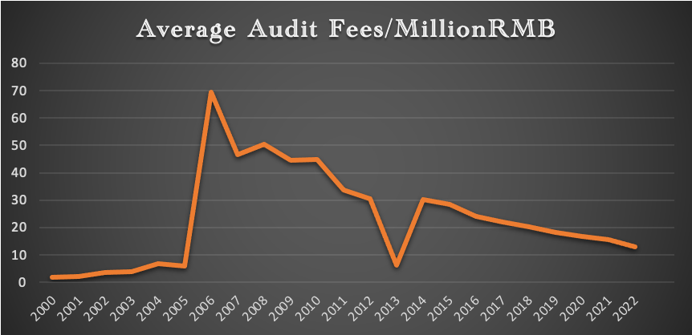

Figure 1.

Figure 1 provides information on how much audit fees were generated from the the part of the second half of the time period to now. Furthermore, we are able to see a rapid increase from 2004-2005, indicating a rise to huge economic development. As indicated from a research paper discussing the emergence of China from the economic imbalances of the early 2000s to an increase in audit fees and organisation of the markets in 2005. This graph also indicates how the government had become more aware about increasing scrutiny and regulated compliance demands.

However, in the years 2007-2008, we see the effects of the stock market crash and as the world began to recover from it, along with China. In the mid 2010s we see the result of China’s own stock market crash in 2015-2016. From there onwards, we see a deviating graphline all down towards the time of the pandemic 2020-2022 where economic activity had been hindered, specifically in China who saw a second hard wave of the virus in late 2022.

**Systemic Risks on the Bank in China**

1. **Liquidity Risk**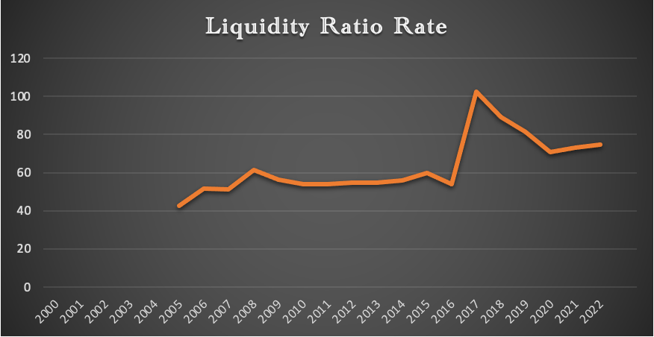

Figure 2.

Furthermore, in terms of Systemic Risks that lead to the prudential policy making, I also focused towards the liquidity risk data sets and tried to find the trend in the liquidity ratio during the period of 2000-2007, 2008-2015 and 2016-2022.

Here, we are able to see an interesting trend: from the years 2008 – 2009, the companies’ liquidity ratio in China seemed to have suddenly gone down from 61.5% to around 56.3%. The liquidity ratio is calculated by taking the ratio of the total assets to the total liabilities of a company. A company’s liquidity ratio signifies their ability to overcome their short-term liabilities through their short-term assets. The Chinese government reported and according to an article from the American Journal of Economics and Sociology by Mason Gaffney, there was a huge increase in fluctuation of land prices and real estate during the 2015 stock market crash. It also posed a major component of the share in assets in the economy of China

This trend can most likely have been caused by the renowned 2008 financial crisis whereby companies were not able to overcome their losses and liabilities. However, we see that this trend continued downwards till 2010. It was not until 2010, where we saw the trend to rise non-uniformly, whereby the economy recovered from the crisis and overcame its liabilities through a steady climb till 2013. We see that there was quite a uniform rise from 2013 onwards up and the continuation of the liquid ratio in years 2014 and 2015 onwards.

The trend we see in the graph below is that of the after effects of the stock market crash in China of 2016. However, as the market quickly began to progress and the volatility of these assets within the market began to increase in liquidity ratio on a yearly basis.  This could be attributed to the Chinese market reshifting its export demand to the domestic market, therefore; this shift in trade policies led to a substantial growth in China.

In this assessment, we find that the liquidity ratio fluctuated a lot in China and began to decline at a steady pace from 2017 where the economy had begun to recover. However, it saw its lowest point in 2020 and then there was little recovery as can be seen. The following factors such as COVID-19 pandemic posed as a major contributor to this decline and slow recovery time as assets had become really volatile during that time and the years following to present time.

This trend is very much understandable, especially in the case of China where the initial hit of the pandemic not only affected foreign companies around the world, but also the very harsh wave of the pandemic seen in 2022. This also exacerbated the recovery time for many companies operating from outside into China as well as those within China from meeting up to their short-term financial obligations.

1. **Market Risk**

Amongst the Systemic risks, there was also a Market Risk issue that is very much relevant to prudential policy making.   Market Risk showcases the potential for financial loss due to the changes and fluctuations in the market, it can be caused by various factors, including but not limited to changes in currency exchange, interest rates and price fluctuations.

The methodology I have attempted to showcase the market risk is divided into two different data sets. The first one is the average rate of return on assets(ROA) and the second one is the average rate of return on capital(ROC). These rates are important to take into consideration because the ROA showcases the ability of companies efficiency in utilising their assets and generating profits, similarly, the ROC represents the performance of the company in generating returns from its capital.

In the average rate of return on assets, there was a short decline from 2008-2009. From 2009 onwards, there was a steady climb till 2012 and steady decline from there onwards and an even steep decline from 2014 to 2015.

Furthermore, in the case of Market Risk, a crucial factor in seeing the trend of the financial market and the risks associated with it may be assessed with data showcasing the Rates of Return of Assets as well as the Rate of Return of Capital. Therefore, I collected both of the datasets associated with the rate of returns of Capital and Assets and computed them into their subsequent years from time periods 2016-2022.

As shown in figure 3 below, for the case of the rate of return of assets, we see that from the stock exchange crash from 2015-2016 and the economy began to gradually recover. Figure 3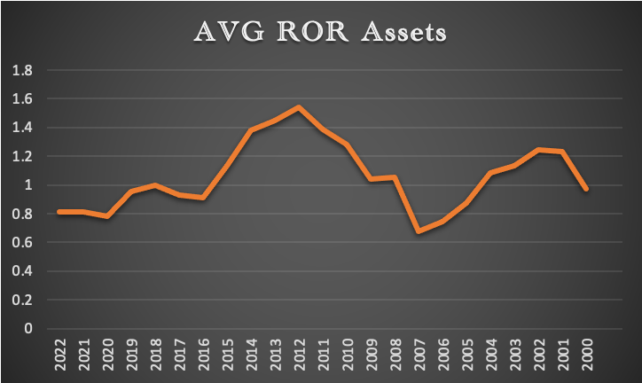

The companies within the markets were able to make gradual returns on a yearly basis after recovering from the after effects of the crash as can be seen from the years 2016 to 2018. However, from 2018 to 2019, we may see that there was a slight decline in the return of assets, mainly due to the market being heavily volatile at the time. This was mainly due to the Covid-19 pandemic which caused a lot of economic undertow and uncertainty in the market.

However, we see that there was a sharp decline from 2019 to 2020 with companies being unable to make profitable returns with their assets, not only in China but also around the world as it faced the financial strain from the pandemic. 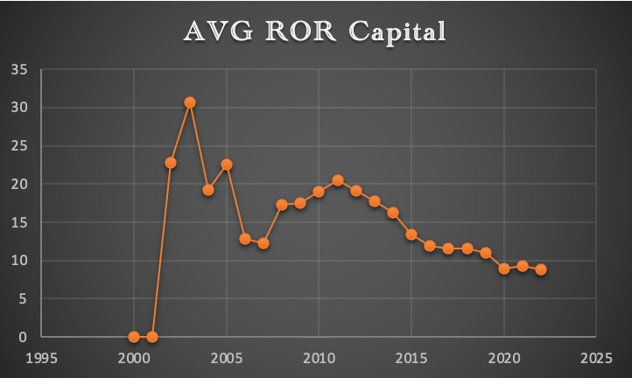

Figure 4.

The average return of capital has been showing a decreasing trend, largely due to the large expansion of the market and issues like corporate debt, government debt as well as shadow banking that largely played a role in decreasing value.

As in the case of the rate return on Capital, we see a much steeper decreasing trend in the companies in China that were able to meet their returns for debt as well as equity in investors. In the years 2016 to 2019, we can see a more constant trend, keeping in mind that the companies in China were recovering from the stock market crash of 2016. However, in 2019-2020, there was a sharp decline in return of capital and for companies to generate sufficient profitability levels as well as provide returns for debt and other equity investors within the market.

Even till date, we are seeing how the events of the pandemic affected the economy of China, especially in regards to profitability and returns of capital.

Conclusively, these measures facilitated me a lot in finding the trends within the financial market of China. In this fourth period, I was able to see and understand these trends largely because of the effect of the pandemic that brought the economies of the world to a spontaneous halt.

As far as data collection is concerned, the key difference to note is that between these two indicators is that the ROA was documented as opposed to the ROC. In addition, another important difference is that the ROA is more understandable in the sense that in the early 2000s, the government had incentivized the banking sector in loan distribution and the ROC can be seen after the generation of capital returns from 2003 onwards as can be seen above in figure 4.

1. **Credit Risk** 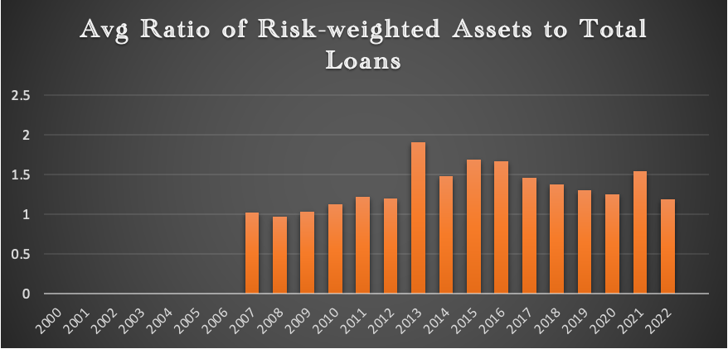

Figure 5.

The Credit Risk, another kind of Systemic Risk is also something that I very much relied on and examined a trend within the given period. Credit risk refers to the potential that the borrower or in this case a company or entity fails to meet their debt repayments. This could be in the form of loans, bonds or any kind of extra credit in the form of financial transactions. It is usually calculated from the ratio of the total debt to the total income of the individual or entity.

For the case of the credit risk in China We find that the credit risk in China has very much remained steady in 2008 and began to increase gradually yet steadily from 2008 to 2011. There was however a slight decline in 2011-2012 and a sudden increase in 2012-2013. As I looked into this sudden increase, I found out that China faced significant challenges with regards to credit risks during this time due to the rapid growth of its shadow banking sector.

China had experienced mass growth and development in this sector and certain issues like shadow banking where intermediaries providing credit and financial services had expanded significantly. Due to suspicions of the lack of transparency led to the assumption that they had been accumulating a lot of credit. Other issues like Corporate debt, local Government debt as well as Housing Market risks which grew at an exponential rate and concerns about a housing bubble and if it were to burst.

However, this trend decreased in 2014 and had been fluctuating throughout this time onwards. This trend increased in 2021 as indicated in Figure 5 above, when a lot of banking institutions failed to meet their debt obligations and therefore, suffered financial losses.

**Macro-prudential Policy**

As far as the macroprudential policy is concerned in China, there is a huge time variation in policies that were implemented. If we were to examine the policies made in the early 2000s, some notable examples would be the Recapitalization of Banks as well as the establishment of Asset Management Companies (AMCs). These were both measures taken by the government to inject capital into the major banks of china to strengthen their balance sheets. We can also see this in figures 3 and 4 where the ROR assets had also increased in these time frames.

In the third period, from 2008-2015, there were mostly policies made specifically due to the global financial crisis of 2008. The main measure taken in regards to prudential policy was the stimulus measures provided in response to the financial crisis. This mainly refers to increased bank lending to curb the economic downturn. Although this was not a direct indication to prudential policy, it definitely facilitated companies in overcoming their liabilities and this rising trend in figure 2 where the liquidity ratio from 2009 onwards increased.

For the fourth period, the main policy or measure taken was the deleveraging campaign to mitigate the issue of increasing debt levels within China. The key stakeholders here were the local governments who implemented independent policies along with the corporate sector to tackle the increasing credit risk. And this policy can be seen to have made successful outcomes, as can be seen in figure 5 where the credit risk rate from the weighted assets to loans was decreasing gradually from 2016 to 2019, up until the time of the pandemic where it rose again.

**Conclusion and Limitations**

For certain periods, I faced multiple challenges in data extraction as well as for finding data related to Credit Risks in the fourth period (2016-2022). For the first period, I was not able to find sufficient data whatsoever dating from the 70s to the late 90s, therefore I limited myself to the second half of the second period and the whole third as well as fourth period.

The three types of risks and responses act as indicators for driving the macroprudential policy, the divergence in the graph lines are causes of major events whether it was the 2008 global financial crisis or the stock market crash of 2015 or even the pandemic from 2019-2022 that show the performance of the financial system of China.

**Bibliography**

Lardy, Nicholas R., and Arvind Subramanian. *Sustaining China's economic growth after the global financial crisis*. Peterson Institute, 2011.

Gaffney, Mason. "A Real‐Assets Model of Economic Crises: Will China Crash in 2015?." *American Journal of Economics and Sociology* 74.2 (2015): 325-360.

Cashin, Paul, Kamiar Mohaddes, and Mehdi Raissi. "China's slowdown and global financial market volatility: Is world growth losing out?." *Emerging Markets Review* 31 (2017): 164-175.

Zhang, Xing, et al. "Macroprudential policy, credit cycle, and bank risk-taking." *Sustainability* 10.10 (2018): 3620.

Pan, Shiyuan, et al. "Excess liquidity and credit misallocation: Evidence from China." *China Economic Journal* 10.3 (2017): 265-286.

Cerutti, Eugenio, Stijn Claessens, and Luc Laeven. "The use and effectiveness of macroprudential policies: New evidence." *Journal of financial stability* 28 (2017): 203-224.

Galati, Gabriele, and Richhild Moessner. "What do we know about the effects of macroprudential policy?." *Economica* 85.340 (2018): 735-770.