Workflow to ingest document into Postgres Vector database:
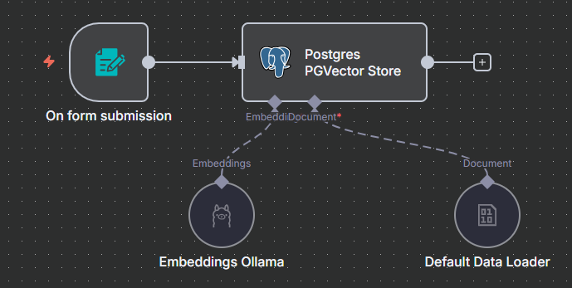

AI Agent: Ai Buddy
That can answer questions form documents in vector database, perform web search etc. developed with n8n, Ollama (llama3.2:2b, nomic-embed-text), Postgres (pgvector) and pgadmin; all running locally in docker containers.
