4. Basic Simulation:

% What modes is this example obtaining?

TE and TM modes

% How are these modes being calculated?

inite-difference eigenmode solver finding eigenvalues (neff) and eigenfunctions (Hx, Hy)

The modes are being calculated using a full-vector finite-difference eigenmode solver, which solves Maxwell's equations for the given waveguide structure.

%(c) Change the number of modes to 10 and run. You will need to add a loop to plot each mode.

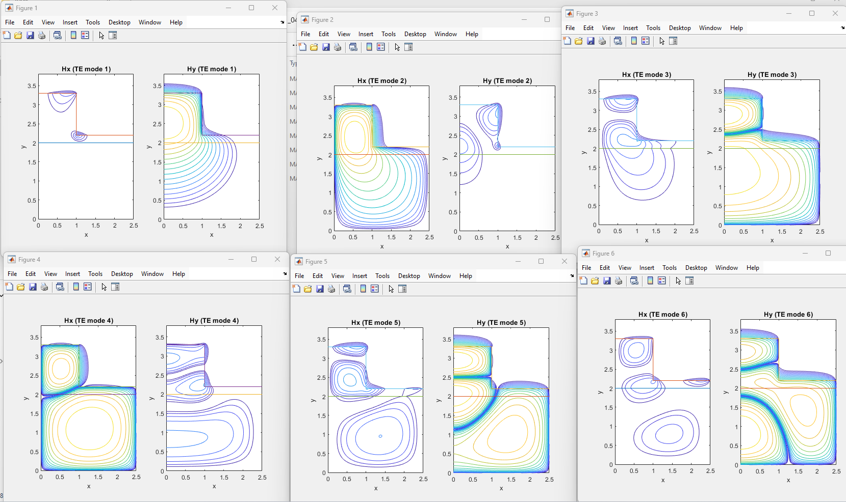

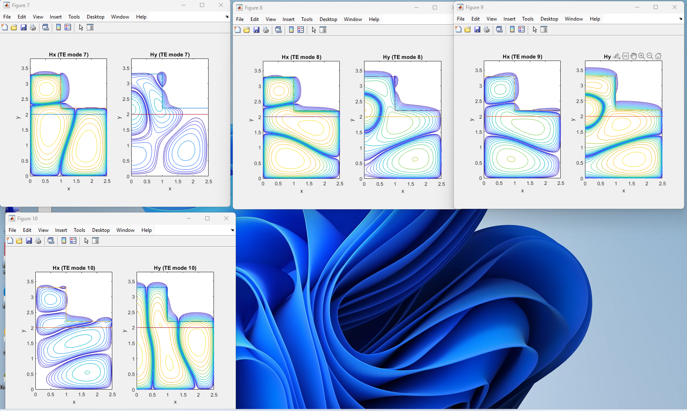

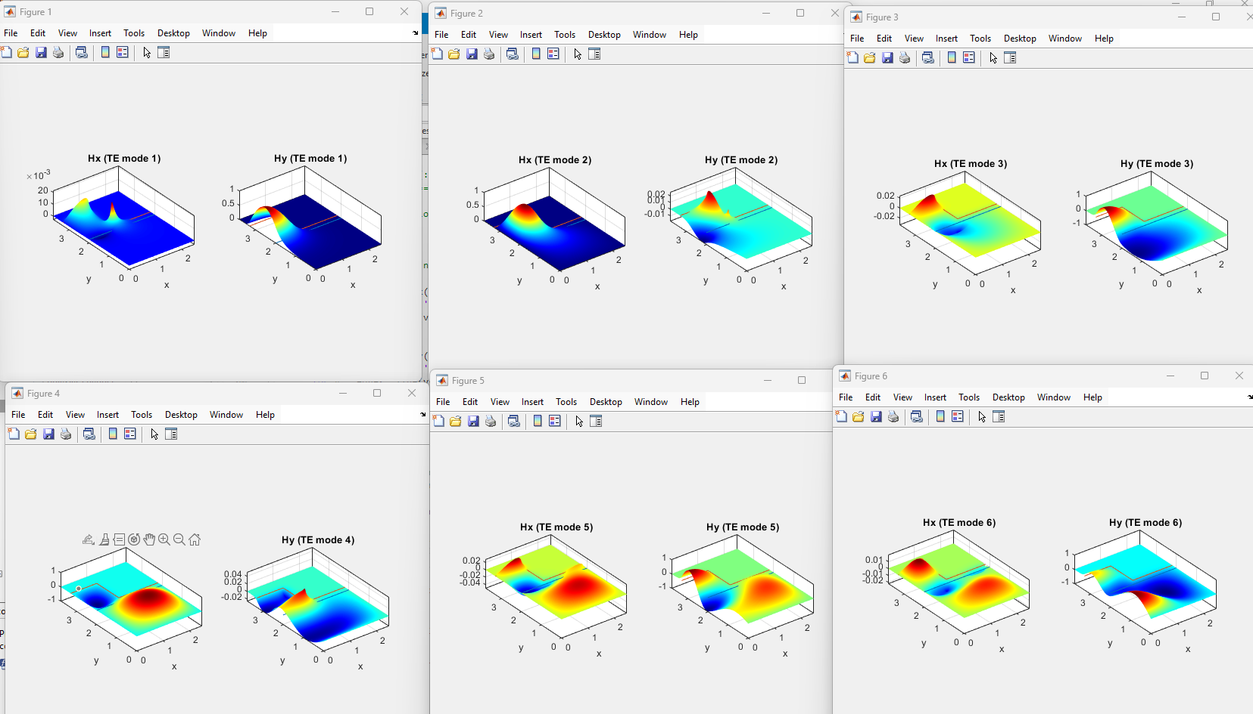

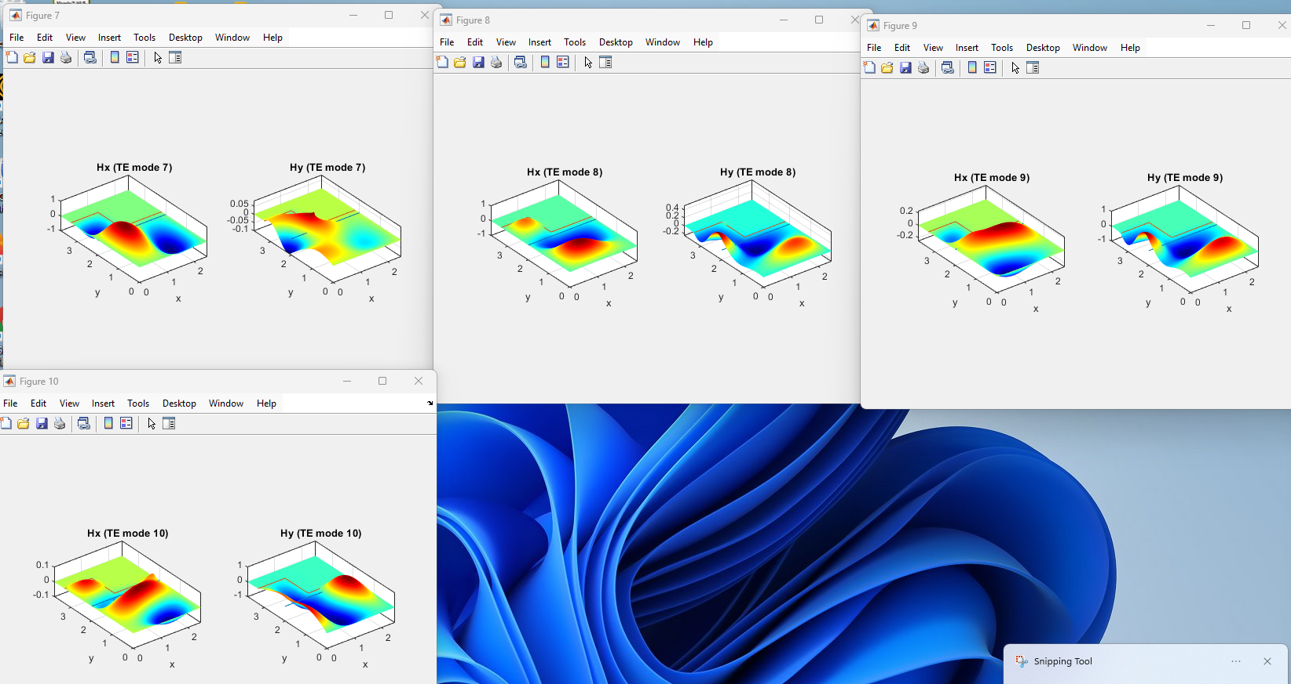

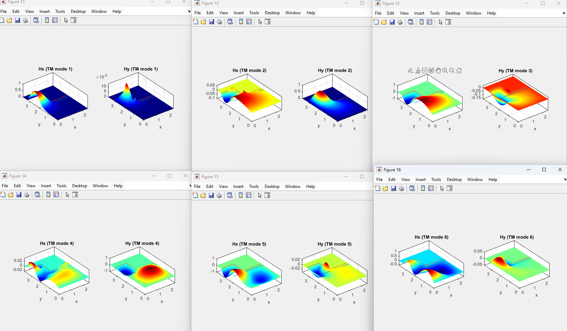

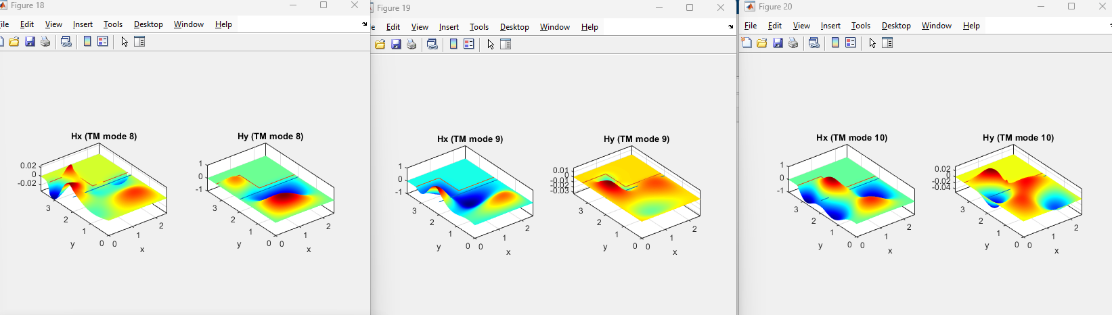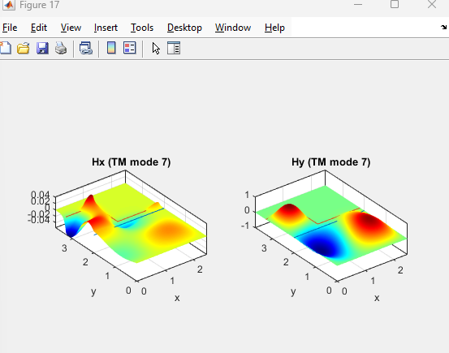

5. Geometry changes:

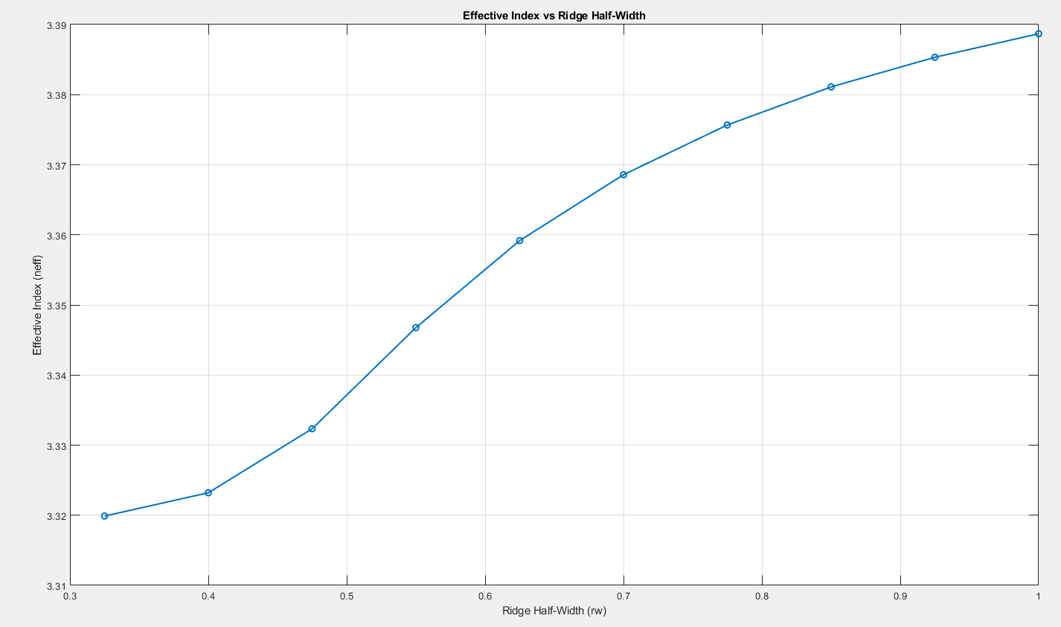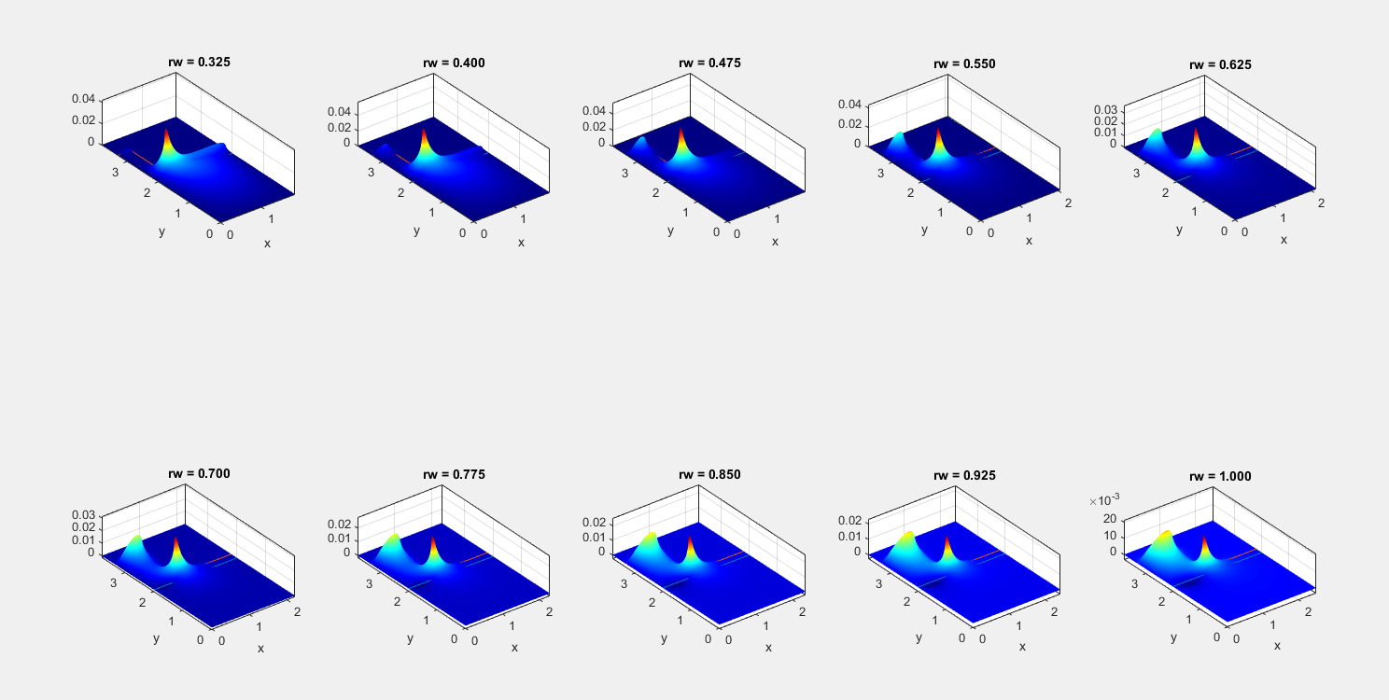

What happens as the ridge get very narrow? Why?

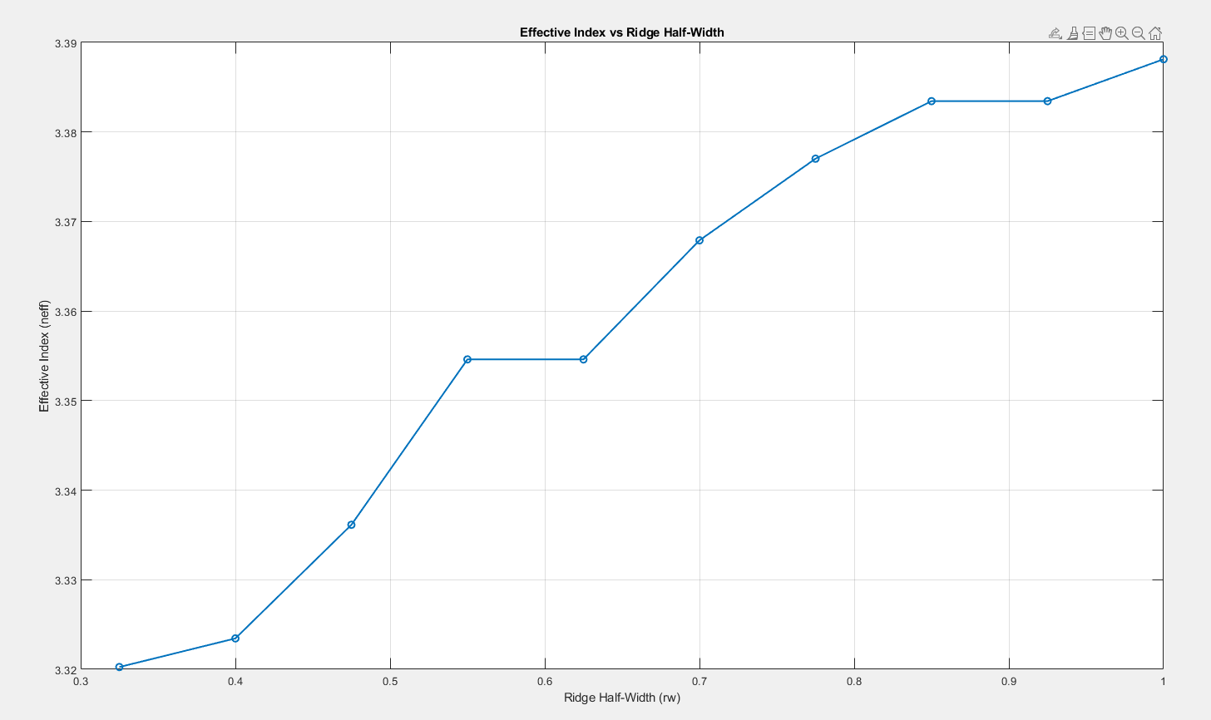

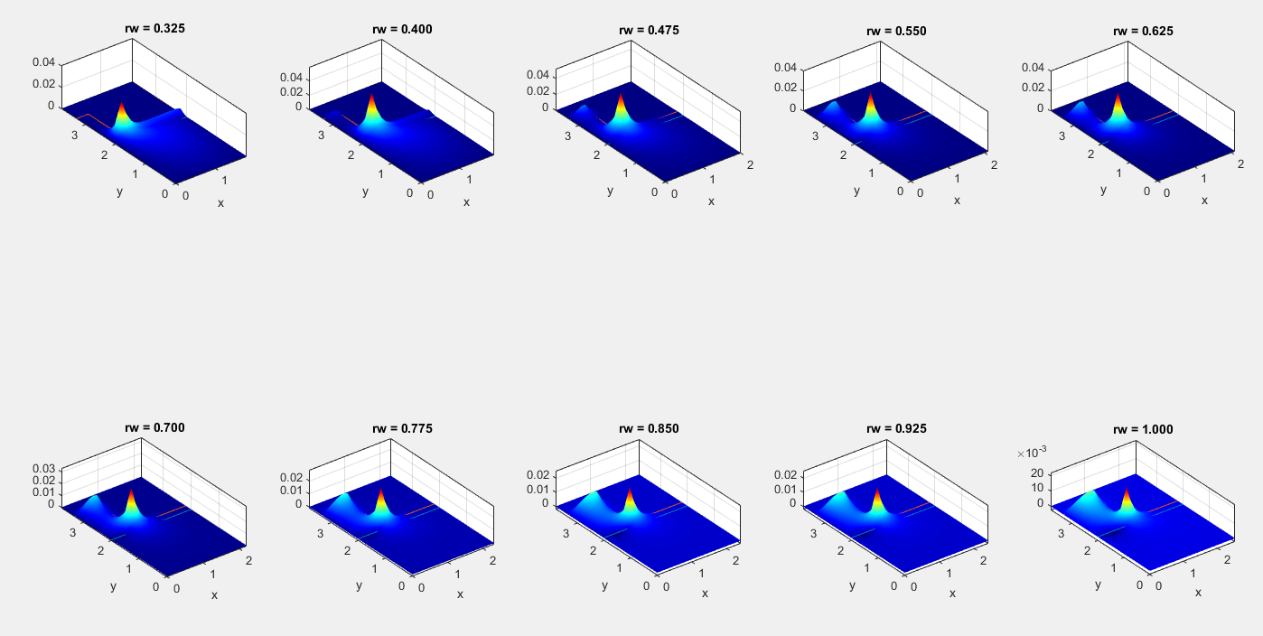

Accuracy Decreases

6. Material changes:

